Supplementary Table 1. Pubmed Search String
Subject | String
Cancer | ((((cancer) OR (neoplasm)) OR (carcinogen))
 | AND
Caribbean | (((((((((((((((((((((((((((((((((((((((caribbean) OR (caribbean region)) OR (caribbean diaspora)) OR (west indian)) OR (Anguilla)) OR (St. Maarten)) OR (Virgin Islands (US))) OR (St. Kitts and Nevis)) OR (Montserrat)) OR (Martinique)) OR (St. Vincent and the Grenadines)) OR (Curacao)) OR (Grenada))) OR (Bonaire)) OR (St. Eustatius)) OR (Saba)) OR (Guyana)) OR (Suriname)) OR (Trinidad and Tobago)) OR (Barbados)) OR (St. Lucia)) OR (Dominica)) OR (Guadeloupe)) OR (Antigua and Barbuda)) OR (Bermuda)) OR (Puerto Rico)) OR (The Bahamas)) OR (Dominican Republic)) OR (Cuba)) OR (Haiti)) OR (Jamaica)) OR (Cayman Islands)) OR (Belize)) OR (Aruba)) OR (British Virgin Islands)) OR (St. Barthélemy)) OR (turks and caicos)) OR (Netherlands Antilles)))
 | AND
Time | (("2004/01/01"[Date - Publication] : "2019/12/31"[Date - Publication]))
Filters | Abstract, Case Reports, Clinical Conference, Clinical Study, Clinical Trial, Journal Article, Meta-Analysis, Randomized Controlled Trial, Review, Systematic Review, Technical Report, Humans, Cancer, Systematic Reviews
Result: 4935 articles
Supplementary Table 2. Association between country income classification, number of universities and publication rate.

 | Average publication rate (no of articles/year) | p value
Income classification
High | 2.33 | 0.81
Upper-middle | 1.87
No. of universities |  | 0.79
<=10 | 1.6
>10 | 4.27

Supplementary Table 3. Comparison of the cancer types with the highest age-standardized mortality rates versus the cancer types with highest publication rates (2004-2019) for the top 5 countries in with the highest publication rates in the Caribbean region.

Country | Cancer types with the highest mortality rate | Cancer types with the highest publication rate
Puerto Rico | Colorectal (12.4 per 100 000) | Breast/Colorectal (2.60 pubs/year)
Puerto Rico | Lung (7.5 per 100 000) | Cervical (2.20 pubs/year)
Puerto Rico | Prostate (11.9 per 100 000) | Prostate (1.20 pubs/year)
Cuba | Lung (25.9 per 100 000) | Lung (1.20 pubs/year)
Cuba | Prostate (24.7 per 100 000) | Breast (0.73 pubs/year)
Cuba | Colorectal (11.3 per 100,000) | Brain (0.47 pubs/year)
Jamaica | Prostate (39.4 per 100 000) | Prostate (1.73 pubs/year)
Jamaica | Breast (34.1 per 100 000) | Breast (0.73 pubs/year)
Jamaica | Colorectal (13.4 per 100 00) | Cervical (0.67 pubs/year)
Trinidad and Tobago | Prostate (38.9 per 100 000) | Prostate (0.93 pubs/year)
Trinidad and Tobago | Breast (23.2 per 100 000) | Breast (0.80 pubs/year)
Trinidad and Tobago | Colorectal (11.0 per 100 000) | Cervical (0.40 pubs/year)
Martinique | Colorectal (10.3 per 100 000) | Prostate (0.47 pubs/year)
Martinique | Prostate (16.9 per 100 000) | Colorectal (0.33 pubs/year)
Martinique | Stomach (7.0 per 100 000) | Brain/Cervical/Eye  (0.13 pubs/year)

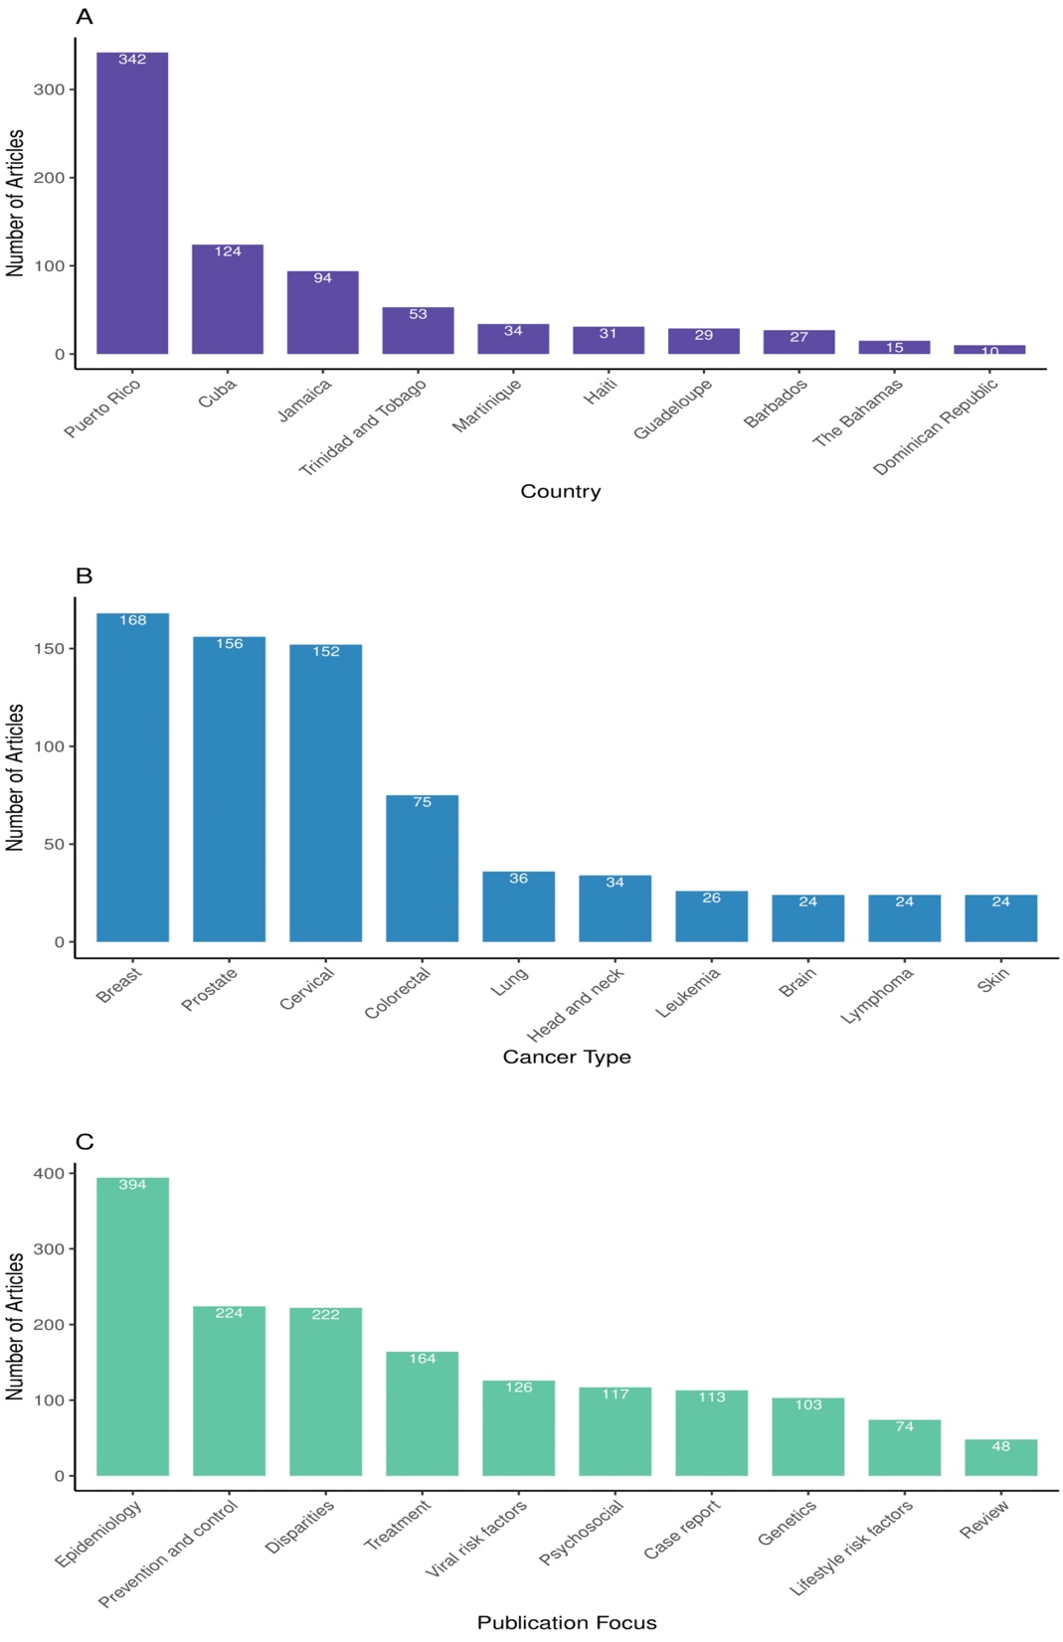
Supplementary Figure 1. Bar charts of the total number of publications by a) top 10 countries; b) top 10 cancer types and; (c) by top 10 publication fields

