Supplementary data file 2
Supplementary tables
Supplementary table S1. Detailed analysis of samples with false positive and false negative detection results
¹ Patient had COVID-19 antibody test, but IgM and IgG were not detected. Patient had symptoms 10 days before PCR test was performed and COVID-19 contact before feeling the symptoms.
² Patient had following symptoms: febrile fever with body temperature to 38,1 °C, feeling chills, painful urination, headache.
 | Nasopharyngeal swab samples
 |  | FAM channel | Texas RED channel
Patient code | Date of Sample Collection | ORF1ab gene, Ct | N gene, Ct | Test Result
BST142¹ | 2020-11-02 | - | - | Negative
BST083² | 2020-02-14 | 14.80 | 19.70 (Cy5) | Positive
 | Saliva samples
 |  | FAM channel | Texas RED channel
Patient code | Date of Sample Collection | ORF1ab & S genes, Ct | RPP, Ct | Test Result
BST142¹ | 2020-11-02 | 28.58 | 29.69 | Positive
BST083² | 2021-02-15 | - | 29.74 | Negative

Supplementary table S2. Viral Score value comparison by COVID-19 symptoms
 | Viral Score medians and quartiles in the saliva samples of subjects grouped by symptoms
Group of symptoms | Asymptomatic | Other symptoms | Symptoms belonging to a specific group | ANOVA p-value
Shortness of breath | 17,76 (16,39-18,92) | 15,55 (9,32-21,41) | 16,95 (13,44-19,41) | 0,341
Fever | 17,76 (16,39-18,92) | 16,15 (9,60-20,42) | 16,96 (12,46-19,65) | 0,367
Cough | 17,76 (16,39-18,92) | 15,45 (10,89-21,18) | 17,40 (12,31-19,48) | 0,383
Fatigue | 17,76 (16,39-18,92) | 17,91 (9,45-20,66) | 16,15 (12,19-20,21) | 0,394
Digestive dysfunction | 17,76 (16,39-18,92) | 16,65 (11,80-19,28) | 17,40 (12,05-21,41) | 0,391

Supplementary figures

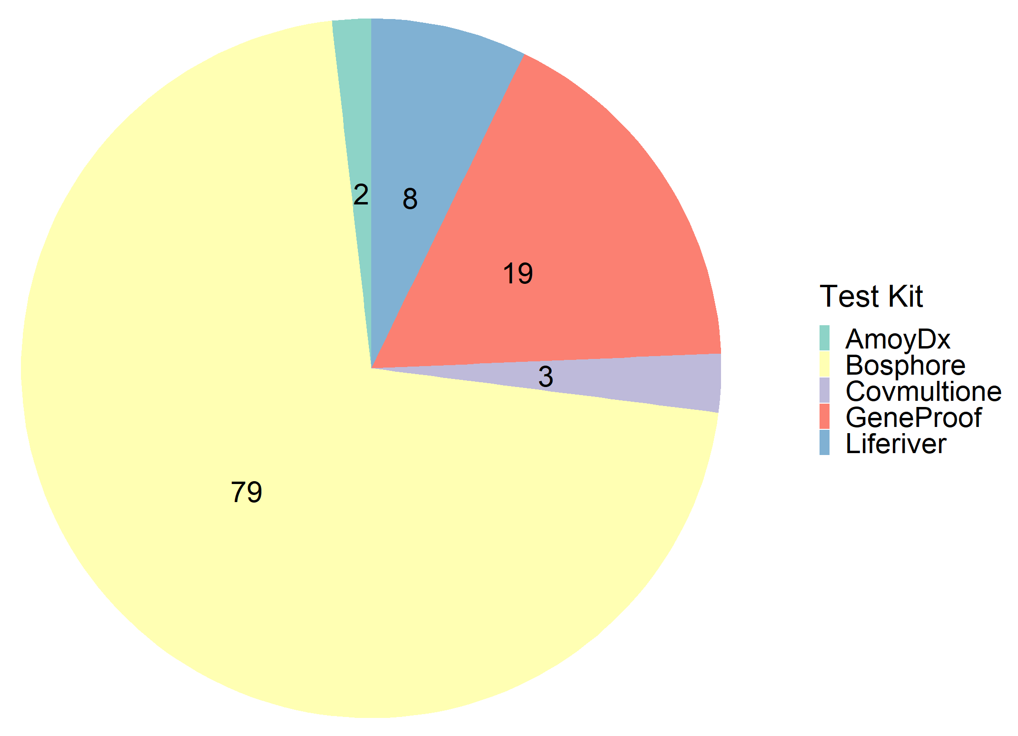

Supplementary figure S1. Number of Tests for Nasopharyngeal Samples by Test Kit.

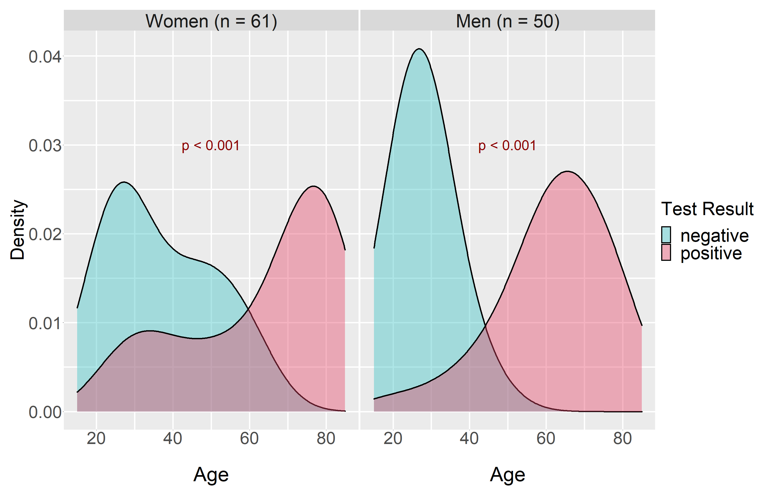

Supplementary figure S2. Distribution of Test Result by Age and Sex.

