Supplementary Table 1. Clinical features and Laboratory values between uterine leiomyosarcoma and leiomyoma
Pre-& postmenopause | LMS,  median (IQR) (n=79) | LM,  median (IQR) (n=257) | P-value
Body Weight (Kg) | 60.0 | 59 | 0.825
Size (largest, cm) | 8.0 | 7.8 | 0.225
Lymphocyte (cells/μL) | 1785.6 | 1745.6 | 0.734
Hb (g/dL) | 11.80 | 12.45 | 0.058
MCV | 88.85 | 88.75 | 0.696
RDW | 13.90 | 13.50 | 0.866
Platelets (×10³/µL) | 293.0 | 291.5 | 0.851
PDW | 11.80 | 12.45 | 0.058
CA-125 | 17.77 | 17.05 | 0.991
PLR | 178.24 | 164.13 | 0.583
LMR | 4.38 | 4.72 | 0.408
MLR | 0.23 | 0.21 | 0.408
P-values for comparisons of medians were obtained using the Mann-Whitney-U test.
LMS, uterine leiomyosarcoma; LM, uterine leiomyoma; IQR, interquartile range; MCV, mean corpuscular volume; RDW, red cell distribution width; PDW, Platelet distribution width; CA125, cancer antigen 125; PLR, platelet-lymphocyte ratio; LMR, lymphocyte-monocyte ratio; MLR, monocyte -lymphocyte ratio

Supplementary Table 2. Clinical features and Laboratory values between uterine leiomyosarcoma and leiomyoma
 | LMS,  median (IQR) (n=79) | LM, median (IQR) |  | P-value
 | LMS,  median (IQR) (n=79) | with degeneration (n=92) | without degeneration (n=165) | P-value
Body Weight (Kg) | 60.0 | 58.0 | 59.1 | 0.391
Size (largest, cm) | 8.0 | 8.0 | 7.7 | 0.473
Lymphocyte (cells/μL) | 1785.6 | 1761.2 | 1719.6 | 0.827
Hb (g/dL) | 11.8 | 12.5 | 12.4 | 0.156
MCV | 88.85 | 89.30 | 88.60 | 0.804
RDW | 13.90 | 13.50 | 13.60 | 0.725
Platelets (×10³/µL) | 293.0 | 277.0 | 294.0 | 0.572
PDW | 11.80 | 11.70 | 11.40 | 0.338
CA-125 | 17.77 | 18.44 | 16.45 | 0.077
PLR | 178.24 | 148.82 | 167.52 | 0.284
LMR | 4.38 | 4.70 | 4.75 | 0.635
MLR | 0.23 | 0.21 | 0.21 | 0.635
P-values for comparisons of medians were obtained using the Kruskal-Wallis test. A post-hoc test (Bonferroni) was applied with pairwise comparison between medians.
LMS, uterine leiomyosarcoma; LM, uterine leiomyoma; IQR, interquartile range; MCV, mean corpuscular volume; RDW, red cell distribution width; PDW, Platelet distribution width; CA125, cancer antigen 125; PLR, platelet-lymphocyte ratio; LMR, lymphocyte-monocyte ratio; MLR, monocyte- lymphocyte ratio

Supplementary Figure 1

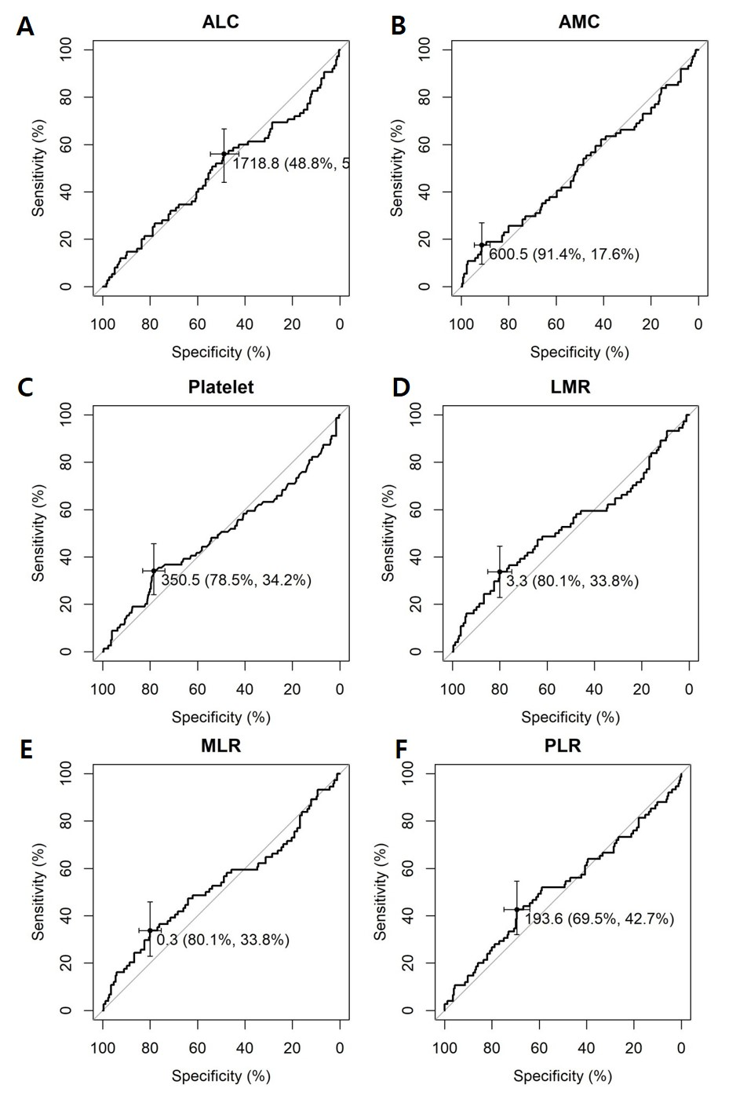

Figure 1 (supplementary). Receiver operating characteristic (ROC) curves for (A) absolute lymphocyte count (ALC), (B) absolute monocyte count (AMC), (C) ), platelet, (D) lymphocyte-to-monocyte ratio (LMR), (E) monocyte-to-lymphocyte ratio (MLR), and (F) platelet-to-lymphocyte ratio (PLR). Cut-off values are shown, and numbers in parentheses present specificity and sensitivity in order.

