Supplementary material

Determination of DOX and TAIII
DOX was determined through high-performance liquid chromatography (HPLC) under the following conditions: use of a Platisil ODS column (250mm×4.6mm, 5μm), mobile phase of methanol–water (55:45, v/v) containing 0.05% acetic acid and 0.01mol/L ammonium acetate, flow rate of 1 mL/min, detection wavelength of 254 nm and injection volume of 20 μL. TAIII was determined through HPLC equipped with an evaporative light-scattering detector (HPLC–ELSD) under the following conditions: use of a Platisil ODS column (250mm×4.6mm, 5μm), mobile phase of methanol–water (85:15, v/v), flow rate of 1 mL/min, and injection volume of 20 μL. The ELSD system was set to a probe temperature of 60 ℃, a gain of 1.0, and nebulizer N2 gas at 1.5 L/min.
Preparation of the orthotopic transplantation tumor model
The orthotopic transplantation tumor model was successfully established. Concretely, BALB/c nude mice were inoculated through subcutaneous injection with 0.1 mL HCC-LM3 cell suspension (2 × 10⁷ cells/mL) on the right sides of their backs. When the tumor volume reached approximately 500 mm³, mice were sacrificed and tumors were collected in Dulbecco’s modified Eagle medium containing 10% fetal bovine serum. A subcostal incision was made on nude mice under anesthesia with 20% urethane, and the left lobe of the liver was then exposed. The fish meat–like fresh tumor tissue was cut into 2.0 × 2.0 mm² pieces and implanted under the left lateral liver lobe with suture lines. The wound was carefully sutured, and an orthotopic hepatoma was obtained.
In vitro photothermal imaging
TAIII-DOX-LPs and MLPs were irradiated by NIR at 808 nm and in vitro photothermal imaging photos were recorded by an infrared thermal camera (FLIR Systems, Wilsonville, OR, USA). The results are consistent with data presented in Figure 2K and 2L. Increasing radiation intensity of NIR laser induced higher temperature increment of MLPs. And the temperature of TAIII-DOX-LPs without ICG stabilized below 30℃, suggesting that heat induced by laser irradiation was ICG-dependent.
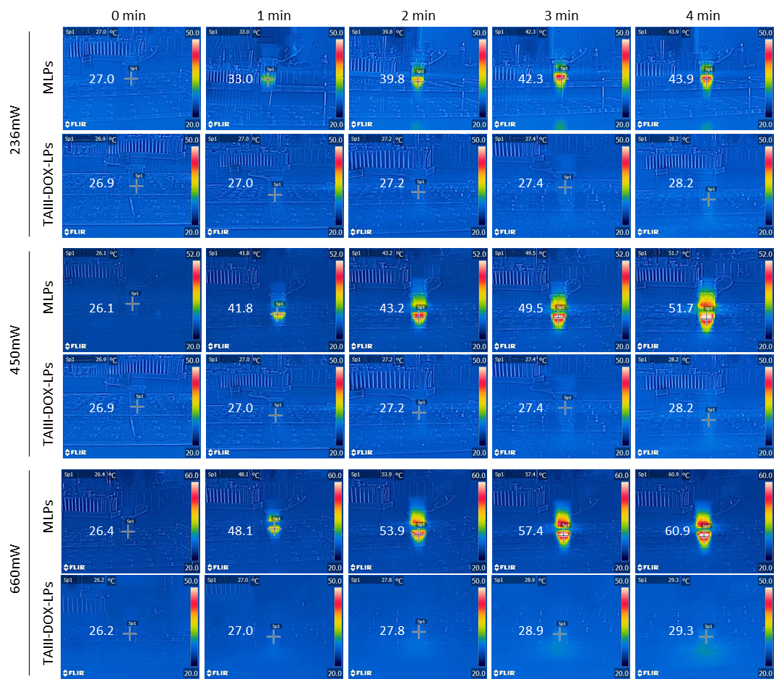
Figure S1 Photothermal imaging photos of MLPs irradiated by NIR at 808 nm

Photothermal stability of ICG in MLPs
Photothermal stability of ICG in MLPs was assessed by recording the temperature after irradiated by NIR at 808 nm (450mW) and in vitro photothermal imaging photos were displayed below. MLPs was stored at 4 °C in dark during the experiment. The photothermal conversion effect of ICG in MLPs was relatively stable, which is mainly attributed to the liposomal encapsulation. It is consistent with the studies that liposomal encapsulation could greatly improve the stability of ICG .^{1,2}
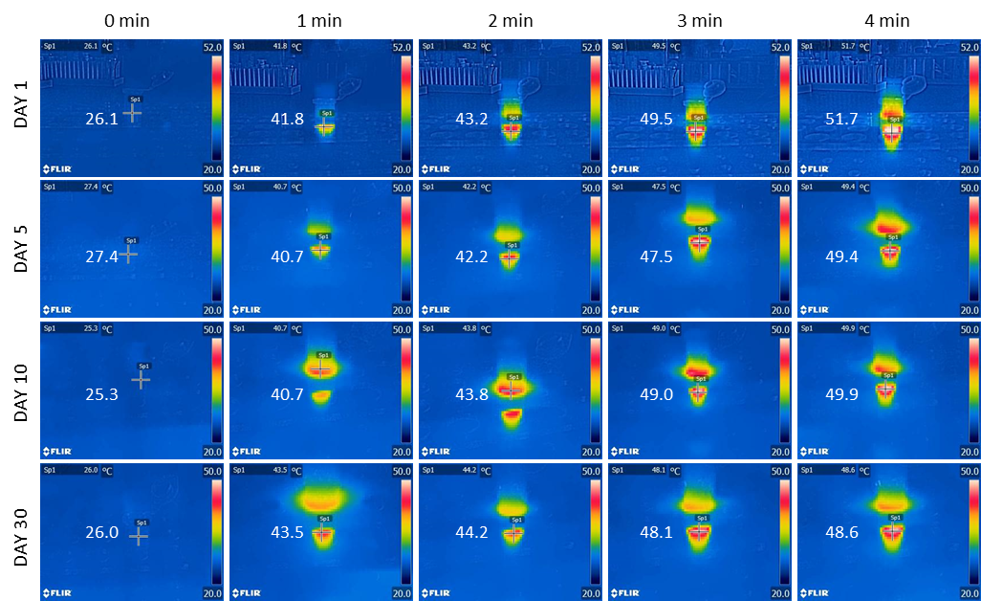
Figure S2 Photothermal imaging photos of MLPs irradiated by NIR at 808 nm

Table S1 Photothermal stability of ICG irradiated by NIR at 808 nm
Time (day) | 0 min | 1 min | 2 min | 3min | 4 min
1 | 26.3±0.3 | 41.3±0.3 | 42.9±1.1 | 49.6±1.4 | 52.0±1.3
5 | 27.0±0.1 | 40.9±0.9 | 43.1±0.7 | 48.1±0.4 | 49.7±2.1
10 | 25.9±0.2 | 40.3±1.2 | 42.7±0.4 | 48.6±1.2 | 50.4±1.8
30 | 26.3±0.2 | 42.1±0.8 | 43.9±1.4 | 49.0±1.6 | 49.1±1.3

Apoptosis assay and western blot analysis
Cell apoptosis was detected using an annexin V-APC/7AAD (PI) apoptosis assay kit. Concretely, 1 × 10⁶ HepG2 cells and HCC-LM3 cells were respectively seeded in 6-well plates and incubated for 24 h. The cells were treated with DOX, TAIII, DOX/TAIII and TAIII-DOX-LPs for 48 h. The molar ratio of DOX and TAIII was fixed at 1:4, where the concentration of DOX was 3 μM and TAIII concentration was 12 μM, respectively. After incubation, the cells were washed twice with PBS, resuspended in binding buffer, and mixed with annexin V-APC and 7-AAD at room temperature for 15 min. Finally, cell apoptosis induced by drug treatment analyzed by BD FACSCalibur flow cytometry.
The expression of apoptosis related protein, cleaved forms of caspase-3, caspase-9, caspase-8, Bax and Bcl-2 were evaluated with western blotting. HepG2 cells and HCC-LM3 cells were treated with DOX, TAIII, DOX/TAIII and TAIII-DOX-LPs (DOX concentration = 3 μM; TAIII concentration = 12μM) for 24 h. After incubation, cells were collected and total protein was extracted using the cell lysis reagent. The total protein was quantified using the BCA protein assay kit (Promega, USA) and equal amounts of protein were electrophoresed on SDS-PAGE and transferred to polyvinylidene difluoride (PVDF) membranes. After blocking for 15 min with QuickBlock™ Blocking Buffer, membranes were blotted with primary antibodies at recommended concentrations overnight at 4℃, followed with appropriate secondary antibodies. The immunoreactivities were visualized with an enhanced chemiluminescent system. Cells cultured as usual without treatment were used as a control. The band intensities were measured, and the protein signals were normalized to the β-actin levels.
Figure S3 The apoptosis-inducing effect of DOX and TAIII by flow cytometer and western blot analysis against HepG2 cells and HCC-LM3 cells. Apoptosis analysis of HepG2 cells (A) and HCC-LM3 cells (B) was carried out by flow cytometry. Quantitative analysis of apoptotic HepG2 cells (C) and HCC-LM3 cells (D) after treated with DOX, TAIII, DOX/TAIII and TAIII-DOX-LPs. The expression of apoptosis related protein, Bax, Bcl-2, caspase-8, caspase-3 and caspase-9 in HepG2 cells (E) and HCC-LM3 cells (F)were evaluated with western blotting using β-actin as an internal control. * P < 0.05. ** P < 0.01.
In vitro Cytotoxicity
Figure S4 Effect of Blank-LP on HepG2 cells (A) and HCC-LM3 cells (B). Effect of ICG ranging within the molar used in the formulations on HepG2 cells (C) and HCC-LM3 cells (D).

Histological characteristics of major organs excised from HepG2 tumor-bearing mice and HCC-LM3 tumor-bearing mice
Figure S5 Histological characteristics of tumor, liver, spleen, lung and kidney excised from HepG2 tumor-bearing mice. The images were obtained using a digital microscope at 200× magnification. Scale bar =100μm.
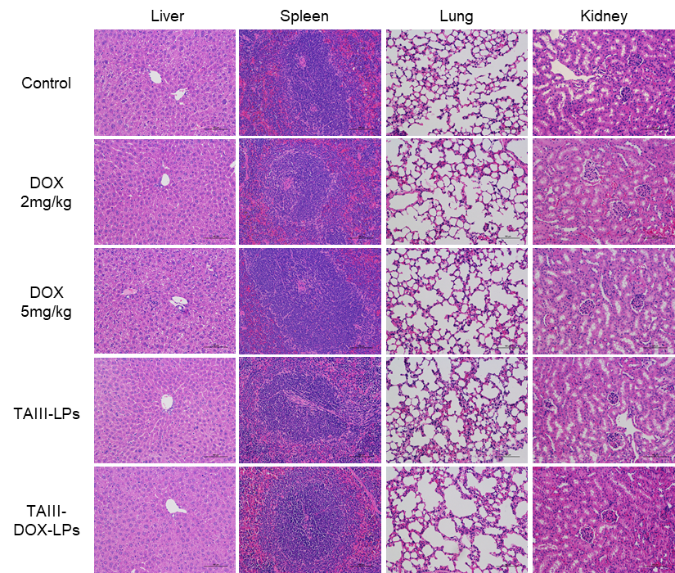
Figure S6 Histological characteristics of liver, spleen, lung and kidney excised from HCC-LM3-bearing mice. The images were obtained using a digital microscope at 200× magnification. Scale bar =100μm.
Effect of NIR Irradiance on MLPs Cytotoxicity
The screening process for irradiation time and power was shown in Figure S7. Irradiation at 0.8 W/cm² for 2~10 min had no effect on cell viability. When the irradiation intensity was set at 1 W/cm², 1.5 W/cm² and 2 W/cm², 10min-irradiation inhibited cells in both MLPs group and control group. 5 min-irradiation at 1.5 W/cm² and 2 W/cm² also inhibited cells in control group, while 2 min-irradiation had little effect on cells in control group. Thus, 2 min-irradiation was thought to be appropriate and it was convenient for operation. MLPs treated cells combined with irradiation 2 W/cm² for 2min showed lower cell viability than that at 1.5 W/cm². Therefore, 2 W/cm² for 2min was adopted in cytotoxicity evaluation.
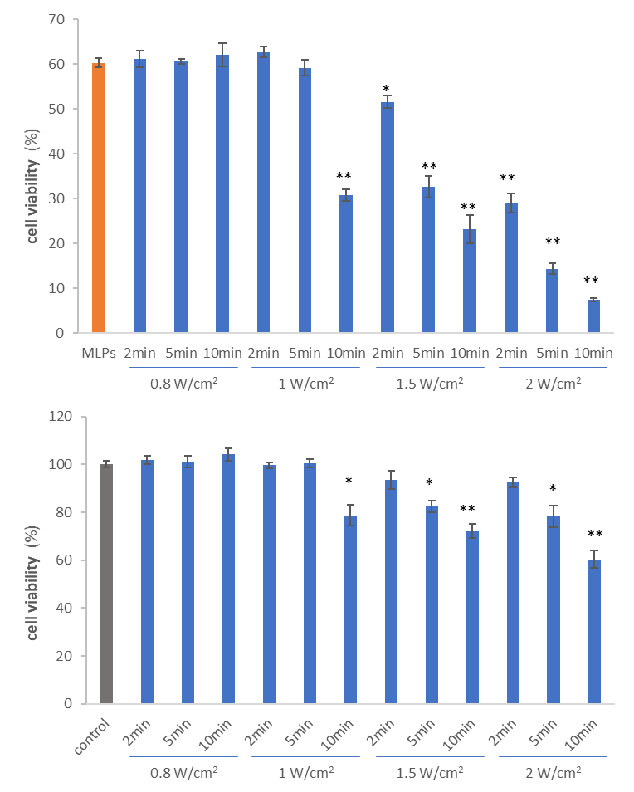
Figure S7 The effect of irradiation time and power on MLPs cytotoxicity. * P < 0.05. ** P < 0.01, compared to MLPs and control.

In vivo antitumor activity on the subcutaneous transplantation tumor model
The screening process for time and power was shown in Figure S8. The temperature at tumor site was recorded after irradiation. When the irradiation powder was set at 2 W/cm² , 5 min-irradiation induced a temperature of 48.3℃ and the mouse would flinch as increasing irradiation time. Although 10 min-irradiation at 1 W/cm² and 1.5 W/cm² would cause hyperthermia at tumor site, the time was much too long to operate. Thus, irradiation at 1.5 W/cm² for 5 min induced mild hyperthermia of 45.2℃ was adopted as proper parameters.
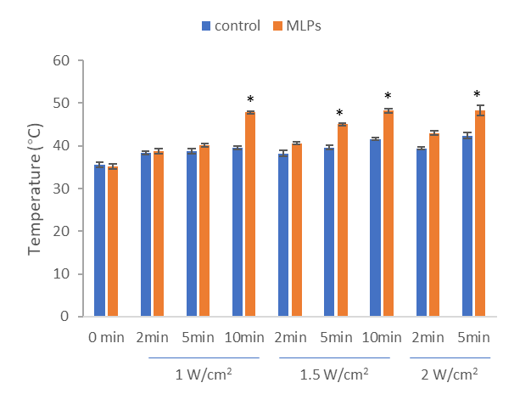
Figure S8 The effect of irradiation time and power on temperature at tumor site in control and MLPs groups. * P < 0.05, compared to control.

References：
1. Shemesh CS, Moshkelani D, Zhang H. Thermosensitive liposome formulated indocyanine green for near-infrared triggered photodynamic therapy: in vivo evaluation for triple-negative breast cancer. Pharm Res.2015 May;32(5):1604-14.
2. Chopra A. Folic acid-indocyanine green-poly(d,l-lactide-coglycolide)-lipid nanoparticles. In: Molecular Imaging and Contrast Agent Database (MICAD). Bethesda (MD): National Center for Biotechnology Information (US); August 30,2012.

