Supplementary Figure 1 Scatter plot displaying the relationship between PGI scores and EQ-5D-5L scores.
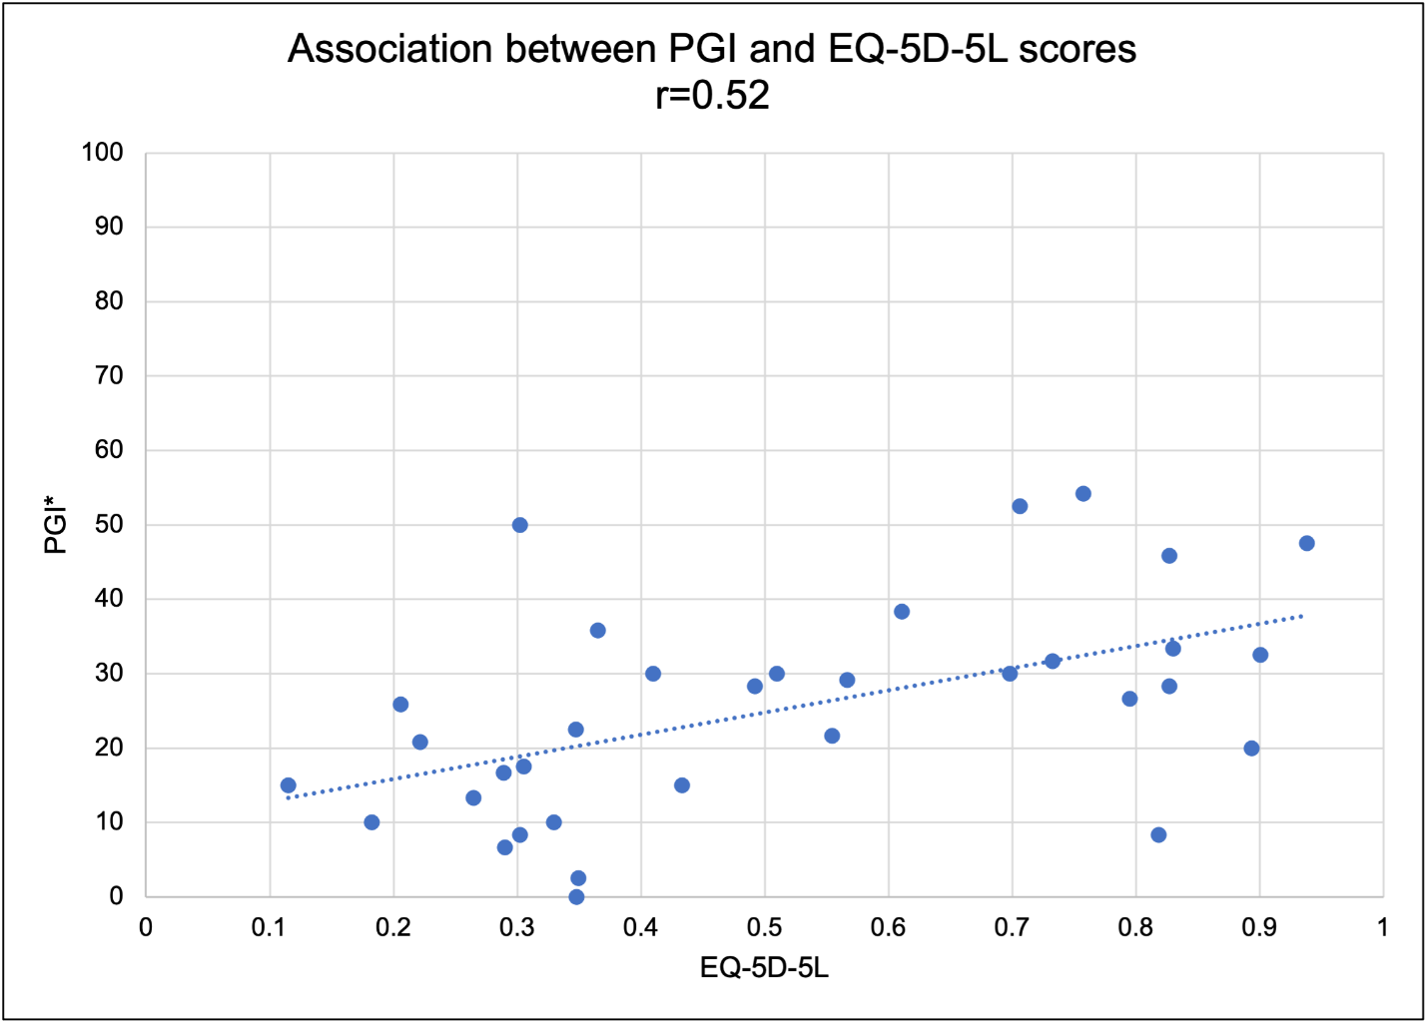

Notes: *Missing data (N=17)
Abbreviations: PGI, Patient Generated Index; EQ-5D-5L, EuroQol 5 Dimension 5 Level

