Smart polymeric nanoparticles with pH-responsive and PEG-detachable properties (II): co-deliver of paclitaxel and VEGF siRNA for synergistic breast cancer therapy in mice
Mingji Jin^{1,2,#}, Yan Hou^{1,2,3,#}, Xiuquan Quan^{1,2,4,#}, Liqing Chen^{1,2}, Zhonggao Gao^{1,2,}*, Wei Huang^{1,2,}*
¹ State Key Laboratory of Bioactive Substance and Function of Natural Medicines, Institute of Materia Medica, Chinese Academy of Medical Sciences and Peking Union Medical College, Beijing 100050, China
² Beijing Key Laboratory of Drug Delivery Technology and Novel Formulations, Institute of Materia Medica, Chinese Academy of Medical Sciences and Peking Union Medical College, Beijing 100050, China
³ Department of Pharmacy, Yanbian University, Yanji Jilin 133000, P.R. China
⁴ Department of Emergency Medicine, Affiliated Hospital of Yanbian University, Yanji Jilin 133000, P.R. China
* Corresponding authors: Zhonggao Gao, zggao@imm.ac.cn, Tel.: +86 010 63028096. Wei Huang, huangwei@imm.ac.cn, Tel.: +86 010 63026505
# These authors contributed equally to this work.

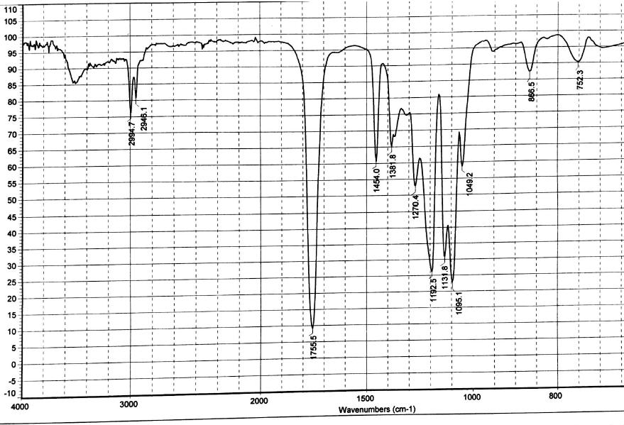

Figure S1. FTIR spectra of PLA-COOH.
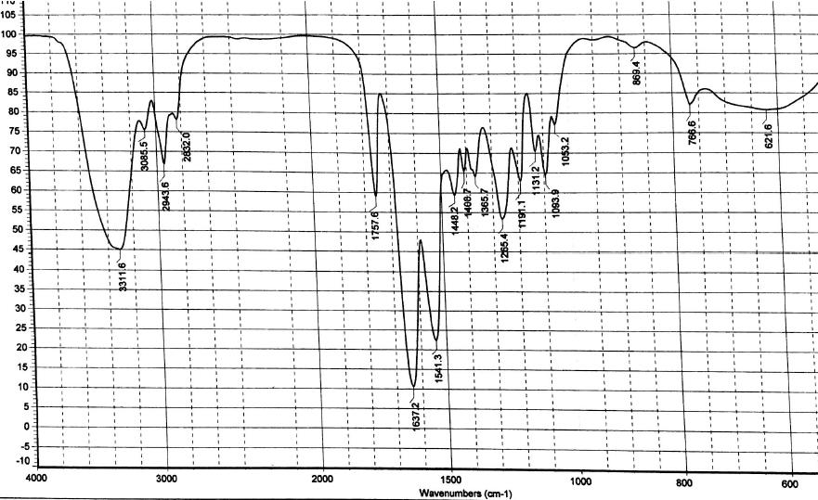

Figure S2. FTIR spectra of PEI-PLA.
As shown in the figures, strong absorption appears at 1755 cm⁻¹ in the FTIR of PLA-COOH, which is attributed to the stretching vibration absorption peak (V_{C =O}) of the carboxyl group in PLA-COOH. In PEI-PLA, strong absorption appeared at 3300 cm⁻¹ and 1540-1640 cm⁻¹, of which 3300 cm⁻¹ was attributed to the absorption peak of amino on PEI, and 1540-1640 cm⁻¹ was attributed to the characteristic absorption peak of C=O stretching vibration in the amide bond.

