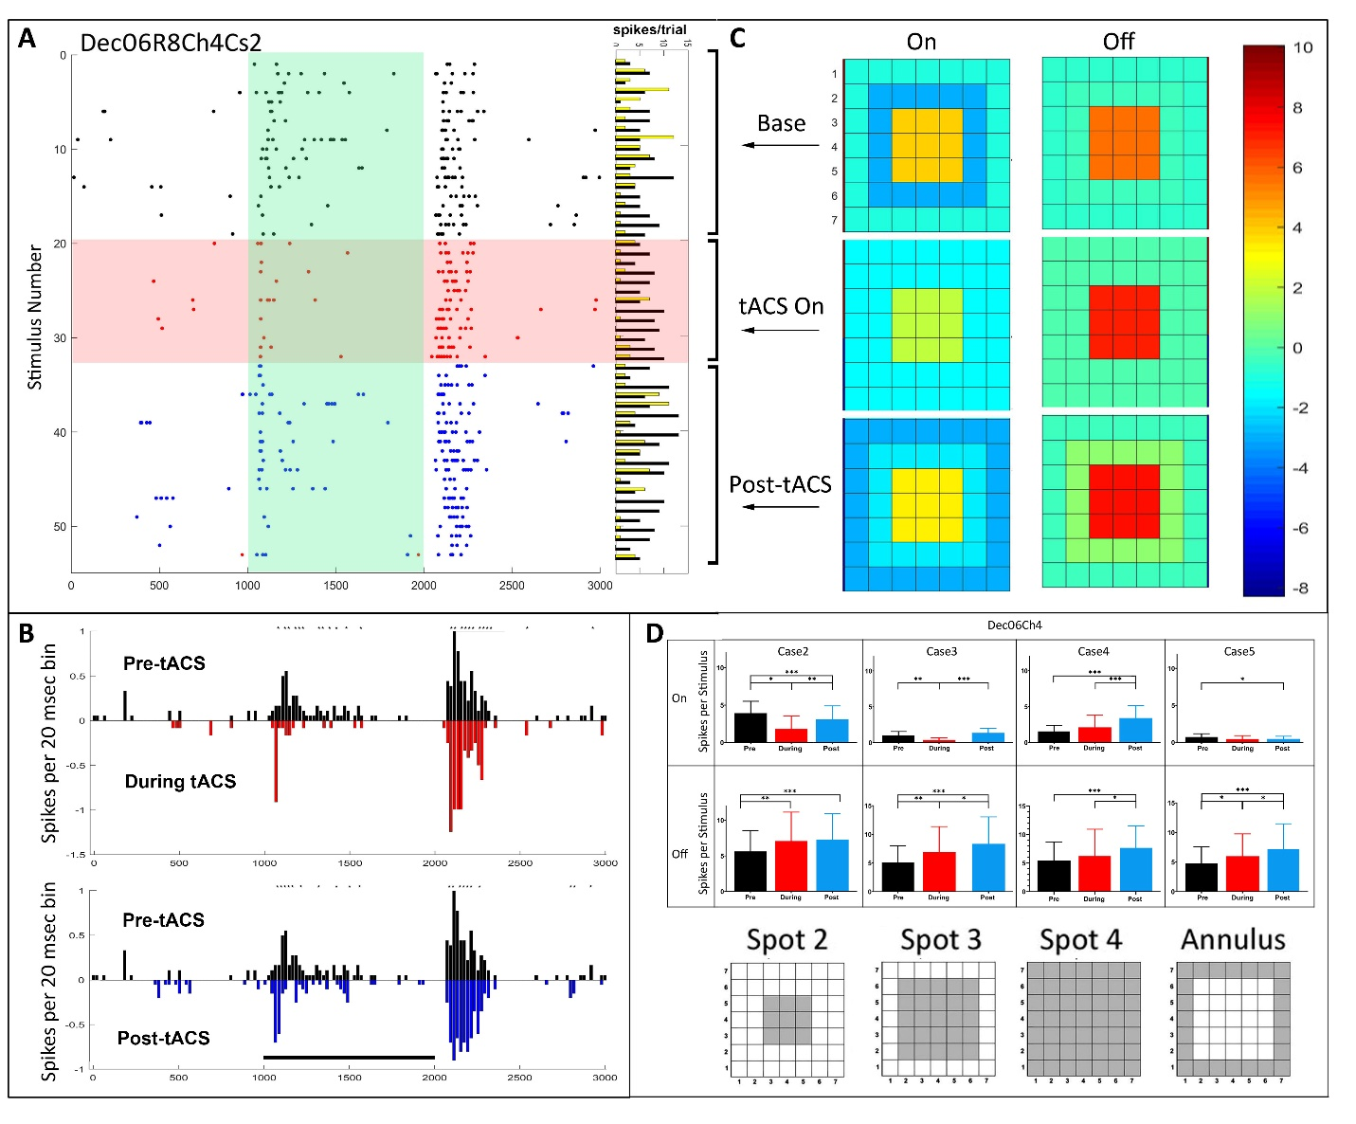Figure S1. Temporal and spatial characteristics of the pattern 1 responses of an Off-center sustained retinal ganglion cell (Dec06R8Ch4Cs2) before, during and after tACS current. A. Raster plots of the spikes occurring during each stimulus epoch for the case 2 spot. Horizontal columns at right indicate On (yellow) and Off (black) spike totals from each raster line. B. PST histograms of baseline (black), during tACS (red) and post-tACS (blue) responses, as in Figure 2. Black bar indicates the timing of the light stimulus. . Asterisks above a bin denote significance at the p<0.05 level. C. Heat maps of the responses as a function of spatial configuration constructed from responses to all spots. D. Bar plots of On and Off response spikes as a function of stimulus configuration for pre-tACS (black), during tACS (red) and post-tACS (blue) epochs. Error bars indicate 95% confidence intervals. * p<0.05, ** p<0.001, *** p<0.0001

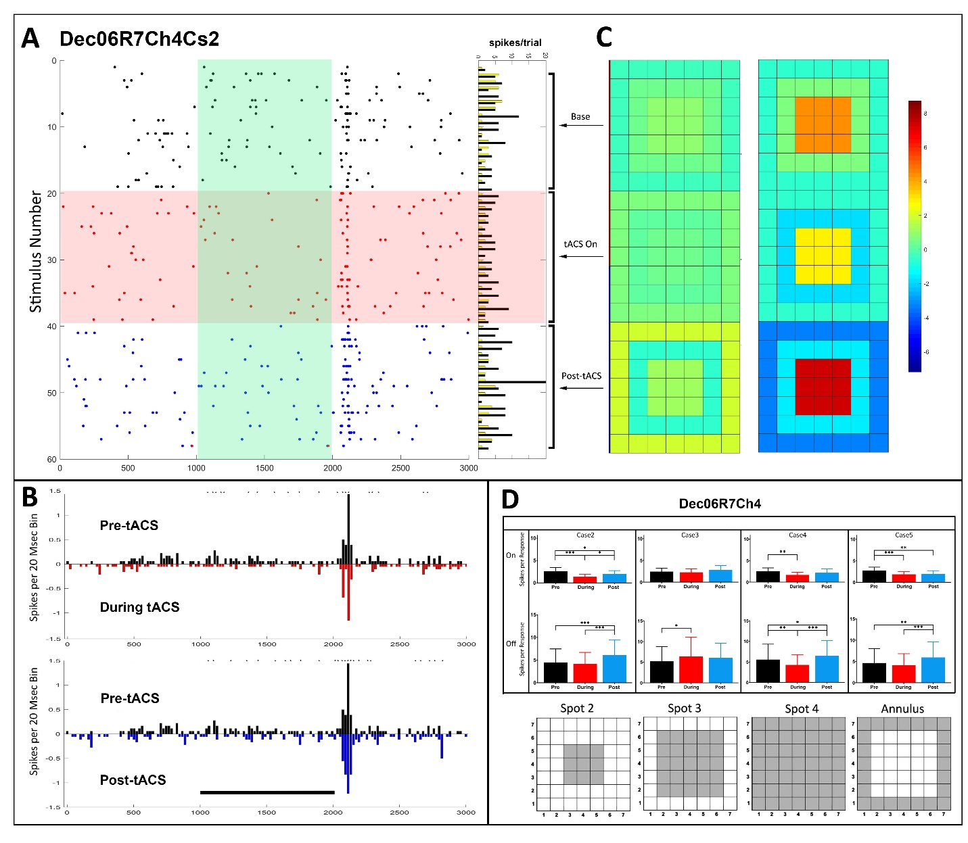
Figure S2. Temporal and spatial characteristics of the pattern 2 responses of an Off-center transient retinal ganglion cell (Dec06R7Ch4Cs2) before, during and after tACS current. A. Raster plots of the spikes occurring during each stimulus epoch during each stimulus epoch for the case 2 spot (plotting conventions same as Figure 2). Horizontal columns at right indicate On (yellow) and Off (black) spike totals from each raster line. B. PST histograms of baseline (black), during tACS (red) and post-tACS (blue) responses. Black bar indicates the timing of the light stimulus. Asterisks above a bin denote significance at the p<0.05 level, C. Heat maps of spatial dependence of On and Off responses. D. Bar plots of total On and Off responses. Error bars indicate 95% confidence intervals. * p<0.05, ** p<0.001, *** p<0.0001

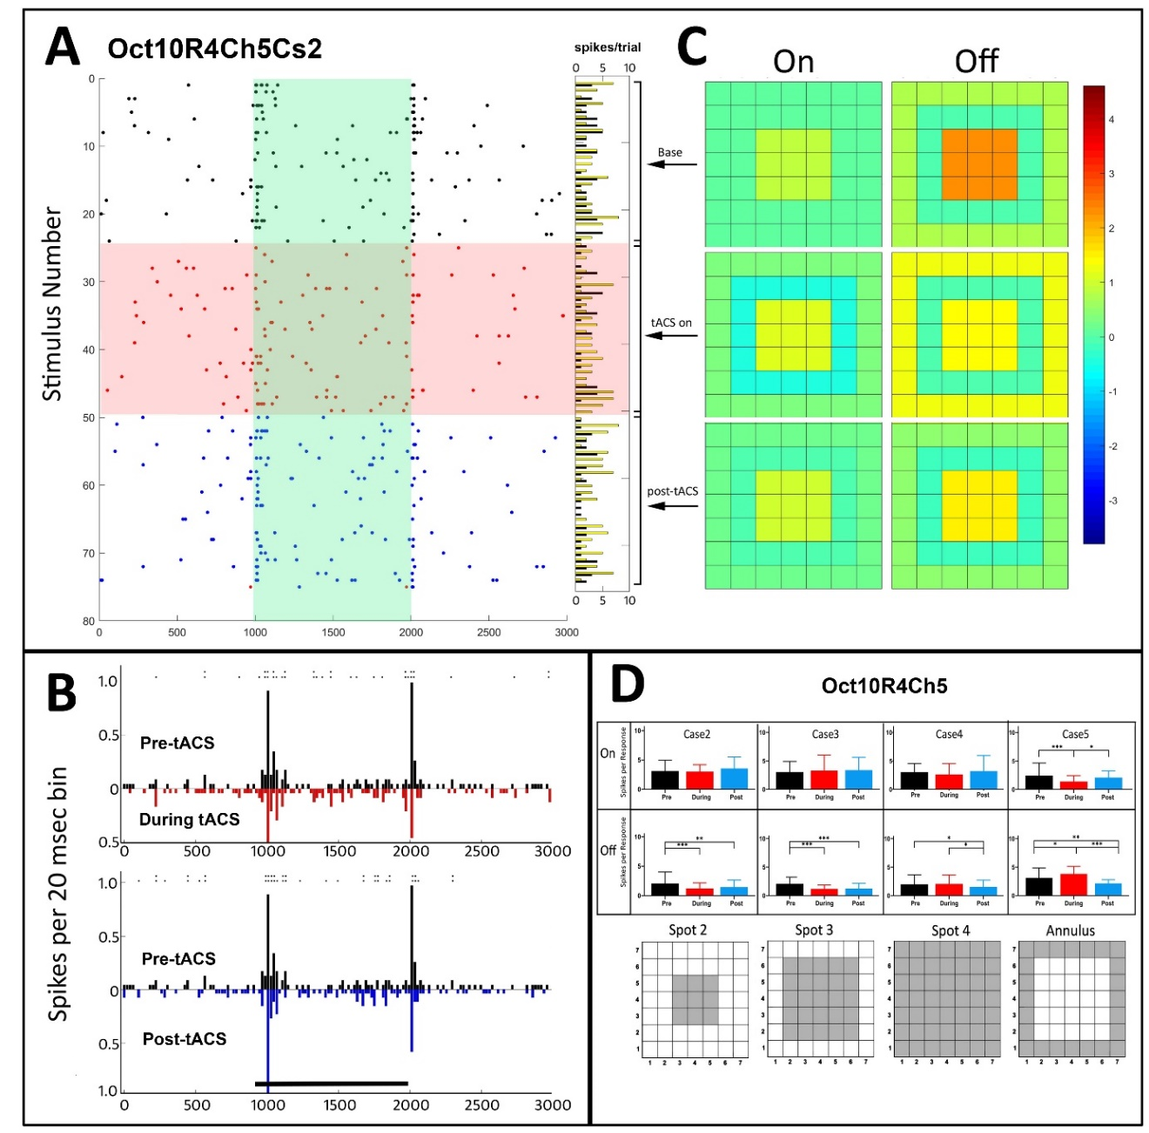
Figure S3. Temporal and spatial characteristics of the responses of an On-Off retinal ganglion cell (Oct10R4Ch5) before, during and after tACS current. Symbols and layout conventions as in Figure 2. A. Raster plots of the spikes occurring during each stimulus trial for the spot 2 stimulus. Horizontal columns at right indicate spike totals from each raster line. B. PST histograms of baseline (black), during tACS (red) and post-tACS (blue) responses. Asterisks above a bin denote significance at the p<0.05 level, double height symbols denote significant difference at the p<0.005 level. Black bar indicates the timing of the light stimulus. C. Heat maps of spatial dependence of On and Off responses constructed from responses to all spots. D. Bar plots of response spikes as a function of stimulus configuration for pre-tACS (black), during tACS (red) and post-tACS (blue) epochs. Error bars indicate 95% confidence intervals. * p<0.05, ** p<0.001, *** p<0.0001
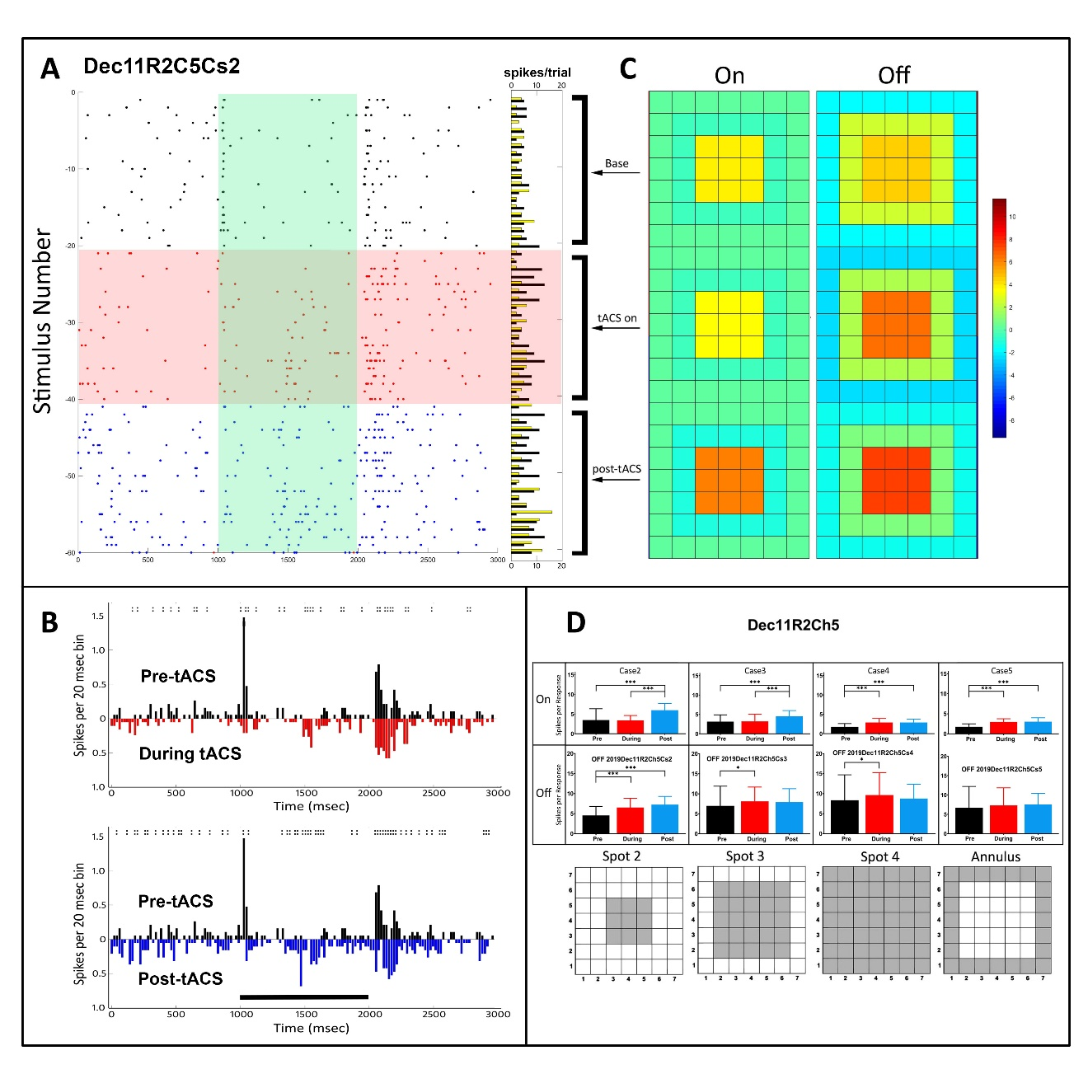
Figure S4. Temporal and spatial characteristics of the responses of an On-Off retinal ganglion cell (Dec11R2Ch5; simultaneously recorded with the cell shown in Figure 6) to the case 4 spot before, during and after 20 Hz tACS current. Symbols and layout conventions as in Figure 2. A. Raster plots of the spikes occurring during each stimulus epoch (plotting conventions same as Figure 2). B. PST histograms of baseline (black), during tACS (red) and post-tACS (blue) responses. Asterisks above a bin denote significant differences between the plots at the p<0.05 level, double height symbols denote significant differences at the p<0.005 level. Black bar indicates the timing of the light stimulus. C. Heat maps of the responses as a function of spatial configuration constructed from responses to all spots. D. Bar plots of On and Off response spikes as a function of stimulus configuration for pre-tACS (black), during tACS (red) and post-tACS (blue) epochs. Error bars indicate 95% confidence intervals. * p<0.01, *** p<0.0001
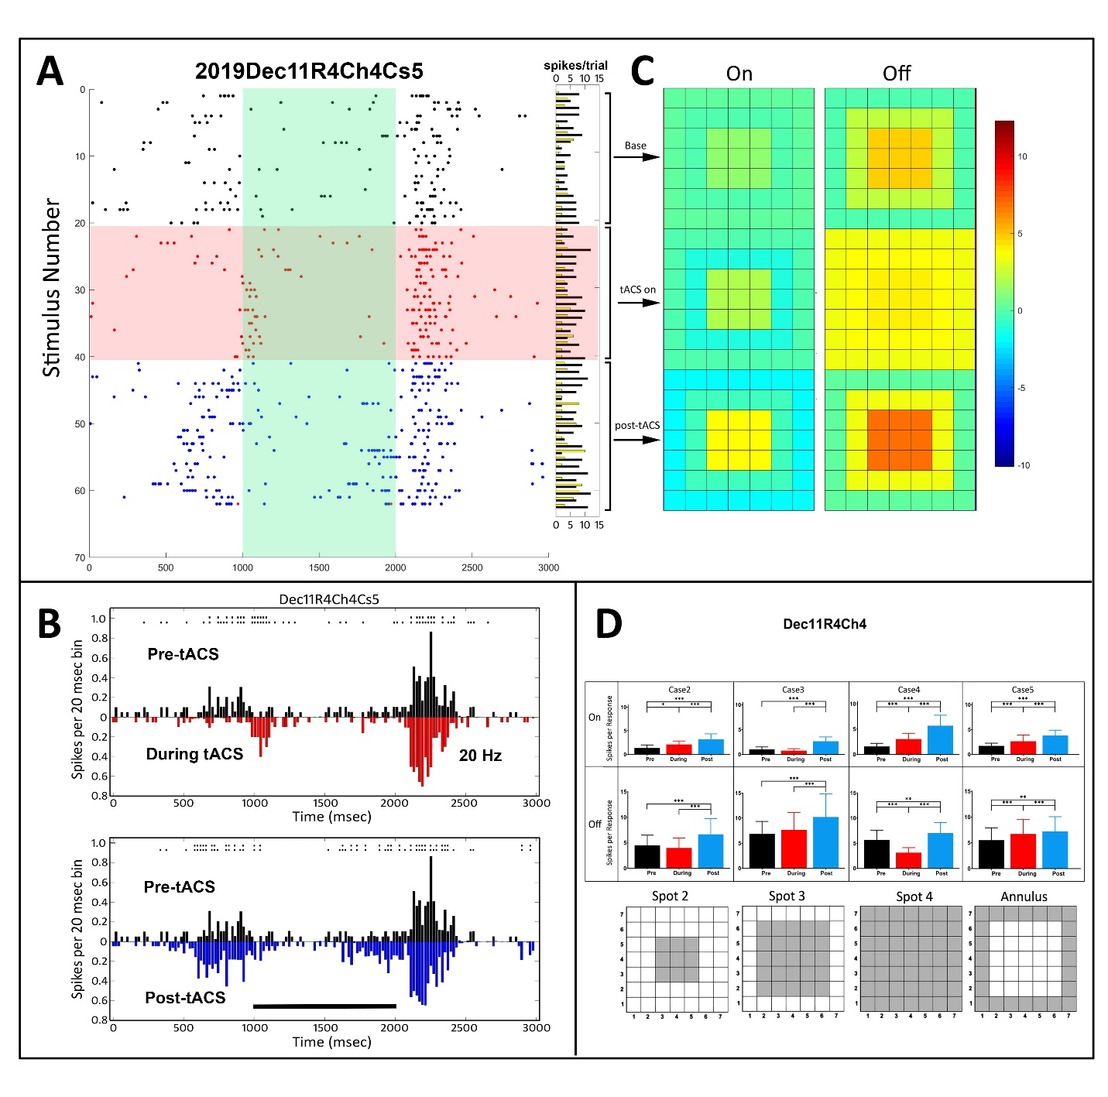
Figure S5. Temporal and spatial characteristics of the responses of an On-Off retinal ganglion cell (Dec11R4Ch4), before, during and after 20 Hz tACS current. Symbols and layout conventions as in Figure 2. A. Raster plots of the spikes occurring during each stimulus epoch for the annular stimulus. Horizontal columns at right indicate On (yellow) and Off (black) spike totals from each raster line. Note that the on-response latency was greater during and after tACs current application. B. PST histograms of baseline (black), during tACS (red) and post-tACS (blue) responses. Asterisks above a bin denote significant differences between the plots at the p<0.05 level, double height symbols denote significant differences at the p<0.005 level. Black bar indicates the timing of the light stimulus. C. Heat maps of spatial dependence of On and Off responses constructed from responses to all spots. D. Bar plots of response spikes as a function of stimulus configuration for pre-tACS (black), during tACS (red) and post-tACS (blue) epochs. Error bars indicate 95% confidence intervals. *p<0.05, ** p<0.001, *** p<0.0001
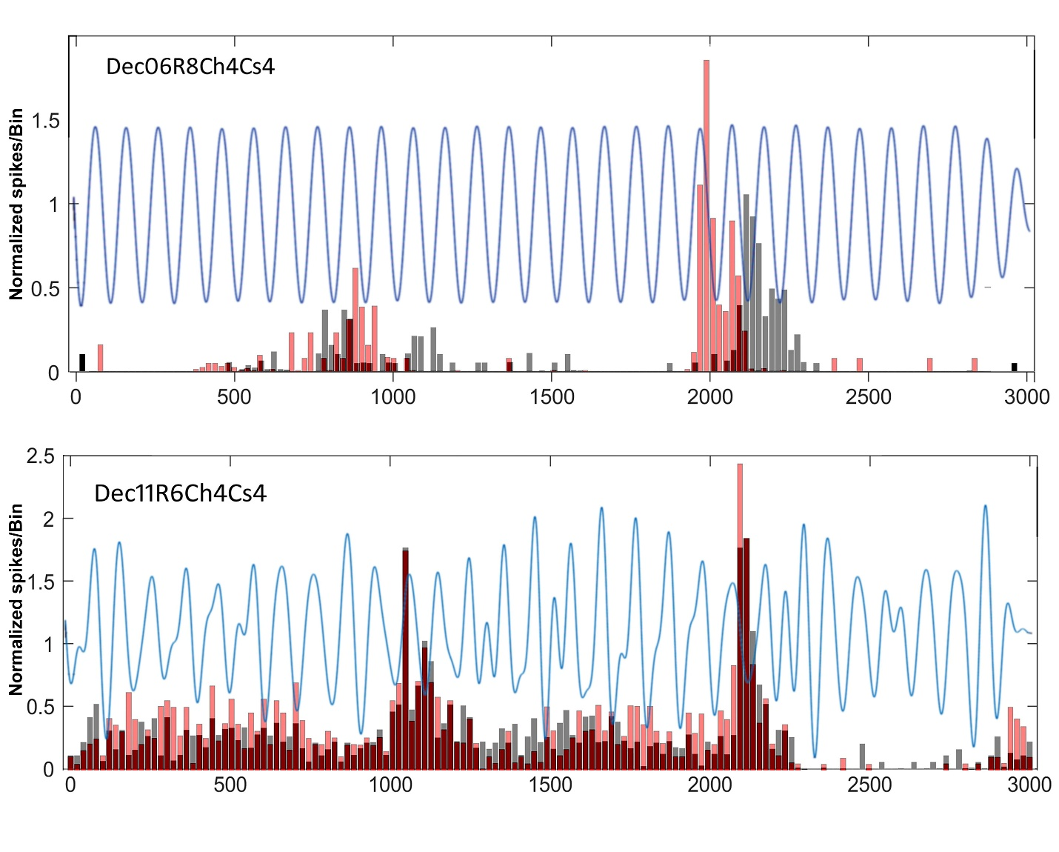
Figure S6. Superimposed PST plots during baseline (black), versus during tACS (red), with the average tACS stimulus waveform also superimposed at an arbitrary scale (see the ‘Methods’ section). For cell Dec06R8Ch4Cs4 (top panel) enhancement of firing appears to occur near several positive peaks of the tACS current. For the cell Dec11R6Ch4Cs4 (bottom) enhanced firing appears near one or two negative peaks.

