Supplementary Methods

Blood measurements
Blood samples were obtained between 7 and 9 AM from participants who had fasted overnight and had refrained from smoking for at least 6 hours (h). Biochemical analyses were performed in the centralized Moli-sani laboratory [1]. All haemochromocytometric analyses (white blood cell and platelet counts, granulocyte % and lymphocyte %) were performed by cell counter (Coulter HMX, Beckman Coulter, Milan, Italy) within 3 h from venipuncture. High sensitivity C reactive protein (CRP) was measured in fresh serum, by a latex particle-enhanced immunoturbidimetric assay (ILab 350 Instrumentation Laboratory, Milan, Italy).

Definition of covariates
A recruiting center (binary) variable was defined based on the city where the participant was recruited (Termoli or Campobasso).
For educational attainment, subjects were divided into four categories, based on their education level (i.e., the school level that they had completed): Primary, Lower secondary, Upper secondary and Post-secondary.
For smoking status, subjects were assigned to three categories based on their cigarette smoking habits: smokers, previous- (i.e., subjects who quitted at least one year before the interview) and non-smokers. Leisure-time physical activity was assessed through a structured questionnaire (including questions on sport participation, walking and gardening), and expressed as daily energy expenditure in metabolic equivalent task-hours (MET-h/day) [2].
Prevalent diabetes was defined as dichotomous variables (Yes/No), based on the reported and verified use of specific drugs for the treatment of these disorders. Prevalent cardiovascular disease (CVD) and cancer were defined as three-classes variables: subjects with no medical history of the disease, subjects reporting the disease with medical documentation or reporting and demonstrating the use of specific drugs (in the case of CVD), and those reporting the disease without medical documentation. As a proxy measure of adiposity (which may influence the release of inflammatory cytokines and hence act as a potential confounder), Relative Fat Mass (RFM) was computed, following the formula [3]:
RFM = 64 – (20 x height/waist circumference) + (12 x sex),
Here height and waist are in the same scale unit, sex = 0 for men and 1 for women. RFM has been reported to be more accurate than body mass index in estimating whole-body fat percentage measured by dual energy X-ray absorptiometry in the NHANES cohort, and to improve body fat-defined obesity misclassification [3].
Food intake was assessed through the validated Italian EPIC food frequency questionnaire [4]. The EPIC questionnaire allowed to compute the daily energy intake for the subjects assessed (Kcal/day), as well as alcohol consumption habits, along with a few additional questions (see [5] for details).
Based on this information, drinking status was instead classified into five categories: lifetime abstainers, former drinkers, current drinkers of 12.1-24 (moderate drinkers), 24.1-48 (heavy drinkers) and >48 g/day (very-heavy drinkers), as specified elsewhere [5].
Adherence to Mediterranean Diet (MeDi) was determined through the score developed by Trichopoulou et al. [6], assigning 1 point to healthy foods and 0 points to detrimental ones and defining a score ranging from 0 to 9 (the latter reflecting maximal adherence).
Psychological resilience was assessed through the Connor-Davidson Resilience Scale (CD-RISC), which is based on 25 items. This assessed five main subdomains like personal competence, trust/tolerance/strengthening effects of stress, acceptance of changes and secure relationships, control and spiritual influences, ranging from 0 to 100, with higher score reflecting greater psychological resilience [7].
Antidepressants use was based on self-report and coded as a binary variable (Yes/No). This was further verified by the recruitment staff by asking the participants to show the drug box in use, and only those subjects which were able to provide such a proof were classified as anti-depressant users.

Table S1. Food parameters used for the dietary inflammatory index (DII) calculation in the Moli-sani study cohort.

Pro-inflammatory | Anti-inflammatory
Carbohydrate  Cholesterol  Energy  Iron  Protein  Saturated fat  Total fat | Alcohol  Anthocyanidins  Beta-carotene  Fiber  Flavan-3-ol  Flavones  Flavonols  Flavonones  Folic acid  Isoflavones  Mono-unsaturated fat  n-3 fatty acids  n-6 fatty acids  Niacin  Garlic/Onion  Poly-unsaturated fat  Riboflavin  Selenium  Tea  Thiamine  Vitamin A  Vitamin C  Vitamin D  Vitamin E  Vitamin B6  Zinc
Figure S1. Polychoric correlation matrix of depressive symptoms assessed.

Legend: item 1 = anhedonia; item 2 = low mood; item 3 = altered sleeping; item 4 = tiredness, low energy; item 5 = altered appetite/eating; item 7 = impaired concentration; item 8 = altered movements/speaking; item 9 = suicidal ideation. Note: feeling of failure (item 6) was not assessed and hence not included in the analysis.

Supplementary Results

Table S2. Stratified associations between dietary inflammatory index (DII) and depressive symptoms.

a)
Gender  (N) | Covariates | Overall symptoms (PHQ9-6)  β (SE),  p-value | Somatic factor  β (SE),  p-value | Cognitive factor  β (SE),  p-value
Men  (6,556) | Age | 0.032 (0.006),  9.6 × 10⁻⁷ | 0.016 (0.005),  9.4 × 10⁻⁴ | 0.002 (0.005),  0.70
Men  (6,556) | Age + education + PA + smoking + drinking + diabetes + cancer + CVD | 0.028 (0.007),  3.4 × 10⁻⁵ | 0.013 (0.005),  0.009 | 0.003 (0.005),  0.59
Women  (6,745) | Age | 0.052 (0.007),  1.4 × 10⁻¹² | 0.010 (0.005),  <0.05 | 0.017 (0.005),  0.001
Women  (6,745) | Age + education + PA + smoking + drinking + diabetes + cancer + CVD | 0.047 (0.007),  2.3 × 10⁻¹⁰ | 0.011 (0.005),  0.04 | 0.014 (0.005),  0.009

b)
Condition  (N) | Covariates | Overall symptoms (PHQ9-6)  β (SE),  p-value | Somatic factor  β (SE),  p-value | Cognitive factor  β (SE),  p-value
CVD  (604) | Age + sex | 0.016 (0.028)  0.58 | 0.010 (0.021),  0.64 | 0.004 (0.020),  0.82
CVD  (604) | Age + sex + education + PA + smoking + drinking | 0.005 (0.029),  0.86 | 0.004 (0.021),  0.87 | 0.003 (0.021),  0.87
Cancer  (391) | Age + sex | 0.094 (0.033)  0.005 | 0.054 (0.025)  0.03 | -0.005 (0.023)  0.83
Cancer  (391) | Age + sex + education + PA + smoking + drinking | 0.079 (0.034)  0.02 | 0.044 (0.025)  0.08 | -0.003 (0.024)  0.90
Diabetes  (515) | Age + sex | 0.070 (0.030)  0.02 | 0.016 (0.022)  0.45 | 0.028 (0.024)  0.24
Diabetes  (515) | Age + sex + education + PA + smoking + drinking | 0.076 (0.032)  0.02 | 0.009 (0.023)  0.71 | 0.041 (0.025)  0.10
Multimorbidity  (170) | Age + sex | -0.003 (0.056)  0.96 | -0.046 (0.040)  0.25 | 0.060 (0.042)  0.15
Multimorbidity  (170) | Age + sex + education + PA + smoking + drinking | 0.005 (0.058)  0.94 | -0.057 (0.041)  0.17 | 0.077 (0.042)  0.07
Antidepressants users  (398) | Age + sex | 0.073 (0.037)  <0.05 | 0.048 (0.024)  0.04 | -0.018 (0.024)  0.45
Antidepressants users  (398) | Age + sex + education + PA + smoking + drinking | 0.064 (0.038)  0.09 | 0.033 (0.024)  0.17 | -0.005 (0.024)  0.84

Associations between dietary inflammatory index (DII) and depressive symptoms are reported, stratified by a) gender and b) prevalent health conditions and use of anti-depressants. All models were adjusted for recruiting center, in addition to the above mentioned covariates (see Supplementary Methods for detailed definitions). When symptom factors were modelled as outcome, the factor other than the outcome was also included among covariates. Beta coefficients and Standard Errors (SE) are reported for standardized PHQ9-6 and for factor scores associated to unitary increase of DII, along with relevant p-values. Significant associations (p<0.05) are highlighted in bold. Abbreviations: PA = leisure-time physical activity; CVD = cardiovascular disease.

Figure S2. Scree plot of exploratory polychoric factor analysis.

Scree plot of the actual data shows a flattening of the curve after factor nr = 2, and approaches the curve of random generated data for factor nr = 3, which further justified the choice to compute two factors.

Figure S3. Cluster plot of the two factors computed in the polychoric factor analysis.

Here we report a visual display of the results of the analysis. All loadings with an absolute value greater than 0.3 are represented as an edge. Factors showed a Pearson correlation of 0.72 (since they were extracted through oblique rotation).
Legend: MR1 = “somatic” factor; MR2 = “cognitive” factor; item 1 = anhedonia; item 2 = low mood; item 3 = altered sleeping; item 4 = tiredness, low energy; item 5 = altered appetite/eating; item 7 = impaired concentration; item 8 = altered movements/speaking; item 9 = suicidal ideation. Note: feeling of failure (item 6) was not assessed and hence not included in the analysis.

Figure S4. Scatter plot of somatic depressive symptoms (MR1) factor vs DII.
a)
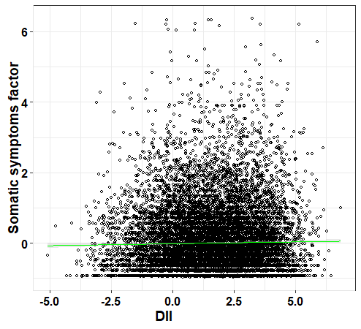
b)
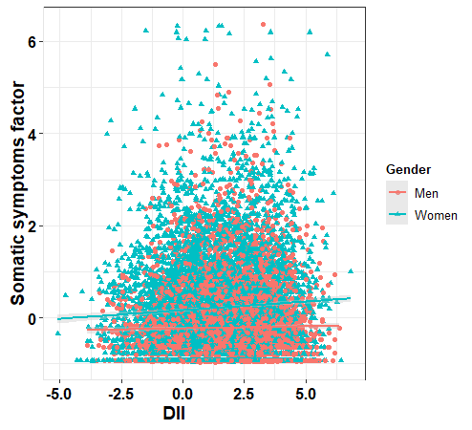

c)
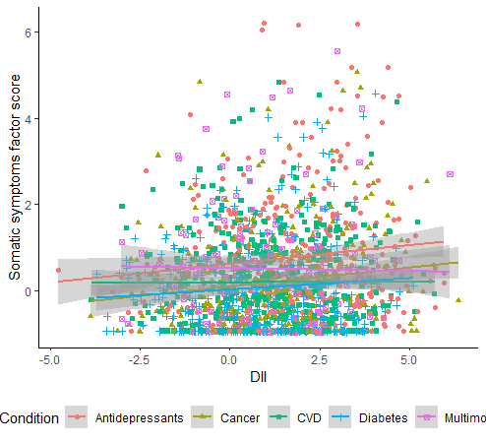

Linear interpolation of data is reported for a) the total sample (N=13,301), b) separate genders and c) prevalent health conditions or use of antidepressants, along with their 95% Confidence Interval (grey shade). Multimorbidity was defined as meeting two or more of the other conditions.

Figure S5. Scatter plot of cognitive depressive symptoms (MR2) factor vs DII.
a)
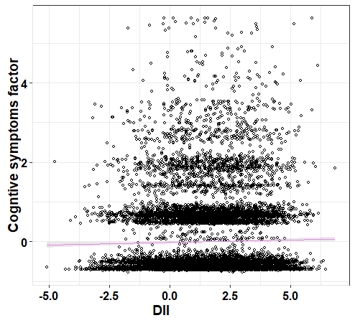

b)
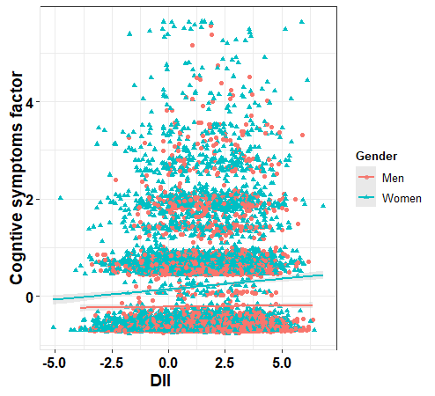
c)
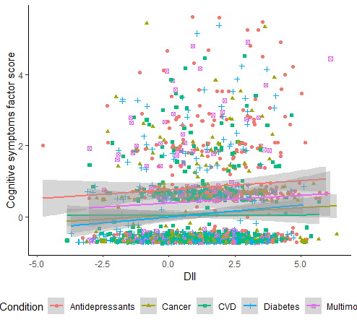

Linear interpolation of data is reported for a) the total sample (N=13,301), b) separate genders and c) prevalent health conditions or use of antidepressants, along with their 95% Confidence Interval (grey shade). Multimorbidity was defined as meeting two or more of the other conditions.

Table S3. Proportion of total effect (PTE) explained by INFLA-score [8] and its component biomarkers in the association between dietary inflammatory index (DII), a) somatic and b) cognitive symptoms factor.
a)
Model | INFLA-score  PTE [CI 95%]  (p-value) | CRP  PTE [CI 95%]  (p-value) | Plt  PTE [CI 95%]  (p-value) | WBC  PTE [CI 95%]  (p-value) | GLR  PTE [CI 95%]  (p-value)
N | 4.66%  [1.65 – 14.00] %  (< 2.0 × 10⁻¹⁶) | 2.43%  [0.00 – 9.00] %  (0.10) | 0.00%  [0.00 – 1.00] %  (0.40) | 2.03%  [0.27 – 7.00] %  (0.01) | 2.01%  [0.00 – 7.00] %  (0.06)
Y | 2.66%  [0.44 – 8.00] %  (0.02) | 0.69%  [0.00 – 4.00] %  (0.54) | 0.00%  [0.00 – 1.00] %  (0.49) | 0.53%  [0.00 – 3.00] %  (0.22) | 1.33%  [0.00 – 6.00] %  (0.23)
b)
Model | INFLA-score  PTE [CI 95%]  (p-value) | CRP  PTE [CI 95%]  (p-value) | Plt  PTE [CI 95%]  (p-value) | WBC  PTE [CI 95%]  (p-value) | GLR  PTE [CI 95%]  (p-value)
N | 0.00%  [0.00 – 2.00] %  (0.29) | 0.00%  [0.00 – 0.00] %  (0.11) | 0.65%  [0.00 – 4.00] %  (0.38) | 0.00%  [0.00 – 1.00] %  (0.43) | 1.26%  [0.00 – 7.00] %  (0.26)
Y | 0.00%  [0.00 – 0.00] %  (0.07) | 0.00%  [0.00 – 3.00] %  (0.70) | 0.56%  [0.00 – 4.00] %  (0.46) | 0.00%  [0.00 – 1.00] %  (0.27) | 1.07%  [0.00 – 7.00] %  (0.47)

PTE 95% Confidence Interval (95CI) and p-values are reported for INFLA-score, c-reactive protein (CRP, log scale), platelet count (Plt), white blood cell count (WBC, log scale) and granulocyte-to-lymphocyte ratio (GLR). Significant PTEs (p<0.05) are highlighted in bold. Model “N” was adjusted for recruiting center, sex and age, whilst model “Y” was also adjusted for education, leisure-time physical activity, smoking status, drinking habits, diabetes, cancer, and cardiovascular disease. Note: PTEs and their confidence intervals were rounded to the second decimal place, therefore some of the limits may equal zero.
References
1. Santimone I, Di Castelnuovo A, De Curtis A, Spinelli M, Cugino D, Gianfagna F, et al. White blood cell count, sex and age are major determinants of heterogeneity of platelet indices in an adult general population: results from the MOLI-SANI project. Haematologica [Internet]. 2011 [cited 2018 Sep 8];96:1180–8. Available from: http://www.ncbi.nlm.nih.gov/pubmed/21546503
2. Ainsworth BE, Haskell WL, Whitt MC, Irwin ML, Swartz AM, Strath SJ, et al. Compendium of physical activities: an update of activity codes and MET intensities. Med Sci Sports Exerc [Internet]. 2000 [cited 2018 Sep 8];32:S498-504. Available from: http://www.ncbi.nlm.nih.gov/pubmed/10993420
3. Woolcott OO, Bergman RN. Relative fat mass (RFM) as a new estimator of whole-body fat percentage ─ A cross-sectional study in American adult individuals. Sci Rep. 2018;8:1–11.
4. Pisani P, Faggiano F, Krogh V, Palli D, Vineis P, Berrino F. Relative validity and reproducibility of a food frequency dietary questionnaire for use in the Italian EPIC centres. Int J Epidemiol [Internet]. 1997 [cited 2018 Sep 8];26 Suppl 1:S152-60. Available from: http://www.ncbi.nlm.nih.gov/pubmed/9126543
5. Costanzo S, Mukamal KJ, Di Castelnuovo A, Bonaccio M, Olivieri M, Persichillo M, et al. Alcohol consumption and hospitalization burden in an adult Italian population: prospective results from the Moli-sani study. Addiction. 2019;114:636–50.
6. Trichopoulou A, Costacou T, Bamia C, Trichopoulos D. Adherence to a Mediterranean Diet and Survival in a Greek Population. N Engl J Med [Internet]. 2003 [cited 2018 Sep 8];348:2599–608. Available from: http://www.ncbi.nlm.nih.gov/pubmed/12826634
7. Connor KM, Davidson JRT. Development of a new resilience scale: the Connor-Davidson Resilience Scale (CD-RISC). Depress Anxiety. United States; 2003;18:76–82.
8. Pounis G, Bonaccio M, Di Castelnuovo A, Costanzo S, De Curtis A, Persichillo M, et al. Polyphenol intake is associated with low-grade inflammation, using a novel data analysis from the Moli-sani study. Thromb Haemost. 2016;115:344–52.

