Supplementary Materials

This document includes:

Supplementary Table 1
Supplementary Table 2
Supplementary Figure 1
Supplementary Figure 2
Supplementary Figure 3

Supplementary Table 1. Results of the sensitivity analyses that included the body mass index or waist circumference as one of the covariates.
 | β | t | p
Relationship with the CBF in cluster 1 (right middle temporal and lateral occipital cortices)
Sensitivity analysis 1: Age, sex, mean CBF, and body mass index as covariates
Sleep efficiency | 0.10 | 1.54 | 0.13
WASO | -0.13 | -2.13 | 0.036
Total sleep time | -0.03 | -0.49 | 0.62
Sleep latency | -0.03 | -0.44 | 0.66
Sensitivity analysis 2: Age, sex, mean CBF, and waist circumference as covariates
Sleep efficiency | 0.11 | 1.76 | 0.082
WASO | -0.13 | -2.28 | 0.026
Total sleep time | -0.01 | -0.23 | 0.82
Sleep latency | -0.04 | -0.61 | 0.55
Relationship with the CBF in cluster 2 (right orbitofrontal cortex)
Sensitivity analysis 1: Age, sex, mean CBF, and body mass index as covariates
Sleep efficiency | 0.22 | 3.22 | 0.002*
WASO | -0.23 | -3.45 | 0.001*
Total sleep time | 0.03 | 0.36 | 0.72
Sleep latency | -0.14 | -2.10 | 0.039
Sensitivity analysis 2: Age, sex, mean CBF, and waist circumference as covariates
Sleep efficiency | 0.23 | 3.46 | 0.001*
WASO | -0.23 | -3.62 | 0.001*
Total sleep time | 0.04 | 0.65 | 0.52
Sleep latency | -0.15 | -2.27 | 0.026
Relationship with the CBF in cluster 3 (right insular cortex)
Sensitivity analysis 1: Age, sex, mean CBF, and body mass index as covariates
Sleep efficiency | 0.18 | 2.34 | 0.022
WASO | -0.19 | -2.65 | 0.010*
Total sleep time | 0.03 | 0.39 | 0.70
Sleep latency | -0.10 | -1.37 | 0.17
Sensitivity analysis 2: Age, sex, mean CBF, and waist circumference as covariates
Sleep efficiency | 0.17 | 2.38 | 0.020
WASO | -0.19 | -2.66 | 0.010*
Total sleep time | 0.04 | 0.50 | 0.62
Sleep latency | -0.10 | -1.45 | 0.15
*p<0.013
Abbreviations: CBF, cerebral blood flow; WASO, wake after sleep onset

Supplementary Table 2. The relationship between the scores of self-report questionnaires and the CBF of each cluster
 | β | t | p
Relationship with the CBF in cluster 1 (right middle temporal and lateral occipital cortices)
Athens Insomnia Scale | 0.12 | 2.17 | 0.033
Epworth Sleepiness Scale | 0.15 | 2.51 | 0.014
Fatigue Severity Scale | 0.06 | 1.03 | 0.31
Karolinska Sleepiness Scale | -0.02 | -0.33 | 0.74
Pittsburgh Sleep Quality Index | 0.07 | 1.11 | 0.27
Relationship with the CBF in cluster 2 (right orbitofrontal cortex)
Athens Insomnia Scale | -0.12 | -1.92 | 0.059
Epworth Sleepiness Scale | 0.04 | 0.55 | 0.59
Fatigue Severity Scale | -0.04 | -0.54 | 0.59
Karolinska Sleepiness Scale | -0.09 | -1.45 | 0.15
Pittsburgh Sleep Quality Index | -0.11 | -1.70 | 0.094
Relationship with the CBF in cluster 3 (right insular cortex)
Athens Insomnia Scale | -0.05 | -0.72 | 0.47
Epworth Sleepiness Scale | 0.09 | 1.30 | 0.20
Fatigue Severity Scale | -0.01 | -0.15 | 0.88
Karolinska Sleepiness Scale | -0.02 | -0.31 | 0.76
Pittsburgh Sleep Quality Index | -0.14 | -2.07 | 0.042

Supplementary Figure 1. The relationships between sleep efficiency and cerebral blood flow of the clusters 1-3 in each group. The left and right panels show the results in the firefighters (circles filled with black) and non-firefighters (blank circles), respectively. The regression lines and beta coefficients are from the multivariate regression models including the following variables: the CBF values extracted from each cluster as the dependent variables; sleep efficiency as an independent variable; age, sex, and mean global CBF as covariates. The CBF of each cluster is displayed in the values adjusted for age, sex, and mean global CBF.
Supplementary Figure 2. The relationships between wake after sleep onset and cerebral blood flow of the clusters 1-3 in each group. The left and right panels show the results in the firefighters (circles filled with black) and non-firefighters (blank circles), respectively. The regression lines and beta coefficients are from the multivariate regression models including the following variables: the CBF values extracted from each cluster as the dependent variables; wake after sleep onset as an independent variable; age, sex, and mean global CBF as covariates. The CBF of each cluster is displayed in the values adjusted for age, sex, and mean global CBF.
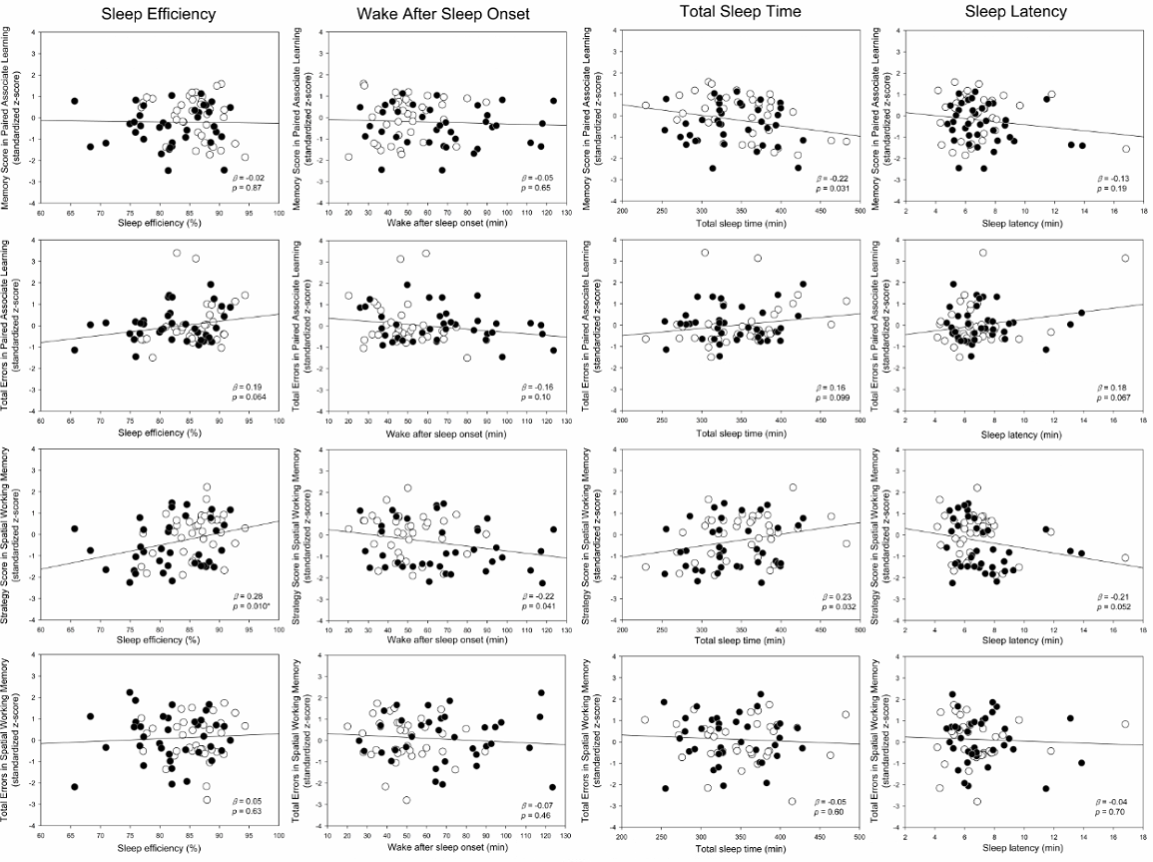
Supplementary Figure 3. The relationship between each sleep parameter and cognitive measures. Data in the firefighters are shown in circles filled with black, while those of non-firefighter controls are presented in blank circles. The regression lines and beta coefficients are from the multivariate regression models including the following variables: each cognitive measure as the dependent variable; each sleep measure as an independent variable; age, sex, and education level as covariates. The plot showing the relationship between sleep efficiency and strategy score of the Spatial Working Memory task showed is the same as Figure 3 of the main text.

