Table S1- P value of correlation analysis in Figure 6
 | FEV25 | FEV50 | FEV75 | FVC | MMEF | FEF25 | FEF50 | FEF75 | IL-4 | IL-5 | IL-13 | IL-17A | TNF-α | Muc5ac
FEV25 | 0.0000
FEV50 | 0.1130
FEV75 | 0.0626 | 0.0229
FVC | 0.2479 | 0.5561 | 0.2149
MMEF | 0.0220 | 0.0018 | 0.0235 | 0.7166
FEF25 | 0.3708 | 0.0107 | 0.0358 | 0.0844 | 0.0084
FEF50 | 0.0150 | 0.0003 | 0.0077 | 0.8020 | 0.0000 | 0.0173
FEF75 | 0.3813 | 0.0839 | 0.1169 | 0.5334 | 0.0716 | 0.0188 | 0.0196
IL-4 | 0.1013 | 0.0105 | 0.0327 | 0.8134 | 0.0004 | 0.0008 | 0.0089 | 0.1263
IL-5 | 0.0084 | 0.0119 | 0.0076 | 0.3560 | 0.0001 | 0.0153 | 0.0002 | 0.0499 | 0.0000
IL-13 | 0.2369 | 0.1224 | 0.1391 | 0.9482 | 0.0008 | 0.0335 | 0.0307 | 0.0516 | 0.0002 | 0.0000
IL-17A | 0.9580 | 0.0247 | 0.0638 | 0.9535 | 0.0032 | 0.0004 | 0.0379 | 0.0419 | 0.0403 | 0.0238 | 0.0021
TNF-α | 0.4186 | 0.3787 | 0.0255 | 0.1002 | 0.0852 | 0.0209 | 0.0937 | 0.7119 | 0.0110 | 0.0119 | 0.0852 | 0.2166
Muc5ac | 0.5379 | 0.0105 | 0.0648 | 0.5470 | 0.0001 | 0.0055 | 0.0043 | 0.0713 | 0.0016 | 0.0006 | 0.0000 | 0.0000 | 0.0123
-logPC100 | 0.3658 | 0.0804 | 0.1091 | 0.5697 | 0.0378 | 0.0002 | 0.1257 | 0.1107 | 0.0098 | 0.0073 | 0.0262 | 0.0008 | 0.1503 | 0.0039

Figure S1-Typical picture of Flow-volume Curve
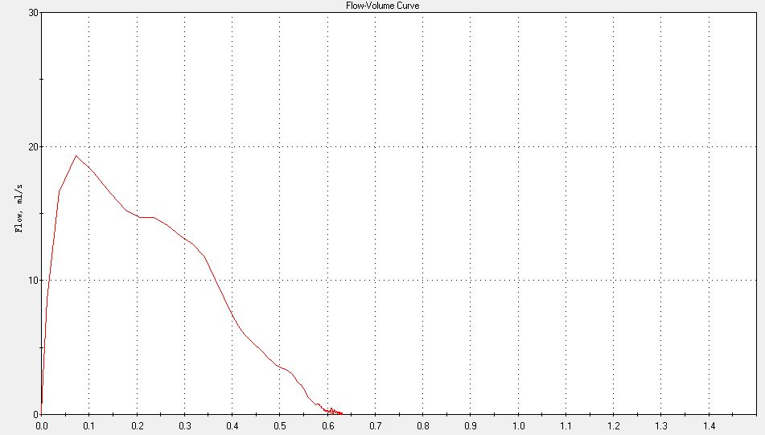
X-axis: time (s)
Y-axis: volume (ml)

Figure S2-Schematic diagram of mouse experiment
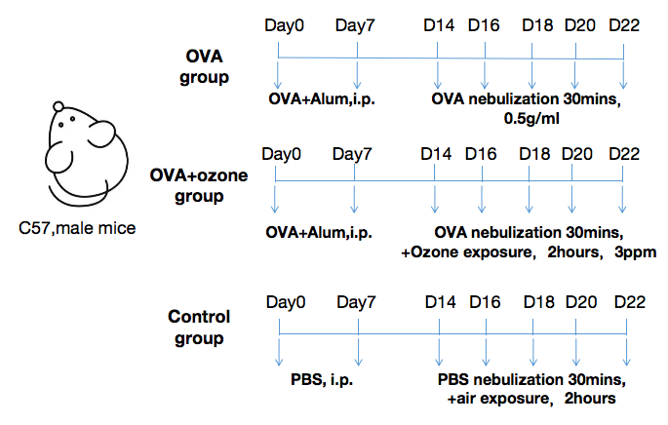

Figure S3-Correlation between α-SMA positive area% and airway function

