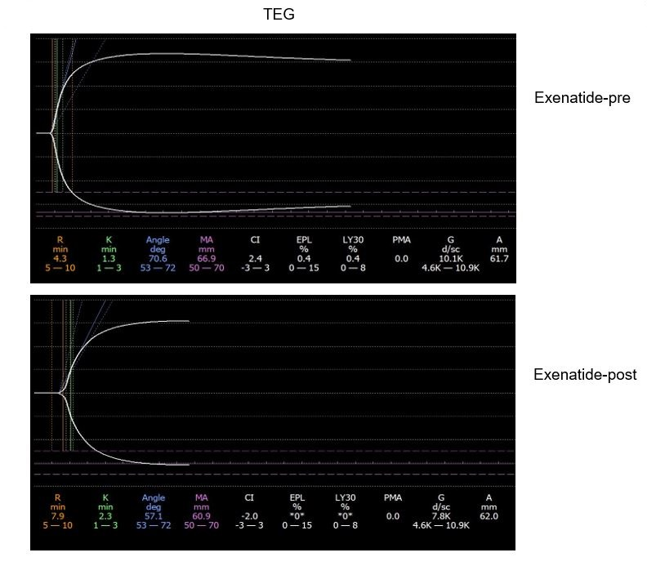
Figure S1 Changes of TEG in T2DM patients before and after exenatide treatment
Note: The results showed that the blood of T2DM patients was in a hypercoagulable state before exenatide treatment, and the K value was prolonged (1.3 min vs. 2.3 min), the α angle was reduced (70.6 deg vs. 57.1 deg) and the MA (maximum amplitude) value was decreased (66.9 min vs. 60.9 min) after exenatide treatment, p<0.05, respectively.
TEG: thromboelastogram, R: reaction time, K: kinetics time, Angle: kinetics of clot development, MA: maximum amplitude, maximum strength of clot, LY30: percent lysis 30 min after MA.

Table S1 Comparison of coagulation and platelet aggregation in different therapeutic doses (%,‾x ± s)
Variables | Exenatide therapeutic dose (sc, bid) |  | χ²//t values | P values
Variables | 5μg×4w →10μg×4w (n=25) | 5μg×4w→ 10μg×1w →5μg×3w (n=5) | χ²//t values | P values
Sex (male/female) | 19/6 | 4/1 | 0.036 | NS
Age (years) | 42.06±9.77 | 41.11±10.34 | 0.043 | NS
PLT (×10¹² g/L) | 220.52±50.02 | 215.33±51.46 | 1.032 | NS
PT (s) | 12.29±1.54 | 10.95±1.47 | 0.056 | NS
PTA (%) | 105.22±14.22 | 107.33±16.12 | 0.066 | NS
INR | 1.30±1.20 | 1.29±1.22 | 0.030 | NS
APTT (s) | 30.25±24.30 | 33.81±23.56 | 1.059 | NS
FIB (g/L) | 2.90±0.42 | 3.08±0.58 | 0.082 | NS
TT (s) | 16.52±1.50 | 17.00±1.47 | 0.078 | NS
FDP (μg/mL) | 1.80±1.14 | 1.76±1.11 | 0.945 | NS
DD (μg/mL) | 0.28±0.30 | 0.31±0.28 | 1.720 | NS
NO（μmol/L） | 90.30±10.10 | 88.24±9.70 | 0.184 | NS
CD62p (%) | 10.20±3.75 | 11.36±3.66 | 1.020 | NS
PAC-1 (%) | 19.40±1.87 | 18.96±2.08 | 0.047 | NS
EPI induction (%) | 60.15±5.37 | 62.76±6.01 | 1.008 | NS
COLL induction (%) | 58.30±5.10 | 61.22±5.34 | 1.733 | NS
ADP induction (%) | 48.06±5.45 | 50.80±6.63 | 1.204 | NS
AA induction (%) | 51.74±4.03 | 48.87±5.20 | 1.586 | NS
Notes: NO: nitric oxide, PLT: platelets, PT: prothrombin time, PTA: prothrombin time activity, INR: international normalized ratio, APTT: activated partial thromboplastin time, FIB: fibrinogen, TT: thrombin time, FDP: fibrin degradation products, DD: D-dimer, PAC-1: platelet activation complex-1, EPI: epinephrine, COLL: collagen, ADP: adenosine diphosphate, AA: arachidonic acid, w: week, NS: no significant.

