Table S1. The drug loading efficiency of DOX in PNPs/DOX complexes and APAS-PNPs/DOX complexes.
Materials | DOX percentage (wt.%) | Number of complexed DOX per PEI
PNPs/DOX | 8.75% | 12.03
APAS-PNPs/DOX | 8.39% | 12.35

Table S2. The hydrodynamic sizes of PNPs/DOX complexes and APAS-PNPs/DOX complexes dispersed in PBS buffer with different pH conditions.
pH condition | Materials | Hydrodynamic size (nm) | PDI
pH 7.4 | PNPs/DOX | 201.53 ± 12.64 | 0.32 ± 0.13
pH 7.4 | APAS-PNPs/DOX | 208.21 ± 9.54 | 0.51 ± 0.08
pH 6.0 | PNPs/DOX | 205.48 ± 16.84 | 0.56 ± 0.14
pH 6.0 | APAS-PNPs/DOX | 241.16 ± 13.57 | 0.62 ± 0.09
Abbreviation: PDI, Poly dispersity index.

Figure S1. ¹H NMR spectra of PEI.NH₂-(mPEG) (a), PEI.NH₂-(PEG-MAL)-(mPEG) (b), PEI.NH₂-(PEG-APAS)-(mPEG) (c), and PEI.NH₂-HPAO-(PEG-APAS)-(mPEG) (d). All the products were dispersed in D₂O.
Figure S2. UV-Vis spectra of PEI.NH₂-(PEG-APAS)-(mPEG), PEI.NH₂-HPAO-(PEG-APAS)-(mPEG), DOX, and APAS-PNPs/DOX complexes (0.2 mg/mL) dispersed in water.
Figure S3. The hydrodynamic size distribution graph of PNPs/DOX complexes (a) and APAS-PNPs/DOX complexes (b) dispersed in PBS buffer with pH 7.4.
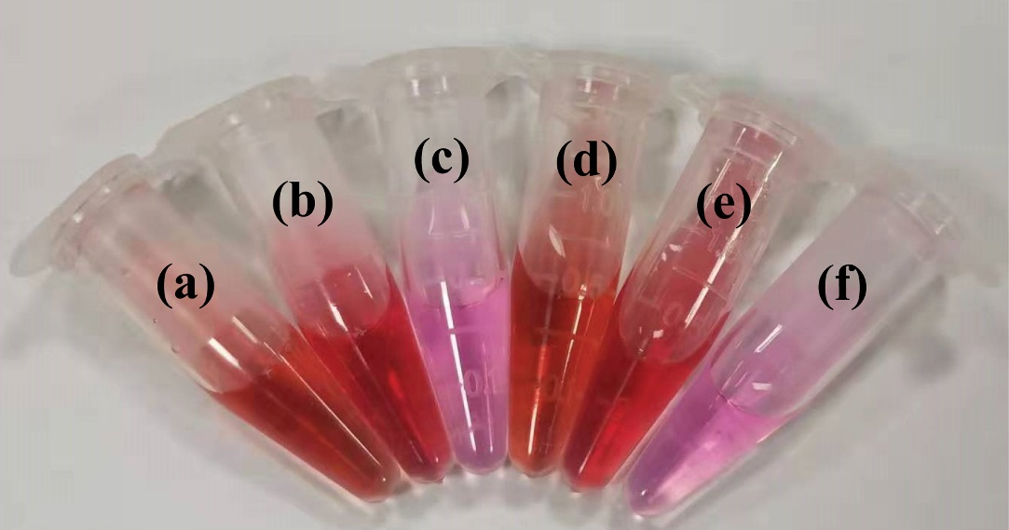
Figure S4. Photograph of the APAS-PNPs/DOX complexes (a-b) and PNPs/DOX complexes (d-e) dispersed in water (a, d), and cell culture medium (b, e) at the concentration of 0.5 mg/mL, respectively. (c, f) show the blank cell culture medium.
Figure S5. Radiochemical purities of the APAS-¹³¹I-PNPs/DOX complexes and ¹³¹I-PNPs/DOX complexes exposed to PBS at room temperature (a) and FBS at 37 °C (b) for different time periods.

Figure S6. Relative SPECT signal intensities of different organs at 6 h post-injection of ¹³¹I-PNPs/DOX complexes or APAS-¹³¹I-PNPs/DOX complexes. (***p < 0.001)
Figure S7. The absolute tumor volume of C6 tumor-bearing mice after various treatments.
Figure S8. The body weight of C6 tumor-bearing mice after various treatments. Saline was used as control. The relative body weights were normalized according to their initial weights (Mean ± SD, n = 5).
Figure S9. TUNEL-positive percentage of tumor tissue measured by TUNEL assay. (**p < 0.01, ***p < 0.001)

