Data Supplement
Table S1 Odds ratios for new-onset acute kidney injury
Variables | OR (95% CI) | p value
Plasma SO₂ | 1.180 (1.109-1.255) | ＜0.001
Urine NGAL | 1.013 (1.005-1.021) | 0.001
[TIMP-2]·[IGFBP7] | 7.126 (1.349-37.641) | 0.021
OR odds ratio, SO₂ Sulfur dioxide, NGAL neutrophil gelatinase-associated lipocalin, TIMP-2 tissue inhibitor of metalloproteinases-2, IGFBP7 insulin-like growth factor-binding protein 7.

Table S2 clinical risk factors for new-onset acute kidney injury
Variables | Crude OR (95% CI) | Adjusted OR (95% CI) | p value
Hypertension | 2.813 (1.417-5.584) | 3.136 (1.440-6.827) | 0.004
estimated blood loss | 1.001 (1.000-1.002) | 1.001 (1.000-1.002) | 0.005
baseline creatinine | 1.020 (1.003-1.038) | 1.021 (1.003-1.040) | 0.026
SOFA | 1.165 (1.038-1.307) | 1.062 (0.923-1.222) | 0.402
Use of vasopressor | 1.020 (1.003-1.038) | 1.929 (0.919-4.048) | 0.082
Lactate | 1.182 (0.993-1.408)
OR odds ratio, SOFA sequential organ failure assessment.

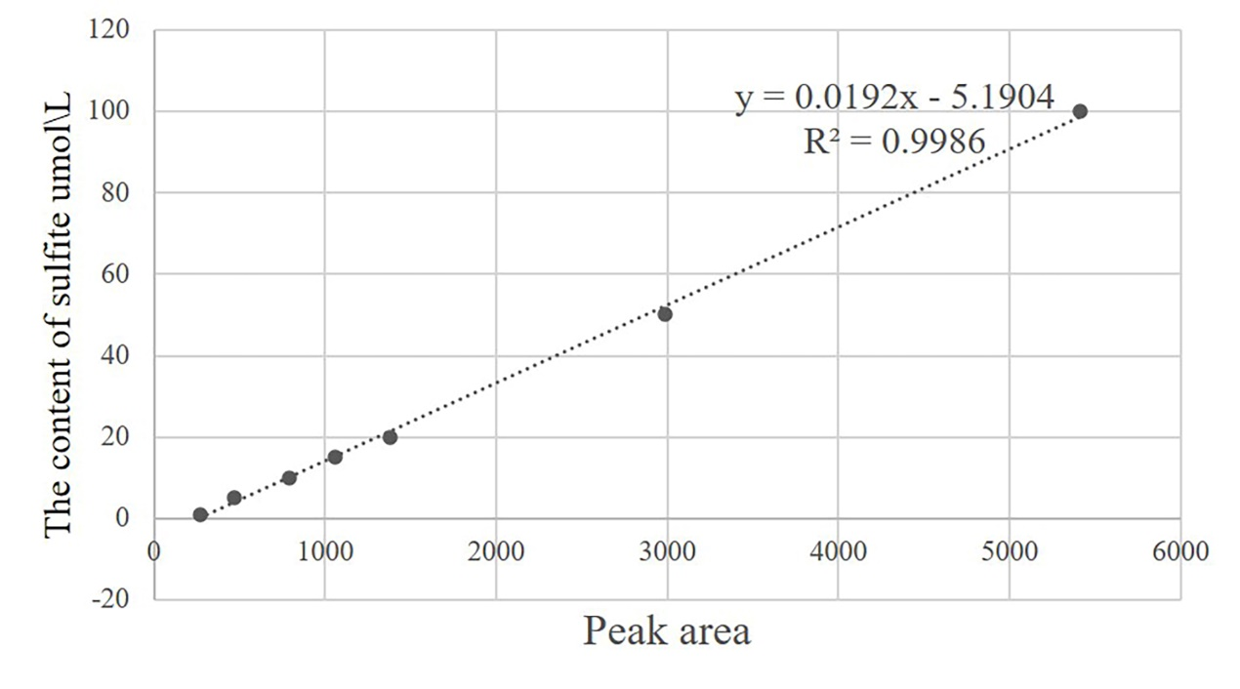Figure S1 HPLC standard curve of sulfite in standard sample. HPLC, high performance liquid chromatography analysis.

