US Health Resource Utilization and Cost Burden Associated With Choroideremia

SUPPLEMENTAL MATERIAL

Supplemental Table 1. Patient selectionª
Criteria, n | All payors | Commercial | Medicare | Medicaid
IBM MarketScan Database (Armonk, NY) from 01/01/2013 to 12/31/2018 | 117 million | 90 million | 60 million | 21 million
≥1 choroideremia-specific ICD-9/10  diagnostic code (363.55 or H31.21) | 386 | 267 | 60 | 59
≥1 choroideremia-specific ICD-9/10  diagnostic code and continuous  enrollment ≥6 mo before index | 263 | 178 | 42 | 43
Continuous enrollment ≥6 mo postindex | 207 | 135 | 34 | 38
Note: ªPatient selection criteria before matching to control cohort.
Abbreviation: ICD-9/10, International Classification of Diseases, Ninth or Tenth Edition.

Supplemental Table 2. Baseline characteristics and annualized costs in individuals with choroideremia, by sex
Individuals with choroideremia
(N=199)
 | Males  (n=131) | Females  (n=68) | p value
Baseline characteristics
Age, mean (SD), y | 41.8 (22.6) | 52.0 (20.4) | 0.0021
Region, n (%) |  |  | 0.3459
Northeast | 23 (18) | 15 (22)
North Central | 27 (21) | 13 (19)
South | 32 (24) | 23 (34)
West | 21 (16) | 9 (13)
Unknown | 28 (21) | 8 (12)
Payor, n (%) |  |  | 0.1011
Commercial | 86 (66) | 45 (66)
Medicaid | 28 (21) | 8 (12)
Medicare supplemental | 17 (13) | 15 (22)
CCI, mean (SD)ª | 0.43 (0.86) | 0.54 (0.92) | 0.3769
CCI group, n (%)  0  1  2  3  ≥4 | 96 (73)  21 (16)  10 (8)  2 (2)  2 (2) | 45 (66)  14 (21)  5 (7)  3 (4)  1 (1) | 0.6742
Total cost per patient, LSM | $17,669 | $18,522 | 0.8837
Inpatient admissions | $3,617 | $4,983 | 0.6689
Outpatient visits | $10,592 | $7,539 | 0.4967
Emergency department visits | $508 | $3,654 | 0.0276
Pharmacy prescriptions | $2,952 | $2,346 | 0.5910
Note: ªCCI based on data 6 months before the index.
Abbreviations: CCI, Charlson Comorbidity Index; LSM, least squares mean; SD, standard deviation.

Supplemental Figure 1. Postindex comorbidities by percentage of difference between the choroideremia and control cohorts (all odds ratios shown, p < 0.05).
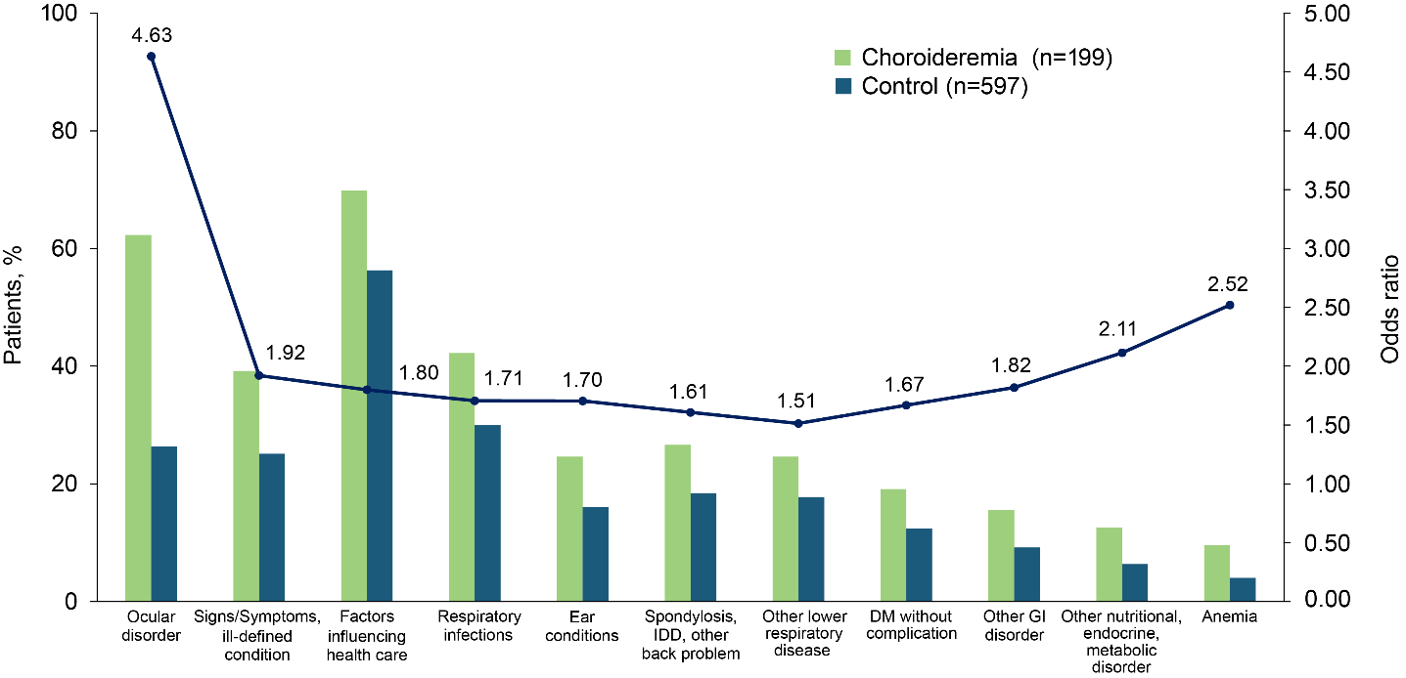
Abbreviations: DM, diabetes mellitus; GI, gastrointestinal; IDD, intervertebral disc disorder.

