Supplementary Figure legends
Figure S1 The GO analysis of DEGs in GSE96804 dataset.
- The top 5 biological process of GO terms. (B) The top 5 cell component of GO terms. (C) The top 5 molecular function of GO terms. (D) The heatmap of the GO terms.

Figure S2 The common DEGs between GSE30528 and GSE96804 datasets.
(A-B) The volcano map of GSE30528 and GSE96804 dataset. C3 and C7 were both upregulated in the two datasets.
(C-D) The heatmap of GSE30528 and GSE96804 datasets.
(E) The venn map of common DEGs between GSE30528 and GSE96804 datasets.
(F) The protein-protein interaction network of the common DEGs in between GSE30528 and GSE96804 datasets.

Figure S3 The scRNA-seq analysis validation of C3.
- DN and control samples were integrated into a single dataset. PCT, proximal convoluted tubule; CFH, complement factor H; LOH, loop of Henle; DCT, distal convoluted tubule; CT, connecting tubule; CD, collecting duct; PC, principal cell; IC, intercalated cell; PODO, podocyte; ENDO, endothelium; MES, mesangial cell; LEUK, leukocyte. (B) The distribution of C3 in different cells between healthy controls and DN. (C) The relative expression level of C3 in identified cell types between healthy controls and DN. (D)The percent expression of C3 in identified cell types between healthy controls and DN.

Figure S4 The DEGs in GSE9006.
(A-B) The volcano map of Type 1 (A) and Type 2 (B) diabetic samples from GSE9006 dataset. C7 was not significant expressed in Type 1 and Type 2 diabetic samples.

Figure S1
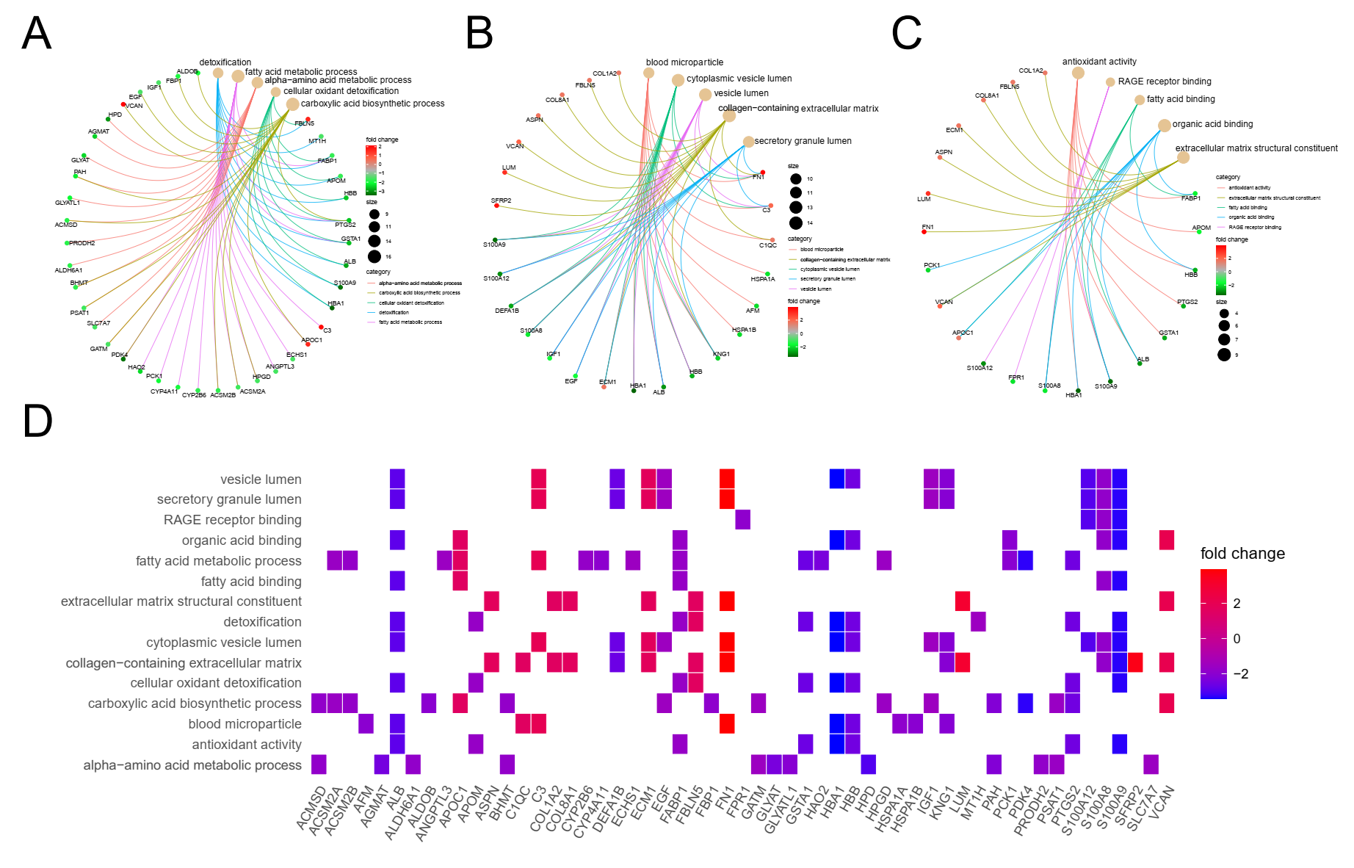

Figure S2
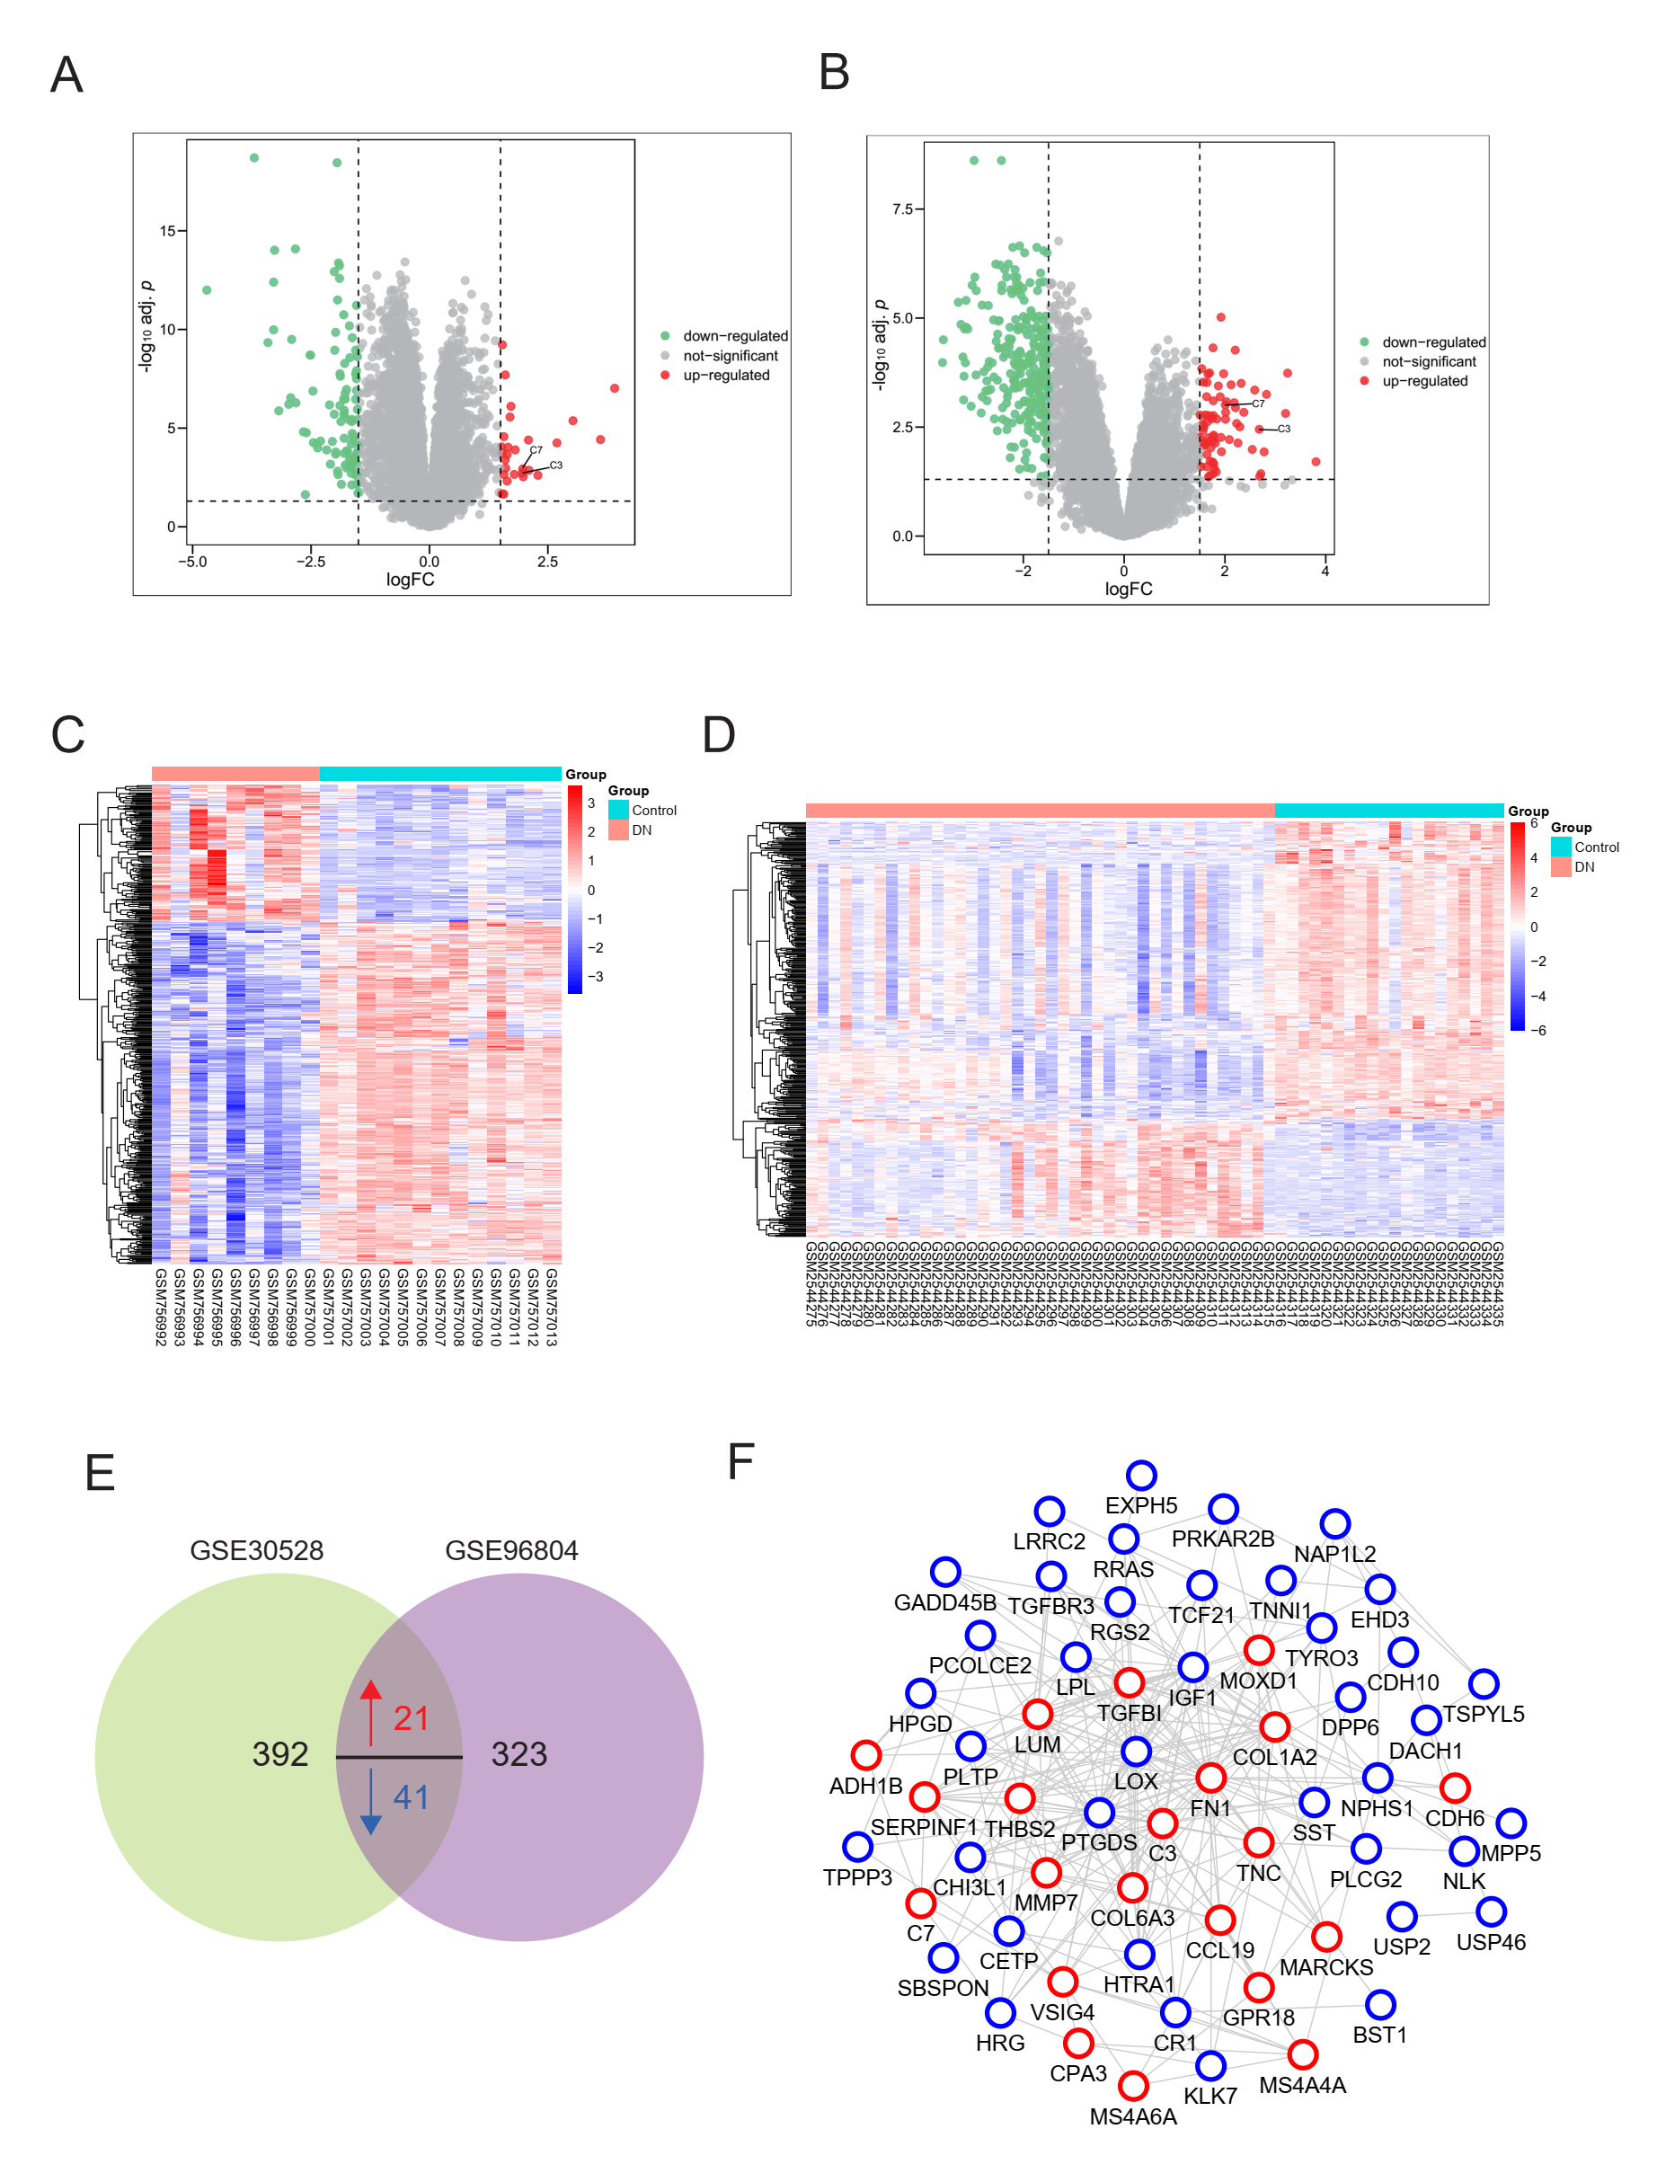

Figure S3
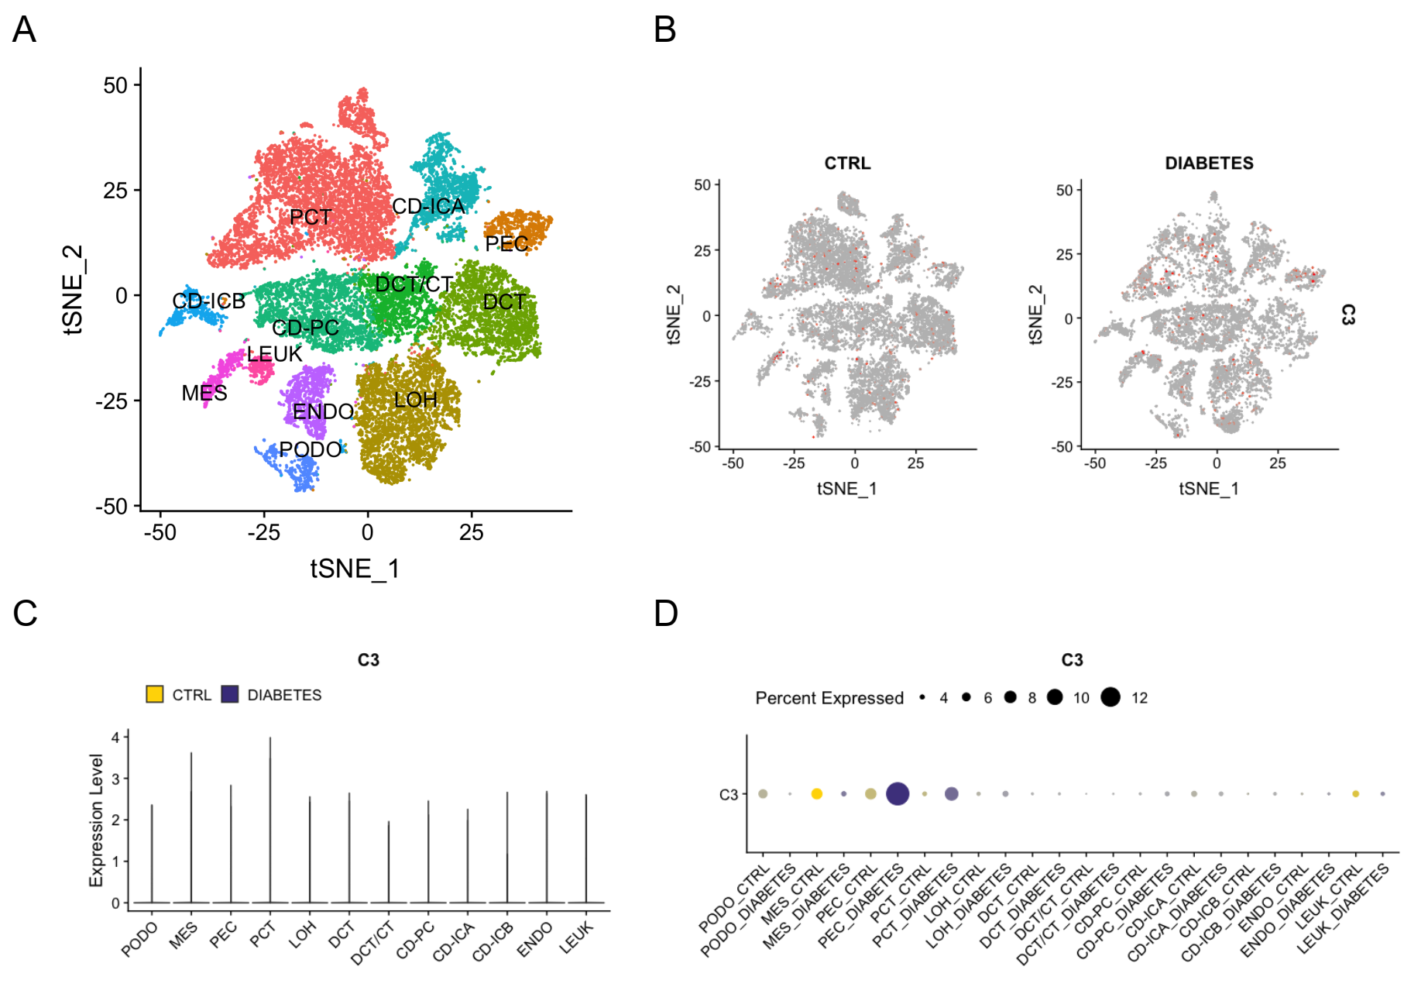

Figure S4
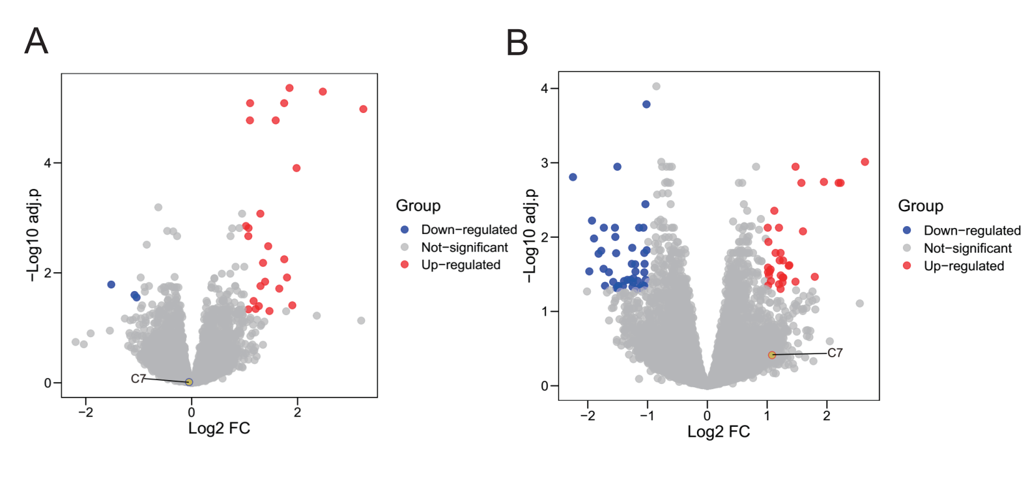

Tables
Table S1. The differentially expressed genes in green module
Genes | P-Value | log2FC
COL6A3 | 0.00114 | 2.2092967
LUM | 0.00145 | 2.3746193
LTF | 0.00154 | 3.2036143
ARL4C | 0.00377 | 1.5662343
COL1A2 | 0.00268 | 1.5589439
C1QB | 0.0000544 | 2.2046858
C7 | 0.000984 | 2.0070538
THBS2 | 0.00145 | 2.0139856
CD53 | 0.00171 | 1.6720554
CD163 | 0.000635 | 1.6363295
IRF8 | 0.00316 | 1.5832472
CD48 | 0.00205 | 1.7367058
MMP7 | 0.00611 | 2.0864495
ABCA8 | 0.0135 | 1.6467035
EVI2A | 0.00206 | 1.8399305
GZMA | 0.00741 | 1.8060946
GHR | 0.000216 | -1.8007286
CPA3 | 0.000831 | 2.031023
IL7R | 0.00848 | 1.5867266
TDO2 | 0.00306 | 1.5665464
CXCL6 | 0.00733 | 2.2583625
GZMK | 0.00523 | 1.7674232
LTB | 0.0193 | 1.7084566
BLNK | 0.00557 | 1.5047605
CORO1A | 0.00726 | 1.5717644
ADH1B | 0.000873 | 2.1839657
MOXD1 | 0.000638 | 1.905562
HGF | 0.00773 | 1.6040717
CCL19 | 0.0116 | 1.9312706
TRBC1 | 0.00209 | 2.0115272
CD3D | 0.0024 | 1.6492245
LYZ | 0.0255 | 1.5295324
C3 | 0.00356 | 2.6799609
C1QA | 0.00000955 | 1.9222762
MS4A6A | 0.00036 | 1.8690374

