Supplementary material

Supplementary text
The model structure was based on principles of Random Utility Theory (RUT) and utility maximization, which states that decision makers compare alternative goods and services within a market and select the bundle of attributes or goods that yield the maximum utility (i.e., the respondent is a utility maximiser). It proposes that overall utility, $U_{nsj}$, for alternative $j$ by respondent $n$ in choice situation $s$, is expressed as the sum of the observable component, $V_{nsj}$, and a random component $ϵ_{nsj}$, as follows:
$$U_{nsj}=V_{nsj}+ ϵ_{nsj}$$

The multinomial logit model (MNL)
The simplest discrete choice model, the multinomial logit model (MNL), is often used to estimate the $V_{nsj}$ component of the utility equation as a function of the alternative’s defining attributes. It takes the following form, where $β_{jk}$ is the parameter coefficient for attribute $k$ of alternative $j$, and $x_{nsjk}$ is the data variable indicating the level shown for attribute $k$ of alternative $j$ in choice scenario $s$for participant $n$.
$$V_{nsj}=\sum_{k=1}^{K}{β_{jk}x_{nsjk}}$$
The MNL model structure relies on certain assumptions that impose restrictive conditions on its behavior. Firstly, it assumes that the error terms ($ϵ_{nsj}$) are independent and identically distributed (IID) of extreme value type 1 (EV1). This leads to further restrictions around the independence of observed choices and independence of irrelevant alternatives (IIA), where the relative probabilities of two alternatives being chosen is not affected by the inclusion or exclusion of other alternatives. Furthermore, the parameter coefficients ($β_{jk}$) are assumed to be invariant across the sample. This means that it limits itself to only one set of parameter coefficients (or parameter weights) to describe the trade-off behavior of all survey participants combined (i.e., homogeneity of preferences).

Latent Class Model (LCM)
To overcome the limitations with the MNL, a latent class model (LCM) was used to model the DCE data. The Latent Class Model (LCM) allows for preference heterogeneity (i.e., different participants can have different marginal utility or parameter weights for each of the features), which is handled via a discrete distribution of ‘classes’. According to the model, each individual resides up to a probability in each ‘latent’ class, c, where the number of classes, $C$, is fixed, and defined a priori. Model estimates consist of the class specific parameters, and for each participant, a set of probabilities defined over the classes. Within each class, the parameters and choice probabilities are assumed to be generated by MNL models (Supplementary Figure 1). The MNL models are referred to as conditional class models, as the class-specific estimates are applied to individuals based on their probability of belonging to each class, determined through the class assignment model. Respondent characteristics can be explored as covariates in the class assignment model to determine their association with the class membership probability distribution ($p_{1}, p_{2},…, p_{C}$).
$$p_{C}$$
$$p_{2}$$
$$p_{1}$$
Supplementary Figure 1: Class assignment model
Conditional class probabilities
Conditional on belonging to class c, the probability that respondent n chooses alternative j in choice situation s is defined as:
$$P_{nsj/c}=\frac{\exp\left(V_{nsj/c}\right)}{\sum_{i}{\exp\left(V_{nsi/c}\right)}}$$ | (3)
Given observed choices $y_{nsj}$ the probability, conditional to belonging to class c, that respondent n is observed to make a sequence of choices of s choice scenarios is computed as:
$$P_{n|c}={\prod_{s}{\left(\frac{\exp\left(V_{nsj|c}\right)}{\sum_{i}{\exp\left(V_{nsi|c}\right)}}\right)}}^{y_{nsj}}$$ | (4)
Where:
$y_{nsj}$ = 1 if the individual n chooses alternative j in choice scenario s and 0 otherwise

Class assignment probabilities (unconditional)
The probability that respondent n belongs to class c is given by:
$$P_{nc}=\frac{\exp\left(V_{nc}\right)}{\sum_{c∈C}{\exp\left(V_{nC}\right)}}$$ | (5)

Where:
$V_{nc}=\sum_{l=1}^{L}{δ_{cl}z_{nl}}$ represents the observed component based on $L$ covariates,
$δ_{cl}$ a parameter associated with covariate $z_{nl}.$
The parameters $δ_{cl}$ is normalised to unity for one entire class for model identification.
Likelihood function
The objective of the model is to find parameters that best predict the observed choices $y_{nsj}$. In the LCM model this is done using maximum likelihood estimation (i.e., maximising the log-likelihood function below, the joint probability of both the conditional class probabilities $P_{n/c}$ and class assignment probabilities $P_{nc}$
$$LogL=\sum_{n=1}^{N}{ln\left(\sum_{c}{\prod_{s}{P_{n/c}}}P_{nc}\right)}$$ | (6)

Decision support system
A decision support system (DSS), or dashboard, was created to assist stakeholders in interpretation of the model. The dashboard, which was constructed in the Shiny package for R¹ and can be accessed via https://cappre.shinyapps.io/JanssenTRD/, supports the visualisation of the model results and enables the user to perform ‘what if’ scenarios based on hypothesised changes to the treatments. A screenshot of the online dashboard is shown in Supplementary Figure 2.
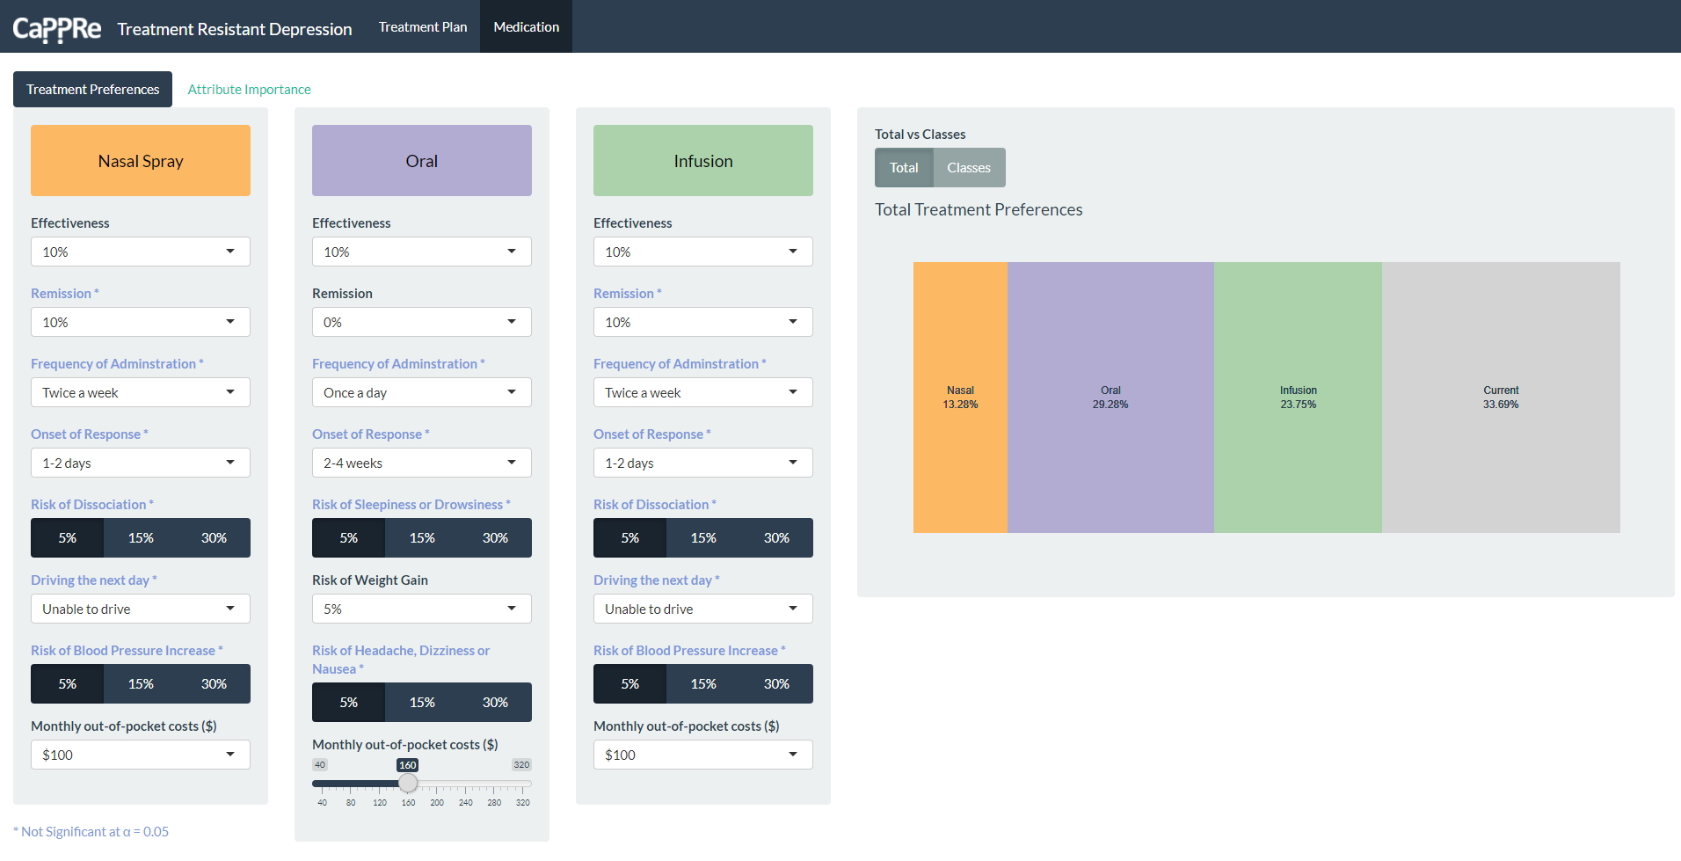
Supplementary Figure 2: Screenshot of dashboard

References
1. Shiny: Web Application Framework for R. 2018. R package version 1.1. 0 [computer program]. 2018.

Supplementary table 1: Medication DCE attribute grid
Attributes | Description | Nasal spray (administered in addition to oral medication  at hospital/community mental health facility) |  | Oral (administered at home) |  | Infusion (administered at a  hospital/community mental health facility)
Effectiveness | Percentage improvement in mood symptoms | 10% |  | 10% |  | 10%
Effectiveness | Percentage improvement in mood symptoms | 30% |  | 30% |  | 30%
Effectiveness | Percentage improvement in mood symptoms | 50% |  | 50% |  | 50%
Effectiveness | Percentage improvement in mood symptoms | 70% |  | 70% |  | 70%
Remission | Proportion of people whose mood symptoms are controlled or have disappeared after  treatment | 10% |  | 0% |  | 10%
Remission |  | 30% |  | 10% |  | 30%
Remission |  | 50% |  | 30% |  | 50%
Remission |  |  |  | 50%
Freq of admin | How often the treatment is administered | twice a week |  | once a day |  | twice a week
Freq of admin | How often the treatment is administered | weekly |  | twice a day |  | weekly
Freq of admin | How often the treatment is administered | fortnightly |  | once a week |  | fortnightly
Freq of admin | How often the treatment is administered | monthly |  |  |  | monthly
Onset of response | How long it takes for the treatment to start  working | 1-2 day |  | 2-4 weeks |  | 1-2 day
Onset of response | How long it takes for the treatment to start  working | 1-2 weeks |  | 4-6 weeks |  | 1-2 weeks
Onset of response | How long it takes for the treatment to start  working | 4-6 weeks |  | 6-8 weeks |  | 4-6 weeks
Risk of side effects | Side-effects that may or may not interfere with daily activities. Some of these side-effects may require additional treatment. | Dissociation (feeling disconnected from one's thoughts, feelings, memories and/or sense of identity) for 60-90 min, in addition to side effects  of oral medications | 5% | Sleepiness or drowsiness | 5% | Dissociation (feeling disconnected from one's thoughts, feelings, memories and/or sense of identity)  for 60-90 min | 5%
Risk of side effects |  |  | 15% | Sleepiness or drowsiness | 15% |  | 15%
Risk of side effects |  |  | 30% | Sleepiness or drowsiness | 30% |  | 30%
Risk of side effects |  | Inability to drive until the next day, in addition to side effects of oral medications | Yes | Weight gain | 5% | Inability to drive until the next day | Yes
Risk of side effects |  |  | No | Weight gain | 15% | Inability to drive until the next day | No
Risk of side effects |  |  |  | Weight gain | 30% | Inability to drive until the next day
Risk of side effects |  | Short term increase in blood pressure, in addition to side effects of oral medication | 5% | Headache, dizziness or nausea | 5% | Short term increase in blood pressure | 5%
Risk of side effects |  |  | 15% | Headache, dizziness or nausea | 15% | Short term increase in blood pressure | 15%
Risk of side effects |  |  | 30% | Headache, dizziness or nausea | 30% | Short term increase in blood pressure | 30%
Monthly out-of- pocket cost | Out-of-pocket costs associated with treatment including visits to healthcare professionals, cost of treatments and travel costs associated with treatment | $100 |  | $40 |  | $100
Monthly out-of- pocket cost |  | $250 |  | $80 |  | $250
Monthly out-of- pocket cost |  | $500 |  | $120 |  | $500
Monthly out-of- pocket cost |  | $750 |  | $160 |  | $750
Monthly out-of- pocket cost |  | $1,000 |  | $200 |  | $1,000
Monthly out-of- pocket cost |  | $1,500 |  | $240 |  | $1,500
Monthly out-of- pocket cost |  | $2,000 |  | $280 |  | $2,000
Monthly out-of- pocket cost |  | $2,500 |  | $320 |  | $2,500

Supplementary table 2: Treatment plan DCE attribute grid
Attribute |  |  | Definition | Levels
Effectiveness |  |  | Percentage improvement in mood symptoms | 30%
 |  |  | Percentage improvement in mood symptoms | 50%
 |  |  | Percentage improvement in mood symptoms | 70%
Remission |  |  | Proportion of people whose mood symptoms are controlled or have disappeared after treatment | 0%
 |  |  |  | 10%
 |  |  |  | 30%
 |  |  |  | 50%
Treatments included | Medication |  | Pharmacological treatments prescribed by a doctor which have been shown to reduce symptoms of depression. There are several classes or groups of medications, including newer treatments that are administered as a nasal spray. | Infusion in clinic
Treatments included |  |  |  | Nasal in clinic + oral
Treatments included |  |  |  | Oral pills at home
Treatments included |  |  |  | No medication
Treatments included | Psychotherapy |  | Face-to-face psychotherapy or "talk therapy" with a specially-trained health professional to help you adapt how you feel, think and act in response to symptoms. | None
Treatments included |  |  |  | 1 session per month
Treatments included |  |  |  | 2 sessions per month
Treatments included |  |  |  | 1 session per week
Treatments included | Brain stimulation | Electroconvulsive therapy (ECT) | A medical treatment that involves passing a carefully controlled electric current through the brain. The current changes brain activity to improve  symptoms of depression. | ECT
Treatments included | Brain stimulation | Transcranial magnetic  stimulation (TMS) | A non-invasive procedure that uses magnetic field to stimulate nerve  cells in the brain to improve symptoms of depression. | TMS
Treatments included | Brain stimulation | None |  | None
Treatments included | Lifestyle changes |  | Changes to lifestyle and habits to improve your physical and mental  health including changes to diet, sleep and exercise. | No
Treatments included |  |  |  | Yes
Treatments included | Mindfulness |  | A mental and physical technique used to focus your awareness on the  present moment. | No
Treatments included |  |  |  | Yes
Treatment setting | Primary Healthcare practitioner |  | The healthcare practitioner who is responsible for overseeing your treatment plan | GP
Treatment setting |  |  |  | Psychologist
Treatment setting |  |  |  | Psychiatrist
Treatment setting | Setting |  | Where the treatments are received | Across different providers in different locations
Treatment setting |  |  | Where the treatments are received | All treatments can be received at one holistic  centre with a dedicated team
Cost | Monthly out-of-pocket costs |  | Out-of-pocket costs associated with treatment including visits to healthcare professionals, cost of treatments and travel costs associated with treatment | $2,500
Cost |  |  |  | $2,000
Cost |  |  |  | $1,500
Cost |  |  |  | $1,000
Cost |  |  |  | $750
Cost |  |  |  | $500
Cost |  |  |  | $250
Cost |  |  |  | $100

