Hormone-replacement therapy may be associated with increased incidence of luminal breast cancer: Results from a large-scale HMO analysis

Vered Rosenberg, Avital Bareket-Samish, Gabriel Chodick and Nava Siegelmann-Danieli

Corresponding Author: Dr. Nava Siegelmann-Danieli, Phone: +972-3-7462527; Fax: +972-3-7952779; email: danieli_na@mac.org.il

Online Resource 1

Tables S1. Breast cancer subtypes as defined in the current study.
Tumor type | Anti-hormonal therapy  (anastrozole, exemestane, letrozole, tamoxifen) | Anti-HER2 therapy (pertuzumab, trastuzumab) | Chemotherapy
Luminal A & B without HER2 overexpression  (HR+ and HER2-) | Yes | None | Yes/ None
Luminal B with HER2 overexpression  (HR+ and HER2+) | Yes | Yes | Yes
Hormone-receptor negative HER2-enriched  (HR- and HER2+) | None | Yes | Yes
Triple negative  (HR- and HER2-) | None | None | Yes
Unknown | None | None | None

Table S2. Distribution of invasive breast cancer subtypes by age groups 2007-2014 (n=7771)
 | <45  (n=1553, 100%) | ≥45  (n=6218, 100%) | All age groups (n=7771, 100%)
Luminal A & B without HER2 overexpression  (HR+ and HER2-) | 869 (56.%) | 4548 (73.1%) | 5417 (69.7%)
Luminal B with HER2 overexpression  (HR+ and HER2+) | 215 (13.8%) | 480 (7.7%) | 695 (8.9%)
Hormone-receptor negative HER2-enriched  (HR- and HER2+) | 119 (7.7%) | 302 (4.9%) | 421 (5.4%)
Triple-negative  (HR- and HER2-) | 260 (16.7%) | 514 (8.3%) | 774 (10.0%)
Unknown | 90 (5.8%) | 374 (6.%) | 464 (6.0%)

Supplementary Figures
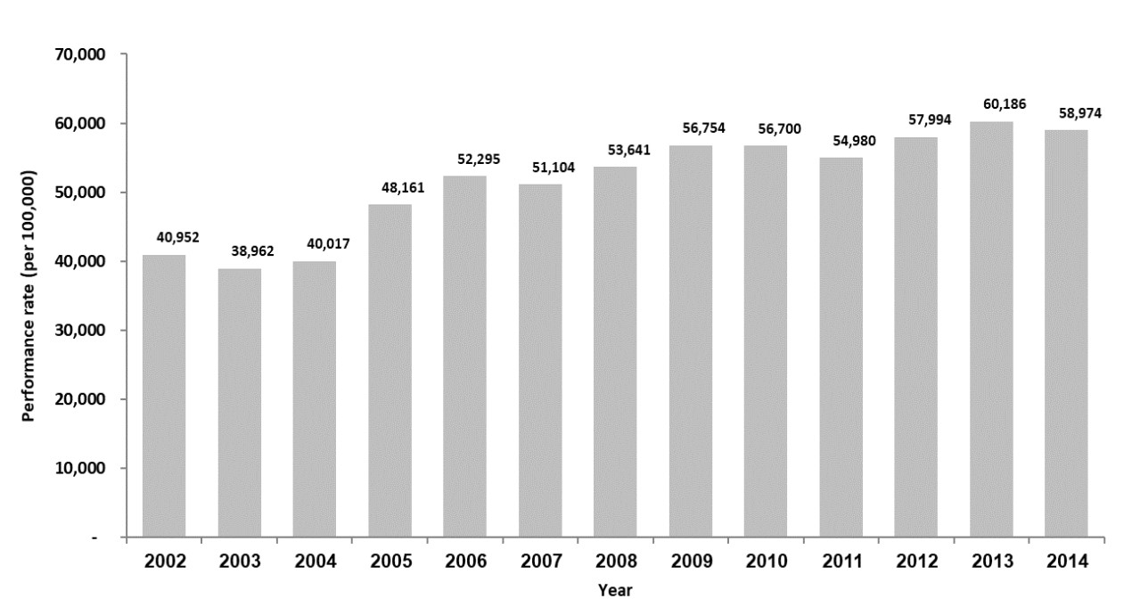
Fig. S1. Mammography testing rates in Maccabi Healthcare Services (MHS) members ≥45 years of age.

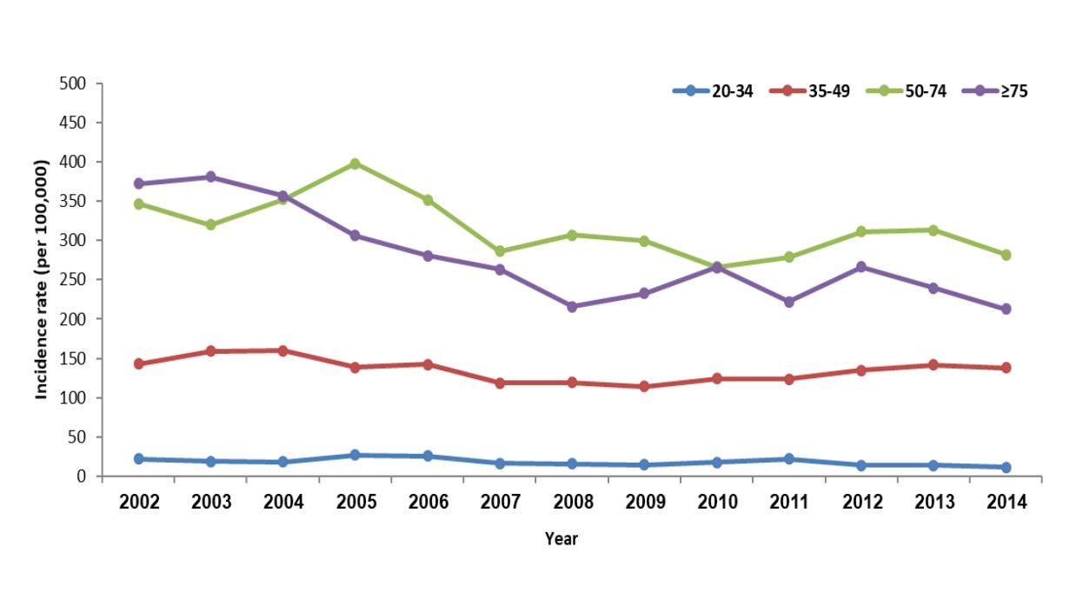
A. Age-specific incidence rates for invasive breast cancer.
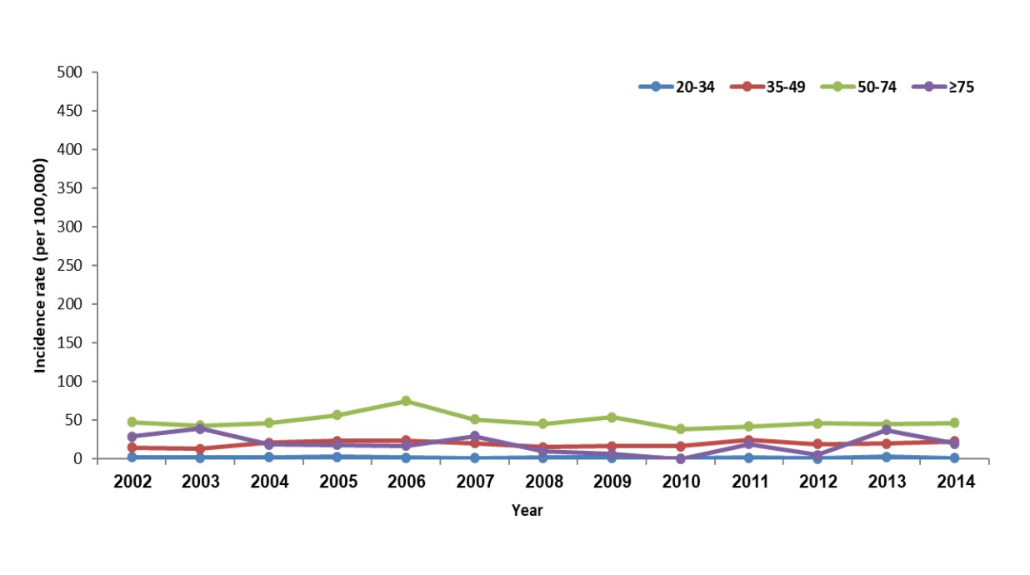
- Age-specific incidence rates for in situ breast cancer.
Fig. S2. Breast cancer incidence over time.

