Supporting information

Hyaluronic Acid Coated Liposomes Co-Delivery of Natural Cyclic Peptide RA-XII and Mitochondrial Targeted Photosensitizer for Highly Selective Precise Combined Treatment of Colon Cancer
Yanqing Xu,# Yongrong Yao,# Linxiao Wang, Huachao Chen,* Ninghua Tan*
State Key Laboratory of Natural Medicines, School of Traditional Chinese Pharmacy, China Pharmaceutical University, Nanjing 211198, P. R. China
#These authors contributed equally to this work
Correspondence: Ninghua Tan; Huachao Chen
State Key Laboratory of Natural Medicines, School of Traditional Chinese Pharmacy, China Pharmaceutical University, Nanjing, 211198, PR China;
Tel/Fax +86 25 86185772
Email nhtan@cpu.edu.cn; huachao.chen@cpu.edu.cn
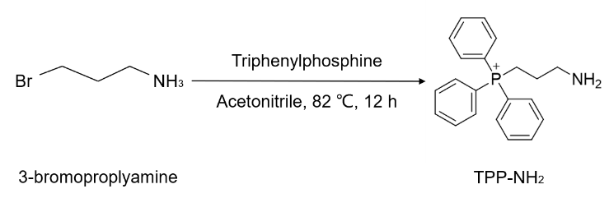
(a) Synthesis of TPP-NH₂

(b) Synthesis of TPPP
Fig. S1 Structure and synthetic routes for TPPP. (a) TPP-NH₂ (3-aminopropyl)triphenylphosphonium was synthesized by substitution of bromine in 3-bromopropylamine with triphenylphosphine. (b) Synthesis scheme for the preparation of TPPP.

(a)
(b)
(c)
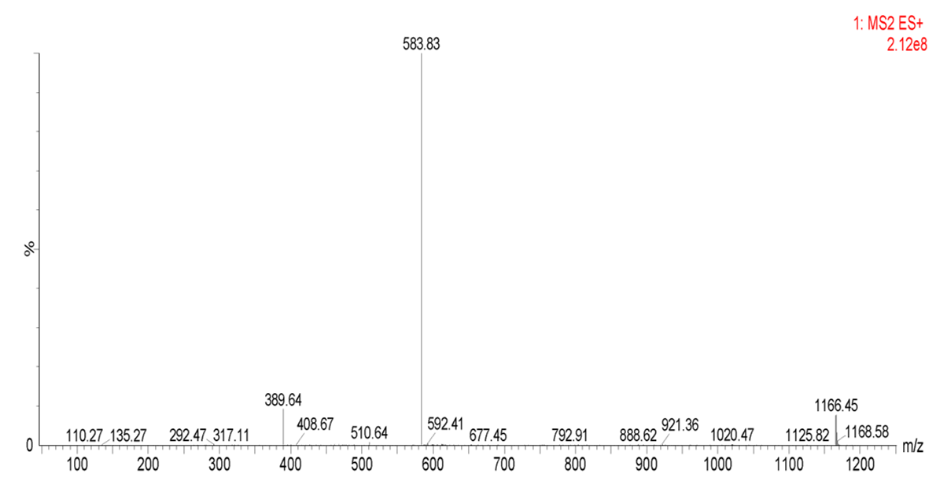
Fig. S2 (a) The ¹H NMR spectrum of TPPP. (b) The ¹³C NMR spectrum of TPPP. (c) The MS spectrum of TPPP.

Fig. S3 Long-term-stability study of RA/TPPP-Lip in 10% PBS.

Fig. S4 H&E staining images of tissue sections from different organs of mice after RA/TPPP-Lip-mediated therapy and the age-match healthy mice without treatment (control). Scale bars: 100 μm.

