Supplemental materials
Table S1. Descriptive statistics of the responder’s dietary habits during the COVID-19 quarantine (“How many times a week do you consume the following foods?”) (Post-propensity match sample).
Answer | N. of responders | Response* | LEPRE  (N=64) | PRESTO (N=128) | Combined (N=192) | P value
Cereals and derivatives. e.g.: pasta, rice, bread, pizza, spelt, barley, etc. | 173 | - | 7.00 (6-7) | 7.00 (3-7.75) | 7.00 (4-7) | 0.103
Cereal products. e.g.: corn flakes, cookies, rusks, crackers, etc. | 173 | - | 7.00 (5-7) | 7.00 (2.25-7) | 7.00 (3-7) | 0.184
Fresh meat. | 172 | - | 3 (2-5) | 3 (2-4) | 3 (2-4) | 0.282
Processed meats. e.g.: ham, salami, sausages, etc. | 172 | - | 2 (1-3.5) | 1 (1-3) | 2 (1-3) | 0.104
Fish and other fishery products. e.g.: sea bass, octopus, prawns, etc. | 172 | - | 2 (1-2) | 2 (1-3) | 2 (1-3) | 0.865
Milk and yogurt. | 172 | - | 7 (2-7) | 7 (1-7) | 7 (1-7) | 0.77
Dairy products. e.g.: fresh and aged cheeses. | 172 | - | 3 (2-5) | 3 (1-5) | 3 (1-5) | 0.451
Fresh fruit. | 172 | - | 6 (4-7) | 7 (5-10) | 7 (4-10) | 0.202
Dried fruit. e.g.: walnuts, hazelnuts, almonds, etc. | 172 | - | 1 (0-4) | 2 (0-5) | 2 (0-5) | 0.256
Vegetables or greens. e.g.: lettuce, radicchio, endive, spinach, chard, etc. | 172 | - | 7 (6-14) | 9 (7-14) | 7 (6-14) | 0.32
Legumes. e.g.: beans, lentils, peas, chickpeas, etc. | 172 | - | 2 (1-3) | 2 (1-4) | 2 (1-4) | 0.051
Eggs. | 172 | - | 1 (1-2) | 2 (1-2) | 2 (1-2) | 0.005
Desserts. e.g.: cakes, ice cream, chocolate, etc. | 172 | - | 3 (2-6.5) | 4 (2-7) | 4 (2-7) | 0.884
Carbonated drinks. e.g.: coca cola, orange soda, etc. | 172 | - | 0 (0-2) | 0 (0-1) | 0 (0-1.25) | 0.428
Alcoholic beverages. e.g.: wine, beer, spirits, etc. | 172 | - | 1 (0-3) | 1 (0-3) | 1 (0-3) | 0.606
Cereals and derivatives. e.g.: pasta, rice, bread, pizza, spelt, barley, etc. | 173 | Normal | 0% ( 0) | 1% ( 1) | 1% ( 1) | 0.471
 | 173 | Below threshold | 100% ( 59) | 99% (113) | 99% (172) | 0.471
Fresh meat. | 172 | Normal | 71% ( 42) | 60% ( 68) | 64% (110) | 0.153
Fresh meat. | 172 | Below threshold | 29% ( 17) | 40% ( 45) | 36% ( 62) | 0.153
Processed meats. e.g.: ham, salami, wurstel, etc. | 172 | Normal | 86% ( 51) | 82% ( 93) | 84% (144) | 0.485
Processed meats. e.g.: ham, salami, wurstel, etc. | 172 | Below threshold | 14% ( 8) | 18% ( 20) | 16% ( 28) | 0.485
Fish and other fishery products. e.g.: sea bass, octopus, prawns, etc. | 172 | Normal | 12% ( 7) | 19% ( 22) | 17% ( 29) | 0.206
 | 172 | Below threshold | 88% ( 52) | 81% ( 91) | 83% (143) | 0.206
Milk and yogurt. | 172 | Normal | 0% ( 0) | 0% ( 0) | 0% ( 0) | 1.0
Milk and yogurt. | 172 | Below threshold | 100% ( 59) | 100% (113) | 100% (172) | 1.0
Dairy products. e.g.: fresh and aged cheeses. | 172 | Normal | 61% (36) | 54% (61) | 56% (97) | 0.377
Dairy products. e.g.: fresh and aged cheeses. | 172 | Below threshold | 39% (23) | 46% (52) | 44% (75) | 0.377
Dried fruit. e.g.: walnuts, hazelnuts, almonds, etc. | 172 | Normal | 31% ( 18) | 42% ( 47) | 38% ( 65) | 0.155
Dried fruit. e.g.: walnuts, hazelnuts, almonds, etc. | 172 | Below threshold | 69% ( 41) | 58% ( 66) | 62% (107) | 0.155
Vegetables or greens. e.g.: lettuce, radicchio, endive, spinach, chard, etc. | 172 | Normal | 2% ( 1) | 1% ( 1) | 1% ( 2) | 0.638
 | 172 | Below threshold | 98% ( 58) | 99% (112) | 99% (170) | 0.638
Legumes. e.g.: beans, lentils, peas, chickpeas, etc. | 172 | Normal | 41% (24) | 47% (53) | 45% (77) | 0.436
Legumes. e.g.: beans, lentils, peas, chickpeas, etc. | 172 | Below threshold | 59% (35) | 53% (60) | 55% (95) | 0.436
Eggs. | 172 | Normal | 41% (24) | 60% (68) | 53% (92) | 0.015
Eggs. | 172 | Below threshold | 59% (35) | 40% (45) | 47% (80) | 0.015
Carbonated drinks. e.g.: coca cola, orange soda, etc. | 172 | Normal | 3% ( 2) | 6% ( 7) | 5% ( 9) | 0.433
Carbonated drinks. e.g.: coca cola, orange soda, etc. | 172 | Below threshold | 97% ( 57) | 94% (106) | 95% (163) | 0.433
Alcoholic beverages. e.g.:wine, beer, spirits, etc. | 172 | Normal | 58% ( 34) | 60% ( 68) | 59% (102) | 0.747
Alcoholic beverages. e.g.:wine, beer, spirits, etc. | 172 | Below threshold | 42% (25) | 44% (44) | 44% (69) | 0.747
Legend: significant P values between LEPRE and PRESTO groups are expressed in bold characters. Answers are reported as median of the week (I-III interquartile range) and as qualitative categorical variable.

Sub analyses
- LEPRE vs PRESTO (only people with chronic diseases)
Table S2. Descriptive statistics of the survey responders (only people declaring chronic diseases).
Answer | N. of responders | Variable | LEPRE  (N=64) | PRESTO  (N=179) | Combined  (N=243) | P value
How old are you? | 243 | Age, median (I-III quartile range) | 43 (35-54.5) | 59 (45-65.5) | 55 (42-63) | <0.001
Age class | 243 | <=29 | 16% ( 10) | 6% ( 11) | 9% ( 21) | <0.001
Age class | 243 | 29-65 | 81% ( 52) | 69% (123) | 72% (175) | <0.001
Age class | 243 | 65+ | 3% ( 2) | 25% ( 45) | 19% ( 47) | <0.001
What is your gender | 243 | Female | 88% ( 56) | 58% (104) | 66% (160) | <0.001
What is your gender | 243 | Male | 12% ( 8) | 42% ( 75) | 34% ( 83) | <0.001
Please specify your nationality | 243 | Other | 3% ( 2) | 3% ( 5) | 3% ( 7) | 0.892
Please specify your nationality | 243 | Italian | 97% ( 62) | 97% (174) | 97% (236) | 0.892
What is your level of education? | 243 | High School | 70% ( 45) | 53% ( 95) | 58% (140) | 0.01
What is your level of education? | 243 | University | 28% ( 18) | 47% ( 84) | 42% (102) | 0.01
What is your level of education? | 243 | Secondary school | 2% ( 1) | 0% ( 0) | 0% ( 1) | 0.01
What is your employment status? | 243 | Employed | 97% ( 62) | 98% (176) | 98% (238) | 0.483
What is your employment status? | 243 | Student | 3% ( 2) | 2% ( 3) | 2% ( 5) | 0.483
What is your house like? | 243 | Flat | 39% ( 25) | 72% (128) | 63% (153) | <0.001
What is your house like? | 243 | Studio flat | 2% ( 1) | 2% ( 4) | 2% ( 5) | <0.001
What is your house like? | 243 | Detached house | 59% ( 38) | 26% ( 47) | 35% ( 85) | <0.001
Can you access a private garden? | 243 | No | 19% ( 12) | 47% ( 85) | 40% ( 97) | <0.001
Can you access a private garden? | 243 | Yes | 81% ( 52) | 53% ( 94) | 60% (146) | <0.001
Did you take the swab test? | 168 | No | 81% ( 51) | 95% (100) | 90% (151) | 0.003
Did you take the swab test? | 168 | Yes | 19% ( 12) | 5% ( 5) | 10% ( 17) | 0.003
Have you lost anyone during this period? | 166 | No | 89% ( 56) | 86% ( 89) | 87% (145) | 0.641
Have you lost anyone during this period? | 166 | Yes | 11% ( 7) | 14% ( 14) | 13% ( 21) | 0.641
Besides yourself, how many people live in your home? | 239 | I do not live alone | 94% (59) | 82% (144) | 85% (203) | 0.024
Besides yourself, how many people live in your home? | 239 | I live alone | 6% ( 4) | 18% ( 32) | 15% ( 36) | 0.024
AFTER the measures taken by the government to contain the spread of the coronavirus since you have been in quarantine do you habitually practice some physical activity | 195 | No | 73% ( 43) | 60% ( 81) | 64% (124) | 0.076
 | 195 | Yes | 27% ( 16) | 40% ( 55) | 36% ( 71) | 0.076
Own a pet | 243 | No | 33% ( 21) | 54% ( 97) | 49% (118) | 0.003
Own a pet | 243 | Yes | 67% ( 43) | 46% ( 82) | 51% (125) | 0.003
Mental health scores
GHQ 12 Total score | 213 | 0-13 | 15% ( 9) | 14% ( 22) | 15% ( 31) | 0.958
GHQ 12 Total score | 213 | 14-36 | 85% ( 52) | 86% (130) | 85% (182) | 0.958
IES R Total score | 207 | 0-23 | 43% ( 26) | 59% ( 87) | 55% (113) | 0.208
IES R Total score | 207 | 24-32 | 27% ( 16) | 19% ( 28) | 21% ( 44) | 0.208
IES R Total score | 207 | 33-36 | 7% ( 4) | 6% ( 9) | 6% ( 13) | 0.208
IES R Total score | 207 | 37-88 | 23% ( 14) | 16% ( 23) | 18% ( 37) | 0.208
CESD Total score | 202 | 0-15 | 55% ( 33) | 58% ( 83) | 57% (116) | 0.818
CESD Total score | 202 | 16-23 | 27% ( 16) | 23% ( 32) | 24% ( 48) | 0.818
CESD Total score | 202 | 24-60 | 18% ( 11) | 19% ( 27) | 19% ( 38) | 0.818
Legend: significant P values between LEPRE and PRESTO groups are expressed in bold characters.
Table S3. Descriptive statistics of the survey responders post propensity score matching (only people declaring chronic diseases).
Answer | N. of responders | Variable | LEPRE  (N=64) | PRESTO (N=128) | Combined (N=192) | P value
How old are you? | 192 | Age, median (I-III quartile range) | 43 (35-54.5) | 53 (41-61) | 49 (39-60) | 0.005
Age class | 192 | <=29 | 16% ( 10) | 9% ( 11) | 11% ( 21) | 0.246
Age class | 192 | 29-65 | 81% ( 52) | 85% (109) | 84% (161) | 0.246
Age class | 192 | 65+ | 3% ( 2) | 6% ( 8) | 5% ( 10) | 0.246
What is your gender | 192 | Female | 88% ( 56) | 70% ( 90) | 76% (146) | 0.009
What is your gender | 192 | Male | 12% ( 8) | 30% ( 38) | 24% ( 46) | 0.009
Please specify your nationality | 192 | Other | 3% ( 2) | 4% ( 5) | 4% ( 7) | 0.785
Please specify your nationality | 192 | Italian | 97% ( 62) | 96% (123) | 96% (185) | 0.785
What is your level of education? | 192 | High School | 70% ( 45) | 63% ( 81) | 66% (126) | 0.197
What is your level of education? | 192 | University | 28% ( 18) | 37% ( 47) | 34% ( 65) | 0.197
What is your level of education? | 192 | Secondary school | 2% ( 1) | 0% ( 0) | 1% ( 1) | 0.197
What is your employment status? | 192 | Employed | 97% ( 62) | 98% (125) | 97% (187) | 0.749
What is your employment status? | 192 | Student | 3% ( 2) | 2% ( 3) | 3% ( 5) | 0.749
What is your house like? | 192 | Flat | 39% ( 25) | 66% ( 85) | 57% (110) | 0.001
What is your house like? | 192 | Studio flat | 2% ( 1) | 3% ( 4) | 3% ( 5) | 0.001
What is your house like? | 192 | Detached house | 59% ( 38) | 30% ( 39) | 40% ( 77) | 0.001
Can you access a private garden? | 192 | No | 19% ( 12) | 44% ( 56) | 35% ( 68) | 0.001
Can you access a private garden? | 192 | Yes | 81% ( 52) | 56% ( 72) | 65% (124) | 0.001
Did you take the swab test? | 135 | No | 81% ( 51) | 93% ( 67) | 87% (118) | 0.034
Did you take the swab test? | 135 | Yes | 19% ( 12) | 7% ( 5) | 13% ( 17) | 0.034
Have you lost anyone during this period? | 134 | No | 89% ( 56) | 85% ( 60) | 87% (116) | 0.458
Have you lost anyone during this period? | 134 | Yes | 11% ( 7) | 15% ( 11) | 13% ( 18) | 0.458
Besides yourself, how many people live in your home? | 189 | I do not live alone | 94% ( 59) | 85% (107) | 88% (166) | 0.084
Besides yourself, how many people live in your home? | 189 | I live alone | 6% ( 4) | 15% ( 19) | 12% ( 23) | 0.084
Own a pet | 192 | No | 33% ( 21) | 45% ( 58) | 41% ( 79) | 0.097
Own a pet | 192 | Yes | 67% ( 43) | 55% ( 70) | 59% (113) | 0.097
Mental health scores
GHQ 12 Total score | 176 | 0-13 | 15% ( 9) | 17% ( 20) | 16% ( 29) | 0.654
GHQ 12 Total score | 176 | 14-36 | 85% ( 52) | 83% ( 95) | 84% (147) | 0.654
IES R Total score | 171 | 0-23 | 43% (26) | 54% (60) | 50% (86) | 0.552
IES R Total score | 171 | 24-32 | 27% (16) | 20% (22) | 22% (38) | 0.552
IES R Total score | 171 | 33-36 | 7% ( 4) | 7% ( 8) | 7% (12) | 0.552
IES R Total score | 171 | 37-88 | 23% (14) | 19% (21) | 20% (35) | 0.552
CESD Total score | 167 | 0-15 | 55% (33) | 55% (59) | 55% (92) | 0.742
CESD Total score | 167 | 16-23 | 27% (16) | 22% (24) | 24% (40) | 0.742
CESD Total score | 167 | 24-60 | 18% (11) | 22% (24) | 21% (35) | 0.742
Legend: significant P values between LEPRE and PRESTO groups are expressed in bold characters.

Table S4. Descriptive statistics of the missing activities “Which of the following activities are you missing the most during this quarantine period?” (only people declaring chronic diseases) during the COVID-19 quarantine (Post-propensity match sample).

Answer | N. of responders | Variable | LEPRE (N=64) | PRESTO (N=128) | Combined (N=192) | P value
Going to the cinema, theater. | 191 | Not selected | 75% ( 47) | 81% (104) | 79% (151) | 0.288
Going to the cinema, theater. | 191 | Yes | 25% ( 16) | 19% ( 24) | 21% ( 40) | 0.288
Playing sports/exercise. | 191 | Not selected | 81% ( 51) | 64% ( 82) | 70% (133) | 0.017
Playing sports/exercise. | 191 | Yes | 19% ( 12) | 36% ( 46) | 30% ( 58) | 0.017
Going to exhibitions and museums. | 191 | Not selected | 89% ( 56) | 81% (104) | 84% (160) | 0.178
Going to exhibitions and museums. | 191 | Yes | 11% ( 7) | 19% ( 24) | 16% ( 31) | 0.178
Going to nightclubs. | 191 | Not selected | 98% ( 62) | 98% (126) | 98% (188) | 0.99
Going to nightclubs. | 191 | Yes | 2% ( 1) | 2% ( 2) | 2% ( 3) | 0.99
Attending sporting events. | 191 | Not selected | 95% ( 60) | 95% (122) | 95% (182) | 0.982
Attending sporting events. | 191 | Yes | 5% ( 3) | 5% ( 6) | 5% ( 9) | 0.982
Going out to eat. | 191 | Not selected | 56% ( 35) | 58% ( 74) | 57% (109) | 0.767
Going out to eat. | 191 | Yes | 44% ( 28) | 42% ( 54) | 43% ( 82) | 0.767
Going to coffee shops. | 191 | Not selected | 84% ( 53) | 85% (109) | 85% (162) | 0.852
Going to coffee shops. | 191 | Yes | 16% ( 10) | 15% ( 19) | 15% ( 29) | 0.852
Gardening. | 191 | Not selected | 95% ( 60) | 91% (116) | 92% (176) | 0.265
Gardening. | 191 | Yes | 5% ( 3) | 9% ( 12) | 8% ( 15) | 0.265
Going out for a walk. | 191 | Not selected | 40% ( 25) | 38% ( 48) | 38% ( 73) | 0.77
Going out for a walk. | 191 | Yes | 60% ( 38) | 62% ( 80) | 62% (118) | 0.77
Going out with friends. | 191 | Not selected | 40% ( 25) | 48% ( 61) | 45% ( 86) | 0.298
Going out with friends. | 191 | Yes | 60% ( 38) | 52% ( 67) | 55% (105) | 0.298
See the family. | 191 | Not selected | 29% (18) | 62% (80) | 51% (98) | <1e-04
See the family. | 191 | Yes | 71% (45) | 38% (48) | 49% (93) | <1e-04
Going shopping. | 191 | Not selected | 78% ( 49) | 77% ( 99) | 77% (148) | 0.946
Going shopping. | 191 | Yes | 22% ( 14) | 23% ( 29) | 23% ( 43) | 0.946
Going to work. | 191 | Not selected | 75% ( 47) | 75% ( 96) | 75% (143) | 0.953
Going to work. | 191 | Yes | 25% ( 16) | 25% ( 32) | 25% ( 48) | 0.953
Legend: significant P values between LEPRE and PRESTO groups are expressed in bold characters.

- LEPRE vs PRESTO (by excluding patients with chronic diseases)
Table S5. Descriptive statistics of the survey responders (by excluding patients with chronic diseases).
Answer | N. of responders | Variable | Lepre  (N=64) | Presto Insieme  (N=935) | Combined  (N=999) | P value
How old are you? | 999 | Age, median (I-III quartile range) | 43 (35-54.5) | 45 (32-54) | 45 (33-54.0) | 0.65
Age class | 999 | <29 | 16% ( 10) | 21% (196) | 21% (206) | 0.196
Age class | 999 | 29-65 | 81% ( 52) | 71% (668) | 72% (720) | 0.196
Age class | 999 | 65+ | 3% ( 2) | 8% ( 71) | 7% ( 73) | 0.196
What is your gender | 997 | Female | 88% ( 56) | 61% (569) | 63% (625) | <0.001
What is your gender | 997 | Male | 12% ( 8) | 39% (364) | 37% (372) | <0.001
Please specify your nationality | 999 | Other | 3% ( 2) | 2% ( 15) | 2% ( 17) | 0.363
Please specify your nationality | 999 | Italian | 97% ( 62) | 98% (920) | 98% (982) | 0.363
What is your level of education? | 999 | High School | 70% ( 45) | 50% (468) | 51% (513) | 0.002
What is your level of education? | 999 | University | 28% ( 18) | 50% (464) | 48% (482) | 0.002
What is your level of education? | 999 | Secondary school | 2% ( 1) | 0% ( 3) | 0% ( 4) | 0.002
What is your employment status? | 999 | Employed | 97% ( 62) | 91% (853) | 92% (915) | 0.115
What is your employment status? | 999 | Student | 3% ( 2) | 9% ( 82) | 8% ( 84) | 0.115
What is your house like? | 999 | Flat | 39% ( 25) | 65% (612) | 64% (637) | <0.001
What is your house like? | 999 | Studio flat | 2% ( 1) | 2% ( 22) | 2% ( 23) | <0.001
What is your house like? | 999 | Detached house | 59% ( 38) | 32% (301) | 34% (339) | <0.001
Can you access a private garden? | 997 | No | 19% ( 12) | 43% (402) | 42% (414) | <0.001
Can you access a private garden? | 997 | Yes | 81% ( 52) | 57% (531) | 58% (583) | <0.001
Did you take the swab test? | 528 | No | 81% ( 51) | 96% (448) | 95% (499) | <0.001
Did you take the swab test? | 528 | Yes | 19% ( 12) | 4% ( 17) | 5% ( 29) | <0.001
Have you lost anyone during this period? | 526 | No | 89% ( 56) | 91% (420) | 90% (476) | 0.643
Have you lost anyone during this period? | 526 | Yes | 11% ( 7) | 9% ( 43) | 10% ( 50) | 0.643
Besides yourself, how many people live in your home? | 977 | I do not live alone | 94% ( 59) | 85% (780) | 86% (839) | 0.067
Besides yourself, how many people live in your home? | 977 | I live alone | 6% ( 4) | 15% (134) | 14% (138) | 0.067
AFTER the measures taken by the government to contain the spread of the coronavirus since you have been in quarantine do you habitually practice some physical activity | 831 | No | 73% ( 43) | 56% (435) | 58% (478) | 0.013
 | 831 | Yes | 27% ( 16) | 44% (337) | 42% (353) | 0.013
Own a pet | 999 | No | 33% ( 21) | 54% (509) | 53% (530) | 0.001
Own a pet | 999 | Yes | 67% ( 43) | 46% (426) | 47% (469) | 0.001
Mental health scores
GHQ 12 Total score | 906 | 0-13 | 15% ( 9) | 12% (101) | 12% (110) | 0.518
GHQ 12 Total score | 906 | 14-36 | 85% ( 52) | 88% (744) | 88% (796) | 0.518
IES R Total score | 885 | 0-23 | 43% ( 26) | 63% (520) | 62% (546) | 0.024
IES R Total score | 885 | 24-32 | 27% ( 16) | 18% (149) | 19% (165) | 0.024
IES R Total score | 885 | 33-36 | 7% ( 4) | 5% ( 41) | 5% ( 45) | 0.024
IES R Total score | 885 | 37-88 | 23% ( 14) | 14% (115) | 15% (129) | 0.024
CESD Total score | 865 | 0-15 | 55% ( 33) | 63% (507) | 62% (540) | 0.446
CESD Total score | 865 | 16-23 | 27% ( 16) | 21% (168) | 21% (184) | 0.446
CESD Total score | 865 | 24-60 | 18% ( 11) | 16% (130) | 16% (141) | 0.446
Legend: significant P values between LEPRE and PRESTO groups are expressed in bold characters.

Table S6. Descriptive statistics of the survey responders post propensity score matching (by excluding patients with chronic diseases).
Answer | N. of responders | Variable | Lepre  (N=64) | Presto Insieme  (N=128) | Combined  (N=192) | P value
How old are you? | 192 | Age, median (I-III quartile range) | 43 (35-54.5) | 47 (37.8-54) | 46 (37-54) | 0.51
Age class | 192 | <29 | 16% ( 10) | 8% ( 10) | 10% ( 20) | 0.227
Age class | 192 | 29-65 | 81% ( 52) | 90% (115) | 87% (167) | 0.227
Age class | 192 | 65+ | 3% ( 2) | 2% ( 3) | 3% ( 5) | 0.227
What is your gender | 191 | Female | 88% ( 56) | 85% (108) | 86% (164) | 0.645
What is your gender | 191 | Male | 12% ( 8) | 15% ( 19) | 14% ( 27) | 0.645
Please specify your nationality | 192 | Other | 3% ( 2) | 1% ( 1) | 2% ( 3) | 0.217
Please specify your nationality | 192 | Italian | 97% ( 62) | 99% (127) | 98% (189) | 0.217
What is your level of education? | 192 | High School | 70% ( 45) | 70% ( 89) | 70% (134) | 0.994
What is your level of education? | 192 | University | 28% ( 18) | 29% ( 37) | 29% ( 55) | 0.994
What is your level of education? | 192 | Secondary school | 2% ( 1) | 2% ( 2) | 2% ( 3) | 0.994
What is your employment status? | 192 | Employed | 97% ( 62) | 98% (125) | 97% (187) | 0.749
What is your employment status? | 192 | Student | 3% ( 2) | 2% ( 3) | 3% ( 5) | 0.749
What is your house like? | 192 | Flat | 39% ( 25) | 38% ( 49) | 39% ( 74) | 0.872
What is your house like? | 192 | Studio flat | 2% ( 1) | 1% ( 1) | 1% ( 2) | 0.872
What is your house like? | 192 | Detached house | 59% ( 38) | 61% ( 78) | 60% (116) | 0.872
Can you access a private garden? | 192 | No | 19% ( 12) | 20% ( 26) | 20% ( 38) | 0.798
Can you access a private garden? | 192 | Yes | 81% ( 52) | 80% (102) | 80% (154) | 0.798
Did you take the swab test? | 125 | No | 81% ( 51) | 95% ( 59) | 88% (110) | 0.015
Did you take the swab test? | 125 | Yes | 19% ( 12) | 5% ( 3) | 12% ( 15) | 0.015
Have you lost anyone during this period? | 125 | No | 89% ( 56) | 97% ( 60) | 93% (116) | 0.088
Have you lost anyone during this period? | 125 | Yes | 11% ( 7) | 3% ( 2) | 7% ( 9) | 0.088
Besides yourself, how many people live in your home? | 186 | I do not live alone | 94% ( 59) | 95% (117) | 95% (176) | 0.674
Besides yourself, how many people live in your home? | 186 | I live alone | 6% ( 4) | 5% ( 6) | 5% ( 10) | 0.674
AFTER the measures taken by the government to contain the spread of the coronavirus since you have been in quarantine do you habitually practice some physical activity | 166 | No | 73% ( 43) | 72% ( 77) | 72% (120) | 0.899
 | 166 | Yes | 27% ( 16) | 28% ( 30) | 28% ( 46) | 0.899
Own a pet | 192 | No | 33% ( 21) | 34% ( 43) | 33% ( 64) | 0.914
Own a pet | 192 | Yes | 67% ( 43) | 66% ( 85) | 67% (128) | 0.914
Mental health score
GHQ 12 Total score | 175 | 0-13 | 15% ( 9) | 16% ( 18) | 15% ( 27) | 0.857
GHQ 12 Total score | 175 | 14-36 | 85% ( 52) | 84% ( 96) | 85% (148) | 0.857
IES R Total score | 171 | 0-23 | 43% (26) | 55% (61) | 51% (87) | 0.376
IES R Total score | 171 | 24-32 | 27% (16) | 17% (19) | 20% (35) | 0.376
IES R Total score | 171 | 33-36 | 7% ( 4) | 8% ( 9) | 8% (13) | 0.376
IES R Total score | 171 | 37-88 | 23% (14) | 20% (22) | 21% (36) | 0.376
CESD Total score | 168 | 0-15 | 55% ( 33) | 67% ( 72) | 62% (105) | 0.284
CESD Total score | 168 | 16-23 | 27% ( 16) | 18% ( 19) | 21% ( 35) | 0.284
CESD Total score | 168 | 24-60 | 18% ( 11) | 16% ( 17) | 17% ( 28) | 0.284
Legend: significant P values between LEPRE and PRESTO groups are expressed in bold characters.

Table S7. Descriptive statistics of the missing activities (“Which of the following activities are you missing the most during this quarantine period?”). (Post-propensity match sample by excluding patients with chronic diseases).
Answer | N. of responders | Response | Lepre  (N=64) | Presto Insieme  (N=128) | Combined  (N=192) | P value
Going to the cinema, theater. | 191 | Not selected | 75% ( 47) | 77% ( 99) | 76% (146) | 0.675
Going to the cinema, theater. | 191 | Yes | 25% ( 16) | 23% ( 29) | 24% ( 45) | 0.675
Playing sports/exercise. | 191 | Not selected | 81% ( 51) | 62% ( 79) | 68% (130) | 0.007
Playing sports/exercise. | 191 | Yes | 19% ( 12) | 38% ( 49) | 32% ( 61) | 0.007
Going to exhibitions and museums. | 191 | Not selected | 89% ( 56) | 88% (113) | 88% (169) | 0.902
Going to exhibitions and museums. | 191 | Yes | 11% ( 7) | 12% ( 15) | 12% ( 22) | 0.902
Going to nightclubs. | 191 | Not selected | 98% ( 62) | 98% (126) | 98% (188) | 0.99
Going to nightclubs. | 191 | Yes | 2% ( 1) | 2% ( 2) | 2% ( 3) | 0.99
Attending sporting events. | 191 | Not selected | 95% ( 60) | 89% (114) | 91% (174) | 0.159
Attending sporting events. | 191 | Yes | 5% ( 3) | 11% ( 14) | 9% ( 17) | 0.159
Going out to eat. | 191 | Not selected | 56% (35) | 46% (59) | 49% (94) | 0.219
Going out to eat. | 191 | Yes | 44% (28) | 54% (69) | 51% (97) | 0.219
Going to coffee shops. | 191 | Not selected | 84% ( 53) | 87% (111) | 86% (164) | 0.629
Going to coffee shops. | 191 | Yes | 16% ( 10) | 13% ( 17) | 14% ( 27) | 0.629
Gardening. | 191 | Not selected | 95% ( 60) | 98% (125) | 97% (185) | 0.368
Gardening. | 191 | Yes | 5% ( 3) | 2% ( 3) | 3% ( 6) | 0.368
Going out for a walk. | 191 | Not selected | 40% ( 25) | 34% ( 43) | 36% ( 68) | 0.409
Going out for a walk. | 191 | Yes | 60% ( 38) | 66% ( 85) | 64% (123) | 0.409
Going out with friends. | 191 | Not selected | 40% ( 25) | 39% ( 50) | 39% ( 75) | 0.934
Going out with friends. | 191 | Yes | 60% ( 38) | 61% ( 78) | 61% (116) | 0.934
See the family. | 191 | Not selected | 29% ( 18) | 70% ( 89) | 56% (107) | <0.01
See the family. | 191 | Yes | 71% ( 45) | 30% ( 39) | 44% ( 84) | <0.01
Going shopping. | 191 | Not selected | 78% ( 49) | 78% (100) | 78% (149) | 0.957
Going shopping. | 191 | Yes | 22% ( 14) | 22% ( 28) | 22% ( 42) | 0.957
Going to work. | 191 | Not selected | 75% ( 47) | 66% ( 84) | 69% (131) | 0.209
Going to work. | 191 | Yes | 25% ( 16) | 34% ( 44) | 31% ( 60) | 0.209
Legend: significant P values between LEPRE and PRESTO groups are expressed in bold characters.

Cluster analysis
Table S8. Descriptive statistics of the Clusters identified on the propensity score matched sample.
Answer | N. of responders | Variable | CLUSTER 1 (N=152) | CLUSTER 2 (N=40) | Combined (N=192) | P value
 | 192 | Source: LEPRE | 32% ( 49) | 38% ( 15) | 33% ( 64) | 0.53
 | 192 | Source: PRESTO | 68% (103) | 62% ( 25) | 67% (128) | 0.53
How old are you? | 192 | Age (median, I-III quartile range) | 38/46/56  46 (38-56) | 38/44/51 | 38/46/55 | 0.19
What is your gender | 192 | Female | 83% (126) | 98% ( 39) | 86% (165) | 0.018
What is your gender | 192 | Male | 17% ( 26) | 2% ( 1) | 14% ( 27) | 0.018
Please specify your nationality | 192 | Other | 3% ( 4) | 0% ( 0) | 2% ( 4) | 0.3
Please specify your nationality | 192 | Italian | 97% (148) | 100% ( 40) | 98% (188) | 0.3
What is your level of education? | 192 | High School | 68% (104) | 57% ( 23) | 66% (127) | 0.22
What is your level of education? | 192 | University | 30% ( 45) | 42% ( 17) | 32% ( 62) | 0.22
What is your level of education? | 192 | Secondary school | 2% ( 3) | 0% ( 0) | 2% ( 3) | 0.22
What is your employment status? Employed | 192 |  | 97% (148) | 95% ( 38) | 97% (186) | 0.44
What is your employment status? Employed | 192 | Student | 3% ( 4) | 5% ( 2) | 3% ( 6) | 0.44
What is your house like? | 192 | Flat | 38% ( 57) | 42% ( 17) | 39% ( 74) | 0.48
What is your house like? | 192 | Studio flat | 1% ( 1) | 2% ( 1) | 1% ( 2) | 0.48
What is your house like? | 192 | Detached house | 62% ( 94) | 55% ( 22) | 60% (116) | 0.48
Can you access a private garden? | 192 | No | 18% ( 27) | 22% ( 9) | 19% ( 36) | 0.49
Can you access a private garden? | 192 | Yes | 82% (125) | 78% ( 31) | 81% (156) | 0.49
Did you take the swab test? | 126 | No | 84% ( 81) | 80% ( 24) | 83% (105) | 0.57
Did you take the swab test? | 126 | Yes | 16% ( 15) | 20% ( 6) | 17% ( 21) | 0.57
Have you lost anyone during this period? | 125 | No | 94% ( 89) | 83% ( 25) | 91% (114) | 0.081
Have you lost anyone during this period? | 125 | Yes | 6% ( 6) | 17% ( 5) | 9% ( 11) | 0.081
Besides yourself, how many people live in your home? | 188 | I do not live alone | 93% (138) | 98% ( 39) | 94% (177) | 0.31
Besides yourself, how many people live in your home? | 188 | I live alone | 7% ( 10) | 2% ( 1) | 6% ( 11) | 0.31
Own a pet | 192 | No | 28% ( 43) | 42% ( 17) | 31% ( 60) | 0.084
Own a pet | 192 | Yes | 72% (109) | 57% ( 23) | 69% (132) | 0.084
Mental health scores
GHQ 12 Total score | 181 | 0-13 | 16% ( 23) | 0% ( 0) | 13% ( 23) | 0.006
GHQ 12 Total score | 181 | 14-36 | 84% (118) | 100% ( 40) | 87% (158) | 0.006
IES R Total score | 178 | 0-23 | 59% (81) | 12% ( 5) | 48% (86) | <0.001
IES R Total score | 178 | 24-32 | 30% (41) | 5% ( 2) | 24% (43) | <0.001
IES R Total score | 178 | 33-36 | 6% ( 8) | 8% ( 3) | 6% (11) | <0.001
IES R Total score | 178 | 37-88 | 6% ( 8) | 75% (30) | 21% (38) | <0.001
CESD Total score | 176 | 0-15 | 75% (102) | 2% ( 1) | 59% (103) | <0.001
CESD Total score | 176 | 16-23 | 24% ( 32) | 22% ( 9) | 23% ( 41) | <0.001
CESD Total score | 176 | 24-60 | 1% ( 2) | 75% ( 30) | 18% ( 32) | <0.001
Legend: significant P values between LEPRE and PRESTO groups are expressed in bold characters.

Figures
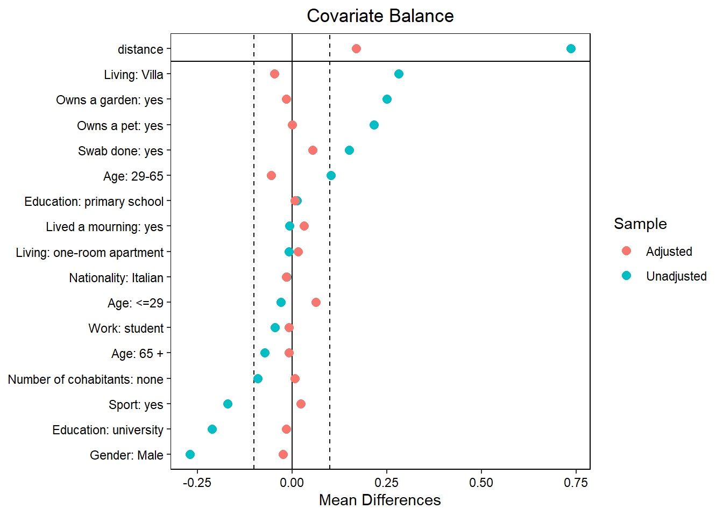
Figure S1. Mean difference in responders’ characteristics across study groups. The blue points represent the unadjusted differences; the red ones are the propensity adjusted difference. The +/-0.1 threshold indicating an acceptable balance has been reported.

PANEL (A)  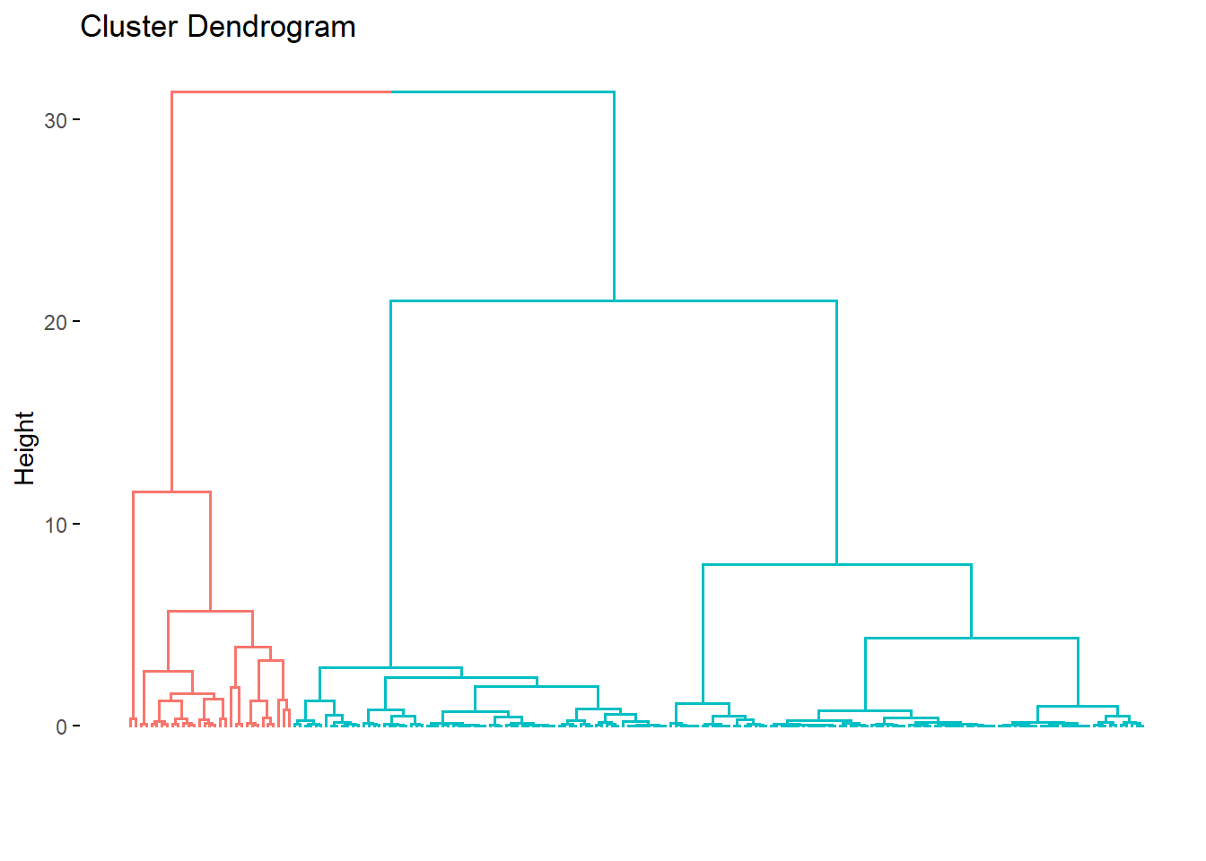 | PANEL (B)  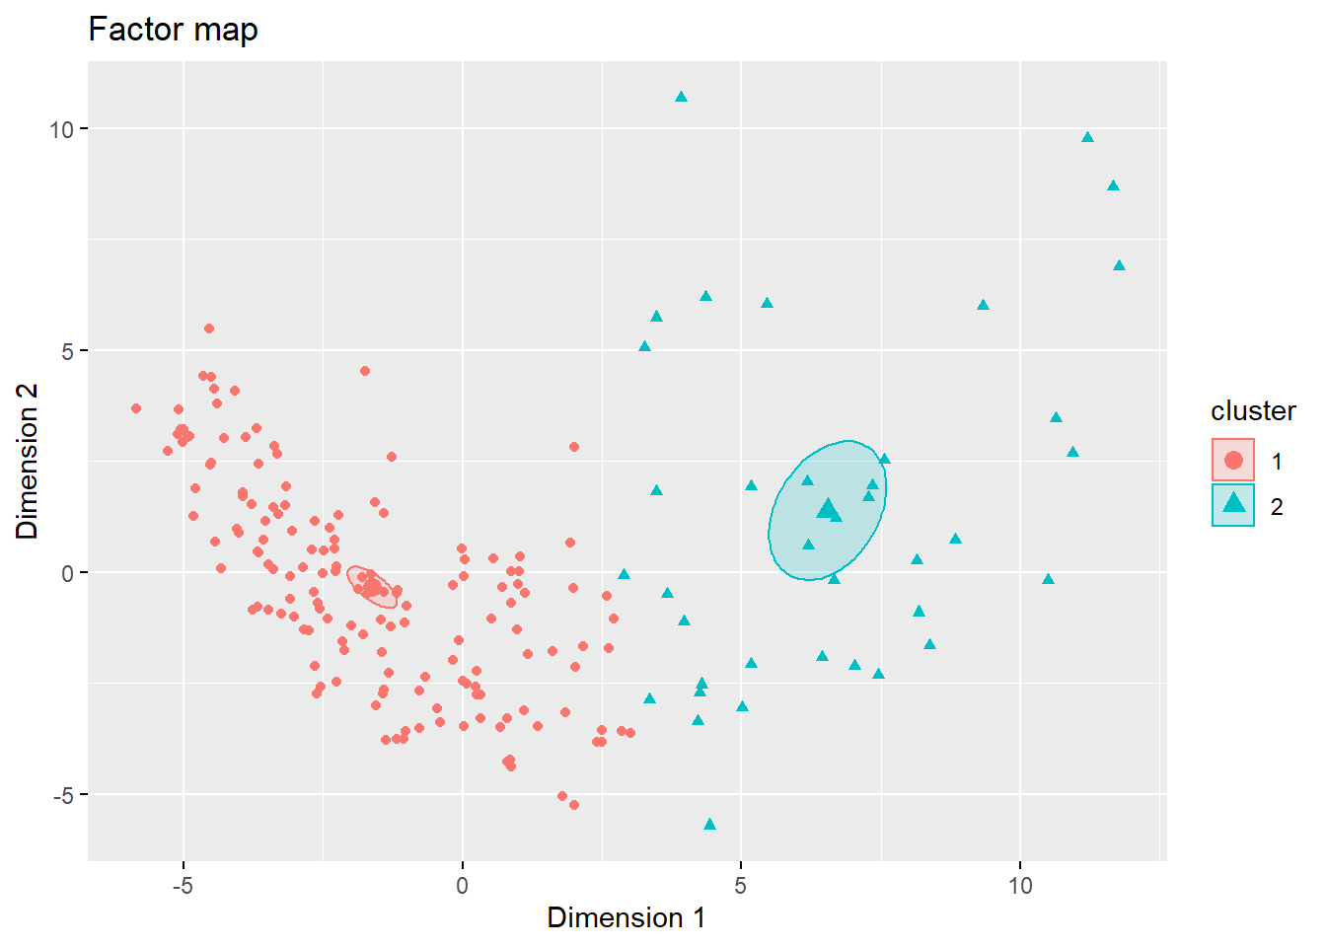

Figure S2. Cluster Analysis.
Cluster Dendrogram (Panel A). The height axis displays the distance (Euclidean) between observations and/or clusters. The horizontal bars indicate the point at which two clusters/observations are merged. The Ward clusters method has been considered with a Manhattan metric for distances
Factor Map (Panel B). Individual loadings are represented according to latent dimensions (Factors). The individual cluster membership is identified according to colors. The cluster centroids are represented together with the 96% confidence ellipses.

