Supplementary Information
A novel silicon platform for selective isolation, quantification, and molecular analysis of small extracellular vesicles
Antonio Alessio Leonardi^{1,2,3}, Rosalia Battaglia⁴, Dario Morganti^{1,2}, Maria Josè Lo Faro^{1,3}, Barbara Fazio², Chiara De Pascali⁵, Luca Francioso⁵, Gerardo Palazzo⁶, Antonia Mallardi⁷, Michele Purrello⁴, Francesco Priolo¹, Paolo Musumeci^{1,*}, Cinzia Di Pietro^{4,*}, Alessia Irrera^{2,*}
¹ Dipartimento di Fisica e Astronomia, Università di Catania, Via Santa Sofia 64, 95123 Catania, Italy;
² CNR-IPCF, Istituto per i Processi Chimico-Fisici, Viale F. Stagno D’Alcontres 37, 98158 Messina, Italy;
³ CNR-IMM UoS Catania, Istituto per la Microelettronica e Microsistemi, Via Santa Sofia 64, 95123 Catania, Italy;
⁴ Department of Biomedical and Biotechnological Sciences, University of Catania, Catania, Italy
⁵ CNR-IMM, Institute for Microelectronics and Microsystems, Via Monteroni, University Campus, 73100 Lecce (Italy)
⁶Chemistry Department, University of Bari ‘Aldo Moro’, via Orabona 4, 70125 Bari, Italy and CSGI, Center for Colloid and Surface Science c/o Chemistry Department, via Orabona 4, 70125 Bari, Italy.
⁷CNR-IPCF, Institute for Chemical-Physical Processes, c/o Chemistry Department, via Orabona 4, 70125 Bari, Italy

* Corresponding Authors: P.M. paolo.musumeci@ct.infn.it, C.D.P. dipietro@unict.it, A.I. alessia.irrera@cnr.it;

- Photolitography process
The manufacturing procedure, reported in Figure S1, was carried out at the National Research Council Institute for Microelectronics and Microsystems (CNR-IMM) in Lecce. The silicon wafers (n-type, ρ = 1-5 Ohm*cm, (100) orientation) were cleaned in acetone and 2-propanol ultrasonic bath for 15 minutes and then rinsed in deionised water, followed by hotplate de-hydration at 120°C for 600 seconds. A single layer of AZ 5214 reversal image (negative tone) photoresist (MicroChemicals GmbH, Germany) was dispensed on the silicon substrate and soft-baked at 110 °C for 50 seconds. The final thickness of AZ5214 layer was about 1.4 µm. The patterning of the photoresist was realized by 365 nm optical lithography process in hard contact mode with a Karl Suss MA6 tool. The photoresist layer was exposed with a 5” quartz mask with chromium square and circular patterns with different side dimensions between 100 and 400 µm diameter. However, in this activity the circular spot of 100 µm were used. After reversal image procedure completion (for AZ5214), the sample was dipped into AZ 326 developer to remove soluble photoresist areas. In order to completely remove photoresist residuals from silicon exposed surface and guarantee highly reproducible subsequent etching process, a final 5 seconds pray step with AZ326 developer was added to standard procedure. After the completion of the above steps, in order to increase the mask etching selectivity towards the HF bath for nanowires formation, a 10 minutes hard bake step at 150 °C for 10 minutes was performed onto hotplate.

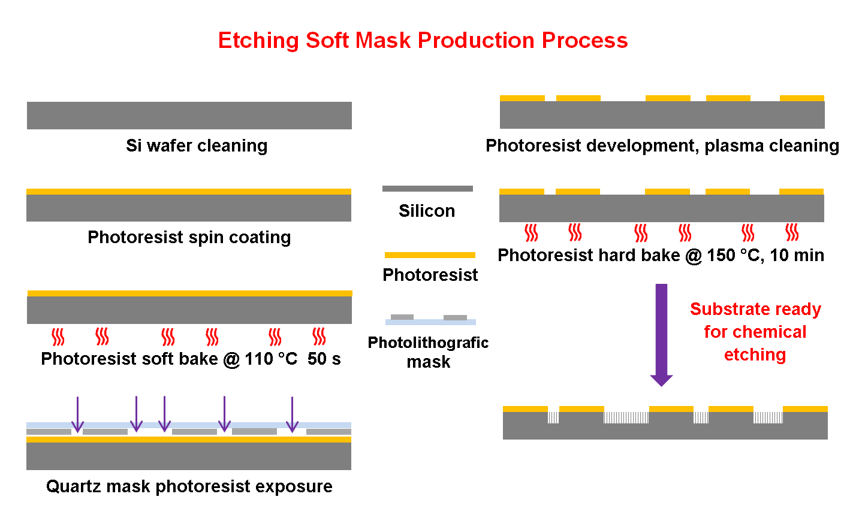
Figure S1: Photolitography flow chart for the Si cavities realization used to obtain the Si NWs cavities.

- Confocal Microscopy analysis and relative experimental procedure
  - Anti-CD81 antibody labeling with fluorescent dye
The Biotinylated anti-CD81 monoclonal antibody (speciﬁc for the CD81 binding) was purchased from LifeSpan BioSciences.
The Biotinylated anti-CD81 Antibody was labelled with the Alexa Fluor 647 dye using the Molecular Probes Protein Labeling Kit (A20173) but adapting the protocol to a very low amount of antibody. The resulting conjugate has absorption and fluorescence emission maxima of approximately 650 nm and 668 nm, respectively.
Briefly, 20 µg of anti-CD81 Antibody (solubilized in a volume of 20 µl) were mixed with 80 µl of PBS and 10 µl of 1 M Sodium bicarbonate. The Reactive Dye provided by the Labeling Kit was solubilized with 250 µl of PBS, then 5 µl of the obtained solution have been added to the Antibody solution in order to have the optimal Dye/Antibody ratio. The reaction mixture was left to react for 1 h at room temperature (20°C), in the dark. The unconjugated dye is removed from the dye-labeled protein following the Labeling Kit protocol, but using a smaller column (10 cm in height). During the run, two faint blue colored bands were observed, which represent the separation of labeled protein from unincorporated dye. The lower colored band, which contains the labeled antibody, was recovered in a total volume of 300 µl at a 25 µg/mL of concentration.

  - Exosome labelling with fluorescent lipid
Exosomes were labelled with the fluorescent lipid NBD-PE (1,2-dipalmitoyl-sn-glycero-3-phosphoethanolamine-N-(7-nitro-2-1,3-benzoxadiazol-4-yl), from Avanti Polar Lipids) which has absorption and fluorescence emission maxima of 460 nm and 535 nm, respectively. 1 mL of exosome solution was incubated for 60 min with 10 µg of NBD-PE solubilized in 10 µL of ethanol, in order to allow fluorescent lipid diffusion into the exosome membrane.

  - Biofunctionalization of NWs for confocal microscopy analysis
Before biofunctionalization, each Si NWs surface was washed in an isopropanol bath for 2 min and rinsed in HPLC water for 2 min, then dried with N2.
After preliminary washing, two NWs surfaces were separately incubated, overnight at room temperature (20°C), in an Alexa 488-labelled Streptavidin (SA) solution (200 µl at a 25 µg/mL, from Thermo Fisher). Each surface was then washed three times with PBS, one time with HPLC water (in order to remove the molecules not bound to the surface) and dried with N₂. One of them was observed through confocal microscopy in order to confirm the Alexa 488-SA adsorption on NWs.
The second surface has been incubated for 4 h in the solution of Biotinylated anti-CD81 antibody labelled with the Alexa Fluor 647 dye (300 µL at a 25 µg/mL concentration), thus allowing the binding of biotinylated antibody to Streptavidin. After washing steps with PBS and water, the obtained sensor was observed at confocal microscope and the binding of antibodies confirmed.
  - Confocal microscopy measurements

Streptavidin was labelled with the fluorophore Alexa-488.The corresponding micrograph, obtained by collecting the emission in the range 500 nm -586 nm upon excitation at 490 nm, is shown in Fig. 2f.
The biotinylated anti-CD81 antibody was then linked to the streptavidin coating the Si NWs through the strong biotin-streptavidin bond (Fig. 2c). The antibody was in this case labelled with the fluorophore Alexa-647, allowing its specific signals to be singled out. The corresponding micrograph, obtained by collecting the emission in the range 648 nm -800 nm, upon excitation at 640 nm, is shown in Fig. 2g.
The anti-CD81 antibody can selectively bind to the corresponding tetraspanin present on the small Extracellular vesicles (sEVs) surfaces, thus anchoring the extracellular vesicles to the silicon NWs as sketched in Fig. 2d. The anchoring of the sEVs can also be probed by Laser Scanning Confocal Microscopy. To this aim, the sEVs have been previously labelled with a phosphoethanolamine bearing the fluorophore NBD. Fig. 2h demonstrates that after the incubation of the sensor with the labelled sEVs, and notwithstanding extensive washing, a measurable fluorescence in the region 500 nm 586 nm appears upon excitation with 470 nm light due to the successful capture of the sEVs.
Both fully biofunctionalized NW surface and Alexa 488-SA functionalized surface (as negative control) have been separately incubated, overnight at room temperature, with 0.5 ml of fluorescent exosome solution. Afterward, they were washed in PBS to remove the unbound vesicles, rinsed with HPLC water and dried under N2. After washing steps, both surfaces were observed at confocal microscope.
In fig. S2 the spectra of all the labeled analytes are reported in their specific experimental condition used to obtain the single labeled biomolecule signal through the confocal measurements. In particular, in Fig. S2a the emission spectrum collected in the range 495 nm – 595 nm with a resolution of 3 nm demonstrates that the fluorescence is due to the physisorbed Alexa 488-labelled streptavidin. In fig. S2b the distinctive signal of the Alexa-647 fluorophore it is obtained. Indeed, in that spectral region neither the Si NWs, nor the Alexa 488-linked to streptavidin emit when excited at 640 nm. Furthermore, the emission spectra of Fig. S1b coincide with that of this fluorophore. Finally, the exosomes were previously labelled with a phosphoethanolamine bearing the fluorophore NBD. Although NBD and Alexa 488 share a large region of the emission spectra, the maxima in absorbance are very different and, under the instrumental condition used, the emission of Alexa-488 upon excitation at 470 nm is almost negligible. In fig. 2c is reported the PL signal obtained for the NBD labeled exosomes. As is it possible to observe, the emission spectra coincides with that of NBD.

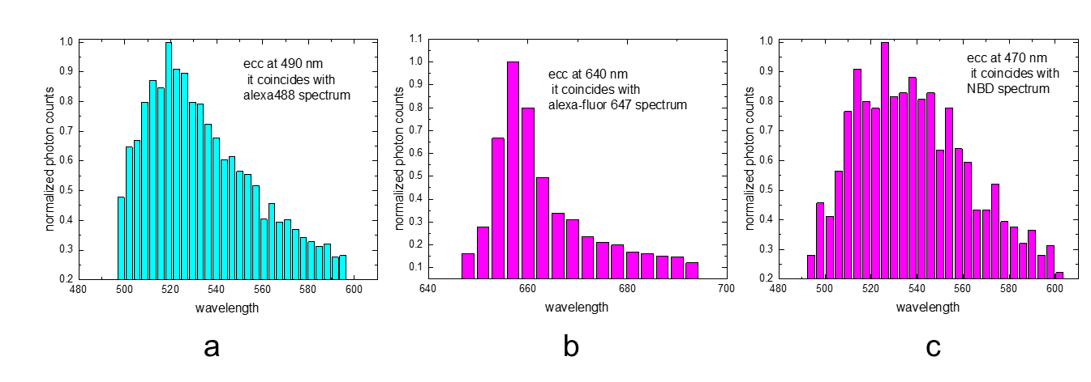
Figure S2: a) Emission spectra of the layer in Fig. 2f collected by LSCM upon excitation at 490 nm and collecting the emission from 495 nm to 595 nm with steps of 3 nm. The spectrum coincides with the emission spectrum of Alexa 488. b)Emission spectra of the layer in Fig. 2g collected by LSCM upon excitation at 640 nm and collecting the emission from 648 nm to 693 nm with steps of 3 nm. The spectrum coincides with the emission spectrum of Alexa 647.c) Emission spectra of the layer in Fig. 2h collected by LSCM upon excitation at 470 nm and collecting the emission from 490 nm to 602 nm with steps of 4 nm. The spectrum coincides with the emission spectrum of NBD [N-(7-nitro-2-1,3-benzoxadiazol-4-yl).
- Hill’s binding model

The Hill’s binding model is represented by the following equation:
$$y=V_{max}\frac{x^{n}}{K_{D}^{n}+x^{n}} (1)$$
Where y represents the Si NWs sensor response, x is the exosome/mL concentration, K_{D} is the dissociation constant, n is the hill coefficient representing the cooperativity degree, and V_{max} is the saturation plateau at the highest concentration reached by the platform. In particular, we obtain a degree of saturation V_{max} equal to 0.85±0.03, and a hill coefficient n of 0.47±0.09 that implies an anti-cooperative binding, and a dissociation constant K_{D} of 3.98* 10⁷ ± 1.17 *10⁷. The fitting of the data produced a r² of 0.989 demonstrating a satisfying representation of the Si NWs sensor dose response trend.
The Limit of Detection (LOD) was calculated considering the concentration that correspond at 2 times the average error on the PL response with respect to the minimum asymptotic value of the Hill’s binding curve
- Exosome detaching and sample preparation for SEM analysis
Small EVs from BF captured on Si NWs were detached with a method described in the Materials section. sEVs were fixed in 100 µl of 2.5 % glutaraldehyde in 0.1 M phosphate buffer overnight at 4°C. Drops of suspension were then layered onto a sterile cover glass coated with 0.1% poly-L-Lysine, postfixed in 1% osmium tetroxide (Merck, Darmstadt, Germany) in the same buffer for 30 min at room temperature and washed in phosphate buffer. After dehydrating in graded ethanol and critical point drying, a 5 nm conductive gold layer was deposited using an Emscope SM 300 (Emscope Laboratories, Ashford, UK) to increase electron scattering and quality images. Samples mounted on silicon holders with a both sided glue carbon tab were placed in the vacuum chamber of a SUPRA 25 ZEISS microscope and observed at a working distance of 3-5 mm. The SEM was operated at low accelerating voltage conditions of 2kV using an in-lens detector.
All the SEM micrographs were then analyzed by ImageJ software for image processing to measure the EV diameter statistics(https://imagej.nih.gov/ij/index.html).
RT-PCR analysis
In order to verify if laser treatment for quantification or different storage protocols could interfere with RT-PCR protocol, we performed miR-212 amplification according to the following scheme.
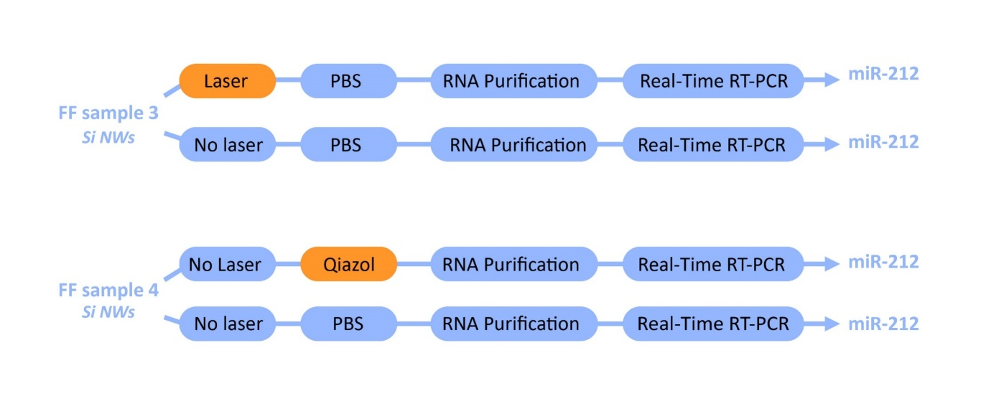
Figure S3: Schematic representation of the protocols used to verify the influence of laser treatments and storage solutions on miRNA amplification.

The results, shown in figure 4, demonstrated no difference in miRNA expression calculated as 2^{-Ct}.
In order to verify if the isolation by Si NWs induce physical degradation of RNA molecules we performed RT-PCR Real-Time amplifying miR-132 and miR-212 (short RNA molecules) and the long non-coding RNA MALAT1 in scalar dilutions of the same sample, according to the following schemes.

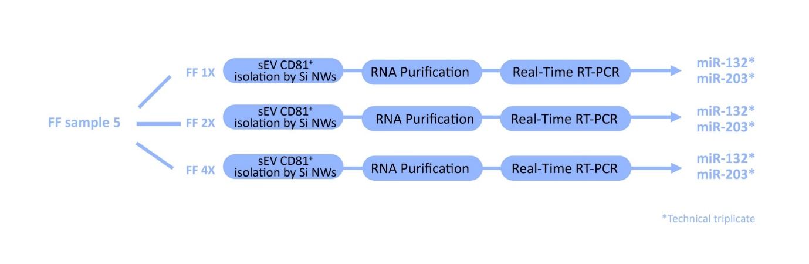
Figure S4: Schematic representation of the experiments performed in order to demonstrate that the EVs isolation by Si NWs sensor do not produce RNA degradation and can allow a quantitative analysis on miRNAs
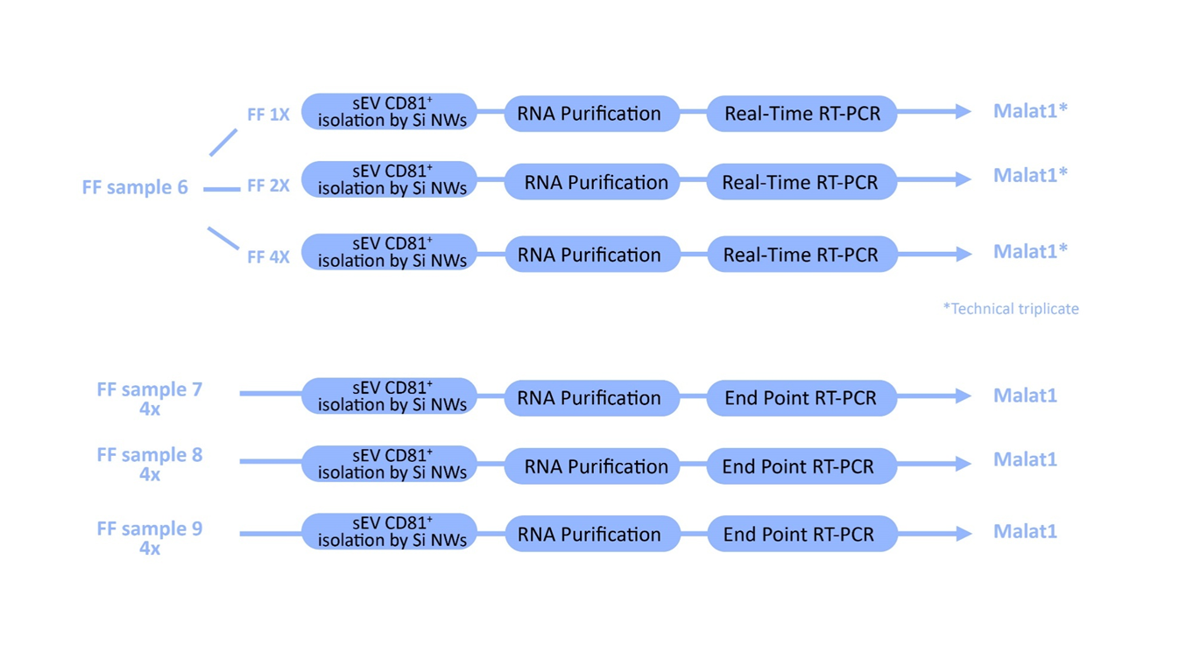Figure S5: Schematic representation of the experiments performed in order to demonstrate that the EVs isolation by Si NWs sensor do not produce RNA degradation and can allow a quantitative analysis on lncRNAs.

The primer pair used for MALAT1 amplification is reported in the following table.
MALAT1 forward | 5’TAGCTTGGATCCTTGTGGGC3’
MALAT1 reverse | 5’AACCCACCAAAGACCTCGAC3’
A significant linear relationship between RNA inputs (from 1x, 2x and 4x EV preparations) and Ct values with (r) ranging between 0.9596 and 0.9868 (P-value <0.0001) for miR-132 and miR-203 and (r) 0.864 (P-value 0.0027) for MALAT1, was observed (Figure 6 and 7).

