Supplementary materials
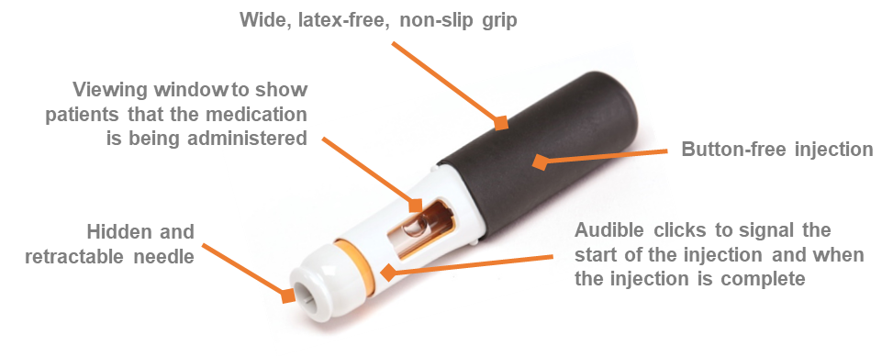
Figure S1 Key features of the certolizumab pegol pre-filled pen.
Note: Adapted by permission from Springer Nature: Adv Ther. Bailey K, Mountian I, Bruggraber R, Sunderland K, Tilt N, Szegvari B. Patient Satisfaction with CIMZIA® (Certolizumab Pegol) AutoClicks® in the UK. 2020;37(4):1522–1535.⁶

Figure S2 HCP perception of training materials.
Notes: “From your observations, please rate this patient’s understanding of the training material?”; “After reviewing the training material, will the patient be confident enough to self-administer their medication using the [CZP PFP] device?”.
Abbreviations: CZP PFP, certolizumab pegol pre-filled pen; HCP, healthcare professional.
- Biologic-naïve patients (n=37)

- Biologic-experienced patients (n=33)

Figure S3 Patients’ confidence about self-injection, stratified by (A) biologic-naïve patients, and (B) patients with previous biologic experience.
Notes: “How confident do you feel about giving yourself the correct dose with a self-injecting pre-filled pen?”; “How confident do you feel about giving yourself an injection in a clean and sterile way?”; “How confident do you feel about giving yourself an injection safely?”; “How confident do you feel about giving yourself an injection in the right way?”; “How confident do you feel about starting a treatment for your rheumatoid arthritis/psoriatic arthritis/ankylosing spondylitis that requires you to inject medication with a self-injecting pre-filled pen?”.

Figure S4 Data from post-injection HCP surveys at Week 4.
Abbreviations: CZP PFP, certolizumab pegol pre-filled pen; HCP, healthcare professional.
Table S1 Question items included in patient surveys, excluding screening questions and open-ended questions.
Question | Response options (one response per question)
Pre-injection survey (A) at Week 0
- Was the information in the step-by-step training guide easy or difficult to understand? | Very easy to understand | Quite easy to understand | Neither easy nor difficult to understand | Quite difficult to understand | Very difficult to understand
- Was there enough information in the step-by-step training guide to teach you how to self-inject using the Cimzia AutoClicks device? | Yes, ALL the information I needed was there. | Yes, MOST of the information I needed was there | SOME of the information I needed was there | No, HARDLY ANY of the information I needed was there | No, NONE of the information I needed was there
- Was the information in the training video easy or difficult to understand? | Very easy to understand | Quite easy to understand | Neither easy nor difficult to understand | Quite difficult to understand | Very difficult to understand
- Is there enough information in the training video to teach you how to self-inject using the Cimzia AutoClicks device? | Yes, ALL the information I needed was there. | Yes, MOST of the information I needed was there | SOME of the information I needed was there | No, HARDLY ANY of the information I needed was there | No, NONE of the information I needed was there
- In general, how do you feel about needles? | They don’t bother me at all | They make me slightly anxious | They make me quite anxious | They make me very anxious | They make me really frightened
- In general, how do you feel about having an injection? | They don’t bother me at all | They make me slightly anxious | They make me quite anxious | They make me very anxious | They make me really frightened
- And how do you feel about giving yourself an injection? | It doesn't bother me at all | It makes me slightly anxious | It makes me quite anxious | It makes me very anxious | It makes me really frightened
- How confident do you feel about giving yourself an injection in the right way? | Very confident | Quite confident | Neither | Quite hesitant | Very hesitant
- How confident do you feel about giving yourself an injection in a clean and sterile way? | Very confident | Quite confident | Neither | Quite hesitant | Very hesitant
- How confident do you feel about giving yourself an injection safely? | Very confident | Quite confident | Neither | Quite hesitant | Very hesitant
- How confident do you feel about giving yourself the correct dose with a self-injecting pre-filled pen? | Very confident | Quite confident | Neither | Quite hesitant | Very hesitant
- How confident do you feel about starting a treatment for your rheumatoid arthritis/psoriatic arthritis/ankylosing spondylitis that requires you to inject medication with a self-injecting pre-filled pen? | Very confident | Quite confident | Neither | Quite hesitant | Very hesitant
- How would you feel if someone saw you with a self-injecting pre-filled pen? | It wouldn't bother me at all | It would only bother me slightly | I would feel a little embarrassed | I would feel quite embarrassed | I would feel very embarrassed
- Overall, how satisfied were you with the way you administered your previous medication? | Very dissatisfied | Dissatisfied | Neither dissatisfied nor satisfied | Satisfied | Very satisfied
- How convenient or inconvenient was the way you administered your previous medication? | Very inconvenient | Inconvenient | Neither convenient or inconvenient | Convenient | Very convenient
Post-injection survey (B) at Week 0
- How difficult or easy was it to administer the injection without any help? | Very difficult | Quite difficult | Neither easy nor difficult | Quite easy | Very easy
- How difficult or easy was it to use the Cimzia AutoClicks device? | Very difficult | Quite difficult | Neither easy nor difficult | Quite easy | Very easy
- Overall, how satisfied or dissatisfied are you with your first experience using the Cimzia AutoClicks device? | Very dissatisfied | Dissatisfied | Neither dissatisfied nor satisfied | Satisfied | Very satisfied
- After giving yourself an injection using the Cimzia AutoClicks device, how do you feel about giving yourself another injection with this self-injecting pre-filled pen? | It doesn't bother me at all | It makes me slightly uneasy | It makes me quite uneasy | It makes me very uneasy | -
- If you did not give yourself the first injection using the Cimzia AutoClicks device, once you had seen the nurse/doctor administer the injection how did you feel about giving yourself the next injection? | Very confident | Quite confident | Neither | Quite hesitant | Very hesitant
Post-injection survey (C) at Weeks 2 and 4
- How sure are you that you have given yourself the full dose of the injection? | Very sure | Quite sure | Neither sure nor unsure | Quite unsure | Very unsure
- How satisfied are you with the time it takes to inject the medication? | Very dissatisfied | Dissatisfied | Neither dissatisfied nor satisfied | Satisfied | Very satisfied
- How difficult or easy was it to administer the injection without any help? | Very difficult | Quite difficult | Neither easy nor difficult | Quite easy | Very easy
- Overall how convenient or inconvenient did you find the Cimzia AutoClicks device? | Very inconvenient | Inconvenient | Neither convenient or inconvenient | Convenient | Very convenient
- How confident do you feel about continuing to give yourself the injections at home with the Cimzia AutoClicks device? | Very confident | Quite confident | Neither | Quite hesitant | Very hesitant
Note: Adapted from Keininger D, Coteur G. Assessment of self-injection experience in patients with rheumatoid arthritis: psychometric validation of the Self-Injection Assessment Questionnaire (SIAQ). Health Qual Life Outcomes. 2011;9(1):2.⁹

Table S2 Question items included in HCP surveys, excluding screening questions and open-ended questions.
Question | Response options (one response per question)
Pre-injection survey (I) at Week 0
- From your observations, please rate this patient’s understanding of the training material? | Very good understanding of the material | Good understanding of the material | Acceptable understanding of the material | Poor understanding of the material | Very poor understanding of the material
- Did the patient have any questions after reviewing the training material that required further training to be provided by a clinical staff member (physician or nurse)? | Yes | No
- After reviewing the training material, will the patient be confident enough to self-administer their medication using the Cimzia AutoClicks device? | Very confident – can self-administer | Quite confident – can self-administer | Neither | Quite hesitant – reluctant to self-administer | Very hesitant – did not want to self-administer
Post-injection survey (II) at Week 0
- Can the patient competently self-inject with Cimzia AutoClicks? | Yes | No
- Was the patient confident to administer the next injection themselves without assistance from clinical staff (physician and/or nurse)? | Very confident – can self-administer | Quite confident – can self-administer | Neither | Quite hesitant – reluctant to self-administer | Very hesitant – does not want to self-administer
Post-injection survey (III) at Week 2
- Can the patient competently self-inject with Cimzia AutoClicks? | Yes | No
- Was the patient confident to administer the next injection themselves without assistance from clinical staff (physician and/or nurse)? | Very confident – can self-administer | Quite confident – can self-administer | Neither | Quite hesitant – reluctant to self-administer | Very hesitant – does not want to self-administer
Post-injection survey (IV) at Week 4
- Can the patient competently self-inject with Cimzia AutoClicks? | Yes | No
- In your opinion did the patient have an overall positive experience with the use of Cimzia AutoClicks? | Yes | No
- In your opinion are you confident in the patient’s ability to continue to use Cimzia AutoClicks? | Yes | No
Note: Adapted from Keininger D, Coteur G. Assessment of self-injection experience in patients with rheumatoid arthritis: psychometric validation of the Self-Injection Assessment Questionnaire (SIAQ). Health Qual Life Outcomes. 2011;9(1):2.⁹
Abbreviation: HCP, healthcare professional.

