Supplemental Table 1. Relationships between parameters obtained by dynamic ventilatory DR and pulmonary function testing from study participants (N = 273)
S_In Td rTN rt Dm lt Dm Rs
r p r p r p r p r p r p
VC (%pred.) 0.50 <0.05 0.08 0.18 0.12 <0.05 0.23 <0.05 0.23 <0.05 -0.09 0.15
VC (L) 0.50 <0.05 0.08 0.17 0.08 0.19 0.13 <0.05 0.20 <0.05 0.02 0.72
FVC (% pred.) 0.50 <0.05 0.08 0.16 0.13 <0.05 0.23 <0.05 0.23 <0.05 -0.09 0.15
FVC (L) 0.50 <0.05 0.09 0.12 0.09 0.14 0.12 <0.05 0.19 <0.05 -0.02 0.73
FEV₁ (% pred.) 0.20 <0.05 -0.02 0.72 -0.02 0.68 0.11 0.07 0.11 0.07 -0.09 0.12
FEV₁ (L) 0.30 <0.05 -0.03 0.95 -0.04 0.47 0.05 0.44 0.07 0.23 -0.01 0.84
FEV₁/FVC ratio -0.35 <0.05 -0.21 <0.05 -0.29 <0.05 -0.14 <0.05 -0.20 <0.05 0.01 0.82
MMEF (% pred.) -0.19 <0.05 -0.18 <0.05 -0.24 <0.05 -0.09 0.15 -0.11 0.07 -0.02 0.71
MMEF (L/s) 0.14 <0.05 -0.17 <0.05 -0.25 <0.05 -0.1 0.11 -0.11 0.06 0.03 0.96
FRC (% pred.) 0.47 <0.05 0.08 0.18 0.15 <0.05 0.15 <0.05 0.16 <0.05 -0.03 0.95
FRC (L) 0.51 <0.05 0.13 <0.05 0.14 <0.05 0.03 0.11 0.10 0.09 0.08 0.17
RV (% pred.) 0.36 <0.05 0.11 <0.05 0.17 <0.05 0.11 0.08 0.12 <0.05 0.01 0.89
RV (L) 0.40 <0.05 0.16 <0.05 0.19 <0.05 0.03 0.59 0.12 <0.05 0.05 0.38
TLC (% pred.) 0.46 <0.05 0.10 0.10 0.18 <0.05 0.23 <0.05 0.24 <0.05 -0.08 0.17
TLC (L) 0.51 <0.05 0.12 <0.05 0.13 <0.05 0.18 <0.05 0.19 <0.05 -0.01 0.97
RV/TLC ratio -0.02 0.77 0.10 0.12 0.13 <0.05 -0.06 0.36 -0.04 0.45 0.06 0.31
Correlations between parameters were assessed using Spearman’s rank correlation coefficient.
S_In: lung area at point of maximum inspiration, Td: change in tracheal diameter due to respiratory motions, rTN: rate of tracheal narrowing,
Dm: diaphragmatic motion, DR: digital radiography, Rs: rate of change in lung area due to respiratory motions

Supplemental Table 2. Parameters obtained dynamic ventilatory DR in subjects with ventilatory disorder
Ventilatory pattern group: Control Obstructive disorder Restrictive disorder
Mild AL Moderate AL Severe AL Moderate RD Severe RD
Number 104 108 25 6 14 16
Lung area_in/height (×10⁻² m²/m) 233.34 251.79 239.64 274.97* 183.63* 179.44*
Lung area_in/height/BMI 10.44 10.85 11.12 14.49* 7.34* 7.88*
Tracheal diameter change (mm) 3.71 4.04* 4.28* 6.55* 3.13 3.62
Tracheal diameter change/BMI 0.16 0.17* 0.19* 0.37* 0.13 0.15
Tracheal narrowing rate (%) 20.35 23.87* 25.66* 37.08* 17.45 17.16
Tracheal narrowing rate/BMI 0.90 1.08* 1.16* 1.83* 0.72 0.86
Right diaphragmatic motion (mm) 45.45 45.66 42.95 33.78* 36.27* 32.31*
Right diaphragmatic motion/BMI 0.19 0.19 0.17 0.15 0.13* 0.16*
Left diaphragmatic motion (mm) 48.78 49.62 49.20 36.07* 31.90* 30.85*
Left diaphragmatic motion/BMI 0.21 0.21 0.19 0.19 0.13* 0.14*
Lung area change rate -0.32 -0.30 -0.27 -0.19* -0.25 -0.19*
Lung area chabge rate/BMI -0.013 -0.013 -0.011 -0.009* -0.010* -0.010*
The data are presented as median. *P < 0.05 compared to control by Mann–Whitney U-test.

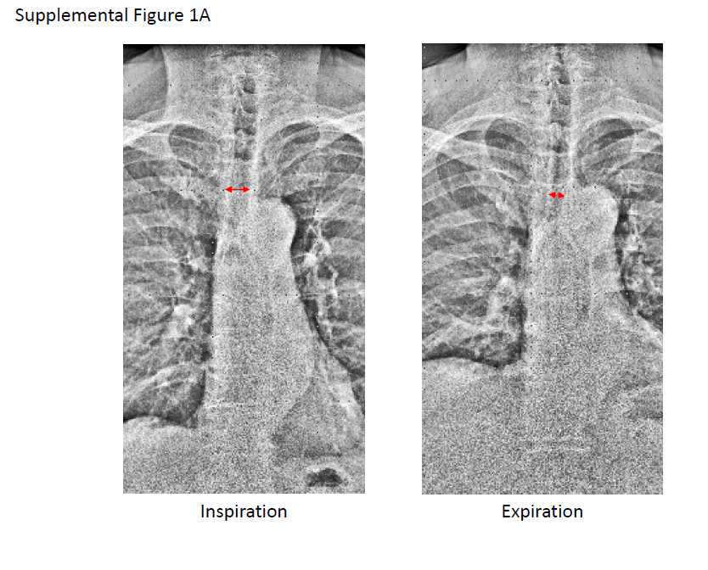
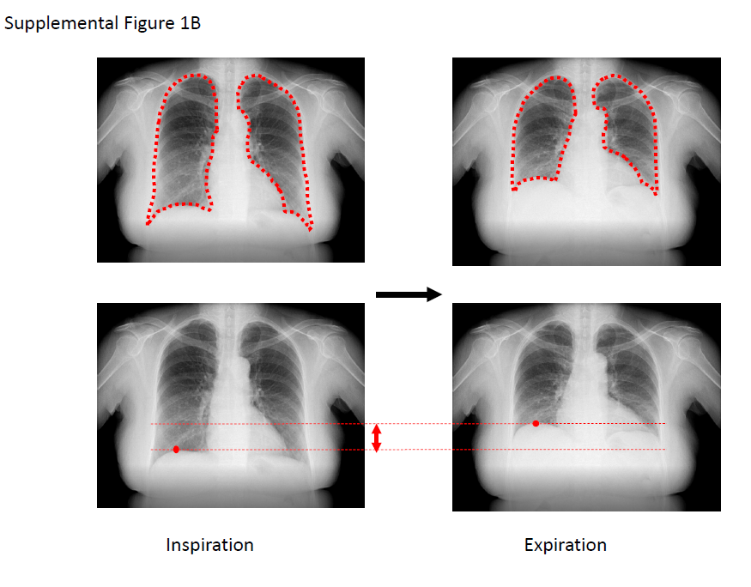
Supplemental figure 1. Representative examples of measurements
- The red arrows indicate the measured lateral diameter of the trachea. Changes in tracheal diameters were monitored through slow breathing to maximal inspiration and expiration by dynamic DR. Tracheal diameter change was measured on the images with improved visibility of lung structures by enhancing high spatial-frequency components.
- The areas surrounded by the red dotted line indicate the area of lung that is measured. The red dot indicates the highest point of the right diaphragm at maximal expiration. The red arrows indicate the measured motion of the diaphragm. Motions of the diaphragm and changes in lung area were monitored through slow breathing to maximum inspiration and expiration by dynamic DR.

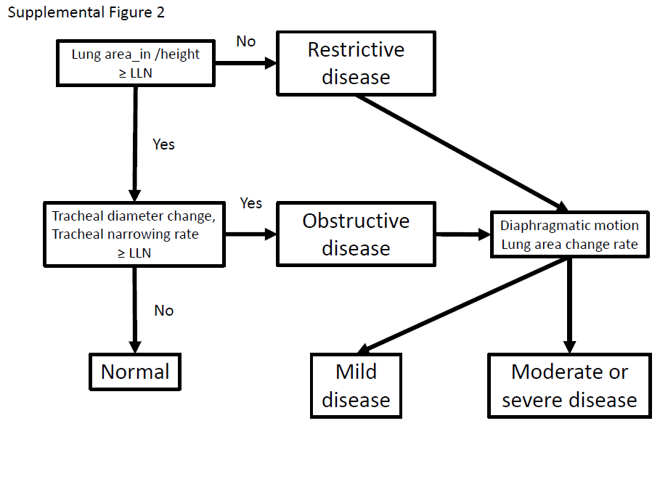
Supplemental figure 2.
A proposed diagnostic algorithm for ventilatory disorders based on this study
LLN: lower limit of normal

