Supplementary materials
Table S1 Serum metabolites identified with characteristic peaks.
No. | Metabolites | Characteristic peak. δ_{H} (ppm)
1 | L-Isoleucine | 0.99 (d, J=7.20 Hz)
2 | L-Valine | 1.05 (d, J=7.20 Hz)
3 | Propylene glycol | 1.13 (d, 6.6 Hz)
4 | Ketoisocaproic acid | 1.33 (d, 6.6 Hz)
5 | Alanine | 1.48 (d, 7.2 Hz)
6 | Ornithine | 1.92 (s)
7 | Glutamine | 2.14 (m), 2.45 (m)
8 | Pyruvate | 2.33 (s)
9 | Succinic acid | 2.39 (s)
10 | Dimethylamine | 2.52 (s)
11 | Citric acid | 2.54 (d, 15.0 Hz)
12 | Trimethylamine | 2.89 (s)
13 | Dimethulglycine | 2.93 (s)
14 | Creatine | 3.02 (s), 3.94 (s)
15 | Creatinine | 3.03 (s)
16 | L-Carnitine | 3.23 (s)
17 | Betaine | 3.27 (s)
18 | Glycine | 3.57 (s)
19 | Leucine | 3.72 (s)
20 | Lysine | 3.74 (t, 12.5 Hz)
21 | Glycerol | 3.78 (m)
22 | Phenylalanine | 3.98 (m)
23 | Lactate | 4.12 (m)
24 | Glucose | 4.66 (d, 8.4 Hz)
25 | Tyrosine | 6.91 (d, 8.4 Hz), 7.20(d, 8.4 Hz)
26 | Xanthine | 7.89 (s)
27 | Formic acid | 8.46 (s)

Table S2 Trends of the biomarker metabolites in CTX-induced rats and HC-induced rats.
Model | Metabolites | Trends between control and drug group | Trends between drug and drug-A4 group
CTX model | Lactate | ↓ | ↑
CTX model | Creatine | ↑ | ↓
CTX model | Glycerol | ↑ | ↓
CTX model | Lysine | ↓ | ↑
CTX model | Glycine | ↓ | ↑
CTX model | Ketoisocaproic acid | ↓ | ↑
HC model | Lactate | ↓ | ↑
HC model | Glucose | ↑ | ↓
HC model | Ketoisocaproic acid | ↓ | ↑

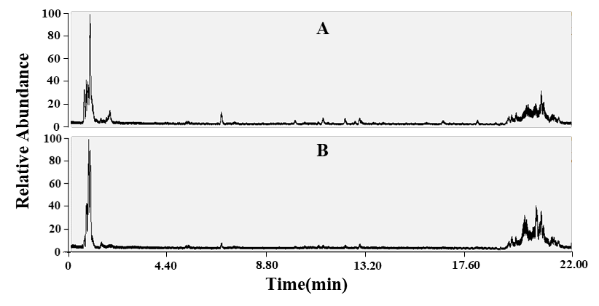
Figure S1 Total ion chromatography of (A) Astragalus and (B) A4.

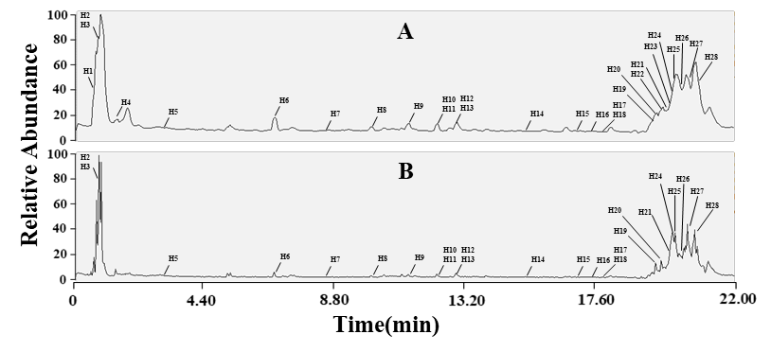
Figure S2 Base peak chromatography of (A) Astragalus and (B) A4.

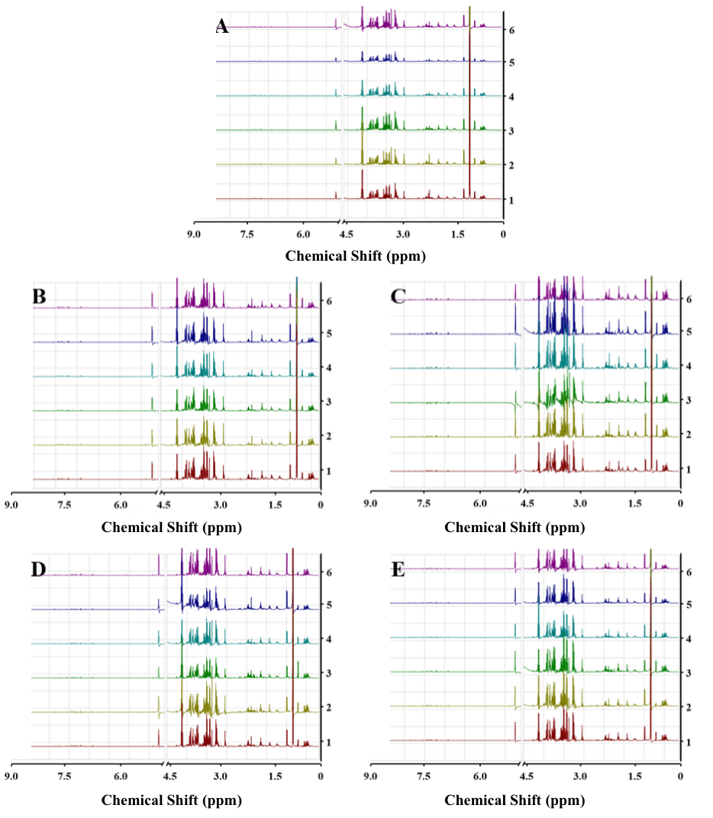

Figure S3 ¹H NMR spectrometry of serum metabolites. (A) Control group, (B) CTX group, (C) CTX-A4 group, (D) HC group, (E) HC-A4 group.

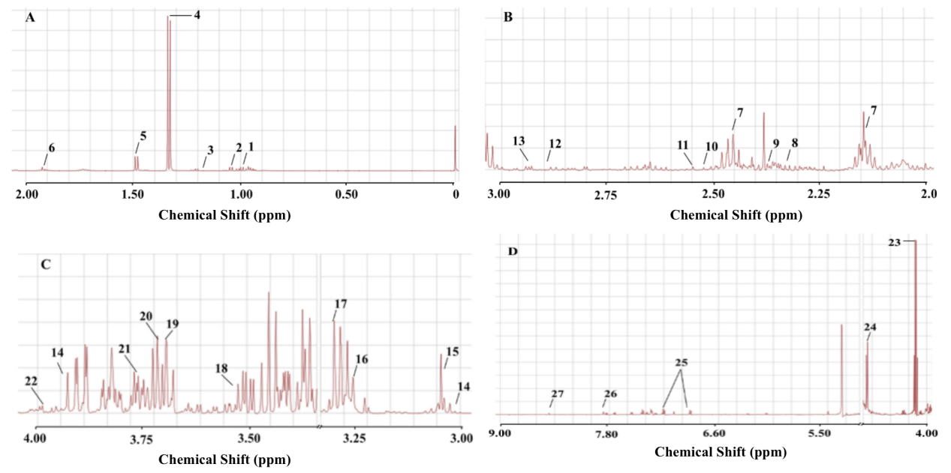
Figure S4 Identification of serum metabolites according to ¹H NMR spectrometry. (A) Control group, (B) CTX group, (C) CTX-A4 group, (D) HC group, (E) HC-A4 group.

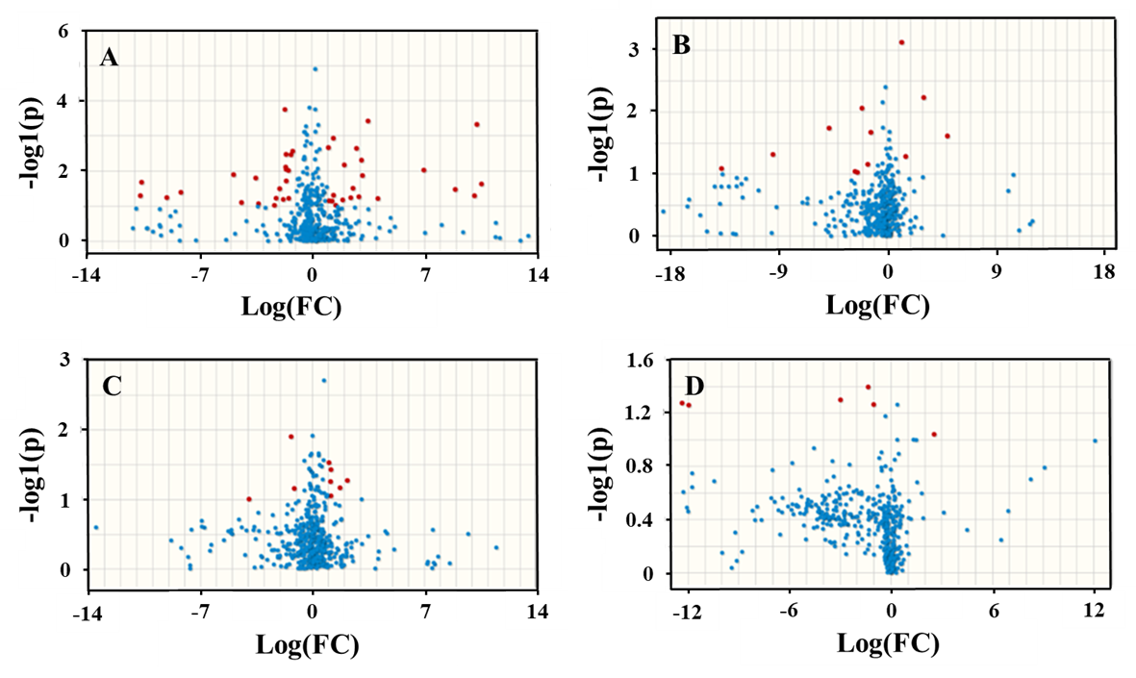
Figure S5 Volcanic map of the biomarker metabolites.
(A) Control vs CTX groups, (B) CTX vs CTX-A4 groups, (C) Control vs HC groups, and D) HC vs HC-A4 groups.

Figure S6 Heat map of the differential abundance of metabolites. The degree of color saturation indicates the metabolite expression value with blue representing the lowest expression and red representing the highest expression. (A) Control vs CTX groups, (B) CTX vs CTX-A4 groups, (C) Control vs HC groups, and D) HC vs HC-A4 groups.

Figure S7 Bubble diagram of VIP scores of different metabolites and their trends. (A) Control vs CTX groups, (B) CTX vs CTX-A4 groups, (C) Control vs HC groups, and D) HC vs HC-A4 groups.

