Supplementary figure 1. Stacked bar chart showing the distribution of scores (from 1-5 where 1 is red, 2 is pink, 3 is white, 4 is light blue and 5 is blue) for each of the 14 parameters evaluated.
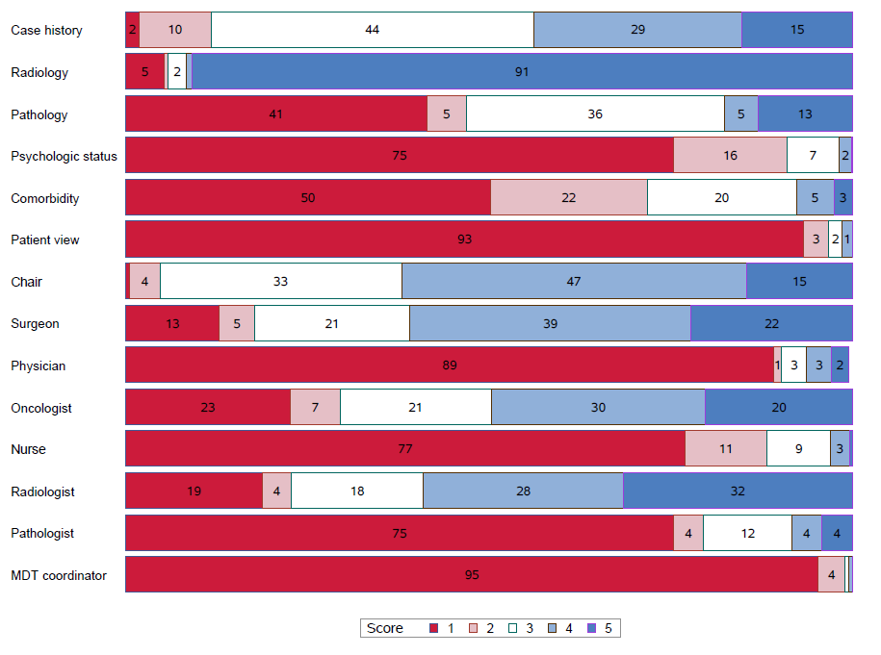

Supplementary table 1. Inter-class correlation, kappa value and mean differences.
 |  |  | Inter-class |  | Kappa | Mean
 |  |  | correlation |  | value | difference
 |  |  | (95% CI) |  | (95% CI)
Quality of information in case presentation
 | Patient history |  | 0.00 (-) |  | 0.07 (-0.02-0.16) | -0.82 (-0.02--0.62)
 | Radiology |  | 0.17 (-0.02-0.35) |  | 0.14 (-0.11-0.39) | -0.12 (-0.36-0.12)
 | Pathology |  | 0.48 (0.32-0.61) |  | 0.36 (0.24-0.47) | 0.94 (0.70-1.19)
 | Psychosocial |  | 0.40 (0.23-0.55) |  | 0.39 (0.23-0.55) | -0.03 (-0.18-0.13)
 | Comorbidity |  | 0.37 (0.19-0.52) |  | 0.30 (0.17-0.43) | 0.13 (-0.10-0.35)
 | Patient views |  | 0.27 0.08-0.44) |  | 0.20 (0.04-0.37) | 0.17 (0.06-0.28)
Quality of contribution to case discussions
 | Chair |  | 0.16 (0.03-0.34) |  | 0.14 (0.02-0.26) | -0.33 (-0.53--0.13)
 | Surgeon |  | 0.80 (0.72–0.86) |  | 0.64 (0.54-0.74) | -0.08 (-0.27-0.11)
 | Oncologist |  | 0.61 (0.47-0.72) |  | 0.52 (0.39-0.65) | -0.25 (-0.50-0)
 | Nurse |  | 0.73 (0.63-0.81) |  | 0.64 (0.52-0.76) | 0.09 (-0.03-0.21)
 | Radiologist |  | 0.27 (0.08-0.44) |  | 0.28 (0.15-0.40) | 0.79 (0.49-1.08)
 | Pathologist |  | 0.52 (0.37-0.65) |  | 0.47 (0.32-0.62) | 0.49 (0.25-0.73)
Supplementary table 2. Summary of studies that have applied the MDT-MODe instrument to MDTs in cancer care.
Reference |  | Country |  | Diagnoses observed |  |  | Cases (n) | Meetings (n) | Observers (n) | Focus and conclusion
Jalil et al. 2014¹⁵ |  | United Kingdom |  | Urological cancer |  |  | 683 | 23 | 2 | Higher scores for cases where treatment decisions were reached.
Seretis et al. 2014¹⁶ |  | United Kingdom |  | Colorectal cancer |  |  | 64 | 4 | 1 | Limited information on patient-related factors.
Shah et al. 2014²² |  | United Kingdom |  | Colorectal cancer |  |  | 267 | 11 | 2 | Case history and radiologic information rated highest. Limited information on patient-related factors.
Soukup et al. 2016¹⁷ |  | United Kingdom |  | Breast cancer, colorectal cancer, lung cancer, urologic cancer |  |  | 1045 | 40 | 4 | Psychosocial information and input from surgeons, radiologists, pathologists and oncologists positive predictors decision-making. Information on comorbidity and from nursies had negative impact
Hahlweg et al. 2017¹⁸ |  | Germany |  | Dermatological, gastrointestinal, gynecological, head and neck cancer, liver and biliary tract, lymphoma and myeloma, neuro-oncological, non-entity-specific oncological, non-entity-specific surgical, thorax, and uro-oncological MDTs |  |  | 249 | 29 | 2 | Limited information on patient-related factors. Variability between specialists and teams.
Gandamihardja et al. 2018²⁰ |  | United Kingdom |  | Breast cancer |  |  | 346 | 10 | 3 | Limited information on patient-related factors. Case discussions biomedically focused.
Soukup et al., 2019³⁵ |  | United Kingdom |  | Breast cancer |  |  | 1335 | 30 | 1 | Quality of discussion lower in second half of the meeting
Lumenta et al. 2019¹⁹ |  | Austria |  | Not specified |  |  | 244 | 27 | 3 | Favorable agreement in team discussions.
Rosell et al. 2019²³ |  | Sweden |  | Penile cancer, anal cancer, vulvar cancer |  |  | 134 | 9 | 4 | Case history, leadership and teamwork rated high. Limited information on patient-related factors.
 |  |  |  |  |  |  |  |  |  | Low involvement of care professionals.
Scott et al. 2020²¹ |  | United Kingdom |  | Ovarian cancer |  |  | 223 | 4 | 1 | Decision-making process driven by patient history, tumor markers and radiology.
 |  |  |  |  |  |  |  |  |  | Limited information on patient-related factors.
Wihl et al., current study |  | Sweden |  | Neuro-oncology, hepatobiliary cancer, soft tissue sarcoma |  |  | 349 | 32 | 3 | Limited information on patient-related factors. Clinical correlations.

