Supplementary materials
Figure S1: Fascia iliaca block before (to the left) and after (to the right) LA anesthetic injection. The arrows indicate the needle, the blue line indicate the facia iliaca and the shaded blue area is the LA injectate. ASIS: anterior superior iliac spine, IOM: internal oblique muscle, SM: sartorius muscle.

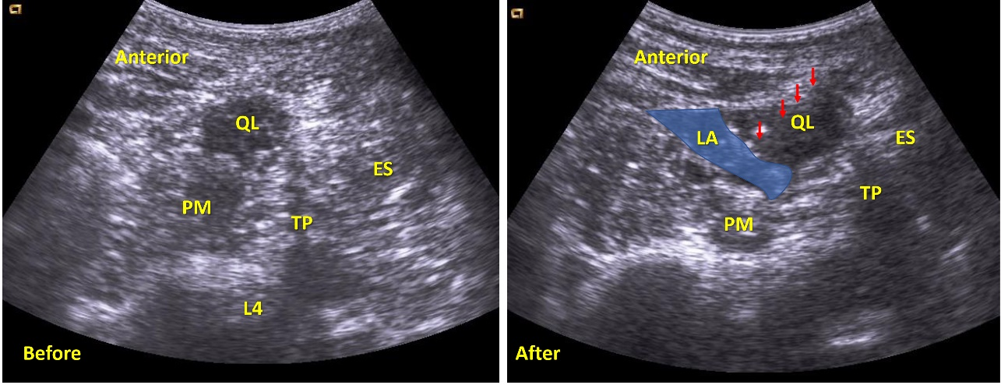
Figure S2: Quadratus lumborum block before (to the left) and after (to the right) LA anesthetic injection. The arrows indicate the needle, and the shaded blue area is the LA injectate between the quadratus lumborum muscle posteriorly and psoas major muscle anteriorly. ES: erector spinae, L4: the body of the fourth lumber vertebrae, PM: psoas major muscle, QL: quadratus lumborum muscle, TP: transverse process

