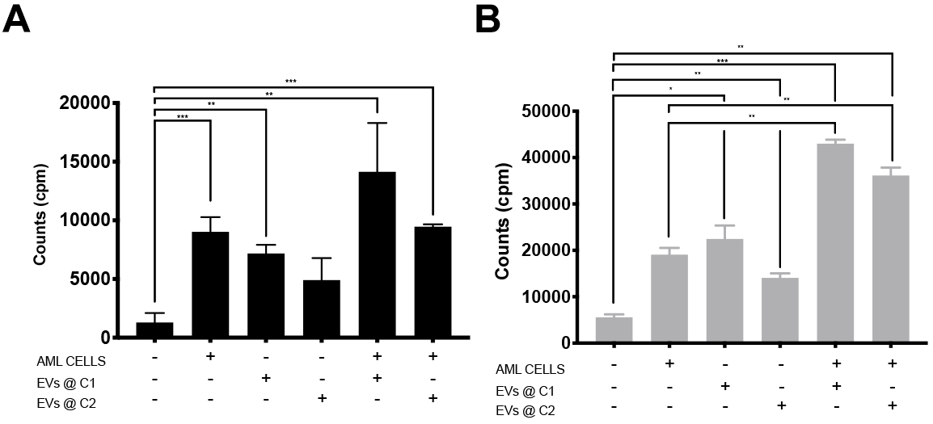
Supplemental Figure S.1: C1498 derived EVs induce a proliferative response by murine splenocytes. Splenocytes (1 x 10⁵ cells) were cultured with PBS, C1498 cells, different concentrations of C1498 derived EVs (C1 = high, C2 = low), or both C1498 cells and C1498 derived EVs. A) Tritiated thymidine incorporation (mean ± SD) of splenocytes isolated from naïve C57BL/6 mice. (**p<0.01, ***p<0.001) B) Tritiated thymidine incorporation (mean ± SD) of splenocytes isolated from C57BL/6J mice immunized with C1498 derived EVs (*p < 0.05, **p<0.01, ***p<0.001).

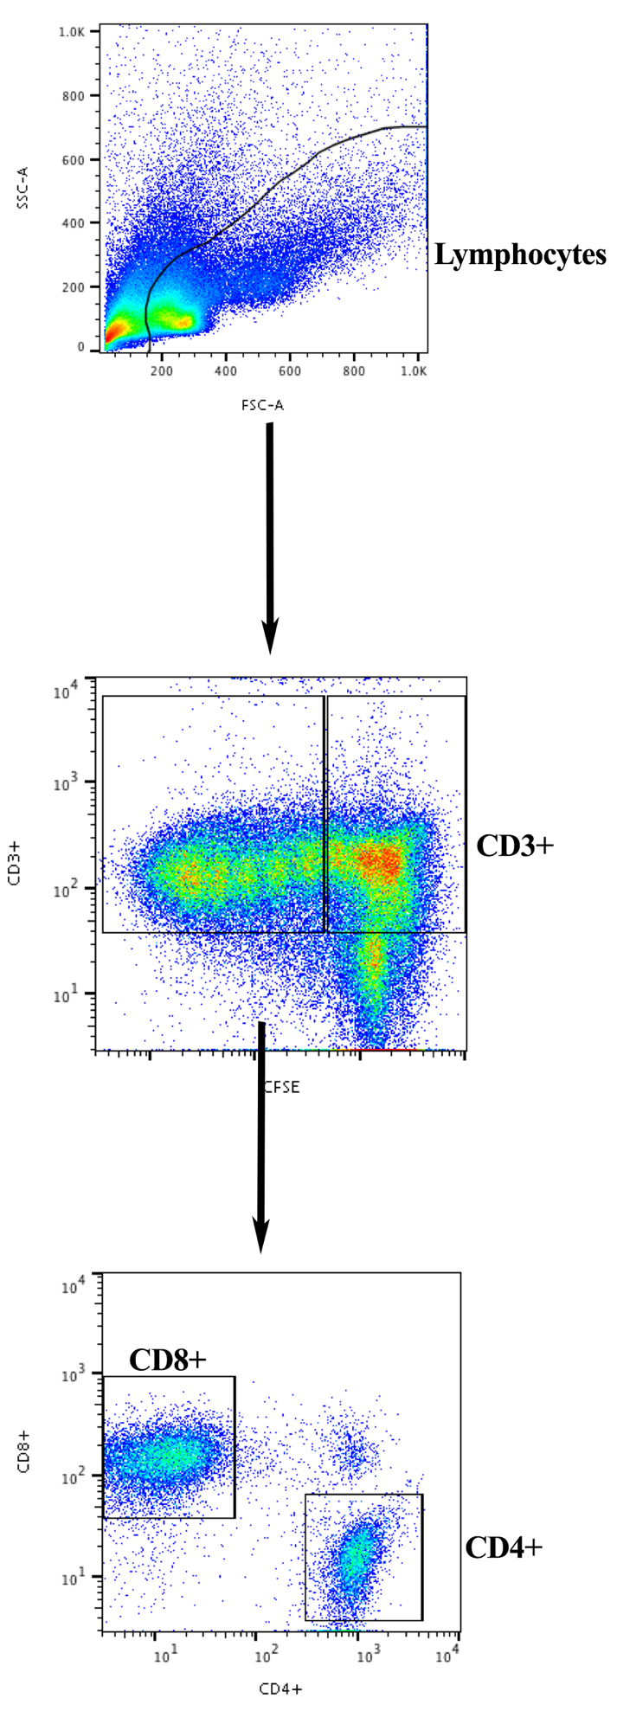
Supplemental Figure S.2: Flow Cytometry Gating Analysis approach strategy. Forward Scatter and Side Scatter were used to identify and select lymphocytes. Lymphocytes were further separated. CD3+ positive cells were separated based on CD8 or CD4 expression

Supplemental Figure. S.3: C1498 derived EVs increase activation induced inhibitory markers. Splenocytes obtained from mice injected with PBS, low concentration of C1498 derived EVs, or high concentration of C1498 derived EVs collected fourteen days post injection and stained for expression of PD-1, TIGIT and LAG3 on CD3+ cells. (Mean ± SD, *p < 0.05, **p<0.01)
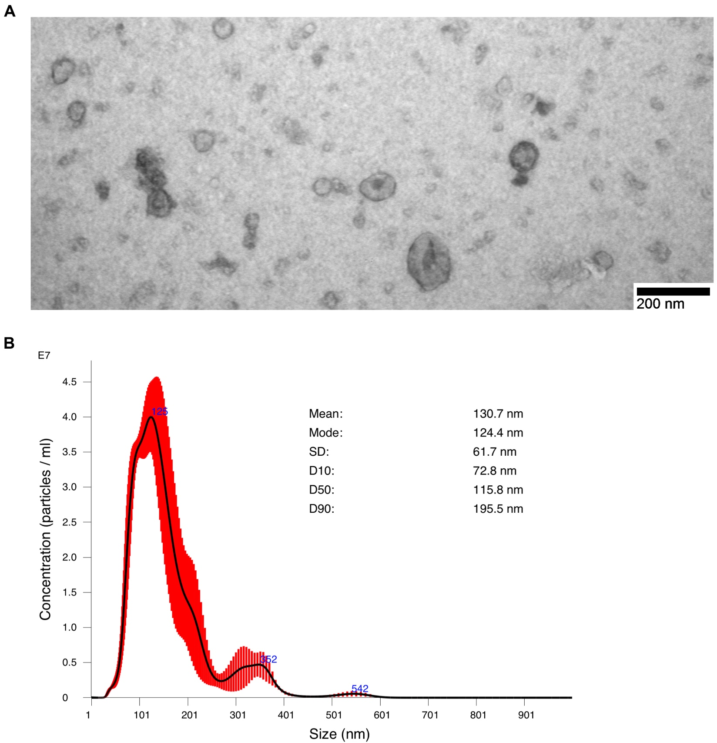 Supplemental Figure S.4: Characterization of EVs A) Electron Microscopy of C1498 derived EVs. Electron micrographs of populations of extracellular vesicles derived from the C1498 cell line (Scale bar = 200 nm, Magnification: x54,800). EVs were fixed in 2% paraformaldehyde and loaded on Formwar-carbon-coated electron microscopy grids. EVs were fixed in 1% glutaraldehyde and contrasted in 4% uranyl acetate. The samples were observed under the transmission electron microscope (FEI Morgagni 268) at 80 kV. B) Analysis of EVs fractions produced by murine AML cell line, C1498 via Nanosight. A typical profile of murine C1498 derived EVs fractions by Nanosight analysis. The mean of EVs are 130.7nm, mode of 124.4 nm, SD of 61.7nm.

