Appendix 1 Behaviour questions in the Rutter B scale Table 1 Behaviour questions in the Rutter B scale
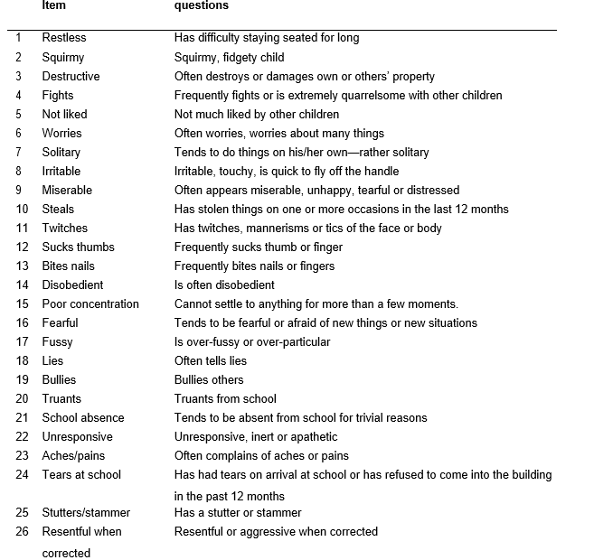

Items 10, 20–26 are absent in Rutter A scale at the age of 16 years. Items 1, 5, 10, 17, 18 and 20–26 are absent in Rutter A scale at the age of 7 and 11 years.
Notes: Reprinted from Pang D, Jones GT, Power C, Macfarlane GJ. Influence of childhood behaviour on the reporting of chronic widespread pain in adulthood: results from the 1958 British birth cohort study. Rheumatology. 2010;49(10):1882–1888, by permission of Oxford University Press.²

