eTable 1
Model Selection Using BIC and Predicted Group Proportions Using Group-Based Trajectory Models in Determining Days Covered Trajectory Groups (N = 438,398)
Predicted Group Proportions
Number of Groups | BICª | Group1 | Group2 | Group3 | Group4 | Group5 | Group6 | Group7 | Group8 | Group9
2 | -7309811 | 50.00% | 50.00%
3 | -6980186 | 41.32% | 24.10% | 34.58%
4 | -6960086 | 9.48% | 23.64% | 29.67% | 37.21%
5 | -6914819 | 21.52% | 9.20% | 9.18% | 23.56% | 36.53%
6 | -6895379 | 5.36% | 10.64% | 8.45% | 18.59% | 21.92% | 35.04%
7 | -6890440 | 4.44% | 6.53% | 8.29% | 5.81% | 18.64% | 21.54% | 34.74%
8 | -6865565 | 15.05% | 6.26% | 3.90% | 4.72% | 5.90% | 15.07% | 18.11% | 31.01%
9 | -6860529 | 15.35% | 3.51% | 5.59% | 5.97% | 6.66% | 10.98% | 4.06% | 17.51% | 30.38%
ªBIC=Bayesian Information Criterion. Higher values indicate better model fit.

eTable 2
Nagin’s Diagnostic Criteria for Days Covered Trajectories
Group | Group Probability (95% Confidence Interval)ª | Proportion Classified in Each Group^{b} | Average Posterior Probability^{c} | Odds Correct Classification^{d} | |∆|^{e}
Slow, Persistent Days Covered Reduction | 0.166 (0.165, 0.167) | 0.154 | 0.702 | 11.87 | 0.012
Days Covered Reduction Followed by Increase | 0.024 (0.023, 0.024) | 0.035 | 0.765 | 133.75 | 0.011
Rapid Days Covered Reduction | 0.041 (0.041, 0.042) | 0.056 | 0.735 | 64.72 | 0.015
Delayed Days Covered Reduction | 0.046 (0.046, 0.048) | 0.060 | 0.839 | 108.18 | 0.014
Rapid Discontinuation | 0.065 (0.065, 0.066) | 0.067 | 0.879 | 103.67 | 0.001
Moderate Paced Discontinuation | 0.109 (0.108, 0.110) | 0.110 | 0.750 | 24.49 | 0.001
Delayed Discontinuation | 0.034 (0.033, 0.034) | 0.041 | 0.836 | 145.71 | 0.007
Persistent, Moderate Days Covered | 0.177 (0.176, 0.179) | 0.175 | 0.734 | 12.80 | 0.002
Persistent, High Days Covered | 0.337 (0.336, 0.339) | 0.304 | 0.844 | 10.66 | 0.034
ª Actual proportion of individuals assigned to each trajectory group using the maximum probability rule.
^{b} Proportion classified in each group is based on the maximum posterior probability rule.
^{c} Average posterior probability is obtained by averaging the posterior probabilities for a given group for all individuals placed in this group by the maximum posterior probability rule. Average posterior probability is acceptable if equal to 0.7 or greater for each group.
^{d} Odds Correct Classification values should be 5.0 or greater for each group.
^{e} This value represents the difference between the group probability and the proportion classified in each group.

eTable 3
Veteran Demographics by Opioid Trajectory

 |  | Persistent Opioid Therapy |  | Reduced Opioid Therapy |  |  |  | Discontinued Opioid Therapy
 | Total Sample | Persistent, High Days Covered | Persistent, Moderate Days Covered | Slow, Persistent Days Covered Reduction | Days Covered Reduction Followed by Increase | Delayed Days Covered Reduction | Rapid Days Covered Reduction | Moderate Paced Discontinuation | Delayed Discontinuation | Rapid Discontinuation | P Valueª
 | 438,398 | 147,930 (33.7%) | 77,753 (17.7%) | 72,720 (16.6%) | 10,370 (2.4%) | 20,222 (4.6%) | 18,010 (4.1%) | 47,887 (10.9%) | 14,833  (3.4%) | 28,673  (6.5%)
Race, (n, %) |  |  |  |  |  |  |  |  |  |  | <.0001
White | 302,159  (68.92) | 108,179  (73.13) | 53,635  (68.98) | 46,536  (63.99) | 6,866  (66.21) | 14,194  (70.19) | 11,229  (62.35) | 31,489  (65.76) | 10,404  (70.14) | 19,627  (68.45)
Black | 75,415 (17.20) | 21,619 (14.61) | 13,375 (17.20) | 1,4668 (20.17) | 1,990 (19.19) | 3,413 (16.88) | 3,920 (21.77) | 9,189  (19.19) | 2,479  (16.71) | 4,762  (16.61)
Multiracial | 13,403 (3.06) | 4,071  (2.75) | 2,432  (3.13) | 2,430 (3.34) | 335  (3.23) | 636  (3.15) | 634  (3.52) | 1,570  (3.28) | 456  (3.07) | 839  (2.93)
Other | 30,604 (6.98) | 8,222  (5.56) | 5,298  (6.81) | 6,233 (8.57) | 811  (7.82) | 1,303  (6.44) | 1,606  (8.92) | 3,877  (8.10) | 959  (6.47) | 2,295  (8.00)
Unknown | 16,817 (3.84) | 5,839  (3.95) | 3,013  (3.88) | 2,853 (3.92) | 368  (3.55) | 676  (3.34) | 621  (3.45) | 1,762  (3.68) | 535  (3.61) | 1,150  (4.01)
Age, (mean, SD)
 | 57.27 (14.36) | 56.02 (13.60) | 58.94  (13.95) | 58.84 (14.53) | 56.73 (14.27) | 55.72 (14.53) | 56.68 (14.69) | 57.17  (15.19) | 55.93  (15.02) | 57.73  (15.82) | <.0001
Age Categories, (n, %) |  |  |  |  |  |  |  |  |  |  | <.0001
18-30 | 24,192 (5.52) | 8,070  (5.46) | 3,085  (3.97) | 3,374 (4.64) | 613  (5.91) | 1,463  (7.23) | 1,161  (6.45) | 3,255  (6.80) | 1,120  (7.55) | 2,051  (7.15)
31-40 | 35,467 (8.09) | 12,591 (8.51) | 5,284  (6.80) | 5,331 (7.33) | 854  (8.24) | 1,803  (8.92) | 1,555  (8.63) | 4,121  (8.61) | 1,381  (9.31) | 2,547  (8.88)
41-50 | 62,445 (14.24) | 22,703 (15.35) | 10,188 (13.10) | 9,673 (13.30) | 1,553 (14.98) | 3,035 (15.01) | 2,673 (14.84) | 6,695  (13.98) | 2,146  (14.47) | 3,779  (13.18)
51-60 | 120,686 (27.53) | 46,348 (31.33) | 20,478 (26.34) | 18,033 (24.80) | 2,886 (27.83) | 5,807 (28.72) | 4,653 (25.84) | 11,892  (24.83) | 4,065  (27.41) | 6,524  (22.75)
61-70 | 130,790 (29.83) | 41,820 (28.27) | 25,410 (32.68) | 23,083 (31.74) | 3,008 (29.01) | 5,569 (27.54) | 5,343 (29.67) | 14,103  (29.45) | 4,082  (27.52) | 8,372  (29.20)
71-80 | 39,809 (9.08) | 10,434 (7.05) | 8,189  (10.53) | 7,910 (10.88) | 926  (8.93) | 1,575  (7.79) | 1,652  (9.17) | 4,731  (9.88) | 1,228  (8.28) | 3,164  (11.03)
≥81 | 25,009 (5.70) | 5,964  (4.03) | 5,119  (6.58) | 5,316 (7.31) | 530  (5.11) | 970  (4.80) | 973  (5.40) | 3,090  (6.45) | 811  (5.47) | 2,236  (7.80)
Gender, (n, %) |  |  |  |  |  |  |  |  |  |  | <.0001
Male | 402,256 (91.76) | 136,899 (92.54) | 71,437 (91.88) | 66,336 (91.22) | 9,451 (91.14) | 18,549 (91.73) | 16,216 (90.04) | 43,641  (91.13) | 13,544  (91.31) | 26,183  (91.32)
Index Year, (n, %) |  |  |  |  |  |  |  |  |  |  | <.0001
2009 | 26,698 (6.09) | 4,314 (5.93) | 803  (7.74) | 1,178  (6.54) | 1,344  (6.65) | 1,388  (4.84) | 2,612  (5.45) | 749  (5.05) | 5,145  (6.62) | 9,165  (6.20)
2010 | 101,609 (23.18) | 16,286  (22.40) | 3,035  (29.27) | 4,382  (24.33) | 5,212  (25.77) | 5,640  (19.67) | 9,976  (20.83) | 3,374  (22.75) | 19,032  (24.48) | 34,672  (23.44)
2011 | 89,942 (20.52) | 14,302  (19.67) | 2,482  (23.93) | 4,058  (22.53) | 4,686  (23.17) | 5,682  (19.82) | 9,708  (20.27) | 3,247  (21.89) | 16,372  (21.06) | 29,405  (19.88)
2012 | 79,829 (18.21) | 13,188  (18.14) | 2,143  (20.67) | 3,659  (20.32) | 4,584  (22.67) | 5,250  (18.31) | 9,191  (19.19) | 3,149  (21.23) | 14,024  (18.04) | 24,641  (16.66)
2013 | 68,909 (15.72) | 11,665  (16.04) | 1,567  (15.11) | 3,045  (16.91) | 4,177  (20.66) | 5,197  (18.13) | 9,495  (19.83) | 3,702  (24.96) | 11,147  (14.34) | 18,914  (12.79)
2014 | 61,460 (14.02) | 10,800  (14.85) | 340  (3.28) | 1,688  (9.37) | 219  (1.08) | 5,516  (19.24) | 6,905  (14.42) | 612  (4.13) | 10,259  (13.19) | 25,121  (16.98)
2015 | 9,951 (2.27) | 2,165  (2.98) | 0  (0.00) | 0  (0.00) | 0  (0.00) | 0  (0.00) | 0  (0.00) | 0  (0.00) | 1,774  (2.28) | 6,012  (4.06)
Marital Status, (n, %) |  |  |  |  |  |  |  |  |  |  | <.0001
Married | 223,361 (50.95) | 72,783 (49.20) | 41,724 (53.66) | 39,189 (53.89) | 5,161 (49.77) | 9,602 (47.48) | 8,998 (49.96) | 23,984  (50.08) | 7,088  (47.79) | 14,832  (51.73)
Divorced | 121,023 (27.61) | 43,542 (29.43) | 20,324 (26.14) | 18,481 (25.41) | 2,944 (28.39) | 5,888 (29.12) | 4,978 (27.64) | 13,104  (27.36) | 4,360  (29.39) | 7,402  (25.82)
Other | 94,014 (21.45) | 31,605 (21.37) | 15,705 (20.20) | 15,050 (20.70) | 2,265 (21.84) | 4,732 (23.40) | 4,034 (22.40) | 10,799  (22.55) | 3,385  (22.82) | 6,439  (22.46)
Rural-Urban Commuting Area, (n, %) |  |  |  |  |  |  |  |  |  |  | <.0001
Urban | 303,997 (69.34) | 101,918 (68.90) | 53,092 (68.28) | 50,604 (69.59) | 7,195 (69.38) | 14,066 (69.56) | 12,946 (71.88) | 33,974  (70.95) | 10,261  (69.18) | 19,941  (69.55)
Large Rural | 62,162 (14.18) | 22,025 (14.89) | 11,321 (14.56) | 9,765 (13.43) | 1,444 (13.92) | 2,845 (14.07) | 2,316 (12.86) | 6,259  (13.07) | 2,196  (14.80) | 3,991  (13.92)
Isolated Small Rural | 63,112 (14.40) | 22,164 (14.98) | 11,698 (15.05) | 10,223 (14.06) | 1,426 (13.75) | 2,868 (14.18) | 2,244 (12.46) | 6,410  (13.39) | 2,073  (13.98) | 4,006  (13.97)
Missing | 9,127 (2.08) | 1,823  (1.23) | 1,642  (2.11) | 2,128 (2.93) | 305  (2.94) | 443  (2.19) | 504  (2.80) | 1,244  (2.60) | 303  (2.04) | 735  (2.56)
Enhanced Charlson Comorbidity Index (eCCI), (mean, SD)
 | 2.17  (1.97) | 2.11  (1.95) | 2.24  (1.96) | 2.23  (2.00) | 2.15  (1.90) | 2.15  (1.91) | 2.20  (2.00) | 2.21  (2.01) | 2.13  (1.90) | 2.09  (2.00) | <.0001
eCCI Categories, (n, %) |  |  |  |  |  |  |  |  |  |  | <.0001
0 | 73,293 (16.72) | 25,735 (17.40) | 11,898 (15.30) | 11,706 (16.10) | 1,757 (16.94) | 3,322 (16.43) | 3,118 (17.31) | 7,947  (16.60) | 2,398  (16.17) | 5,412  (18.87)
1 | 122,073 (27.85) | 41,946 (28.36) | 21,185 (27.25) | 19,784 (27.21) | 2,842 (27.41) | 5,719 (28.28) | 4,931 (27.38) | 13,246  (27.66) | 4,277  (28.83) | 8,143  (28.40)
2 | 98,425 (22.45) | 33,537 (22.67) | 17,699 (22.76) | 16,334 (22.46) | 2,328 (22.45) | 4,570 (22.60) | 3,902 (21.67) | 10,453  (21.83) | 3,415  (23.02) | 6,187  (21.58)
3 | 61,538 (14.04) | 20,355 (13.76) | 11,282 (14.51) | 10,413 (14.32) | 1,467 (14.15) | 2,830 (13.99) | 2,467 (13.70) | 6,797  (14.19) | 2,081  (14.03) | 3,846  (13.41)
4 | 35,357 (8.07) | 11,328 (7.66) | 6,712  (8.63) | 6,103 (8.39) | 864  (8.33) | 1,660  (8.21) | 1,461  (8.11) | 3,923  (8.19) | 1,145  (7.72) | 2,161  (7.54)
5 | 19,873 (4.53) | 6,292  (4.25) | 3,833  (4.93) | 3,461 (4.76) | 459  (4.43) | 918  (4.54) | 903  (5.01) | 2,185  (4.56) | 669  (4.51) | 1,153  (4.02)
≥6 | 27,839 (6.35) | 8,737  (5.91) | 5,144  (6.62) | 4,919 (6.76) | 653  (6.30) | 1,203  (5.95) | 1,228  (6.82) | 3,336  (6.97) | 848  (5.72) | 1,771  (6.18)
Pain Condition, (n, %) |  |  |  |  |  |  |  |  |  |  | <.0001
Back and/or Neck Pain Only | 95,791 (21.85) | 37,399 (25.28) | 15,855  (20.39) | 14,066 (19.34) | 2,174 (20.96) | 4,550 (22.50) | 3,335 (18.52) | 9,310  (19.44) | 3,302  (22.26) | 5,800  (20.23)
Arthritis Only | 116,559 (26.59) | 36,249 (24.50) | 20,951 (26.95) | 19,930 (27.41) | 2,796 (26.96) | 5,347 (26.44) | 4,918 (27.31) | 13,658  (28.52) | 4,080  (27.51) | 8,630  (30.10)
Headaches Only | 5,630 (1.28) | 1,913  (1.29) | 885  (1.14) | 861  (1.18) | 136  (1.31) | 286  (1.41) | 242  (1.34) | 691  (1.44) | 198  (1.33) | 418  (1.46)
Neuropathic Pain Only | 10,188 (2.32) | 3,621  (2.45) | 1,843  (2.37) | 1,634 (2.25) | 226  (2.18) | 453  (2.24) | 385  (2.14) | 994  (2.08) | 331  (2.23) | 701  (2.44)
Arthritis and Back and/or Neck Pain Only | 107,294 (24.47) | 35,632 (24.09) | 19,428  (24.99) | 18,375 (25.27) | 2,579 (24.87) | 4,889 (24.18) | 4,541 (25.21) | 11,697  (24.43) | 3,411  (23.00) | 6,742  (23.51)
Arthritis, Back and/or Neck Pain, and Headaches Only | 16,597 (3.79) | 5,212  (3.52) | 2,895  (3.72) | 2,912 (4.00) | 412  (3.97) | 789  (3.90) | 807  (4.48) | 1,933  (4.04) | 599  (4.04) | 1,038  (3.62)
Neuropathic Pain and One or More Others | 65,111 (14.85) | 20,905 (14.13) | 12,272 (15.78) | 11,387 (15.66) | 1,552 (14.97) | 2,898  (14.33) | 2,802  (15.56) | 7,183  (15.00) | 2,171  (14.64) | 3,941  (13.74)
All Tracer Pain Conditions | 2,326 (0.53) | 744  (0.50) | 437  (0.56) | 457  (0.63) | 54  (0.52) | 96  (0.47) | 113  (0.63) | 250  (0.52) | 56  (0.38) | 119  (0.42)
Other Multiple Pain Conditions | 18,902  (4.31) | 6,255  (4.23) | 3,187  (4.10) | 3,098  (4.26) | 441  (4.25) | 914  (4.52) | 867  (4.81) | 2,171  (4.53) | 685  (4.62) | 1,284  (4.48)
Other Medication Use, (n, %)
Antidepressant Use | 210,800 (48.08) | 72,717  (49.16) | 36,548  (47.01) | 33,534 (46.11) | 5,067  (48.86) | 10,683  (52.83) | 8,657  (48.07) | 23,351  (48.76) | 7,647  (51.55) | 12,596  (43.93) | <.0001
Benzodiazepine Use | 93,352 (21.29) | 34,046  (23.01) | 15,651  (20.13) | 13,719 (18.87) | 2,298  (22.16) | 5,015  (24.80) | 3,761  (20.88) | 10,095  (21.08) | 3,517  (23.71) | 5,250  (18.31) | <.0001
Hypnotics and Non-Benzodiazepine Sedative Use | 58,607  (13.37) | 20,809  (14.07) | 9,978  (12.83) | 8,820  (12.13) | 1,489  (14.36) | 3,153  (15.59) | 2,392  (13.28) | 6,378  (13.32) | 2,218  (14.95) | 3,370  (11.75) | <.0001
Skeletal Muscle Relaxant Use | 149,246  (34.04) | 52,180  (35.27) | 25,720  (33.08) | 2,426  (33.37) | 3,697  (35.65) | 7,124  (35.23) | 6,414  (35.61) | 16,064  (33.55) | 4,992  (33.65) | 8,789  (30.65) | <.0001
Other Non-Opioid Analgesic Use | 297,689  (67.90) | 97,615  (65.99) | 52,744  (67.84) | 49,944  (68.68) | 7,317  (70.56) | 13,917  (68.82) | 13,061 (72.52) | 33,642  (70.25) | 10,088  (68.01) | 19,361  (67.52) | <.0001
Mental Health Conditions, (n, %) |  |  |  |  |  |  |  |  |  |  | <.0001
No Mental Health Conditions | 169,209 (38.60) | 52,499 (35.49) | 32,448 (41.73) | 31,208 (42.92) | 3,936 (37.96) | 6,827 (33.76) | 6,995 (38.84) | 18,262  (38.14) | 5,061  (34.12) | 11,973  (41.76)
Alcohol Use Disorder | 4,848 (1.11) | 1,717  (1.16) | 833  (1.07) | 750  (1.03) | 117  (1.13) | 243  (1.20) | 175  (0.97) | 525  (1.10) | 165  (1.11) | 323  (1.13)
Anxiety Disorders | 13,643 (3.11) | 4,875  (3.30) | 2,374  (3.05) | 2,165 (2.98) | 270  (2.60) | 600  (2.97) | 523  (2.90) | 1,495  (3.12) | 470  (3.17) | 871  (3.04)
Bipolar Disorder | 2,043 (0.47) | 676  (0.46) | 356  (0.46) | 303  (0.42) | 50  (0.48) | 118  (0.58) | 86  (0.48) | 235  (0.49) | 69  (0.47) | 150  (0.52)
Major Depressive Disorder | 31,969  (7.29) | 10,451  (7.06) | 5,973  (7.68) | 5,501 (7.56) | 736  (7.10) | 1,524  (7.54) | 1,363  (7.57) | 3,444  (7.19) | 1,065  (7.18) | 1,912  (6.67)
Non-Opioid Use Disorder | 2,498  (0.57) | 939  (0.63) | 377  (0.48) | 354  (0.49) | 62  (0.60) | 125  (0.62) | 112  (0.62) | 268  (0.56) | 94  (0.63) | 167  (0.58)
Opioid Use Disorder | 301  (0.07) | 147  (0.10) | 30  (0.04) | 30  (0.04) | 7  (0.07) | 16  (0.08) | 10  (0.06) | 36  (0.08) | 11  (0.07) | 14  (0.05)
Post-Traumatic Stress Disorder | 16,285 (3.71) | 4,819  (3.26) | 3,053  (3.93) | 3,025 (4.16) | 388  (3.74) | 723  (3.58) | 776  (4.31) | 1,910  (3.99) | 537  (3.62) | 1,054  (3.68)
Schizophrenia | 1,370  (0.31) | 392  (0.26) | 246  (0.32) | 214  (0.29) | 41  (0.40) | 86  (0.43) | 58  (0.32) | 182  (0.38) | 52  (0.35) | 99  (0.35)
Tobacco Use Disorder | 41,365 (9.44) | 16,513  (11.16) | 7,035  (9.05) | 6,130 (8.43) | 948  (9.14) | 1,743  (8.62) | 1,485  (8.25) | 3,850  (8.04) | 1,297  (8.74) | 2,364  (8.24)
Multiple Mental Health Conditions | 154,867  (35.33) | 54,902  (37.11) | 25,028  (32.19) | 23,040 (31.68) | 3,815 (36.79) | 8,217 (40.63) | 6,427 (35.69) | 17,680  (36.92) | 6,012  (40.53) | 9,746  (33.99)
Number of the Following Visit Types, (mean, SD)
Physical Therapy | 4.82  (8.43) | 4.44  (8.33) | 4.73  (8.25) | 4.85  (7.91) | 4.87  (7.99) | 4.66  (8.67) | 5.55  (8.94) | 5.29  (8.71) | 4.81  (8.59) | 5.52  (9.34) | <.0001
Pain Clinic | 3.50  (4.31) | 3.48  (4.16) | 3.59  (4.66) | 3.63  (4.64) | 3.31  (3.26) | 3.54  (3.89) | 3.46  (4.02) | 3.41  (3.79) | 3.41  (4.03) | 3.30  (5.32) | 0.0105
Chiropractic Care | 4.19  (4.67) | 4.10  (4.86) | 4.34  (4.77) | 4.45  (4.85) | 3.61  (3.48) | 4.24  (4.14) | 4.22  (4.50) | 4.25  (4.79) | 3.81  (4.86) | 3.84  (3.30) | 0.1760
Medicine and Primary Care | 10.54 (9.97) | 10.81  (9.86) | 10.22  (9.80) | 10.16 (9.74) | 10.02  (9.14) | 10.64  (10.02) | 10.86  (11.43) | 10.95  (10.40) | 10.66  (9.80) | 10.07  (10.11) | <.0001
Emergency Department Care | 2.78  (3.04) | 2.67  (2.76) | 2.68  (2.88) | 2.80  (3.15) | 3.01  (3.55) | 2.86  (3.17) | 3.11  (3.65) | 2.97  (3.36) | 2.85  (3.26) | 2.67  (2.91) | <.0001
Mental Health Care | 14.33 (27.47) | 13.56  (25.86) | 13.77  (26.65) | 13.91 (27.24) | 15.25  (27.78) | 15.75  (29.27) | 15.84  (29.77) | 15.94  (30.51) | 15.37  (28.68) | 14.94  (28.57) | <.0001
Pain Score Characteristics (180 Days Prior to Index Date), (mean, SD)
First Pain Score | 4.08  (3.34) | 4.35  (3.31) | 3.98  (3.31) | 3.87  (3.32) | 4.07  (3.39) | 4.22  (3.37) | 3.97  (3.37) | 3.94  (3.37) | 4.17  (3.35) | 3.74  (3.34) | <.0001
Last Pain Score | 4.12  (3.31) | 4.39  (3.28) | 3.94  (3.28) | 3.86  (3.30) | 4.03  (3.35) | 4.26  (3.34) | 4.03  (3.32) | 4.05  (3.33) | 4.26  (3.31) | 3.92  (3.31) | <.0001
Change in Pain Score | 0.04  (3.27) | 0.04  (3.19) | 0.04  (3.25) | 0.01  (3.30) | 0.04  (3.38) | 0.04  (3.30) | 0.06  (3.45) | 0.10  (3.41) | 0.08  (3.24) | 0.18  (3.32) | <.0001
Pain Score Average | 4.06  (2.74) | 4.33  (2.75) | 3.91  (2.71) | 3.83  (2.71) | 4.01  (2.74) | 4.20  (2.76) | 3.95  (2.68) | 3.95  (2.71) | 4.17  (2.75) | 3.80  (2.74) | <.0001
Pain Score Median | 4.03  (3.02) | 4.32  (3.01) | 3.87  (3.00) | 3.78  (3.01) | 3.99  (3.06) | 4.18  (3.05) | 3.92  (3.00) | 3.91  (3.03) | 4.13  (3.04) | 3.73  (3.02) | <.0001
Number of Pain Scores | 9.55 (47.44) | 9.52  (50.48) | 8.86  (44.72) | 8.82 (42.49) | 9.51  (43.27) | 10.65  (52.85) | 10.61  (46.59) | 10.52  (46.45) | 10.14  (48.58) | 10.20  (50.12) | <.0001
Pain Score Characteristics (180 Days After the Index Date), (mean, SD)
First Pain Score | 4.71  (3.30) | 4.96  (3.23) | 4.46  (3.30) | 4.43  (3.34) | 4.71  (3.34) | 4.93  (3.27) | 4.72  (3.33) | 4.71  (3.34) | 4.86  (3.30) | 4.54  (3.36) | <.0001
Last Pain Score | 3.98  (3.26) | 4.30  (3.22) | 3.84  (3.24) | 3.73  (3.26) | 3.93  (3.30) | 4.25  (3.29) | 3.76  (3.27) | 3.81  (3.27) | 4.12  (3.29) | 3.45  (3.24) | <.0001
Change in Pain Score | 0.73  (3.44) | 0.66  (3.38) | 0.62  (3.37) | 0.70  (3.43) | 0.78  (3.53) | 0.68  (3.44) | 0.96  (3.58) | 0.90  (3.57) | 0.73  (3.48) | 1.09  (3.55) | <.0001
Pain Score Average | 4.25  (2.58) | 4.53  (2.54) | 4.07  (2.61) | 4.00  (2.61) | 4.22  (2.59) | 4.48  (2.58) | 4.15  (2.52) | 4.16  (2.55) | 4.37  (2.60) | 3.94  (2.59) | <.0001
Pain Score Median | 4.27  (2.93) | 4.59  (2.88) | 4.07  (2.94) | 4.00  (2.96) | 4.22  (2.97) | 4.54  (2.93) | 4.15  (2.91) | 4.17  (2.93) | 4.40  (2.96) | 3.91  (2.95) | <.0001
Number of Pain Scores | 9.77  (31.54) | 8.89  (28.87) | 8.73  (28.60) | 9.55 (31.45) | 10.83  (33.19) | 9.54  (30.79) | 12.02  (35.56) | 12.35  (38.05) | 9.36  (28.52) | 11.85  (38.03) | <.0001
Opioid Duration of Action (180 Days Prior to Index Date), (n, %) |  |  |  |  |  |  |  |  |  |  | <.0001
No Opioid Use | 242,197 (55.25) | 94,166  (63.66) | 34,635  (44.54) | 30,775 (42.32) | 5,311 (51.22) | 12,015 (59.42) | 9,640 (53.53) | 27,095  (56.58) | 9,120  (61.48) | 19,440  (67.80)
Long-Acting Only | 1,684 (0.38) | 685  (0.46) | 334  (0.43) | 236  (0.32) | 37  (0.36) | 73  (0.36) | 52  (0.29) | 134  (0.28) | 62  (0.42) | 71  (0.25)
Short-Acting Only | 192,022 (43.80) | 52,189  (35.28) | 42,282  (54.38) | 41,294 (56.78) | 4,968 (47.91) | 8,018  (39.65) | 8,228  (45.69) | 20,420  (42.64) | 5,560  (37.48) | 9,063  (31.61)
Combination of Long and Short-Acting | 2,495 (0.57) | 890  (0.60) | 502  (0.65) | 415  (0.57) | 54  (0.52) | 116  (0.57) | 90  (0.50) | 238  (0.50) | 91  (0.61) | 99  (0.35)
Opioid Duration of Action (180 Days After Index Date), (n, %) |  |  |  |  |  |  |  |  |  |  | <.0001
Long-Acting Only | 5,478 (1.25) | 3,107  (2.10) | 619  (0.80) | 404  (0.56) | 75  (0.72) | 281  (1.39) | 100  (0.56) | 400  (0.84) | 226  (1.52) | 266  (0.93)
Short-Acting Only | 406,837  (92.80) | 131,010  (88.56) | 74,348  (95.62) | 70,038 (96.31) | 9,861  (95.09) | 18,504  (91.50) | 17,189  (95.44) | 45,174  (94.33) | 13,607  (91.73) | 27,106  (94.53)
Combination of Long and Short-Acting | 26,083 (5.95) | 13,813  (9.34) | 2,786  (3.58) | 2,278 (3.13) | 434  (4.19) | 1,437  (7.11) | 721  (4.00) | 2,313  (4.83) | 1,000  (6.74) | 1,301  (4.54)
Schedule of Opioid Use (180 Days Prior to Index Date), (n, %) |  |  |  |  |  |  |  |  |  |  | <.0001
No Opioid Therapy | 242,197 (55.25) | 94,166  (63.66) | 34,635  (44.54) | 30,775 (42.32) | 5,311  (51.22) | 12,015  (59.42) | 9,640  (53.53) | 27,095  (56.58) | 9,120  (61.48) | 19,440  (67.80)
Schedule II Only | 101,574 (23.17) | 31,626  (21.38) | 22,016  (28.32) | 19,524 (26.85) | 2,469  (23.81) | 4,475  (22.13) | 4,007  (22.25) | 9,935  (20.75) | 3,097  (20.88) | 4,425  (15.43)
Schedule III Only | 11,557 (2.64) | 2,501  (1.69) | 2,471  (3.18) | 2,839 (3.90) | 308  (2.97) | 470  (2.32) | 642  (3.56) | 1,365  (2.85) | 333  (2.24) | 628  (2.19)
Schedule IV Only | 66,533 (15.18) | 14,750  (9.97) | 15,255  (19.62) | 16,272 (22.38) | 1,808  (17.43) | 2,517  (12.45) | 2,888  (16.04) | 7,680  (16.04) | 1,838  (12.39) | 3,525  (12.29)
Schedule V Only | 2  (0.00) | 0  (0.00) | 1  (0.00) | 1  (0.00) | 0  (0.00) | 0  (0.00) | 0  (0.00) | 0  (0.00) | 0  (0.00) | 0  (0.00)
Use of Multiple Schedules | 16,535 (3.77) | 4,887  (3.30) | 3,375  (4.34) | 3,309  (4.55) | 474  (4.57) | 745  (3.68) | 833  (4.63) | 1,812  (3.78) | 445  (3.00) | 655  (2.28)
Schedule of Opioid Use (180 Days After Index Date), (n, %) |  |  |  |  |  |  |  |  |  |  | <.0001
Schedule II Only | 212,447 (48.46) | 88,146  (59.59) | 35,340  (45.45) | 28,898 (39.74) | 4,448 (42.89) | 10,542 (52.13) | 7,202 (39.99) | 19,734  (41.21) | 7,401  (49.90) | 10,736  (37.44)
Schedule III Only | 15,538 (3.54) | 3,372  (2.28) | 3,212  (4.13) | 3,415 (4.70) | 451  (4.35) | 604  (2.99) | 826  (4.59) | 1,962  (4.10) | 500  (3.37) | 1,196  (4.17)
Schedule IV Only | 131,694 (30.04) | 30,881  (20.88) | 26,362  (33.90) | 27,227  (37.44) | 3,452  (33.29) | 5,365  (26.53) | 6,016 (33.40) | 16,059  (33.54) | 4,266  (28.76) | 12,066  (42.08)
Schedule V Only | 3  (0.00) | 0  (0) | 1  (0.00) | 0  (0) | 0  (0) | 0  (0) | 0  (0) | 2  (0.00) | 0  (0) | 0  (0)
Use of Multiple Schedules | 78,716 (17.96) | 25,531 (17.26) | 12,838 (16.51) | 13,180 (18.12) | 2,019 (19.47) | 3,711 (18.35) | 3,966 (22.02) | 10,130  (21.15) | 2,666  (17.97) | 4,675  (16.30)
Opioid Days’ Covered (180 Days Prior to Index Date), (mean, SD)
 | 44.28 (23.10) | 43.06 (23.89) | 48.63 (23.01) | 45.91 (21.98) | 43.83 (22.40) | 42.49  (23.47) | 39.89 (21.87) | 41.00  (22.48) | 41.83  (23.50) | 38.40  (21.98) | <.0001
Opioid Days’ Covered (180 Days Prior to Index Date), (n, %) |  |  |  |  |  |  |  |  |  |  | <.0001
0 | 242,197 (55.25) | 94,166 (63.66) | 34,635  (44.54) | 30,775 (42.32) | 5,311 (51.22) | 12,015 (59.42) | 9,640 (53.53) | 27,095  (56.58) | 9,120  (61.48) | 19,440  (67.80)
1-20 | 28,790 (6.57) | 9,556  (6.46) | 4,365 (5.61) | 4,532 (6.23) | 720  (6.94) | 1,483 (7.33) | 1,499 (8.32) | 3,674  (7.67) | 1,073  (7.23) | 1,888  (6.58)
21-40 | 70,286 (16.03) | 18,808 (12.71) | 13,945 (17.93) | 15,261 (20.99) | 1,842 (17.76) | 2,916 (14.42) | 3,479 (19.32) | 8,129  (16.98) | 2,076  (14.00) | 3,830  (13.36)
41-60 | 59,024 (13.46) | 14,943 (10.10) | 14,244 (18.32) | 14,026 (19.29) | 1,599 (15.42) | 2,271 (11.23) | 2,228 (12.37) | 5,821  (12.16) | 1,520  (10.25) | 2,372  (8.27)
>60 | 38,101 (8.69) | 10,457 (7.07) | 10,564 (13.59) | 8,126 (11.17) | 898  (8.66) | 1,537 (7.60) | 1,164 (6.46) | 3,168  (6.62) | 1,044  (7.04) | 1,143  (3.99)
Opioid Days’ Covered, (n, %)
Days 1 – 180 | 138.07 (28.12) | 158.38 (18.76) | 131.55 (22.21) | 120.68 (23.90) | 123.53 (25.98) | 153.96 (21.52) | 112.82 (22.91) | 130.22  (26.69) | 151.40  (22.84) | 111.16  (23.26) | <.0001
Days 181 – 360 | 101.31 (59.99) | 160.58 (19.45) | 107.26 (30.46) | 76.96 (31.01) | 30.89 (28.92) | 153.05 (22.88) | 15.44 (18.76) | 42.81  (27.66) | 136.26  (25.25) | 0.08  (0.63)
Days 361 – 540 | 93.75 (64.97) | 163.85 (16.72) | 113.97 (29.63) | 63.91 (31.13) | 59.47 (35.11) | 125.03 (34.42) | 13.76 (17.90) | 10.57  (18.32) | 29.10  (26.65) | 0.00  (0.00)
Days 541 – 720 | 89.30 (67.55) | 161.48 (20.56) | 121.58 (28.35) | 49.42 (27.79) | 129.77 (26.64) | 33.19 (27.08) | 38.96 (24.64) | 0.89  (3.79) | 0.00  (0.00) | 0.00  (0.00)
Opioid Days’ Covered (Days 1 – 180), (n, %) |  |  |  |  |  |  |  |  |  |  | <.0001
90-110 | 85,964 (19.61) | 2,781  (1.88) | 12,377 (15.92) | 27,222 (37.43) | 3,641 (35.11) | 869  (4.38) | 9,466 (52.56) | 12,506  (26.12) | 842  (5.68) | 16,260  (56.71)
111-130 | 93,184 (21.26) | 10,477 (7.08) | 28,606 (36.79) | 22,526 (30.98) | 2,940 (28.35) | 2,253 (11.14) | 4,886 (27.13) | 12,636  (26.39) | 2,065  (13.92) | 6,795  (23.70)
131-150 | 91,620 (20.90) | 32,154 (21.74) | 20,318 (26.13) | 13,401 (18.43) | 1,909 (18.41) | 4,606 (22.78) | 2,118 (11.76) | 10,489  (21.90) | 3,423  (23.08) | 3,202  (11.17)
>150 | 167,630 (38.24) | 102,518 (69.30) | 16,452 (21.16) | 9,571 (13.16) | 1,880 (18.13) | 12,494 (61.78) | 1,540 (8.55) | 12,256  (25.59) | 8,503  (57.32) | 2,416  (8.43)
Average Morphine Equivalent Dose (180 Days Prior to the Index Date), (mean, SD)
 | 19.50 (14.26) | 21.16  (17.72) | 19.58  (13.15) | 18.36 (11.92) | 18.55 (10.93) | 19.93 (15.14) | 18.66 (13.19) | 18.29  (11.84) | 19.36  (13.54) | 18.35  (12.64) | <.0001
Average Morphine Equivalent Dose (180 Days Prior to the Index Date), (n, %) |  |  |  |  |  |  |  |  |  |  | <.0001
No Opioid Therapy | 242,197 (55.25) | 94,166 (63.66) | 34,635 (44.54) | 30,775 (42.32) | 5,311 (51.22) | 12,015 (59.42) | 9,640 (53.53) | 27,095  (56.58) | 9,120  (61.48) | 19,440  (67.80)
<=10 | 50,999 (11.63) | 12,048  (8.14) | 10,743  (13.82) | 12,012 (16.52) | 1,377 (13.28) | 2,147 (10.62) | 2,357 (13.09) | 6,093  (12.72) | 1,501  (10.12) | 2,721  (9.49)
>10-20 | 90,501 (20.64) | 23,751 (16.06) | 20,372 (26.20) | 19,928 (27.40) | 2,409 (23.23) | 3,648 (18.04) | 3,865 (21.46) | 9,623  (20.10) | 2,624  (17.69) | 4,281  (14.93)
>20 | 54,701 (12.48) | 17,965 (12.14) | 12,003 (15.44) | 10005 (13.76) | 1,273 (12.28) | 2,412 (11.93) | 2,148 (11.93) | 5,076  (10.60) | 1,588  (10.71) | 2,231  (7.78)
Average Morphine Equivalent Dose (180 Days After the Index Date), (mean, SD)
 | 21.46 (19.71) | 25.88 (26.30) | 19.56 (14.42) | 18.34 (12.15) | 19.25 (13.26) | 21.86 (20.09) | 18.39 (12.45) | 18.95  (14.70) | 21.44  (21.35) | 18.41  (15.18) | <.0001
Average Morphine Equivalent Dose (180 Days After the Index Date), (n, %) |  |  |  |  |  |  |  |  |  |  | <.0001
<=10 | 102,495 (23.38) | 26,336 (17.80) | 18,614  (23.94) | 19,636 (27.00) | 2,621 (25.27) | 4,777 (23.62) | 4,919 (27.31) | 13,103  (27.36) | 3,621  (24.41) | 8,868  (30.93)
>10-20 | 188,820 (43.07) | 56,191 (37.98) | 36,481 (46.92) | 34,301 (47.17) | 4,787 (46.16) | 8,299 (41.04) | 8,252 (45.82) | 21,552  (45.01) | 6,263  (42.22) | 12,694  (44.27)
>20 | 147,083 (33.55) | 65,403 (44.21) | 22,658 (29.14) | 18,783 (25.83) | 2,962 (28.56) | 7,146 (35.34) | 4,839 (26.87) | 13,232  (27.63) | 4,949  (33.36) | 7,111  (24.80)

ªχ2 and analysis of variance (ANOVA) tests were run on the demographics, χ2 tests were run for categorical variables and ANOVA tests were run for continuous variables.

eTable 4
Model Selection Using BIC and Predicted Group Proportions Using Group-Based Trajectory Models in Determining AMME^{b} Trajectory Groups
(N = 438,398)
Predicted Group Proportions
Number of Groups | BICª | Group1 | Group2 | Group3 | Group4 | Group5 | Group6 | Group7 | Group8 | Group9
2 | -2094300 | 18.66% | 81.34%
3 | -1987547 | 14.21% | 9.20% | 76.59%
4 | -1907864 | 13.71% | 8.33% | 9.42% | 68.55%
5 | -1827022 | 6.96% | 55.82% | 6.63% | 16.52% | 14.07626
6 | -1805094 | 6.92% | 30.23% | 39.38% | 3.98% | 16.53828 | 2.95%
7 | -1783405 | 7.02% | 6.55% | 42.78% | 23.91% | 1.40578 | 16.47% | 1.86%
8 | -1618875 | 7.18% | 6.98% | 3.74% | 2.68% | 39.30% | 8.12% | 4.32% | 27.68%
ªBIC=Bayesian Information Criterion. Higher values indicate better model fit; ^{b}AMME=Average morphine milligram equivalent dose per day

eTable 5
Nagin’s Diagnostic Criteria for AMME Trajectories
Group | Group Probability (95% Confidence Interval)ª | Proportion Classified in Each Group^{b} | Average Posterior Probability^{c} | Odds Correct Classification^{d} | |∆|^{e}
Delayed Discontinuation | 0.059 (0.058, 0.060) | 0.072 | 0.991 | 1792.86 | 0.013
Rapid Discontinuation/Reduction | 0.064 (0.064, 0.065) | 0.070 | 0.996 | 3262.73 | 0.006
Slow, Persistent Dose Reduction | 0.034 (0.033, 0.034) | 0.037 | 0.893 | 240.29 | 0.004
Persistent, High Dose | 0.025 (0.025, 0.026) | 0.029 | 0.889 | 311.37 | 0.002
Persistent Moderate Dose | 0.444 (0.442, 0.445) | 0.393 | 0.804 | 5.15 | 0.051
Midpoint Discontinuation | 0.067 (0.066, 0.067) | 0.081 | 0.998 | 7594.98 | 0.015
Dose Reduction Followed by Increase | 0.040 (0.040, 0.041) | 0.043 | 0.927 | 300.30 | 0.003
Persistent, Moderately-High Dose | 0.267 (0.266, 0.269) | 0.277 | 0.829 | 13.30 | 0.009
ªActual proportion of individuals assigned to each trajectory group using the maximum probability rule.
^{b}Proportion classified in each group is based on the maximum posterior probability rule.
^{c} Average posterior probability is obtained by averaging the posterior probabilities for a given group for all individuals placed in this group by the maximum posterior probability rule. Average posterior probability is acceptable if equal to 0.7 or greater for each group.
^{d} Odds Correct Classification values should be 5.0 or greater for each group.
^{e}This value represents the difference between the group probability and the proportion classified in each group.

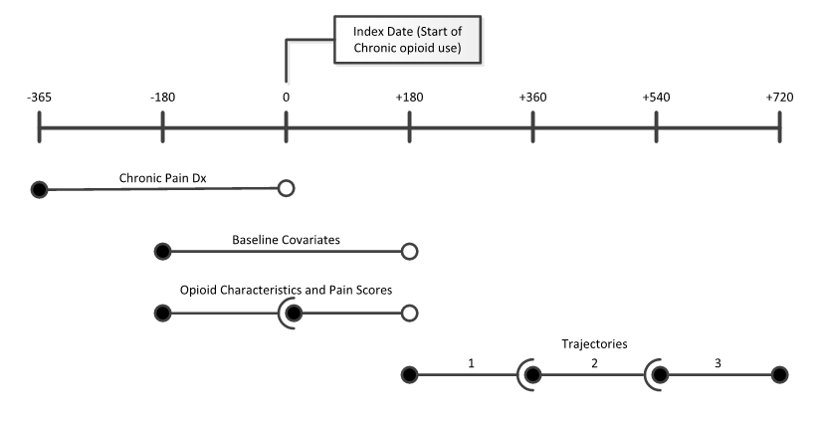

Enclosed black dot represents inclusion of the time point
Open dot represents exclusion of the time point

eFigure 1. Study design.

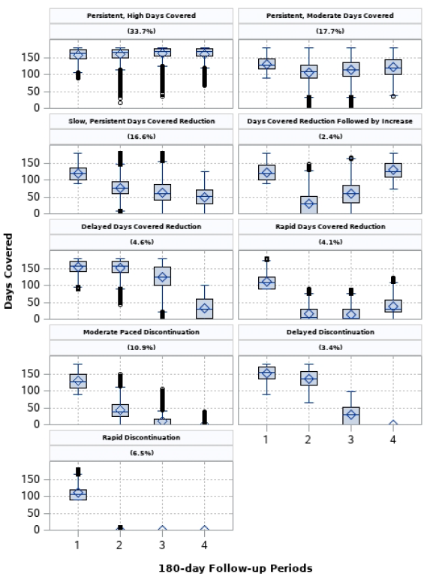
eFigure. 2. Box plots for the nine days covered trajectories of patients initially on long-term opioid therapy.
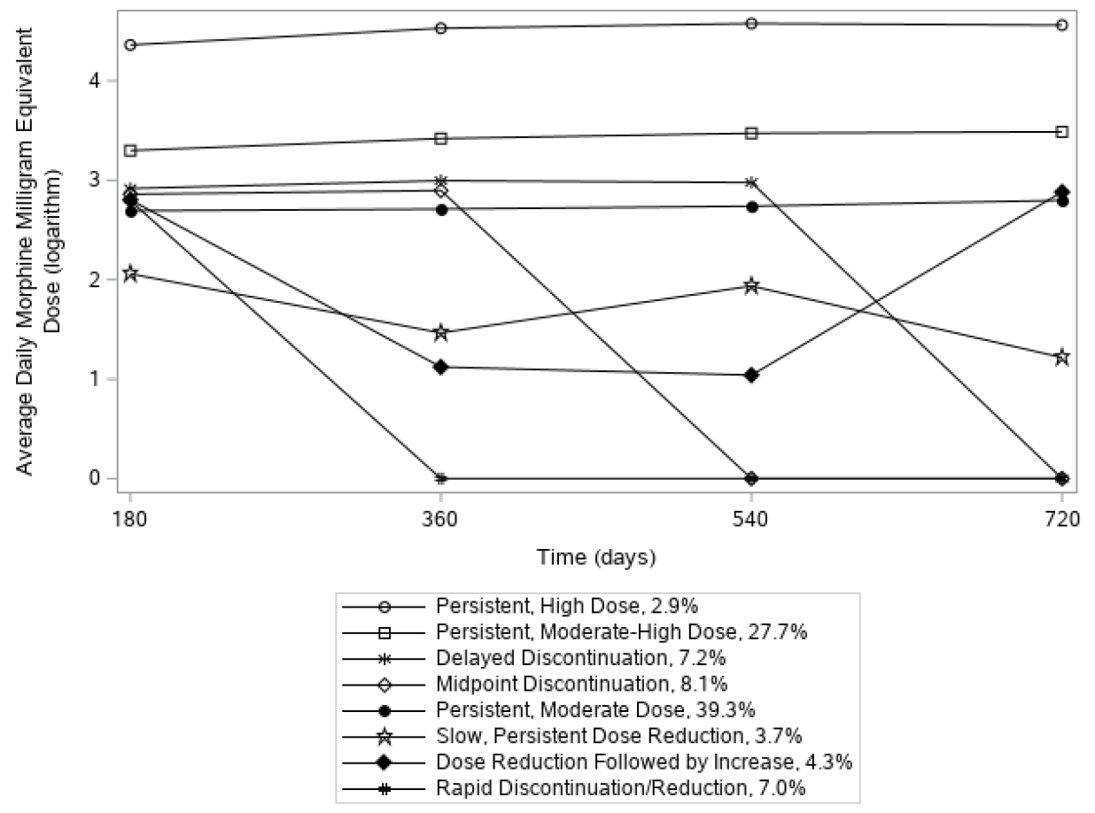
eFigure. 3. Graphical depiction of the eight average daily morphine milligram equivalent trajectories of Veterans initiating long-term opioid therapy.

