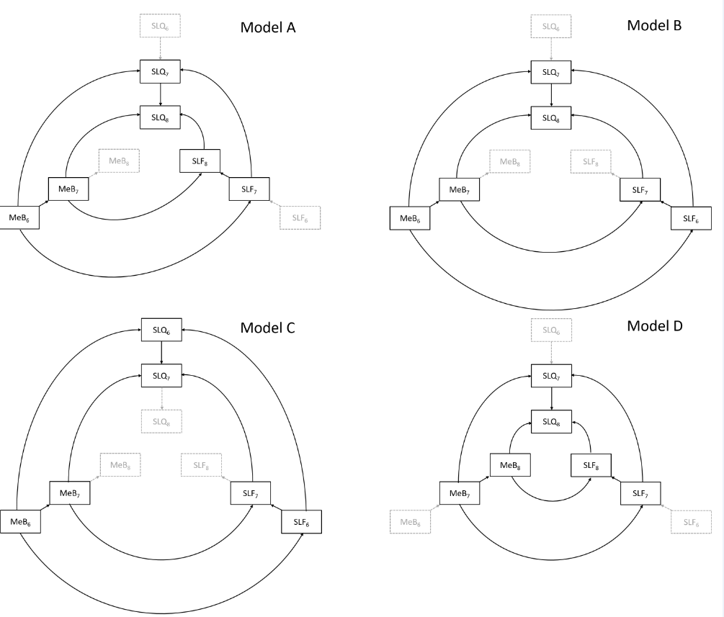

Supplementary Figure 1. Models used for mediation analysis. SQ: Sleep quality score, SD/MF: Sleep duration or Chronotype, AM/TC/PC/BK: Media use or book reading.

