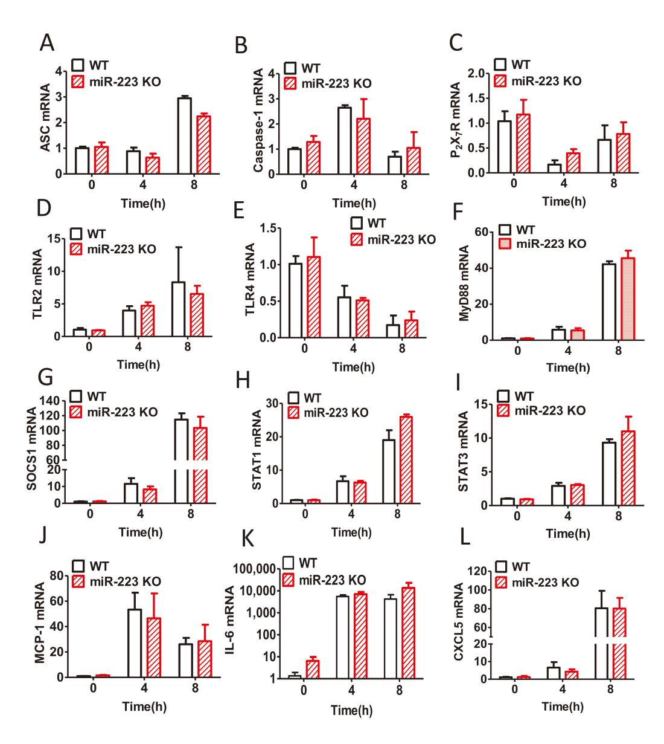
Supplementary Figure 1. Relative expression of pro-inflammatory genes related to gouty inflammation were not altered in BMDMs from miR-223 KO mice in response to MSU crystals in vitro. (A-L) Relative expression of inflammatory genes including ASC, Caspase-1, P₂X₇R, TLR2, TLR4, MyD88, SOCS1, STAT1, STAT3, MCP-1, IL-6, and CXCL5 mRNA in BMDMs treated with MSU (100 μg/mL) at 0, 4 or 8 h were detected by real-time qPCR. The results are representative of 3 independent experiments. n=3-5 for each group.

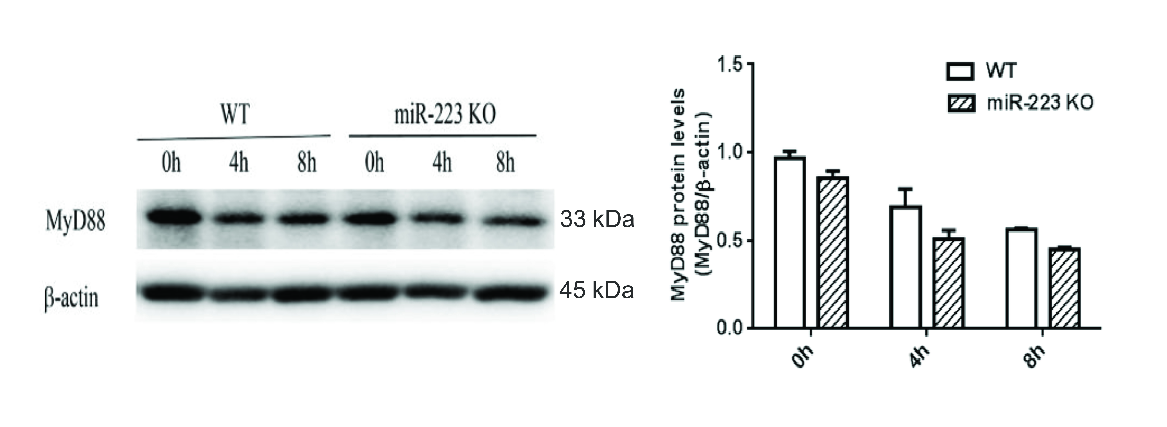
Supplementary Figure 2. The protein levels of MyD88 were comparable in BMDMs from miR-223 KO and WT mice in response to MSU crystals in vitro. MyD88 protein levels in the BMDMs from miR-223 KO or WT mice treated with MSU crystals at 0, 4 or 8 h were detected by Western blot and analyzed using Image J software. The results are representative of 3 independent experiments. n=3-5 for each group.

