Supplementary materials

Pag.

Figure S1-S6. 1D, 2D NMR and HR-ESI-MS spectra of euphorneroid E 2-5

Figure S7-S9. Three repeats of the original Western blot 6-8

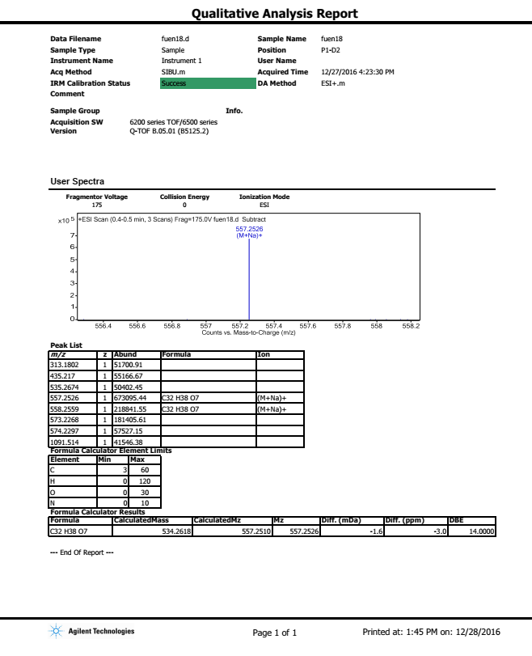
Figure S1. HR-ESI-MS spectrum of euphorneroid E

Figure S2. ¹H-NMR spectrum (600 MHz, CDCl₃) of euphorneroid E
Figure S3. ¹³C-NMR spectra (150 MHz, CDCl₃) of euphorneroid E
Figure S4. HSQC spectrum of euphorneroid E

Figure S5. HMBC spectrum of euphorneroid E

Figure S6. ROESY spectrum of euphorneroid E

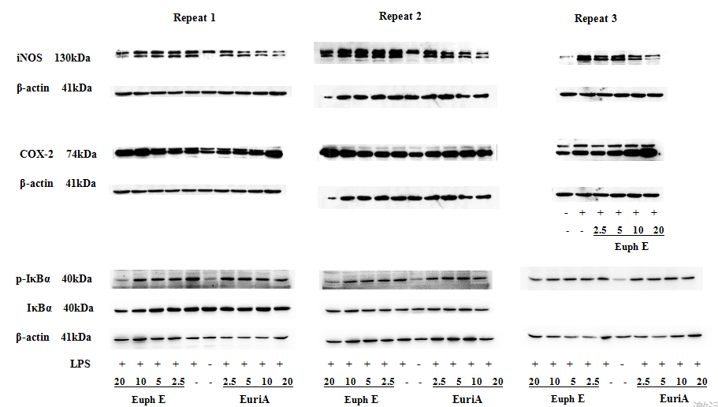
Figure S7. Three repeats of proteins iNOS,COX-2 and p-IκBα
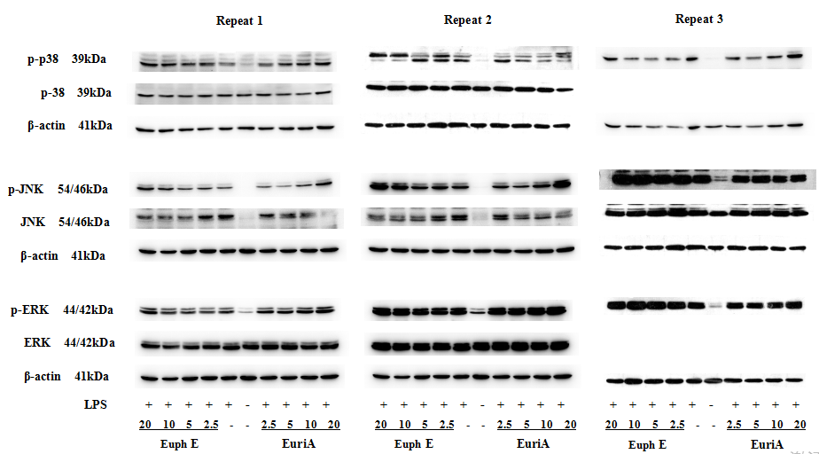 Figure S8. Three repeats of proteins p-p38, p38, p-JNK, JNK, p-ERK and ERK

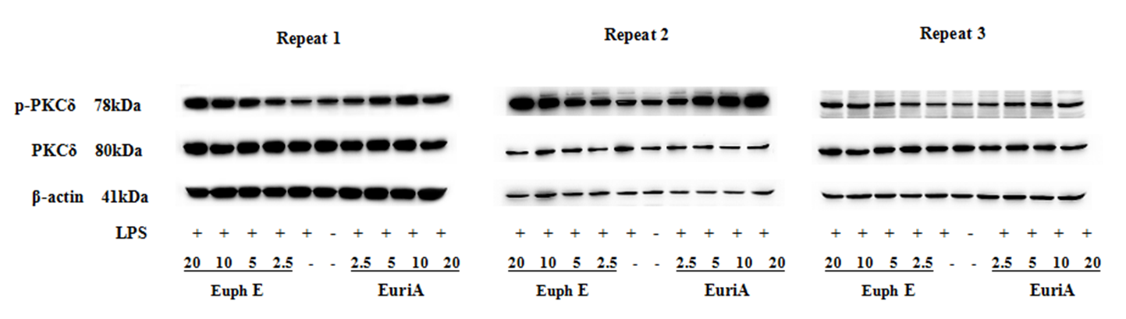
Figure S9. Three repeats of proteins p-PKCδ and PKCδ

