Supplementary files
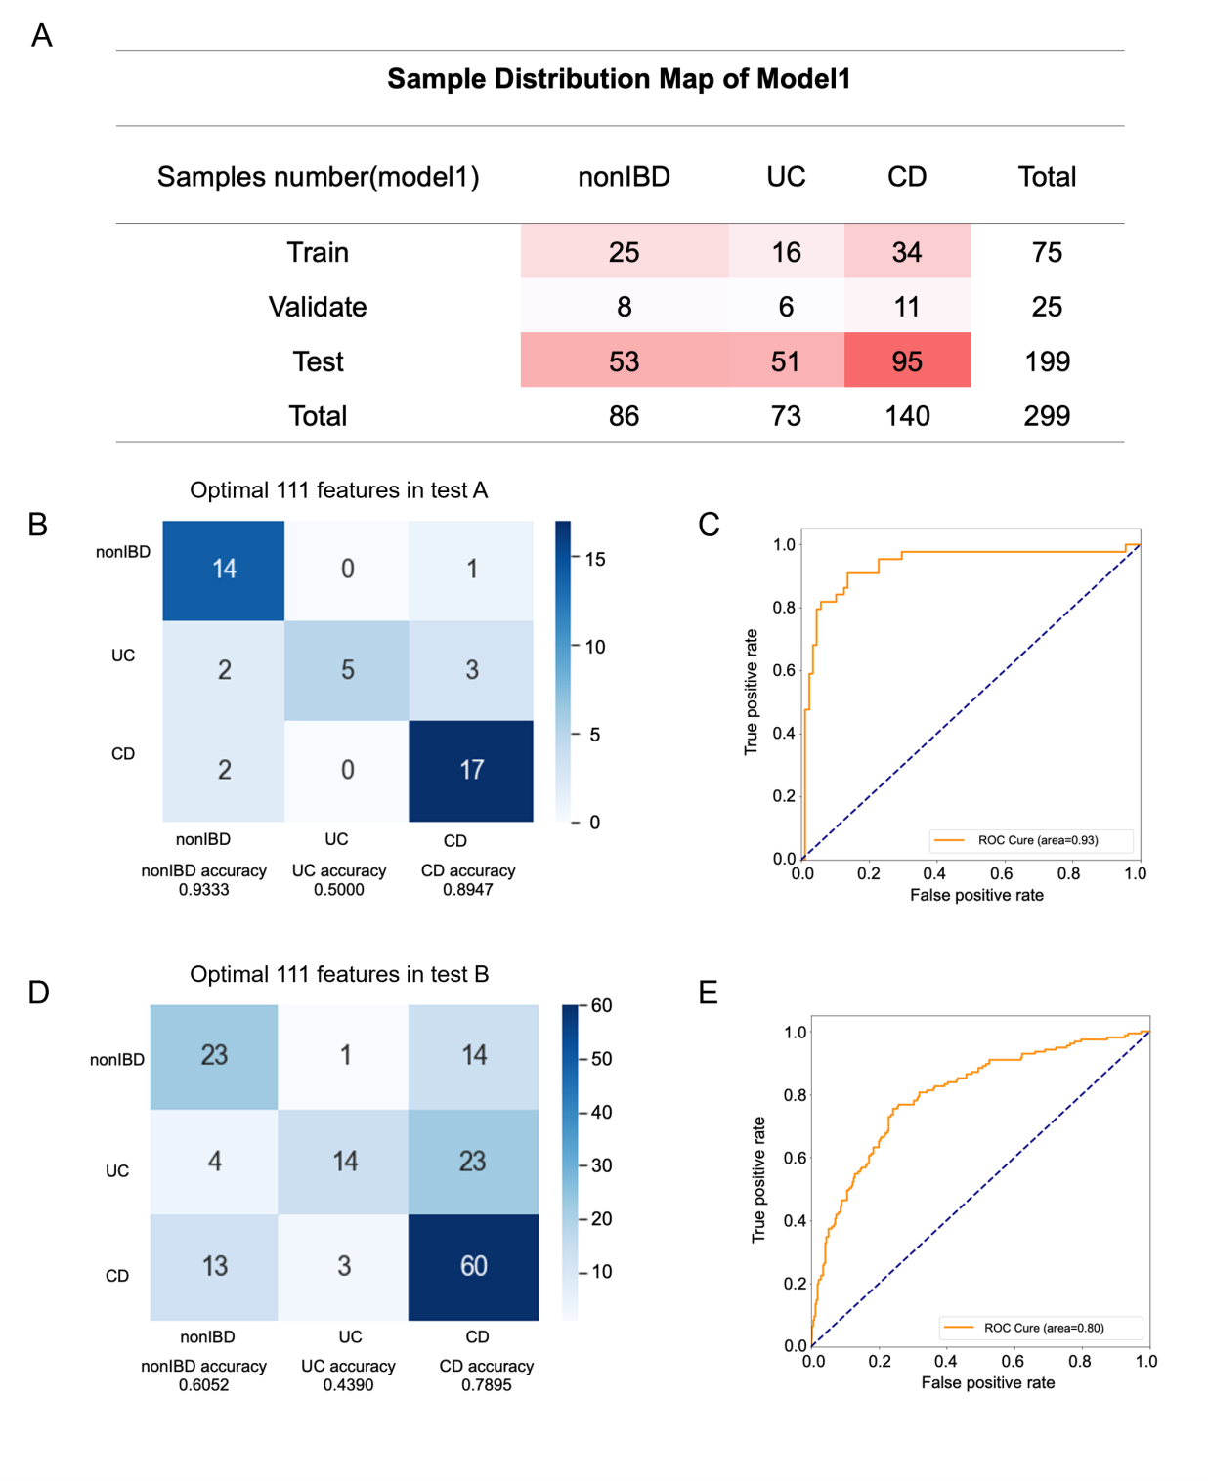
Supplementary Figure s1 Model 1 detailed information during the modeling process. All sample distributions and labels involved in model1 (A). The confusion matrix (B) and AUC value (C) of test A (44 samples) in the total test set. The confusion matrix (D) and AUC value (E) of test B (155 samples) in the total test set.

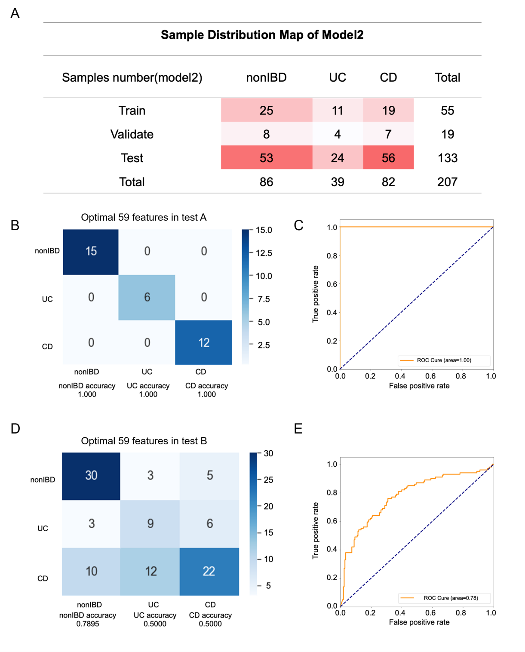
Supplementary Figure s2 Model 2 detailed information during the modeling process. All sample distributions and labels involved in model 2 (A). The confusion matrix (B) and AUC value (C) of test A (33 samples) in the total test set. The confusion matrix (D) and AUC value (E) of test B (100 samples) in the total test set.

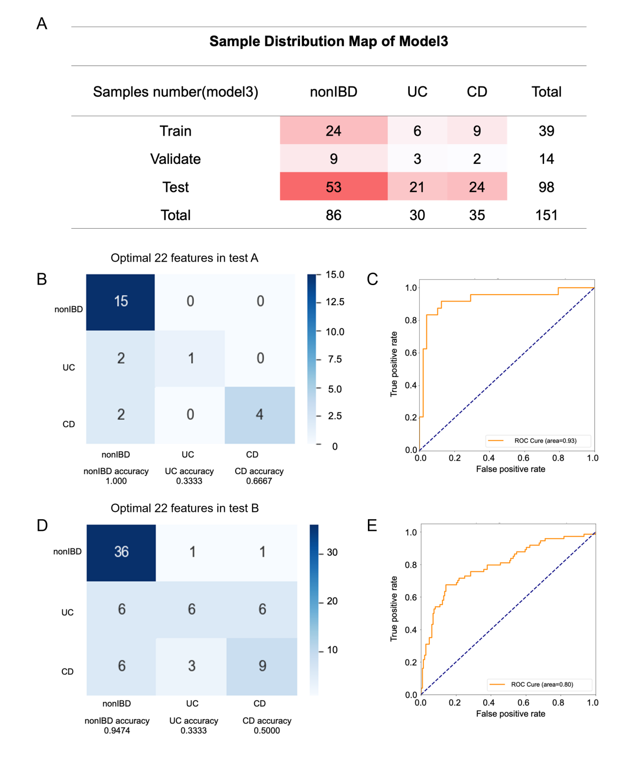
Supplementary Figure s3 Model 3 detailed information during the modeling process. All sample distributions and labels involved in model 3 (A). The confusion matrix (B) and AUC value (C) of test A (24 samples) in the total test set. The confusion matrix (D) and AUC value (E) of test B (74 samples) in the total test set.

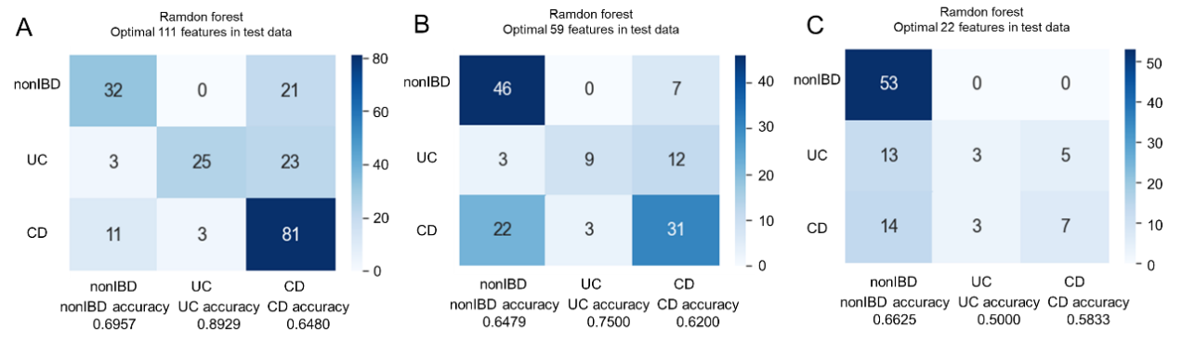
Supplementary Figure s4 the prediction accuracy obtained by the random forest classifier. The random forest classifier uses 111 markers obtained from model1 to make predictions (A). 59 markers obtained from model1 to make predictions (B). 22 markers obtained from model1 to make predictions (C).

Supplementary Table s1：Self-evaluation criteria and demographic information
Self evaluation |  | Slightly below par (65 samples) |  |  | very well(121 samples)
variable name | variable | frequency | percentage(%) | Cumulative percentage(%) | frequency | percentage(%) | Cumulative percentage(%)
sex | male | 27 | 41.54 | 41.54 | 66 | 54.55 | 54.55
sex | female | 38 | 58.46 | 100 | 55 | 45.45 | 100
diagnosis | UC | 29 | 44.62 | 44.62 | 39 | 32.23 | 32.23
diagnosis | CD | 36 | 55.38 | 100 | 82 | 67.77 | 100
Anal fissure | YES | 1 | 1.54 | 1.54 | 3 | 2.48 | 2.48
Anal fissure | NO | 64 | 98.46 | 100 | 118 | 97.52 | 100
Abscess | YES | 2 | 3.08 | 3.08 | 1 | 0.83 | 0.83
Abscess | NO | 63 | 96.92 | 100 | 120 | 99.17 | 100
Abdominal pain | Mild | 24 | 36.92 | 36.92 | 25 | 20.66 | 20.66
Abdominal pain | Moderate | 4 | 6.15 | 43.08 | 1 | 0.83 | 21.49
Abdominal pain | None | 37 | 56.92 | 100 | 95 | 78.51 | 100
Number of liquid or very soft stools in the past 24 hours | 0~1 | 22 | 33.85 | 33.85 | 67 | 55.37 | 55.37
Number of liquid or very soft stools in the past 24 hours | 2~3 | 6 | 9.23 | 43.08 | 7 | 5.79 | 61.16
Number of liquid or very soft stools in the past 24 hours | >=4 | 6 | 9.23 | 52.31 | 4 | 3.31 | 64.46
Number of liquid or very soft stools in the past 24 hours | None | 31 | 47.69 | 100 | 43 | 35.54 | 100
Arthralgia | YES | 1 | 1.54 | 1.54 | 3 | 2.48 | 2.48
Arthralgia | NO | 64 | 98.46 | 100 | 118 | 97.52 | 100
hbi | 0~3 | 20 | 30.77 | 30.77 | 72 | 59.5 | 59.5
hbi | 4~6 | 9 | 13.85 | 44.62 | 3 | 2.48 | 61.98
hbi | 7~9 | 5 | 7.69 | 52.31 | 0 | 0 | 61.98
hbi | None | 31 | 47.69 | 100 | 46 | 38.02 | 100
Arthralgias | YES | 2 | 3.08 | 3.08 | 2 | 1.65 | 1.65
Arthralgias | NO | 63 | 96.92 | 100 | 119 | 98.35 | 100
Bowel frequency during the day | 0~3 | 28 | 43.08 | 43.08 | 35 | 28.93 | 28.93
Bowel frequency during the day | >3 | 2 | 3.08 | 46.16 | 6 | 4.96 | 33.89
Bowel frequency during the day | None | 35 | 53.85 | 100 | 80 | 66.12 | 100
Urgency of defecation | Hurry | 14 | 21.54 | 21.54 | 20 | 16.53 | 16.53
Urgency of defecation | Immediately | 2 | 3.08 | 24.62 | 2 | 1.65 | 18.18
Urgency of defecation | Incontinence | 1 | 1.54 | 26.16 | 0 | 0 | 18.18
Urgency of defecation | None | 48 | 73.85 | 100 | 99 | 81.82 | 100
Blood in the stool | Trace (a little blood) | 17 | 26.15 | 26.15 | 13 | 10.74 | 10.74
Blood in the stool | Occasionally frank (ocassionally a lot of blood) | 1 | 1.54 | 27.69 | 2 | 1.65 | 12.39
Blood in the stool | Usually frank (usually a lot of blood) | 1 | 1.54 | 29.23 | 1 | 0.83 | 13.22
Blood in the stool | None | 46 | 70.77 | 100 | 105 | 86.78 | 100
sccai | 0~2 | 19 | 29.23 | 29.23 | 33 | 27.27 | 27.27
sccai | 3~4 | 8 | 12.31 | 41.54 | 7 | 5.79 | 33.06
sccai | 5~7 | 3 | 4.62 | 46.15 | 1 | 0.83 | 33.88
sccai | None | 35 | 53.85 | 100 | 80 | 66.12 | 100

Supplementary Table s2: Wilcoxon rank-sum test of all biomarkers of model1
Markers | nonIBD_mean | UC_mean | CD_mean | log2(fc-nonIBD vs. UC) | Pvalue-nonIBD vs. UC) | FDR-nonIBD vs. UC) | log2(fc-UC vs. CD) | Pvalue-UC vs. CD | FDR-UC vs. CD | log2(fc-nonIBD vs. CD) | Pvalue-nonIBD vs. CD | FDR-nonIBD vs. CD
HILp_QI4542 | 418824.88 | 293819.12 | 269344.35 | -0.51 | 0.00 | 0.00 | -0.13 | 0.92 | 0.93 | -0.64 | 0.00 | 0.00
HILn_QI8463 | 5161.49 | 8163.74 | 147551.64 | 0.66 | 0.00 | 0.00 | 4.18 | 0.00 | 0.00 | 4.84 | 0.00 | 0.00
C18n_QI13633 | 295.09 | 48977.77 | 5707.69 | 7.37 | 0.00 | 0.00 | -3.10 | 0.00 | 0.00 | 4.27 | 0.03 | 0.06
C18n_QI2985 | 3402.92 | 104698.27 | 32608.55 | 4.94 | 0.00 | 0.00 | -1.68 | 0.00 | 0.00 | 3.26 | 0.00 | 0.00
C18n_QI6575 | 61.65 | 492262.25 | 192340.18 | 12.96 | 0.00 | 0.00 | -1.36 | 0.00 | 0.00 | 11.61 | 0.00 | 0.00
C8p_QI8796 | 16594.37 | 148201.73 | 230723.81 | 3.16 | 0.00 | 0.00 | 0.64 | 0.26 | 0.39 | 3.80 | 0.00 | 0.00
C8p_QI5458 | 19418.55 | 7087.96 | 6364.06 | -1.45 | 0.01 | 0.03 | -0.16 | 0.12 | 0.23 | -1.61 | 0.00 | 0.00
C18n_QI2282 | 7263.36 | 5142.48 | 6033.28 | -0.50 | 0.00 | 0.00 | 0.23 | 0.84 | 0.88 | -0.27 | 0.00 | 0.00
C18n_QI10481 | 6924.70 | 5527.25 | 12938.29 | -0.33 | 0.28 | 0.38 | 1.23 | 0.00 | 0.00 | 0.90 | 0.00 | 0.00
6.1.1.14: Glycine--tRNA ligase|g__Bacteroides.s__Bacteroides_stercoris | 0.00 | 0.00 | 0.00 | -0.33 | 0.26 | 0.37 | 0.32 | 0.65 | 0.75 | 0.00 | 0.07 | 0.12
HILp_QI3109 | 23016.12 | 269914.41 | 55606.69 | 3.55 | 0.00 | 0.00 | -2.28 | 0.00 | 0.00 | 1.27 | 0.25 | 0.33
HILn_QI3904 | 1802.94 | 248.29 | 497.70 | -2.86 | 0.00 | 0.00 | 1.00 | 0.00 | 0.02 | -1.86 | 0.00 | 0.00
C8p_QI14747 | 53472.52 | 17259.47 | 34950.06 | -1.63 | 0.00 | 0.00 | 1.02 | 0.00 | 0.01 | -0.61 | 0.00 | 0.00
HILn_QI24418 | 49433.71 | 16139.18 | 42527.46 | -1.61 | 0.00 | 0.00 | 1.40 | 0.00 | 0.00 | -0.22 | 0.00 | 0.00
HILn_QI15191 | 45864.31 | 13964.60 | 18764.34 | -1.72 | 0.00 | 0.00 | 0.43 | 0.21 | 0.33 | -1.29 | 0.00 | 0.00
HILn_QI3222 | 94.64 | 48070.64 | 28783.76 | 8.99 | 0.00 | 0.00 | -0.74 | 0.00 | 0.00 | 8.25 | 0.00 | 0.00
C18n_QI8756 | 3981.17 | 108300.59 | 26507.14 | 4.77 | 0.00 | 0.00 | -2.03 | 0.00 | 0.00 | 2.74 | 0.00 | 0.00
HILn_QI1116 | 12903.50 | 5070.51 | 9582.21 | -1.35 | 0.00 | 0.00 | 0.92 | 0.00 | 0.01 | -0.43 | 0.00 | 0.00
HILp_QI5082 | 15397.21 | 2755.88 | 8160.39 | -2.48 | 0.00 | 0.00 | 1.57 | 0.19 | 0.32 | -0.92 | 0.00 | 0.00
C8p_QI6477 | 30223.05 | 7214.49 | 7329.01 | -2.07 | 0.00 | 0.00 | 0.02 | 0.02 | 0.04 | -2.04 | 0.00 | 0.00
C8p_QI3478 | 9300.81 | 13033.89 | 15390.52 | 0.49 | 0.00 | 0.00 | 0.24 | 0.00 | 0.01 | 0.73 | 0.44 | 0.53
C18n_QI8909 | 32701.59 | 25802.34 | 36039.92 | -0.34 | 0.04 | 0.07 | 0.48 | 0.02 | 0.05 | 0.14 | 0.90 | 0.92
C18n_QI12710 | 4295.57 | 3610.38 | 7403.06 | -0.25 | 0.95 | 0.95 | 1.04 | 0.00 | 0.00 | 0.79 | 0.00 | 0.00
HILn_QI17951 | 131.35 | 131.41 | 66.96 | 0.00 | 0.47 | 0.57 | -0.97 | 0.19 | 0.32 | -0.97 | 0.59 | 0.66
HILn_QI33358 | 1364.14 | 524.32 | 786.80 | -1.38 | 0.00 | 0.00 | 0.59 | 0.13 | 0.24 | -0.79 | 0.00 | 0.00
HILn_QI8112 | 85406.30 | 79997.11 | 52530.55 | -0.09 | 0.01 | 0.01 | -0.61 | 0.00 | 0.00 | -0.70 | 0.06 | 0.11
HILn_QI8306 | 31858.80 | 18562.92 | 17843.51 | -0.78 | 0.00 | 0.01 | -0.06 | 0.16 | 0.28 | -0.84 | 0.00 | 0.00
C18n_QI506 | 16120.91 | 8351.96 | 14958.32 | -0.95 | 0.04 | 0.08 | 0.84 | 0.00 | 0.00 | -0.11 | 0.19 | 0.26
3.5.1.88: Peptide deformylase|g__Parabacteroides.s__Parabacteroides_merdae | 0.00 | 0.00 | 0.00 | -0.73 | 0.59 | 0.68 | -0.79 | 0.00 | 0.00 | -1.52 | 0.00 | 0.00
HILp_QI2187 | 98256.72 | 48633.14 | 53736.01 | -1.01 | 0.04 | 0.07 | 0.14 | 0.61 | 0.72 | -0.87 | 0.00 | 0.00
HILn_QI31972 | 792.47 | 747.22 | 621.34 | -0.08 | 0.88 | 0.90 | -0.27 | 0.11 | 0.22 | -0.35 | 0.12 | 0.19
HILp_QI12884 | 65089.58 | 47908.97 | 38718.73 | -0.44 | 0.16 | 0.26 | -0.31 | 0.02 | 0.04 | -0.75 | 0.00 | 0.00
C8p_QI23150 | 57732.51 | 27983.73 | 12115.56 | -1.04 | 0.00 | 0.00 | -1.21 | 0.01 | 0.04 | -2.25 | 0.00 | 0.00
C18n_QI7082 | 11434.49 | 22081.26 | 20451.56 | 0.95 | 0.01 | 0.03 | -0.11 | 0.67 | 0.75 | 0.84 | 0.00 | 0.00
C18n_QI1231 | 46524.14 | 35919.22 | 38481.20 | -0.37 | 0.00 | 0.00 | 0.10 | 0.12 | 0.23 | -0.27 | 0.01 | 0.02
1.5.1.20: Methylenetetrahydrofolate reductase (NAD(P)H) | 0.00 | 0.00 | 0.00 | -0.06 | 0.41 | 0.52 | -0.09 | 0.38 | 0.51 | -0.15 | 0.12 | 0.19
C8p_QI27992 | 52606.12 | 116864.97 | 145038.74 | 1.15 | 0.00 | 0.01 | 0.31 | 0.22 | 0.35 | 1.46 | 0.00 | 0.00
HILn_QI31959 | 16099.99 | 17181.99 | 11979.73 | 0.09 | 0.14 | 0.23 | -0.52 | 0.04 | 0.08 | -0.43 | 0.00 | 0.00
C8p_QI24209 | 3501.99 | 187700.85 | 47679.13 | 5.74 | 0.00 | 0.00 | -1.98 | 0.00 | 0.00 | 3.77 | 0.21 | 0.29
C8p_QI4934 | 1537754.86 | 2103321.14 | 2625295.56 | 0.45 | 0.14 | 0.23 | 0.32 | 0.09 | 0.18 | 0.77 | 0.00 | 0.00
C18n_QI13144 | 86758.40 | 37269.36 | 40399.16 | -1.22 | 0.00 | 0.00 | 0.12 | 0.38 | 0.51 | -1.10 | 0.00 | 0.00
C18n_QI5020 | 14335.09 | 6904.90 | 18528.49 | -1.05 | 0.00 | 0.00 | 1.42 | 0.00 | 0.00 | 0.37 | 0.42 | 0.51
HILp_QI10799 | 91670.26 | 72740.22 | 59958.09 | -0.33 | 0.03 | 0.06 | -0.28 | 0.28 | 0.40 | -0.61 | 0.00 | 0.00
C8p_QI7645 | 22200.21 | 17719.29 | 25293.41 | -0.33 | 0.00 | 0.00 | 0.51 | 0.00 | 0.00 | 0.19 | 0.09 | 0.14
C8p_QI13043 | 34531.38 | 28431.95 | 19037.98 | -0.28 | 0.27 | 0.38 | -0.58 | 0.01 | 0.02 | -0.86 | 0.00 | 0.00
1.3.1.98: UDP-N-acetylmuramate dehydrogenase|g__Burkholderiales_noname.s__Burkholderiales_bacterium_1_1_47 | 0.00 | 0.00 | 0.00 | 2.50 | 0.00 | 0.00 | -0.84 | 0.02 | 0.06 | 1.65 | 0.03 | 0.06
C8p_QI15419 | 26545.85 | 10093.67 | 24610.11 | -1.40 | 0.00 | 0.01 | 1.29 | 0.13 | 0.25 | -0.11 | 0.04 | 0.08
HILp_QI4387 | 31361.69 | 44600.18 | 102367.16 | 0.51 | 0.08 | 0.14 | 1.20 | 0.00 | 0.01 | 1.71 | 0.00 | 0.00
C8p_QI29484 | 437528.59 | 254392.68 | 299300.41 | -0.78 | 0.00 | 0.00 | 0.23 | 0.58 | 0.70 | -0.55 | 0.00 | 0.00
HILp_QI9539 | 1528.90 | 1278.93 | 1033.04 | -0.26 | 0.37 | 0.50 | -0.31 | 0.00 | 0.02 | -0.57 | 0.00 | 0.00
HILp_QI2026 | 5645.58 | 3384.68 | 8266.01 | -0.74 | 0.01 | 0.03 | 1.29 | 0.69 | 0.75 | 0.55 | 0.05 | 0.10
C18n_QI13314 | 198939.86 | 140891.01 | 120335.19 | -0.50 | 0.00 | 0.00 | -0.23 | 0.55 | 0.67 | -0.73 | 0.00 | 0.00
C8p_QI23 | 19652.38 | 22701.93 | 75915.61 | 0.21 | 0.00 | 0.00 | 1.74 | 0.80 | 0.86 | 1.95 | 0.00 | 0.00
6.3.4.15: Biotin--[acetyl-CoA-carboxylase] ligase|g__Bacteroides.s__Bacteroides_ovatus | 0.00 | 0.00 | 0.00 | 0.50 | 0.80 | 0.85 | 0.31 | 0.43 | 0.55 | 0.82 | 0.56 | 0.64
HILp_QI2815 | 120334.72 | 116362.15 | 97292.31 | -0.05 | 0.50 | 0.60 | -0.26 | 0.14 | 0.25 | -0.31 | 0.03 | 0.06
C18n_QI6372 | 19458.43 | 17177.45 | 17779.15 | -0.18 | 0.01 | 0.02 | 0.05 | 0.85 | 0.88 | -0.13 | 0.00 | 0.01
HILp_QI7921 | 4323.10 | 5413.58 | 2912.36 | 0.32 | 0.36 | 0.48 | -0.89 | 0.00 | 0.00 | -0.57 | 0.00 | 0.00
HILn_QI7559 | 100082.45 | 37012.21 | 32783.59 | -1.44 | 0.00 | 0.00 | -0.18 | 0.68 | 0.75 | -1.61 | 0.00 | 0.00
C18n_QI10254 | 957852.85 | 478518.14 | 392155.04 | -1.00 | 0.04 | 0.08 | -0.29 | 0.05 | 0.10 | -1.29 | 0.00 | 0.00
C8p_QI4276 | 19502.01 | 24045.08 | 18085.46 | 0.30 | 0.00 | 0.00 | -0.41 | 0.65 | 0.75 | -0.11 | 0.00 | 0.00
HILp_QI20321 | 6765.23 | 24649.97 | 16741.01 | 1.87 | 0.01 | 0.01 | -0.56 | 0.00 | 0.00 | 1.31 | 0.17 | 0.25
HILp_QI6087 | 1599.70 | 1421.16 | 4018.24 | -0.17 | 0.22 | 0.33 | 1.50 | 0.69 | 0.75 | 1.33 | 0.32 | 0.41
1.1.1.267: 1-deoxy-D-xylulose-5-phosphate reductoisomerase|g__Parabacteroides.s__Parabacteroides_distasonis | 0.00 | 0.00 | 0.00 | 1.52 | 0.00 | 0.00 | -0.75 | 0.00 | 0.01 | 0.77 | 0.43 | 0.52
4.2.1.2: Fumarate hydratase|g__Faecalibacterium.s__Faecalibacterium_prausnitzii | 0.00 | 0.00 | 0.00 | 0.57 | 0.26 | 0.37 | -1.02 | 0.00 | 0.00 | -0.44 | 0.01 | 0.02
C18n_QI6774 | 5617.20 | 6498.85 | 6427.81 | 0.21 | 0.40 | 0.52 | -0.02 | 1.00 | 1.00 | 0.19 | 0.28 | 0.37
C8p_QI6064 | 789.13 | 1051.15 | 2465.71 | 0.41 | 0.83 | 0.86 | 1.23 | 0.00 | 0.00 | 1.64 | 0.00 | 0.00
C8p_QI22437 | 122944.71 | 90872.55 | 108591.58 | -0.44 | 0.01 | 0.01 | 0.26 | 0.67 | 0.75 | -0.18 | 0.00 | 0.01
C8p_QI27233 | 195115.13 | 360728.99 | 263218.80 | 0.89 | 0.43 | 0.54 | -0.45 | 0.55 | 0.67 | 0.43 | 0.85 | 0.89
C18n_QI10593 | 258190.36 | 300703.96 | 262138.85 | 0.22 | 0.08 | 0.14 | -0.20 | 0.06 | 0.13 | 0.02 | 0.69 | 0.76
C8p_QI25824 | 44078.43 | 147174.34 | 105969.19 | 1.74 | 0.00 | 0.00 | -0.47 | 0.00 | 0.01 | 1.27 | 0.86 | 0.90
2.6.1.52: Phosphoserine transaminase | 0.01 | 0.01 | 0.01 | -0.11 | 0.24 | 0.35 | 0.22 | 0.12 | 0.23 | 0.11 | 0.55 | 0.63
C18n_QI4365 | 10859.22 | 13361.29 | 29225.41 | 0.30 | 0.02 | 0.04 | 1.13 | 0.09 | 0.18 | 1.43 | 0.17 | 0.24
HILp_QI5723 | 183835.31 | 469553.73 | 571266.81 | 1.35 | 0.00 | 0.00 | 0.28 | 0.40 | 0.52 | 1.64 | 0.00 | 0.01
HILp_QI4614 | 2518.45 | 1316.88 | 2799.86 | -0.94 | 0.00 | 0.00 | 1.09 | 0.01 | 0.03 | 0.15 | 0.21 | 0.29
3.4.21.88: Repressor LexA|unclassified | 0.00 | 0.00 | 0.00 | 0.03 | 0.72 | 0.79 | -0.73 | 0.00 | 0.00 | -0.70 | 0.00 | 0.00
HILn_QI24862 | 9878.37 | 6883.82 | 7478.49 | -0.52 | 0.12 | 0.19 | 0.12 | 0.43 | 0.55 | -0.40 | 0.35 | 0.44
HILn_QI23150 | 6672.17 | 4942.03 | 8203.23 | -0.43 | 0.03 | 0.06 | 0.73 | 0.23 | 0.36 | 0.30 | 0.33 | 0.41
HILp_QI5041 | 129602.88 | 121980.71 | 145617.71 | -0.09 | 0.58 | 0.68 | 0.26 | 0.55 | 0.67 | 0.17 | 0.98 | 0.98
HILn_QI5881 | 31967.58 | 39254.04 | 36022.14 | 0.30 | 0.10 | 0.17 | -0.12 | 0.20 | 0.32 | 0.17 | 0.57 | 0.65
HILn_QI782 | 2737.76 | 34477.51 | 2440.25 | 3.65 | 0.01 | 0.02 | -3.82 | 0.00 | 0.00 | -0.17 | 0.54 | 0.63
HILp_QI7404 | 152525.86 | 145654.41 | 136303.33 | -0.07 | 0.13 | 0.21 | -0.10 | 0.91 | 0.93 | -0.16 | 0.07 | 0.12
C18n_QI131 | 114504.76 | 116485.71 | 156977.31 | 0.02 | 0.47 | 0.57 | 0.43 | 0.01 | 0.02 | 0.46 | 0.01 | 0.03
HILn_QI18073 | 160824.88 | 171703.85 | 351322.09 | 0.09 | 0.17 | 0.26 | 1.03 | 0.17 | 0.29 | 1.13 | 0.97 | 0.97
HILp_QI5262 | 17826.71 | 18353.42 | 14230.65 | 0.04 | 0.75 | 0.81 | -0.37 | 0.02 | 0.06 | -0.33 | 0.03 | 0.07
HILp_QI5704 | 90145.53 | 116977.77 | 94499.54 | 0.38 | 0.01 | 0.03 | -0.31 | 0.01 | 0.02 | 0.07 | 0.75 | 0.81
HILp_QI11742 | 11246.40 | 5277.38 | 8968.49 | -1.09 | 0.00 | 0.00 | 0.77 | 0.03 | 0.07 | -0.33 | 0.03 | 0.06
C8p_QI10951 | 18270.77 | 12516.19 | 15113.55 | -0.55 | 0.00 | 0.00 | 0.27 | 0.01 | 0.04 | -0.27 | 0.12 | 0.19
6.1.1.6: Lysine--tRNA ligase|g__Bacteroides.s__Bacteroides_caccae | 0.00 | 0.00 | 0.00 | 0.11 | 0.18 | 0.28 | 0.00 | 0.83 | 0.88 | 0.12 | 0.08 | 0.13
HILn_QI13282 | 148992.81 | 108276.05 | 128211.13 | -0.46 | 0.95 | 0.95 | 0.24 | 0.28 | 0.40 | -0.22 | 0.43 | 0.52
2.10.1.1: Molybdopterin molybdotransferase | 0.00 | 0.00 | 0.00 | -0.36 | 0.56 | 0.66 | 1.64 | 0.24 | 0.36 | 1.28 | 0.07 | 0.12
HILn_QI24132 | 1131.51 | 772.95 | 867.48 | -0.55 | 0.74 | 0.81 | 0.17 | 0.61 | 0.72 | -0.38 | 0.33 | 0.42
HILp_QI4288 | 28239.41 | 30885.23 | 24979.10 | 0.13 | 0.47 | 0.57 | -0.31 | 0.23 | 0.36 | -0.18 | 0.63 | 0.70
1.5.1.2: Pyrroline-5-carboxylate reductase | 0.00 | 0.00 | 0.00 | -0.12 | 0.04 | 0.08 | 0.00 | 0.70 | 0.75 | -0.13 | 0.06 | 0.10
C18n_QI7894 | 41313.06 | 34661.18 | 26184.01 | -0.25 | 0.95 | 0.95 | -0.40 | 0.14 | 0.26 | -0.66 | 0.15 | 0.23
HILp_QI9423 | 108401.66 | 94237.75 | 66044.98 | -0.20 | 0.64 | 0.72 | -0.51 | 0.01 | 0.02 | -0.71 | 0.00 | 0.00
HILp_QI2700 | 4787.41 | 78.32 | 7096.23 | -5.93 | 0.67 | 0.74 | 6.50 | 0.02 | 0.04 | 0.57 | 0.04 | 0.08
C8p_QI16688 | 58314.85 | 101843.67 | 111753.48 | 0.80 | 0.04 | 0.07 | 0.13 | 0.26 | 0.39 | 0.94 | 0.00 | 0.00
HILn_QI33327 | 254283.55 | 247536.63 | 326687.34 | -0.04 | 0.25 | 0.35 | 0.40 | 0.01 | 0.02 | 0.36 | 0.10 | 0.16
C18n_QI13281 | 86201.15 | 105817.59 | 82036.61 | 0.30 | 0.77 | 0.82 | -0.37 | 0.51 | 0.65 | -0.07 | 0.83 | 0.88
HILp_QI11840 | 223301.51 | 714793.53 | 121377.24 | 1.68 | 0.82 | 0.86 | -2.56 | 0.30 | 0.43 | -0.88 | 0.17 | 0.25
2.7.7.2: FAD synthetase|g__Clostridium.s__Clostridium_leptum | 0.00 | 0.00 | 0.00 | -1.65 | 0.08 | 0.15 | 0.98 | 0.43 | 0.55 | -0.67 | 0.00 | 0.01
HILn_QI1241 | 19224.60 | 88418.47 | 74334.20 | 2.20 | 0.47 | 0.57 | -0.25 | 0.65 | 0.75 | 1.95 | 0.10 | 0.16
1.17.1.8: 4-hydroxy-tetrahydrodipicolinate reductase|g__Bacteroides.s__Bacteroides_vulgatus | 0.00 | 0.00 | 0.00 | 0.36 | 0.56 | 0.66 | -0.13 | 0.34 | 0.48 | 0.23 | 0.67 | 0.73
HILp_QI18079 | 8207.24 | 1974.52 | 19678.98 | -2.06 | 0.22 | 0.33 | 3.32 | 0.03 | 0.07 | 1.26 | 0.32 | 0.41
C18n_QI8468 | 120697.47 | 161653.27 | 185268.14 | 0.42 | 0.33 | 0.45 | 0.20 | 0.19 | 0.32 | 0.62 | 0.87 | 0.91
HILn_QI4584 | 647.27 | 151.78 | 345.19 | -2.09 | 0.24 | 0.35 | 1.19 | 1.00 | 1.00 | -0.91 | 0.17 | 0.24
HILp_QI10651 | 78829.45 | 106878.10 | 139180.77 | 0.44 | 0.42 | 0.54 | 0.38 | 0.37 | 0.51 | 0.82 | 0.91 | 0.92
HILn_QI8435 | 351.98 | 376.14 | 434.46 | 0.10 | 0.04 | 0.08 | 0.21 | 0.35 | 0.49 | 0.30 | 0.13 | 0.19
2.7.2.1: Acetate kinase|g__Streptococcus.s__Streptococcus_thermophilus | 0.00 | 0.00 | 0.00 | -1.27 | 0.63 | 0.71 | 0.00 | 0.02 | 0.04 | -0.20 | 0.00 | 0.01
HILn_QI25300 | 3542.85 | 14936.64 | 4412.05 | 2.08 | 0.00 | 0.01 | -1.76 | 0.03 | 0.08 | 0.32 | 0.23 | 0.31
C8p_QI25956 | 48768.70 | 13608.21 | 31251.64 | -1.84 | 0.01 | 0.02 | 1.20 | 0.02 | 0.06 | -0.64 | 0.45 | 0.53

Supplementary Table s3: Wilcoxon rank-sum test of all biomarkers of model2
Markers | nonIBD_mean | UC_mean | CD_mean | log2(fc-nonIBD vs. UC) | Pvalue-nonIBD vs. UC) | FDR-nonIBD vs. UC) | log2(fc-UC vs. CD) | Pvalue-UC vs. CD | FDR-UC vs. CD | log2(fc-nonIBD vs. CD) | Pvalue-nonIBD vs. CD | FDR-nonIBD vs. CD
HILn_QI11981 | 831.72 | 141.56 | 357.91 | -2.55 | 0.00 | 0.00 | 1.34 | 0.01 | 0.02 | -1.22 | 0.00 | 0.00
C18n_QI1038 | 1070.70 | 11262.18 | 12365.80 | 3.39 | 0.00 | 0.00 | 0.13 | 0.10 | 0.12 | 3.53 | 0.00 | 0.00
C18n_QI382 | 1335.90 | 20738.64 | 9702.79 | 3.96 | 0.00 | 0.00 | -1.10 | 0.00 | 0.00 | 2.86 | 0.00 | 0.00
HILn_QI12814 | 94920.65 | 35692.26 | 39246.89 | -1.41 | 0.00 | 0.00 | 0.14 | 0.34 | 0.37 | -1.27 | 0.00 | 0.00
HILp_QI10008 | 682642.35 | 347419.92 | 380084.22 | -0.97 | 0.00 | 0.00 | 0.13 | 0.06 | 0.09 | -0.84 | 0.00 | 0.00
C18n_QI6687 | 19214.52 | 34355.54 | 55069.18 | 0.84 | 0.00 | 0.01 | 0.68 | 0.03 | 0.06 | 1.52 | 0.00 | 0.00
C8p_QI10089 | 723.51 | 4794.44 | 11850.52 | 2.73 | 0.11 | 0.17 | 1.31 | 0.05 | 0.08 | 4.03 | 0.00 | 0.00
C18n_QI1192 | 553.91 | 771.44 | 2039.11 | 0.48 | 0.32 | 0.42 | 1.40 | 0.05 | 0.08 | 1.88 | 0.00 | 0.00
HILp_QI5507 | 55744.53 | 87622.87 | 46664.41 | 0.65 | 0.02 | 0.04 | -0.91 | 0.00 | 0.00 | -0.26 | 0.04 | 0.06
C18n_QI6040 | 103105.76 | 55941.10 | 91531.68 | -0.88 | 0.03 | 0.06 | 0.71 | 0.01 | 0.02 | -0.17 | 0.59 | 0.67
1.8.4.11: Peptide-methionine (S)-S-oxide reductase|g__Bacteroides.s__Bacteroides_uniformis | 0.00 | 0.00 | 0.00 | 0.75 | 0.31 | 0.42 | -0.58 | 0.22 | 0.25 | 0.18 | 0.61 | 0.67
HILp_QI3065 | 65005.86 | 182773.15 | 128066.44 | 1.49 | 0.00 | 0.00 | -0.51 | 0.17 | 0.20 | 0.98 | 0.00 | 0.00
C18n_QI4210 | 86372.10 | 42113.23 | 72242.98 | -1.04 | 0.00 | 0.00 | 0.78 | 0.00 | 0.00 | -0.26 | 0.04 | 0.06
HILp_QI9362 | 54195.87 | 80041.44 | 33639.82 | 0.56 | 0.05 | 0.09 | -1.25 | 0.00 | 0.00 | -0.69 | 0.00 | 0.00
HILn_QI15356 | 39643.73 | 11385.87 | 12888.49 | -1.80 | 0.00 | 0.00 | 0.18 | 0.06 | 0.08 | -1.62 | 0.00 | 0.00
C18n_QI10170 | 533756.81 | 349045.41 | 736907.57 | -0.61 | 0.01 | 0.02 | 1.08 | 0.00 | 0.00 | 0.47 | 0.00 | 0.01
C8p_QI19750 | 1707.45 | 11542.79 | 3375.16 | 2.76 | 0.73 | 0.77 | -1.77 | 0.06 | 0.09 | 0.98 | 0.00 | 0.00
HILn_QI17486 | 20812.67 | 20840.03 | 30347.55 | 0.00 | 0.88 | 0.91 | 0.54 | 0.04 | 0.08 | 0.54 | 0.01 | 0.02
C18n_QI12711 | 5082.34 | 5896.74 | 8214.83 | 0.21 | 0.50 | 0.60 | 0.48 | 0.01 | 0.02 | 0.69 | 0.00 | 0.01
C18n_QI402 | 623.59 | 975.33 | 879.46 | 0.65 | 0.00 | 0.01 | -0.15 | 0.86 | 0.88 | 0.50 | 0.00 | 0.00
C8p_QI3505 | 39948.83 | 175381.13 | 103791.67 | 2.13 | 0.04 | 0.07 | -0.76 | 0.96 | 0.96 | 1.38 | 0.00 | 0.00
C18n_QI13257 | 121238.47 | 51365.28 | 60003.54 | -1.24 | 0.00 | 0.00 | 0.22 | 0.16 | 0.19 | -1.01 | 0.00 | 0.00
C8p_QI22510 | 100413.69 | 206212.18 | 117496.16 | 1.04 | 0.07 | 0.12 | -0.81 | 0.06 | 0.09 | 0.23 | 0.79 | 0.82
C8p_QI26385 | 83.76 | 5030.41 | 2732.51 | 5.91 | 0.00 | 0.00 | -0.88 | 0.04 | 0.07 | 5.03 | 0.04 | 0.06
HILp_QI254 | 16865.78 | 23226.69 | 20203.65 | 0.46 | 0.04 | 0.08 | -0.20 | 0.04 | 0.08 | 0.26 | 0.70 | 0.74
C8p_QI851 | 7890.51 | 9759.97 | 7540.34 | 0.31 | 0.07 | 0.12 | -0.37 | 0.00 | 0.01 | -0.07 | 0.10 | 0.14
HILn_TF1 | 2497191.99 | 2773760.92 | 2005336.35 | 0.15 | 0.69 | 0.74 | -0.47 | 0.05 | 0.08 | -0.32 | 0.02 | 0.04
HILp_QI6854 | 247283.27 | 187661.18 | 222906.66 | -0.40 | 0.00 | 0.00 | 0.25 | 0.00 | 0.00 | -0.15 | 0.35 | 0.44
HILp_QI10973 | 291.58 | 1609.59 | 732.30 | 2.46 | 0.01 | 0.02 | -1.14 | 0.05 | 0.08 | 1.33 | 0.41 | 0.50
HILn_QI11589 | 12959.84 | 6675.28 | 17139.26 | -0.96 | 0.02 | 0.04 | 1.36 | 0.01 | 0.03 | 0.40 | 0.47 | 0.57
HILp_QI1546 | 19102.81 | 36870.82 | 24601.38 | 0.95 | 0.00 | 0.00 | -0.58 | 0.00 | 0.02 | 0.37 | 0.31 | 0.40
HILp_QI13897 | 142013.87 | 319559.90 | 87479.40 | 1.17 | 0.59 | 0.65 | -1.87 | 0.02 | 0.04 | -0.70 | 0.01 | 0.02
HILn_QI27455 | 1722.12 | 1654.10 | 4283.63 | -0.06 | 0.02 | 0.04 | 1.37 | 0.00 | 0.00 | 1.31 | 0.04 | 0.06
HILp_QI7921 | 4323.10 | 5480.03 | 3116.89 | 0.34 | 0.23 | 0.33 | -0.81 | 0.00 | 0.00 | -0.47 | 0.00 | 0.01
HILn_QI14808 | 4113.78 | 2378.74 | 3791.18 | -0.79 | 0.02 | 0.04 | 0.67 | 0.01 | 0.03 | -0.12 | 0.85 | 0.86
HILn_QI23355 | 704951.20 | 2305389.74 | 1260071.52 | 1.71 | 0.00 | 0.00 | -0.87 | 0.00 | 0.00 | 0.84 | 0.00 | 0.00
HILn_QI12800 | 7829.69 | 10458.87 | 37015.56 | 0.42 | 0.00 | 0.00 | 1.82 | 0.00 | 0.01 | 2.24 | 0.60 | 0.67
HILn_QI2624 | 160.01 | 144.31 | 1049.45 | -0.15 | 0.59 | 0.65 | 2.86 | 0.00 | 0.00 | 2.71 | 0.00 | 0.00
HILn_QI28558 | 143061.95 | 142635.18 | 285309.45 | 0.00 | 0.01 | 0.02 | 1.00 | 0.00 | 0.01 | 1.00 | 0.24 | 0.32
HILp_QI2140 | 25253.83 | 15783.28 | 23711.89 | -0.68 | 0.00 | 0.00 | 0.59 | 0.01 | 0.03 | -0.09 | 0.21 | 0.29
HILn_QI30399 | 63210.90 | 55221.26 | 76704.73 | -0.19 | 0.14 | 0.21 | 0.47 | 0.03 | 0.06 | 0.28 | 0.14 | 0.20
C18n_QI7063 | 3256.31 | 1371.59 | 5378.52 | -1.25 | 0.00 | 0.01 | 1.97 | 0.00 | 0.01 | 0.72 | 0.49 | 0.57
C18n_QI6139 | 215250.85 | 248787.77 | 109021.68 | 0.21 | 0.31 | 0.42 | -1.19 | 0.02 | 0.05 | -0.98 | 0.00 | 0.00
HILp_QI13610 | 8609.69 | 8366.95 | 9248.68 | -0.04 | 0.02 | 0.04 | 0.14 | 0.03 | 0.06 | 0.10 | 0.87 | 0.87
HILp_QI722 | 100.06 | 126.44 | 216.77 | 0.34 | 0.22 | 0.33 | 0.78 | 0.09 | 0.11 | 1.12 | 0.00 | 0.00
HILp_QI4387 | 31361.69 | 46977.46 | 100447.45 | 0.58 | 0.28 | 0.39 | 1.10 | 0.00 | 0.01 | 1.68 | 0.00 | 0.00
HILp_QI6584 | 21168.08 | 41651.10 | 23810.49 | 0.98 | 0.53 | 0.61 | -0.81 | 0.77 | 0.80 | 0.17 | 0.70 | 0.74
C8p_QI22523 | 4093.13 | 3281.72 | 1363.12 | -0.32 | 0.02 | 0.04 | -1.27 | 0.43 | 0.46 | -1.59 | 0.02 | 0.04
HILp_QI7167 | 348463.73 | 528332.56 | 314888.98 | 0.60 | 0.41 | 0.51 | -0.75 | 0.09 | 0.11 | -0.15 | 0.00 | 0.01
C8p_QI11994 | 578.55 | 990.79 | 1835.51 | 0.78 | 0.44 | 0.54 | 0.89 | 0.11 | 0.14 | 1.67 | 0.00 | 0.01
HILp_QI5854 | 15147.91 | 6479.15 | 10292.06 | -1.23 | 0.35 | 0.45 | 0.67 | 0.06 | 0.09 | -0.56 | 0.00 | 0.00
C8p_QI20261 | 1442.41 | 1101.56 | 3331.57 | -0.39 | 0.91 | 0.92 | 1.60 | 0.00 | 0.01 | 1.21 | 0.00 | 0.00
4.1.1.49: Phosphoenolpyruvate carboxykinase (ATP)|g__Odoribacter.s__Odoribacter_splanchnicus | 0.00 | 0.00 | 0.00 | -1.10 | 0.00 | 0.00 | 1.89 | 0.00 | 0.00 | 0.79 | 0.57 | 0.66
HILp_QI7275 | 67706.66 | 60010.82 | 76088.96 | -0.17 | 0.23 | 0.33 | 0.34 | 0.41 | 0.45 | 0.17 | 0.00 | 0.01
HILn_QI4111 | 7776.50 | 6925.21 | 11206.33 | -0.17 | 0.51 | 0.60 | 0.69 | 0.07 | 0.09 | 0.53 | 0.13 | 0.18
4.2.3.3: Methylglyoxal synthase|g__Bacteroides.s__Bacteroides_vulgatus | 0.00 | 0.00 | 0.00 | -0.92 | 0.03 | 0.05 | 0.53 | 0.56 | 0.59 | -0.39 | 0.05 | 0.07
HILn_QI6680 | 18417.26 | 4943.67 | 10259.73 | -1.90 | 0.01 | 0.02 | 1.05 | 0.04 | 0.08 | -0.84 | 0.28 | 0.37
3.6.4.12: DNA helicase|g__Ruminococcus.s__Ruminococcus_lactaris | 0.00 | 0.00 | 0.00 | 0.11 | 0.58 | 0.65 | -0.52 | 0.02 | 0.04 | -0.41 | 0.04 | 0.06
3.6.1.1: Inorganic diphosphatase|g__Lachnospiraceae_noname.s__Lachnospiraceae_bacterium_7_1_58FAA | 0.00 | 0.00 | 0.00 | -1.91 | 0.95 | 0.95 | 3.72 | 0.07 | 0.09 | 1.81 | 0.01 | 0.03

Supplementary Table s4: Wilcoxon rank-sum test of all biomarkers of model3
Markers | nonIBD_mean | UC_mean | CD_mean | log2(fc-nonIBD vs. UC) | Pvalue-nonIBD vs. UC) | FDR-nonIBD vs. UC) | log2(fc-UC vs. CD) | Pvalue-UC vs. CD | FDR-UC vs. CD | log2(fc-nonIBD vs. CD) | Pvalue-nonIBD vs. CD | FDR-nonIBD vs. CD
C18n_QI3056 | 8673.56 | 2001779.76 | 1324098.28 | 7.85 | 3.32E-10 | 7.30E-09 | -0.60 | 0.01 | 0.07 | 7.25 | 1.87E-04 | 3.74E-04
C8p_QI7865 | 8391.67 | 69877.14 | 59656.92 | 3.06 | 0.00 | 0.00 | -0.23 | 7.26E-01 | 0.89 | 2.83 | 1.84E-07 | 8.07E-07
C18n_QI12976 | 52560.66 | 24359.38 | 17362.58 | -1.11 | 9.87E-05 | 4.36E-04 | -0.49 | 6.30E-01 | 8.64E-01 | -1.60 | 0.00 | 0.00
C8p_QI16727 | 10365.91 | 26335.24 | 126104.33 | 1.35 | 3.58E-01 | 3.94E-01 | 2.26 | 9.93E-04 | 2.18E-02 | 3.60 | 7.41E-08 | 0.00
C8p_QI20507 | 3008.69 | 30205.24 | 35782.61 | 3.33 | 1.17E-04 | 4.36E-04 | 0.24 | 9.79E-01 | 9.79E-01 | 3.57 | 9.35E-06 | 3.43E-05
HILn_QI18128 | 1453.30 | 161.69 | 302.94 | -3.17 | 2.45E-08 | 2.70E-07 | 0.91 | 0.93 | 0.97 | -2.26 | 1.36E-07 | 7.51E-07
C18n_QI13373 | 94112.69 | 42508.90 | 43790.69 | -1.15 | 0.00 | 0.00 | 0.04 | 0.53 | 0.84 | -1.10 | 2.21E-05 | 0.00
3.2.1.52: Beta-N-acetylhexosaminidase|g__Flavonifractor.s__Flavonifractor_plautii | 0.00 | 0.00 | 0.00 | 2.14 | 7.41E-02 | 0.10 | 1.26 | 0.49 | 0.84 | 3.40 | 4.99E-03 | 7.31E-03
C18n_QI10541 | 29129.49 | 17025.83 | 14924.11 | -0.77 | 0.00 | 0.00 | -0.19 | 6.68E-01 | 8.64E-01 | -0.96 | 1.04E-04 | 2.28E-04
HILp_QI394 | 15898.92 | 15958.00 | 13246.81 | 0.01 | 0.60 | 0.63 | -0.27 | 0.03 | 0.18 | -0.26 | 0.00 | 0.00
HILp_QI5928 | 109172.85 | 664617.52 | 258665.25 | 2.61 | 7.57E-04 | 1.85E-03 | -1.36 | 6.49E-01 | 8.64E-01 | 1.24 | 0.00 | 0.00
HILp_QI9302 | 37305.81 | 19341.03 | 16734.78 | -0.95 | 2.39E-03 | 4.39E-03 | -0.21 | 0.16 | 0.44 | -1.16 | 1.58E-05 | 4.97E-05
HILp_QI21102 | 6425.17 | 22302.79 | 26964.86 | 1.80 | 1.19E-01 | 1.54E-01 | 0.27 | 0.34 | 0.69 | 2.07 | 0.75 | 0.75
HILp_QI24842 | 52490.65 | 40821.10 | 75770.53 | -0.36 | 2.56E-02 | 3.76E-02 | 0.89 | 0.00 | 0.03 | 0.53 | 1.19E-01 | 1.46E-01
C18n_QI5448 | 23371.27 | 13182.10 | 13469.03 | -0.83 | 1.43E-03 | 3.15E-03 | 0.03 | 0.80 | 0.92 | -0.80 | 1.14E-02 | 1.57E-02
HILn_QI9324 | 173325.12 | 62442.76 | 131107.72 | -1.47 | 1.65E-03 | 3.30E-03 | 1.07 | 1.48E-01 | 4.39E-01 | -0.40 | 1.58E-01 | 1.83E-01
C8p_QI19571 | 28798.02 | 10210.31 | 2539.92 | -1.50 | 7.53E-04 | 1.85E-03 | -2.01 | 2.48E-01 | 6.06E-01 | -3.50 | 7.24E-08 | 0.00
HILp_QI5452 | 20128.35 | 19505.59 | 5995.47 | -0.05 | 2.07E-02 | 3.26E-02 | -1.70 | 0.84 | 0.93 | -1.75 | 1.31E-03 | 2.21E-03
1.1.1.3: Homoserine dehydrogenase|g__Faecalibacterium.s__Faecalibacterium_prausnitzii | 0.00 | 0.00 | 0.00 | 0.29 | 1.63E-01 | 1.99E-01 | -0.39 | 0.13 | 0.44 | -0.10 | 6.04E-01 | 6.36E-01
HILp_QI5937 | 8337.00 | 7563.86 | 4930.39 | -0.14 | 0.21 | 0.24 | -0.62 | 0.08 | 0.36 | -0.76 | 9.09E-05 | 2.22E-04
C8p_QI15740 | 1047098.11 | 719861.76 | 848214.81 | -0.54 | 0.00 | 0.00 | 0.24 | 0.28 | 0.61 | -0.30 | 0.02 | 0.02
2.8.1.10: Thiazole synthase | 0.00 | 0.00 | 0.00 | -0.28 | 0.73 | 0.73 | 0.26 | 0.51 | 0.84 | -0.02 | 0.61 | 0.64

Supplementary Table s5: Metabolite feature metadata
Method | Pooled QC sample CV | m/z | RT | Compound
C18-neg | 0.037775 | 273.0519 | 0.75 | C18n_QI3056
C18-neg | 0.054083 | 188.0921 | 0.87 | C18n_QI1231
C18-neg | 0.129038 | 380.1833 | 0.95 | C18n_QI6372
C18-neg | 0.313653 | 245.049 | 0.97 | C18n_QI2282
C18-neg | 0.120775 | 337.141 | 1.36 | C18n_QI5020
C18-neg | 0.051789 | 123.0076 | 1.58 | C18n_QI382
C18-neg | 0.101354 | 316.0653 | 1.6 | C18n_QI4365
C18-neg | 0.038114 | 179.0277 | 1.89 | C18n_QI1038
C18-neg | 0.150989 | 186.1128 | 1.97 | C18n_QI1192
C18-neg | 0.109157 | 351.0853 | 2.09 | C18n_QI5448
C18-neg | 0.160953 | 124.0393 | 2.61 | C18n_QI402
C18-neg | 0.055173 | 454.1629 | 3.27 | C18n_QI8756
C18-neg | 0.016887 | 91.0539 | 3.68 | C18n_QI131
C18-neg | 0.04491 | 135.044 | 4.04 | C18n_QI506
C18-neg | 0.057546 | 271.0726 | 6.04 | C18n_QI2985
C18-neg | 0.092786 | 427.1796 | 6.1 | C18n_QI7894
C18-neg | 0.149259 | 764.327 | 6.74 | C18n_QI13633
C18-neg | 0.02877 | 373.1692 | 7.5 | C18n_QI6139
C18-neg | 0.046546 | 513.3432 | 8 | C18n_QI10593
C18-neg | 0.186208 | 509.258 | 8.17 | C18n_QI10481
C18-neg | 0.026032 | 501.3223 | 9.76 | C18n_QI10254
C18-neg | 0.123093 | 641.4636 | 10.42 | C18n_QI12976
C18-neg | 0.053177 | 370.2389 | 10.43 | C18n_QI6040
C18-neg | 0.033539 | 446.2373 | 10.43 | C18n_QI8468
C18-neg | 0.043163 | 311.223 | 10.48 | C18n_QI4210
C18-neg | 0.072489 | 459.3104 | 10.49 | C18n_QI8909
C18-neg | 0.166696 | 400.2323 | 10.64 | C18n_QI7063
C18-neg | 0.02053 | 499.3098 | 10.9 | C18n_QI10170
C18-neg | 0.075752 | 4.01E+02 | 1.11E+01 | C18n_QI7082
C18-neg | 0.060122 | 685.4638 | 12.77 | C18n_QI13281
C18-neg | 0.089731 | 511.3408 | 13 | C18n_QI10541
C18-neg | 0.049581 | 701.4321 | 13.55 | C18n_QI13373
C18-neg | 0.17669 | 391.2868 | 13.62 | C18n_QI6774
C18-neg | 0.173511 | 389.2232 | 14.7 | C18n_QI6687
C18-neg | 0.13764 | 386.2704 | 15.34 | C18n_QI6575
C18-neg | 0.520905 | 617.4776 | 15.92 | C18n_QI12711
C18-neg | 0.277546 | 617.4774 | 16.06 | C18n_QI12710
C18-neg | 0.08368 | 679.462 | 16.78 | C18n_QI13257
C18-neg | 0.109525 | 693.4409 | 17.74 | C18n_QI13314
C18-neg | 0.208064 | 661.451 | 17.88 | C18n_QI13144
C8-pos | 0.402725 | 756.5521 | 8.12 | C8p_QI23
C8-pos | 0.346521 | 371.0896 | 2.83 | C8p_QI5458
C8-pos | 0.206097 | 391.2089 | 3.16 | C8p_QI6477
C8-pos | 0.354473 | 545.3247 | 3.32 | C8p_QI14747
C8-pos | 0.378823 | 742.3437 | 3.38 | C8p_QI24209
C8-pos | 1.56E+00 | 8.30E+02 | 3.44E+00 | C8p_QI26385
C8-pos | 0.157388 | 514.3593 | 3.71 | C8p_QI13043
C8-pos | 0.420301 | 227.1643 | 3.76 | C8p_QI851
C8-pos | 0.212769 | 327.078 | 3.91 | C8p_QI3478
C8-pos | 1.256459 | 558.3146 | 3.96 | C8p_QI15419
C8-pos | 0.624961 | 639.2078 | 3.99 | C8p_QI19750
C8-pos | 0.117773 | 345.2402 | 4.4 | C8p_QI4276
C8-pos | 0.075444 | 327.2291 | 5.34 | C8p_QI3505
C8-pos | 5.78E-01 | 3.83E+02 | 5.51E+00 | C8p_QI6064
C8-pos | 0.038261 | 359.3155 | 5.81 | C8p_QI4934
C8-pos | 0.130024 | 915.7254 | 6.29 | C8p_QI27992
C8-pos | 0.575505 | 712.5873 | 6.31 | C8p_QI23150
C8-pos | 0.121297 | 459.3237 | 6.44 | C8p_QI10089
C8-pos | 0.042333 | 417.3341 | 6.61 | C8p_QI7865
C8-pos | 0.029765 | 435.3242 | 6.63 | C8p_QI8796
C8-pos | 0.95539 | 495.3009 | 6.65 | C8p_QI11994
C8-pos | 0.072284 | 413.3626 | 6.91 | C8p_QI7645
C8-pos | 4.91E-01 | 6.99E+02 | 7.00E+00 | C8p_QI22523
C8-pos | 2.34E-01 | 809.7177 | 7.47E+00 | C8p_QI25956
C8-pos | 0.02863 | 564.4962 | 7.67 | C8p_QI15740
C8-pos | 0.147244 | 475.3779 | 7.74 | C8p_QI10951
C8-pos | 0.090365 | 582.4855 | 7.82 | C8p_QI16727
C8-pos | 0.06948 | 696.5558 | 8.21 | C8p_QI22437
C8-pos | 0.533365 | 635.5025 | 8.7 | C8p_QI19571
C8-pos | 0.170777 | 804.5781 | 9.13 | C8p_QI25824
C8-pos | 0.067382 | 581.5508 | 9.6 | C8p_QI16688
C8-pos | 0.115652 | 655.5631 | 9.86 | C8p_QI20507
C8-pos | 0.343674 | 650.6377 | 10.16 | C8p_QI20261
C8-pos | 0.211785 | 698.255 | 10.29 | C8p_QI22510
C8-pos | 0.051222 | 1045.8248 | 11.18 | C8p_QI29484
C8-pos | 0.595325 | 873.7314 | 11.65 | C8p_QI27233
HILIC-neg | 0.072934 | 160.0615 | 5.25 | HILn_TF1
HILIC-neg | 0.092213 | 689.3644 | 0.98 | HILn_QI9324
HILIC-neg | 1.09765 | 276.1098 | 1.14 | HILn_QI27455
HILIC-neg | 0.073199 | 144.0456 | 1.2 | HILn_QI23355
HILIC-neg | 0.506898 | 211.0615 | 1.27 | HILn_QI14808
HILIC-neg | 0.422911 | 218.0673 | 1.41 | HILn_QI11589
HILIC-neg | 2.160366 | 266.0961 | 1.58 | HILn_QI18073
HILIC-neg | 0.248271 | 143.1191 | 1.63 | HILn_QI8463
HILIC-neg | 0.045364 | 139.0402 | 1.66 | HILn_QI30399
HILIC-neg | 0.078213 | 149.8027 | 1.73 | HILn_QI4111
HILIC-neg | 0.748156 | 315.088 | 1.8 | HILn_QI6680
HILIC-neg | 4.08E-01 | 2.08E+02 | 2.08E+00 | HILn_QI8435
HILIC-neg | 0.839068 | 213.1247 | 2.63 | HILn_QI2624
HILIC-neg | 5.24E-01 | 4.95E+02 | 2.78E+00 | HILn_QI15191
HILIC-neg | 0.289945 | 519.2796 | 2.83 | HILn_QI24862
HILIC-neg | 0.084739 | 427.2184 | 2.87 | HILn_QI8112
HILIC-neg | 0.060371 | 229.1195 | 2.89 | HILn_QI17486
HILIC-neg | 0.628281 | 280.1307 | 2.97 | HILn_QI4584
HILIC-neg | 0.618878 | 469.2576 | 3.08 | HILn_QI7559
HILIC-neg | 0.059422 | 531.2995 | 3.31 | HILn_QI13282
HILIC-neg | 2.256488 | 351.1303 | 3.4 | HILn_QI25300
HILIC-neg | 0.036285 | 158.0824 | 3.47 | HILn_QI33327
HILIC-neg | 0.174423 | 380.2308 | 3.51 | HILn_QI8306
HILIC-neg | 0.08986 | 347.2445 | 3.69 | HILn_QI12814
HILIC-neg | 4.39E-02 | 1.89E+02 | 3.79E+00 | HILn_QI28558
HILIC-neg | 0.681829 | 495.3332 | 3.95 | HILn_QI12800
HILIC-neg | 0.540649 | 97.0659 | 3.99 | HILn_QI33358
HILIC-neg | 0.585974 | 193.0178 | 4 | HILn_QI24418
HILIC-neg | 0.367309 | 239.0927 | 4.09 | HILn_QI3904
HILIC-neg | 1.410098 | 155.033 | 4.17 | HILn_QI1116
HILIC-neg | 0.513094 | 152.0719 | 4.27 | HILn_QI18128
HILIC-neg | 0.09427 | 309.1349 | 4.53 | HILn_QI1241
HILIC-neg | 6.43E-01 | 1.82E+02 | 4.7 | HILn_QI11981
HILIC-neg | 0.868308 | 281.9791 | 4.99 | HILn_QI24132
HILIC-neg | 0.540468 | 208.0733 | 5.88 | HILn_QI31972
HILIC-neg | 0.194656 | 460.2348 | 6.59 | HILn_QI3222
HILIC-neg | 0.076939 | 156.0305 | 6.6 | HILn_QI23150
HILIC-neg | 0.784993 | 193.0564 | 6.67 | HILn_QI17951
HILIC-neg | 0.273918 | 275.0232 | 6.88 | HILn_QI782
HILIC-neg | 0.058345 | 113.0609 | 6.9 | HILn_QI31959
HILIC-neg | 0.14991 | 401.1281 | 6.96 | HILn_QI5881
HILIC-neg | 0.872429 | 212.0204 | 8.4 | HILn_QI15356
HILIC-pos | 0.158803 | 723.626 | 1.49 | HILp_QI24842
HILIC-pos | 0.928062 | 394.3175 | 1.67 | HILp_QI11742
HILIC-pos | 4.226161 | 153.1269 | 1.68 | HILp_QI2026
HILIC-pos | 0.159773 | 315.1965 | 1.8 | HILp_QI9302
HILIC-pos | 0.499728 | 208.1695 | 1.82 | HILp_QI4387
HILIC-pos | 0.082313 | 109.0653 | 1.83 | HILp_QI394
HILIC-pos | 0.71149 | 322.1667 | 1.83 | HILp_QI9539
HILIC-pos | 0.483744 | 122.0507 | 1.98 | HILp_QI722
HILIC-pos | 0.498175 | 243.0862 | 2.01 | HILp_QI5937
HILIC-pos | 0.050131 | 180.0658 | 2.07 | HILp_QI3109
HILIC-pos | 0.13323 | 206.045 | 2.19 | HILp_QI4288
HILIC-pos |  | 364.2472 | 2.26 | HILp_QI10973
HILIC-pos | 0.474894 | 156.1042 | 2.28 | HILp_QI2187
HILIC-pos | 0.499475 | 224.1728 | 2.6 | HILp_QI5082
HILIC-pos | 1.735556 | 168.0684 | 2.75 | HILp_QI2700
HILIC-pos | 0.045702 | 211.1331 | 3.08 | HILp_QI4542
HILIC-pos | 0.539455 | 246.0771 | 3.22 | HILp_QI6087
HILIC-pos | 0.06766 | 335.1971 | 3.87 | HILp_QI10008
HILIC-pos | 0.064066 | 263.1029 | 4.32 | HILp_QI6854
HILIC-pos | 0.106764 | 156.0658 | 4.37 | HILp_QI2140
HILIC-pos | 0.145641 | 100.0654 | 4.39 | HILp_QI254
HILIC-pos | 0.033364 | 178.0728 | 4.52 | HILp_QI3065
HILIC-pos | 0.105406 | 488.3374 | 5.1 | HILp_QI13897
HILIC-pos | 0.2315 | 441.3299 | 5.24 | HILp_QI12884
HILIC-pos | 0.648875 | 213.0877 | 5.63 | HILp_QI4614
HILIC-pos | 0.18526 | 231.1137 | 5.63 | HILp_QI5452
HILIC-pos | 0.385224 | 256.1649 | 5.73 | HILp_QI6584
HILIC-pos | 0.696704 | 593.4443 | 5.77 | HILp_QI20321
HILIC-pos | 0.085466 | 358.2942 | 5.83 | HILp_QI10799
HILIC-pos | 0.239276 | 398.429 | 5.9 | HILp_QI11840
HILIC-pos | 0.017312 | 474.1743 | 5.92 | HILp_QI13610
HILIC-pos | 0.060707 | 240.1595 | 6.31 | HILp_QI5854
HILIC-pos | 0.168321 | 227.1754 | 6.53 | HILp_QI5262
HILIC-pos | 0.019853 | 237.1601 | 6.75 | HILp_QI5723
HILIC-pos | 0.182028 | 274.1401 | 7.23 | HILp_QI7404
HILIC-pos | 0.130436 | 318.1664 | 7.31 | HILp_QI9423
HILIC-pos | 0.07565 | 171.1131 | 7.43 | HILp_QI2815
HILIC-pos | 0.080054 | 224.0436 | 7.59 | HILp_QI5041
HILIC-pos | 0.15061 | 272.1136 | 7.65 | HILp_QI7275
HILIC-pos | 0.167884 | 232.1296 | 7.96 | HILp_QI5507
HILIC-pos | 0.150068 | 317.0934 | 7.97 | HILp_QI9362
HILIC-pos | 0.043232 | 270.0975 | 8.01 | HILp_QI7167
HILIC-pos | 0.707802 | 237.124 | 8.12 | HILp_QI5704
HILIC-pos | 0.44295 | 142.0866 | 9.03 | HILp_QI1546
HILIC-pos | 0.756071 | 285.1439 | 9.71 | HILp_QI7921
HILIC-pos | 1.166013 | 242.1615 | 9.89 | HILp_QI5928
HILIC-pos | 1.702274 | 566.3587 | 9.9 | HILp_QI18079
HILIC-pos | 0.451551 | 354.1777 | 10.12 | HILp_QI10651
HILIC-pos | 3.226495 | 605.7172 | 12.1 | HILp_QI21102

