Supplementary Data

Chitosan/gold Hybrid Nanoparticles Enriched Electrospun PVA Nanofibrous Mats for the Topical Delivery of Punica granatum L. Extract: Synthesis, Characterization, Biocompatibility and Antibacterial Properties

Mohamed A. Mohamady Hussein^{a,#}, Songul Ulag ^{b}, Ahmed S. Abo Dena ^{c} , Ali Sahin ^{d}, Mariusz Grinholc ^{e}, Oguzhan Gunduz ^{b,f}, Ibrahim M. El-Sherbiny^{c,*}, Mosaad Megahed ª

ª Clinic of Dermatology, University Hospital of Aachen, Aachen 52074, Germany
^{b} Center for Nanotechnology & Biomaterials Application and Research (NBUAM), Marmara University, Istanbul 34722, Turkey
^{c} Nanomedicine Laboratory, Center for Materials Science (CMS), Zewail City of Science and Technology, 6th of October, Giza 12578, Egypt
^{d} Department of Biochemistry, School of Medicine, Genetic and Metabolic Diseases Research and Investigation Center, Marmara University, Istanbul 34722, Turkey
^{e} Laboratory of Molecular Diagnostics, Department of Biotechnology, Intercollegiate Faculty of Biotechnology, University of Gdansk, Gdansk, Poland
^{f} Department of Metallurgical and Materials Engineering, Faculty of Technology, Marmara University, Istanbul 34722, Turkey

*Corresponding author:
Prof. Ibrahim M. El-Sherbiny,
Center for Materials Sciences,
Zewail City of Science and Technology
Email: ielsherbiny@zewailcity.edu.eg

*Co-corresponding author:
Mohamed A. Mohamady Hussein
University Hospital of Aachen, Aachen 52074, Germany
Email: almohammadeymr2023@gmail.com

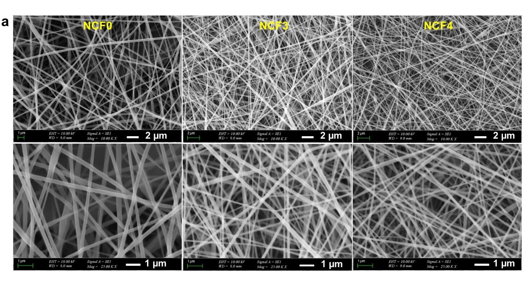Figure S1 SEM micrographs of non-crosslinked Nanofibrous mats: NCF0, NCF3 and NCF4
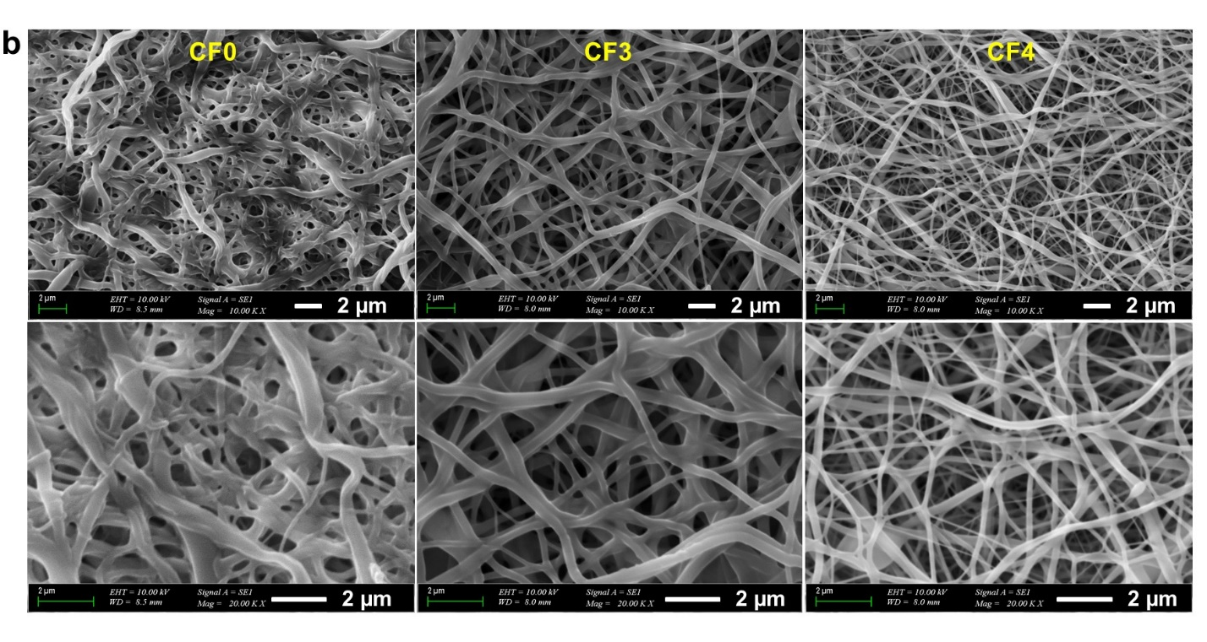Figure S2 SEM micrographs of crosslinked Nanofibrous mats: CF0, CF3 and CF4

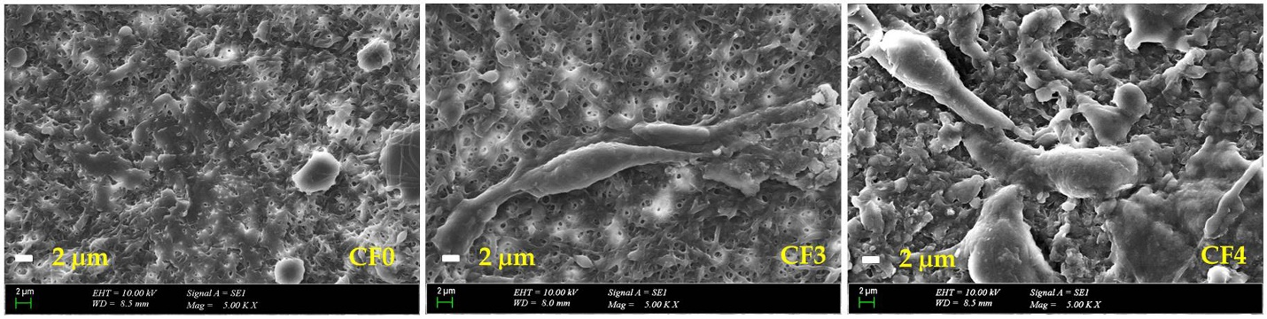
Figure S3 SEM micrographs display cell proliferation and adhesion over CF0, CF3 and CF4 NFs.

