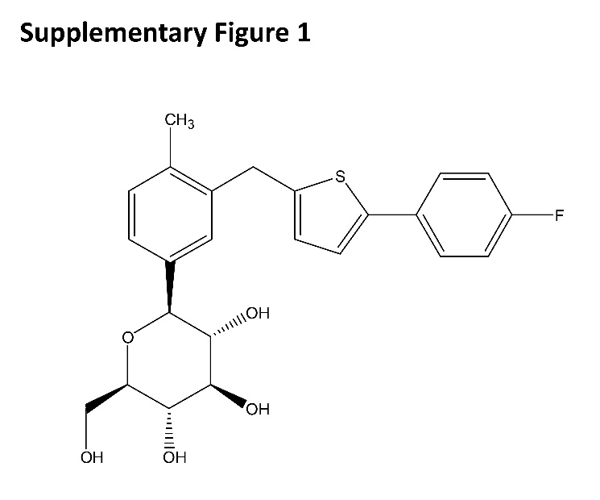
Supplementary figure 1: Chemical structural formula of Canagliflozin

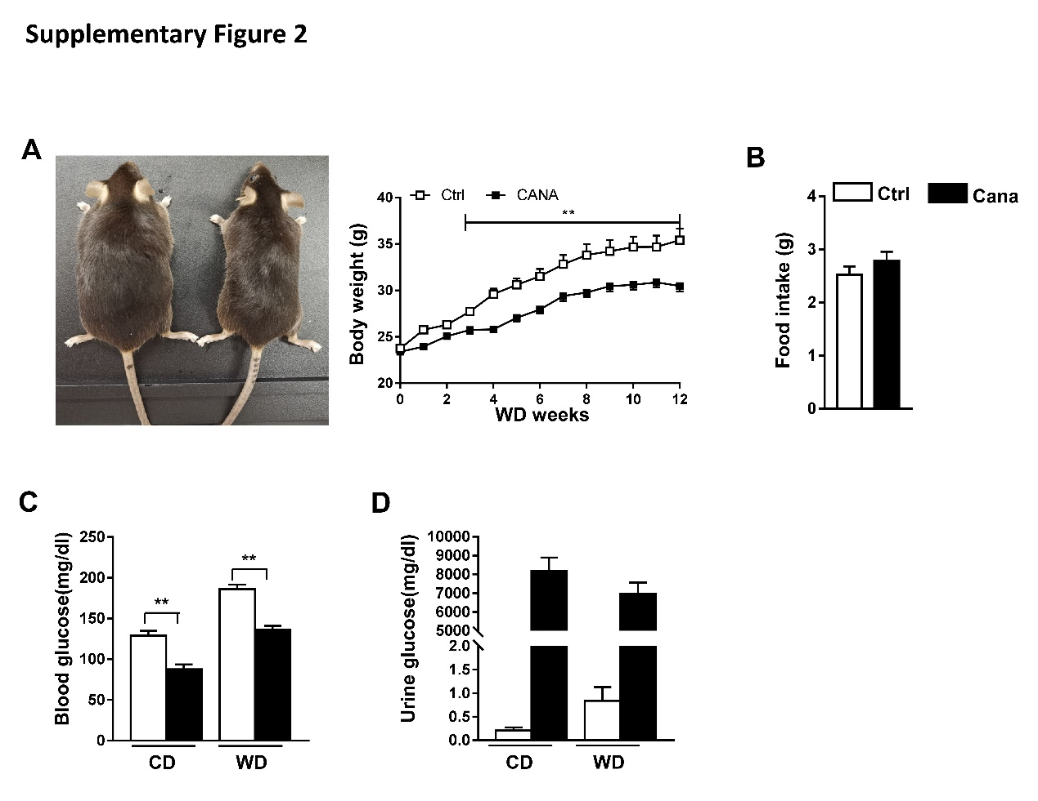 Supplementary figure 2: Biochemical parameters of Cana treated mice
(A)Photographs, body weight and (B) food intake of control and Cana treatment mice after 12 weeks Western diet (n=8). (C) Blood glucose and (D) urine glucose was detected in mice fed with chow diet and western diet (n=8). The data was shown with mean ± SEM. *P<0.05, **P<0.01 compared with control or DMSO group.

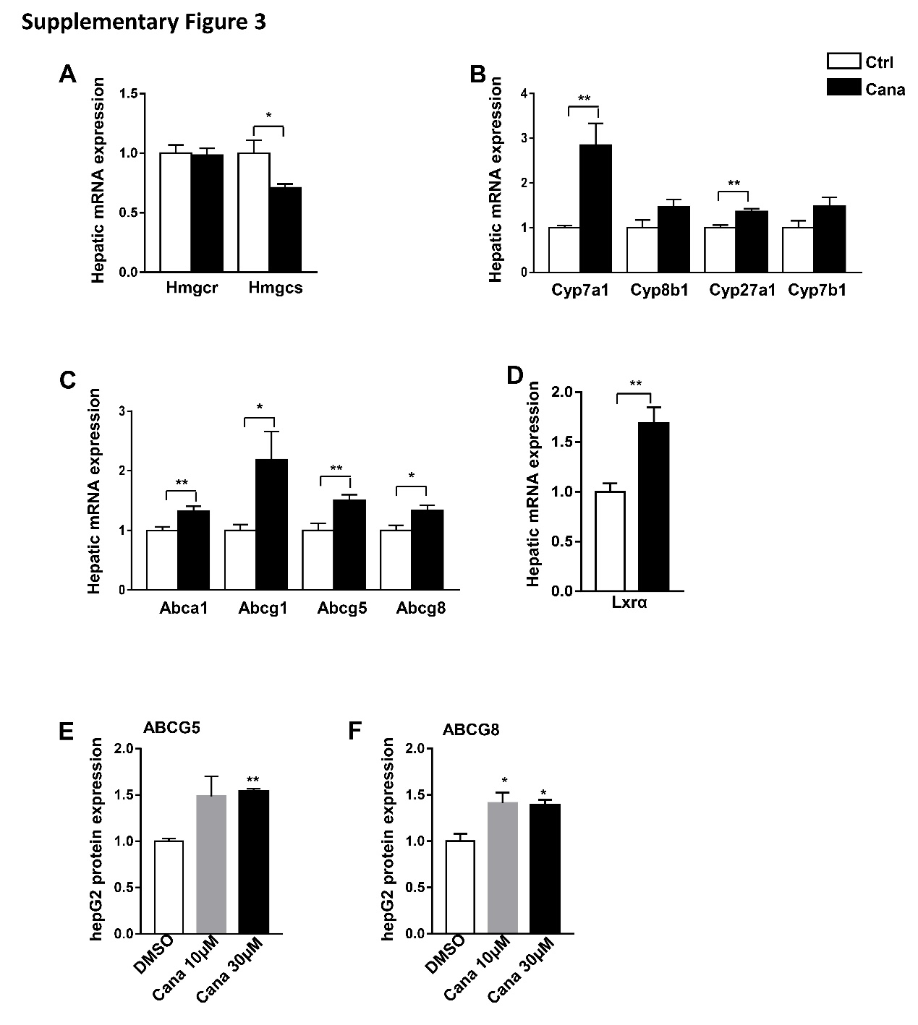
Supplementary figure 3: Cana upregulated hepatic cholesterol transport
8 weeks old C57BL/6J mice were fed chow diet for 12 weeks (n=8). (A) Real-time PCR analyzed of hepatic mRNA levels of cholesterol biosynthesis, (B) bile acid synthesis from cholesterol, (C) cholesterol efflux (D) and cholesterol regulator gene LXR. The quantification of (E) ABCG5 and (F) ABCG8 protein expression of hepG2 cells treated with Cana were shown. The data was shown with mean ±SEM. *P<0.05, **P<0.01 compared with control or DMSO group.

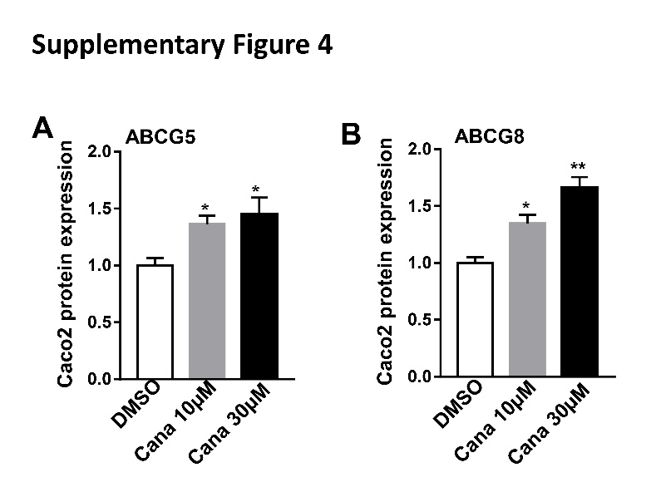
Supplementary figure 4: Cana increased ABCG5/8 expression in Caco2 cells
The quantification of (E) ABCG5 and (F) ABCG8 protein expression of Caco2 cells treated with Cana were shown. The data was shown with mean ±SEM. *P<0.05, **P<0.01 compared with DMSO group.

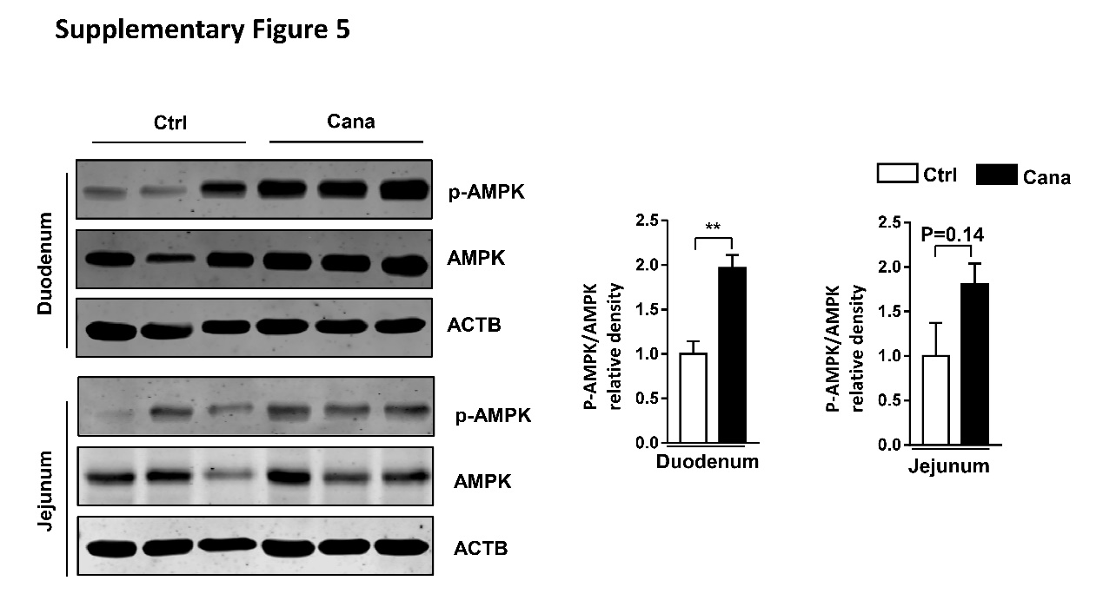
Supplementary figure 5: Cana activated AMPK pathway in duodenum and jejunum
P-AMPK and AMPK protein expression in duodenum and jejunum of western diet fed mice were detected and the ratio of p-AMPK/AMPK was shown (n=3). The data was shown with mean ±SEM. **P<0.01 compared with control.

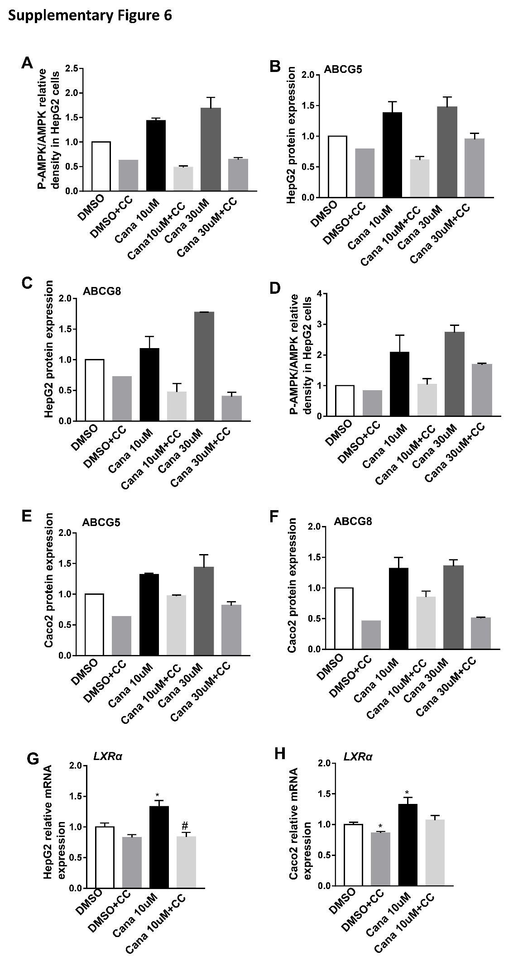
Supplementary figure 6: Cana increased Abcg5/8 expression.
HepG2 and Caco2 cells were treated with Cana (10µM or 30µM) for 24h, after pre-treated with CC for 1h. The quantification of (A) p-AMPK/AMPK ratio, (B) ABCG5 and (C)ABCG8 protein expression in hepG2 cells were shown. And the quantification of (D) p-AMPK/AMPK ratio, (E) ABCG5 and (F)ABCG8 protein expression in Caco2 cells were shown. The mRNA expression of LXRα in (G)hepG2 and (H)Caco2 cells were detected. The data was shown with mean ±SEM. *P<0.05, compared with DMSO group; #p<0.05, Cana 10µM+CC compared with Cana 10µM.

Supplementary table1. Antibodies used.
Supplementary table 1. antibodies used
Antibodies | Catalog | Company
AMPK | 5831S | Cell Signaling Technology
p-AMPK | Apo116 | AB clonal
p-AMPK (Thr172) | 2535 | Cell Signaling Technology
ACC1 | ET1609-77 | Hua bio
p-ACC (Ser79) | #3661 | Cell Signaling Technology
ABCG5 | 27722-1-Ap | Proteintech
ABCG5 | Sc25796 | Santa Cruz Biotechnology
ABCG8 | Sc30111 | Santa Cruz Biotechnology
β-actin | A1978 | sigma
Goat anti-Rabbi | 966-32210 | Licor

Supplementary table2. Real-time PCR primers.
Supplementary table 2. Real-time PCR primers
Genes | Forward sequence | Reverse sequence
mAbcg5 | TCAATGAGTTTTACGGCCTGAA | GCACATCGGGTGATTTAGCA
mAbcg8 | TGCCCACCTTCCACATGTC | ATGAAGCCGGCAGTAAGGTAGA
mCyp7a1 | AGCAACTAAACAACCTGCCAGTACTA | GTCCGGATATTCAAGGATGCA
mCyp8b1 | AGTGCCCTGAAACACACTCC | TCCTCCTGTACCACCCTGAG
mCyp27a1 | CCAGGCACAGGAGAGTACG | GGGCAAGTGCAGCACATAG
mCyp7b1 | GGAGCCACGACCCTAGATG | TGCCAAGATAAGGAAGCCAAC
mHmgcr | AGCTTGCCCGAATTGTATGTG | TCTGTTGTGAACCATGTGACTTC
mHmgcs | AACTGGTGCAGAAATCTCTAGC | GGTTGAATAGCTCAGAACTAGCC
mAbca1 | TCCTCATCCTCGTCATTCAAA | GGACTTGGTAGGACGGAACCT
mAbcg1 | CTCCGGCTTCCTCTTCTTCT | TACACGATGCTGCAGTAGGC
m18s | TTGACTCAACACGGGAAACC | AGACAAATCGCTCCACCAAC
hABCG5 | ACTGCTTCTCCTACGTCCTG | CTGTAGTTGCCAATCAGTCGG
hABCG8 | AGGCCCAGCGTGACAAAAG | TGGGTTCGTCGAGAATAAGGA
hGAPDH | AACGGATTTGGTCGTATTG | GGAAGATGGTGATGGGATT

Supplementary table3. Metabolism parameters of chow diet and western diet fed mice.
 | Chow diet |  | Western diet
 | Ctrl (n=8) | Cana (n=8) | Ctrl (n=8) | Cana (n=8)
Body weight(g) | 26.06±0.22 | 23.65±0.37** | 35.41±1.24 | 30.47±0.58##
Liver weight/body weight (%) | 3.91±0. 09 | 4.22±0. 06 | 4.06±0. 25 | 4.07±0.04
Food intake(g/d) | / | / | 2.52±0.16 | 2.78±0.17
Blood glucose(mg/dl) | 128.9±5.97 | 87.53±6.20** | 186.1±5.52 | 136.6±4.57##
Urine glucose(mg/dl) | 0.21±0.07 | 8170±723.2 | 0.84±0.30 | 6956±602.2
Serum ALT(U/L) | 34.56±0.94 | 39.62±4.10 | 42.49±7.03 | 31.89±2.08##
Serum AST(U/L) | 157.8±9.27 | 124.3±9.68* | 158.9±14.5 | 138.3±4.13
Data was shown with mean±SEM, *P<0.05, **P<0.01 compared with chow diet group; and #P<0.05, ##P<0.01 compared with western diet group.

