Appendix 1: Online health-related quality of life survey question on the Optogenerapy implant
Question a:
Imagine a new medical device is available (6cm x 2cm x 0.2 cm; imagine a thin USB stick) and it is implanted underneath the skin, placed by a surgeon at the outpatient clinic. The device releases interferon beta into your body, whenever your body needs it. You don’t have to administer the treatment yourself, meaning no injections, pills or infusion therapy would be needed.
Would you be interested in using this kind of device? Why or why not would you be interested in using this kind of device?
- Yes
- Maybe
- No

Question b:
“Why, or why not, would you be interested in using this kind of device?”
An open text box was presented for the answer of the respondent.
Appendix 2: Short questionnaire

- What is your age?
- What is your gender?
- What is your marital status?
  - Single
  - Partnered
  - Married
  - Divorced
  - Widowed
- What is your highest attained education level?
  - Primary education (age 4-12)
  - Secondary education (age 12-18)
  - Vocational/ technical education
  - University
  - Other
- What type of multiple sclerosis do you have?
  - Clinically isolated syndrome
  - Relapsing-remitting MS
  - Primary progressive MS
  - Secondary progressive MS
- At what age were you diagnosed with MS?
- What is your current expanded disability status score (EDSS)?
- What treatment to reduce relapses and delay progression have you taken or are you currently taking for your MS? Please fill in the following table.

 | Treatment | I am CURRENTLY using this treatment | I have used this treatment IN THE PAST | I have NEVER used this treatment
Injectables | Avonex (Interferon beta-1a)
 | Rebif (Interferon beta-1a)
 | Plegridy (Peginterferon beta-1a)
 | Extavia (Interferon beta-1b)
 | Copaxone (Glatiramer acetate)
Pills | Tecfidera (Dimethyl fumarate)
 | Mavenclad (Cladribine)
 | Aubagio (Teriflunomide)
 | Gilenya (Fingolimod)
Infusion | Lemtrada (Alemtuzumab)
 | Tysabri (Natalizumab)
 | Ocrevus (Ocrelizumab)

Appendix 3: Interview guide

- Aim focus group: to discuss the treatment preferences and needs of patients with MS
- Why are focus groups held: because it is possible to discuss a certain topic in depth with a group of people. It makes it possible to exchange and discuss different opinions, points of view and ideas with each other. It allows for the researcher to gain more information compared to interviewing persons 1 on 1.
- The procedure
  - I will ask you questions and you, as a group, can discuss the topic, give answers to the question.
  - I will ‘intervene’ as little as possible, but possibly will ask some clarifying questions
  - During the focus group I will be taking notes
  - There will be 3 topics that I want to discuss with you, we will be handling each topic for roughly 15 min.
  - We will then finish up by discussing the most important issues raised on each topic.
- ‘Rules’ during the focus group
  - There is no such thing as a right or wrong answer, only differences of opinions
  - There is no need to agree with each other, however, do be respectful to the opinions of other and listen to these opinions
  - Talk to each other, I am only here to guide the conversation
  - Privacy / anonymity – the results will be anonymizes (it will not be possible to discern who said what), the data will be stored in a safe location at the EUR, only I and direct colleagues involved in the project have access to the data
  - With your permission, the discussion will be audio recorded and notes will be taken.
  - Please turn of your mobile phone and store away.
- Handing out the informed consent forms and fill them out.

Focus group

- Part 1:
  - Filling out the short questionnaire
  - Turn on the voice recorder
  - Short introductory round
- Part 2: the topics
  - The treatment decision-making process
  - Current treatment landscape
  - The Optogenerapy implant

Part 1
Before we start the focus group, I would like for all the participants to fill out a short questionnaire. These are general background questions such as you gender, age, type of MS, and current treatment.

Part 2
During the discussion I will be making notes.

Current treatment landscape
- Could you please tell me about your opinion on the current treatment options available?
  - What are the advantages of the current treatment options?
  - What are the disadvantages of the current treatment options?

The treatment decision-making process
- Could you please tell me how you came to your decision to start taking a certain treatment, and why?
  - Which treatment did you choose, and why?
  - What was the reason why you choose that specific treatment, and why?
- Could you please tell me how you came to your decision to NOT start taking a certain treatment, and why?

The Optogenerapy implant
- Could you please tell me about your opinions and ideas of having a medical device implanted in your body?
  - How do you feel about an implant being placed in the body?
  - How do you feel about the implant allowing for a continuous release of the medication into the body?
  - It is possible that the implant might have to be replaced every 3 years
    - How do you feel about having to go to the hospital for the placement of the device?
    - How do you feel about having to go to the hospital for the removal of the device?
    - Do you trust the physician to implant and replace the device?

End the discussion with the following question: have we discussed everything in your opinion? Are there some aspects that we have missed?

Appendix 4: Slides of the introductory talk
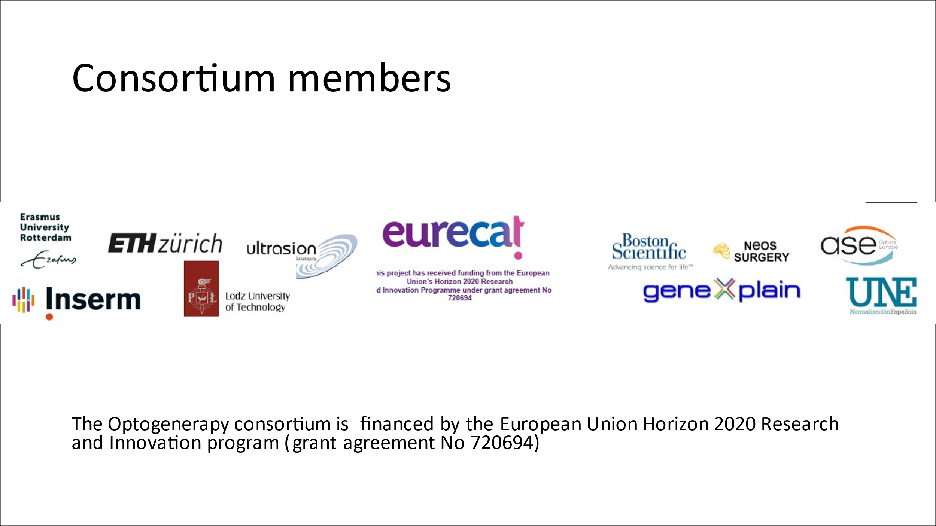
a.
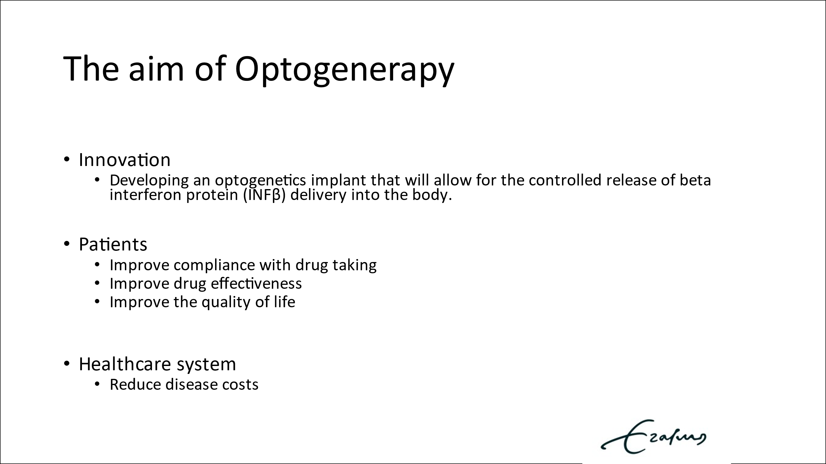
b.
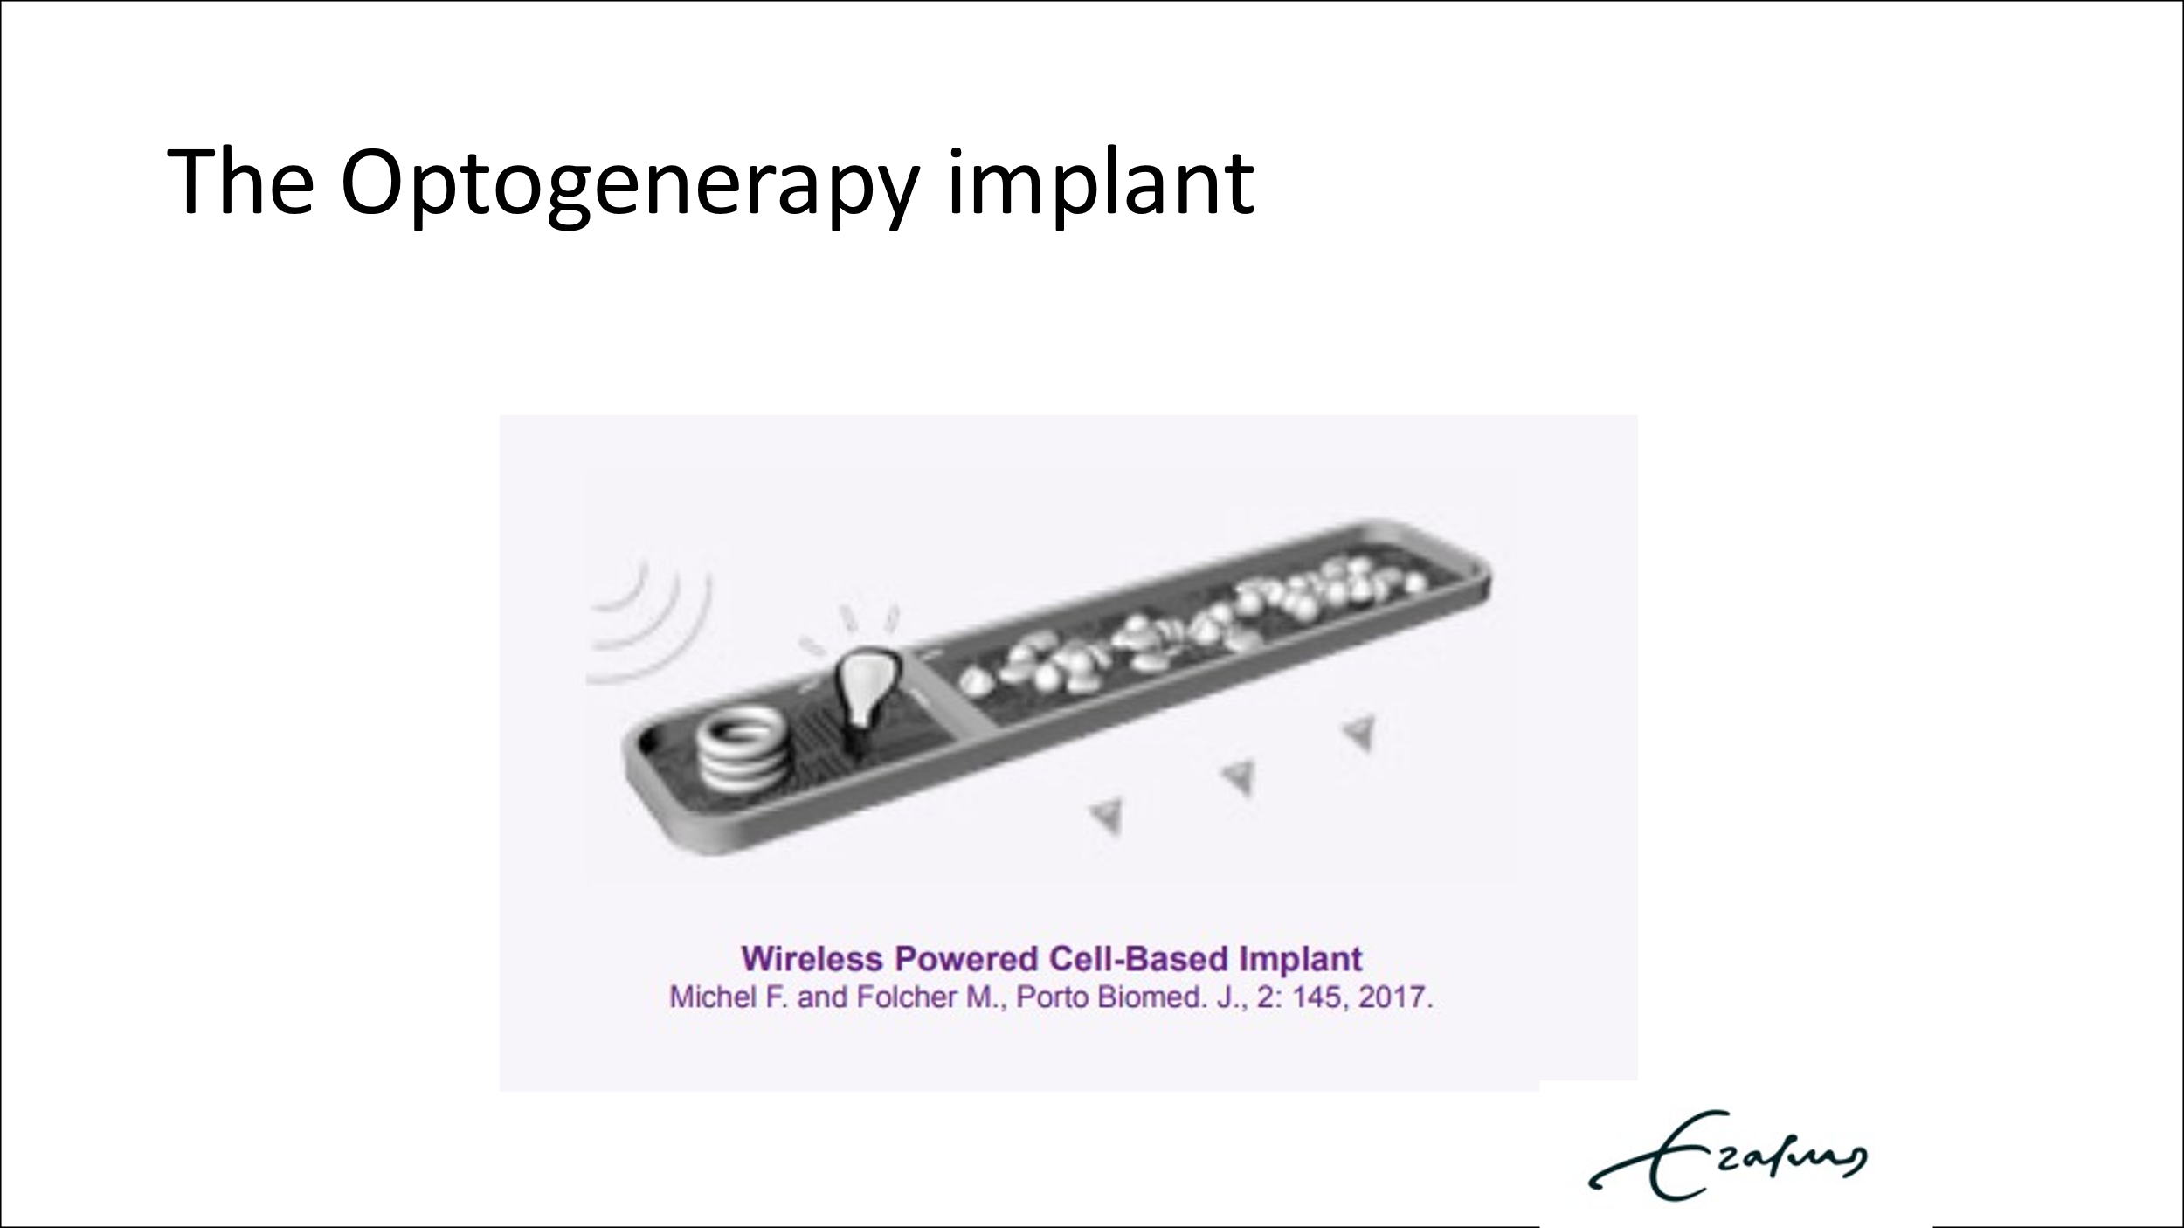
c.
Figure A1. The slides of the introductory talk presented to the participants of the focus group session. The researcher (LV) introduced herself to the participants, gave some general information about the Optogenerapy consortium members (slide a) and her role within the consortium (PhD student responsible for the early health technology assessment). She explained why focus group sessions are necessary during medical device development and that it is important to collect patient preference information. The participants were informed of the aims of the Optogenerapy consortium (slide b). A mock-up of the implant was presented (slide c) and explained – how the wireless belt turns on a light beam that activates the genetically modified cells within the cell chamber to secrete interferon beta. The talk was closed by starting the focus group session (explaining the rules of the focus group and the three topics that will be discussed).

