Supplementary Materials

Figure S1. Spanish clips (same country) used in Hazard Prediction Test
 | Nº | Sec. | Last Photogram | Road | Description | Precursor
CLIPS OF HAZARD PERCEPTION ( SPAIN) | 1 | 30s | 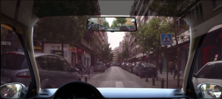 | Urban | A motorbike appears on the left | Blind bend
CLIPS OF HAZARD PERCEPTION ( SPAIN) | 2 | 30s | 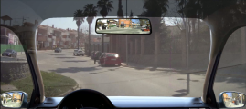 | Urban | The door of the red car on the right opens | Person walking towards the red car on the right
CLIPS OF HAZARD PERCEPTION ( SPAIN) | 3 | 23s | 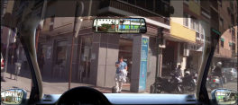 | Urban | A motorcycle on the left enters your lane | Motorcycle flashing indicator
CLIPS OF HAZARD PERCEPTION ( SPAIN) | 4 | 17s | 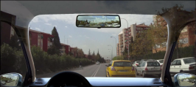 | Urban | A pedestrian on the right crosses the road | The same pedestrian appeared between the bushes before
CLIPS OF HAZARD PERCEPTION ( SPAIN) | 5 | 21s | 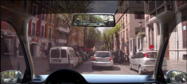 | Urban | A silver car stops and tries to park | Rear lights of the silver car
CLIPS OF HAZARD PERCEPTION ( SPAIN) | 6 | 36s | 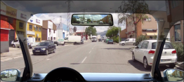 | Suburban | A white van tries to enter your lane from the right | The white van suddenly appears
CLIPS OF HAZARD PERCEPTION ( SPAIN) | 7 | 28s | 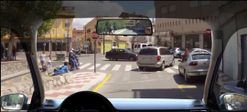 | Urban | Pedestrian on the right | Pedestrian visible between the parked cars
CLIPS OF HAZARD PERCEPTION ( SPAIN) | 8 | 33s | 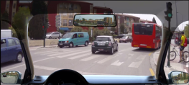 | Urban | Bus entering your lane | Bus flashing indicator
CLIPS OF HAZARD PERCEPTION ( SPAIN) | 9 | 18s | 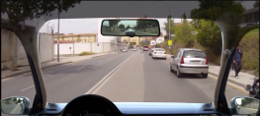 | Urban | Motorcyclist overtakes on the right | Sighting in the right-hand rear-view mirror
CLIPS OF HAZARD PERCEPTION ( SPAIN) | 10 | 28s | 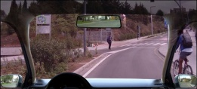 | Urban | Pedestrian on the left | The pedestrian is looking at the car

Figure S2. English clips (different country) used in Hazard Prediction Test
 | Nº | Sec. | Last photogram | Road | Description of the risky situation
HAZARD PERCEPTION CLIPS (UNITED KINGDOM) | 1 | 21s | 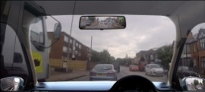 | Suburban | The lorry on the left overtakes | Lorry on the left
HAZARD PERCEPTION CLIPS (UNITED KINGDOM) | 2 | 35s | 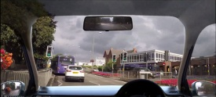 | Urban | The car ahead brakes sharply | Brake lights of the car
HAZARD PERCEPTION CLIPS (UNITED KINGDOM) | 3 | 44s | 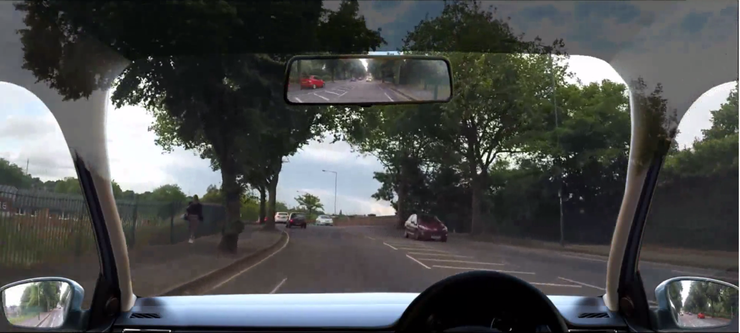 | Urban | A line of cars stops ahead | Brake lights of the car
HAZARD PERCEPTION CLIPS (UNITED KINGDOM) | 4 | 27s | 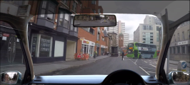 | Urban | A policeman is in the middle of the road | Blind bend
HAZARD PERCEPTION CLIPS (UNITED KINGDOM) | 5 | 38s | 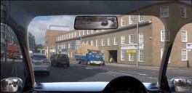 | Urban | The car ahead meets an obstacle | Indicator of the car flashing
HAZARD PERCEPTION CLIPS (UNITED KINGDOM) | 6 | 11s | 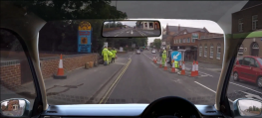 | Urban | Pedestrians on the right | The road-worker signals with his hand that you must stop
HAZARD PERCEPTION CLIPS (UNITED KINGDOM) | 7 | 48s | 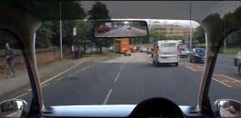 | Urban | The van on the right enters your lane | Abrupt movement of the van
HAZARD PERCEPTION CLIPS (UNITED KINGDOM) | 8 | 22s | 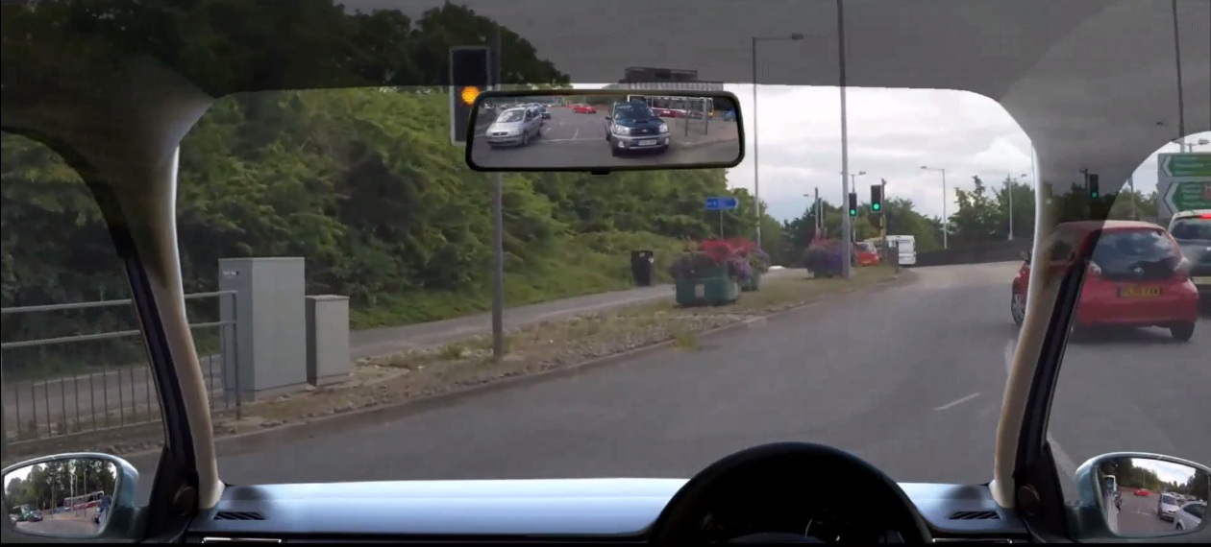 | Suburban | The red car on the right enters our lane | Abrupt movement of the red car
 | 9 | 48s | 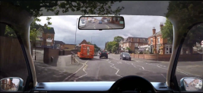 | Urban | A bus enters our lane | Brake lights of the car in front
 | 10 | 44s | 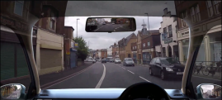 | Urban | A van on the left enters my lane | The stationary van on the left begins to move

Figure S3. Spanish clips used in Risky Decision-Making Test
 | Nº | Sec. | Last photogram | Road | Description of the risky situation
CLIPS OF RDM (SPAIN) | 1 | 28s | 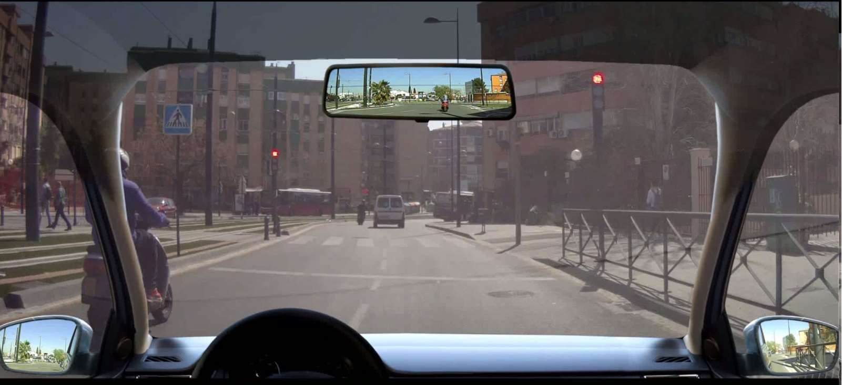 | Urban  Traffic Lights | You are exiting a roundabout and are faced with traffic lights on amber. The lights turn to red. Would you go ahead with the lights on red?
CLIPS OF RDM (SPAIN) | 2 | 27s | 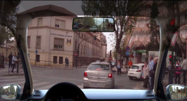 | Urban  Traffic Lights | You are approaching a red traffic light on a dual carriageway. The lights turn to red. Would you go ahead with the lights on red?
CLIPS OF RDM (SPAIN) | 3 | 27s | 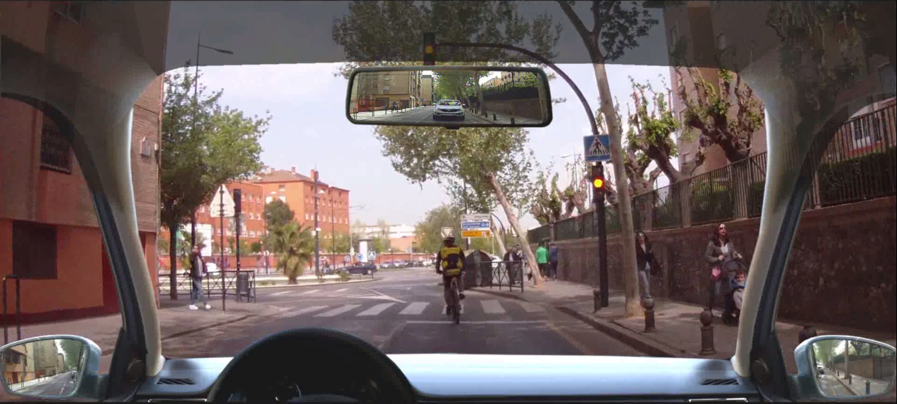 | Urban  Traffic  Lights | You are driving behind a cyclist. You reach some traffic lights. The lights turn to amber. Would you go ahead with the lights on amber?
CLIPS OF RDM (SPAIN) | 4 | 21s | 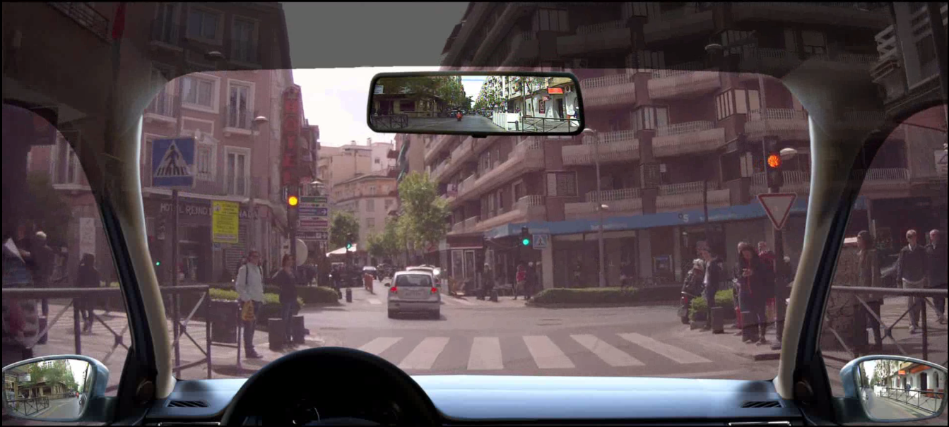 | Urban  Traffic  Lights | You are following a vehicle on a one-way road. The traffic lights turn to amber. Would you go ahead with the lights on amber?
CLIPS OF RDM (SPAIN) | 5 | 18s | 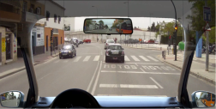 | Urban  Traffic lights | You are overtaking a bus and approaching some traffic lights. The lights turn amber. Would you go ahead with the lights on amber?
CLIPS OF RDM (SPAIN) | 6 | 20s | 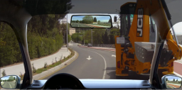 | Suburban  Overtaking the machinery | You are driving behind heavy machinery that is moving very slowly on a lane marked with a continuous white line. A vehicle is approaching from the opposite direction. Would you overtake the machinery at this point?
CLIPS OF RDM (SPAIN) | 7 | 19s | 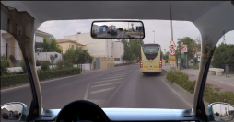 | Suburban  Overtaking a bus | You encounter a bus parked at its bus stop, occupying our lane in a zone where it is forbidden to overtake. Would you overtake the bus at this point?
CLIPS OF RDM (SPAIN) | 8 | 20s | 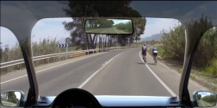 | Suburban  Overtaking the cyclists | After a bend, you encounter some cyclists. Another vehicle is coming towards us, approaching rapidly.  Would you overtake the cyclists at this point?
CLIPS OF RDM (SPAIN) | 9 | 23s | 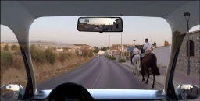 | Suburban  Overtaking the horses | You encounter some horse-riders who are blocking your lane while other cars are approaching from the opposite direction. Would you overtake the horses at this point?
CLIPS OF RDM (SPAIN) | 10 | 26s | 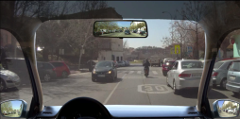 | Urban  Overtaking a car | You encounter a parked vehicle on your lane and another vehicle is coming towards us. Would you overtake the vehicle at this point?
Figure S4. UK clips used in Risky Decision-Making Test
 | Nº | Sec. | Last photogram | Road/ | Description of the risky situation
CLIPS OF RDM (UK) | 1 | 37s | 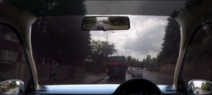 | Suburban  Overtaking a bus | You encounter a bus that has stopped and the car in front of you overtakes the bus on a continuous white line; another vehicle is coming towards you. Would you overtake the bus at this point?
CLIPS OF RDM (UK) | 2 | 16s | 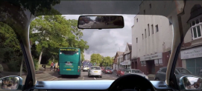 | Suburban  Overtaking a bus | You encounter a bus that has stopped and the car in front of you overtakes the bus on a continuous white line; another vehicle is coming towards us. Would you overtake the bus at this point?
CLIPS OF RDM (UK) | 3 | 21s | 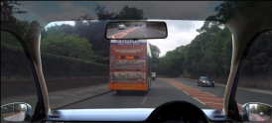 | Suburban  Overtaking a bus | You are driving on one of two lanes of a dual carriageway. Suddenly the road narrows to merge into one lane, which is occupied by a stopped bus. Would you overtake the bus at this point?
CLIPS OF RDM (UK) | 4 | 26s | 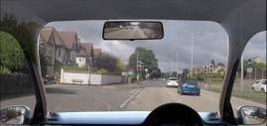 | Urban  Traffic Lights | You are driving behind a vehicle. The traffic lights turn to amber. Would you go ahead with the lights on amber?
CLIPS OF RDM (UK) | 5 | 39s | 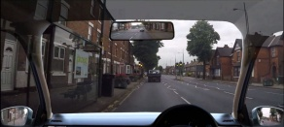 | Urban  Traffic Lights | You are driving along a road and approaching traffic lights that were on green but they turn to amber. Would you go ahead with the lights on amber?
CLIPS OF RDM (UK) | 6 | 47s | 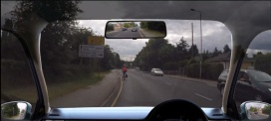 | Urban  Overtaking a cyclist | You encounter a cyclist who is occupying part of your lane while vehicles are approaching from the other direction.  Would you overtake the cyclist at this point?
CLIPS OF RDM (UK) | 7 | 17s | 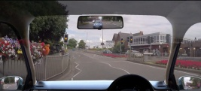 | Urban  Traffic Lights | You are approaching traffic lights that are on red. The lights turn amber. There is an elderly person intending to cross.  Would you go ahead with the lights on amber?
CLIPS OF RDM (UK) | 8 | 32s | 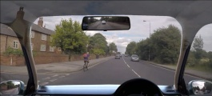 | Suburban  Overtaking  A cyclist | You encounter a cyclist who is occupying our lane while vehicles are approaching from the other direction.  Would you overtake the cyclist at this point?
CLIPS OF RDM (UK) | 9 | 8s | 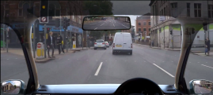 | Urban  Traffic  Lights | You encounter pedestrians who want to cross, on both sides of the road, while a traffic light turns to amber. Would you go ahead with the lights on amber?
CLIPS OF RDM (UK) | 10 | 15s | 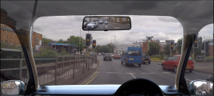 | Urban  Traffic Lights | You encounter pedestrians who want to cross, while a traffic light turns to amber. Would you go ahead with the lights on amber?

