LncRNA HOXA-AS2 Promotes Tumor Progression by Suppressing miR-567 Expression in Oral Squamous Cell Carcinoma

Running title: LncRNA HOXA-AS2 promotes OSCC progression

Rui Chen¹, Xi Wang^{2,3}, Shixian Zhou^{2,4,} Zongyue Zeng^{2,*}

1.Department of Oral and Maxillofacial Surgery, The First Affiliated Hospital of Chongqing Medical University, Chongqing, China,400016

2. Department of Laboratory Medicine, The First Affiliated Hospital of Chongqing Medical University, Chongqing, China, 400016

3.Key Laboratory of Diagnostic Medicine designated by the Ministry of Education, Department of Laboratory Medicine, Chongqing Medical University, Chongqing, China,400016

4.Department of Pathology, Central Hospital of Jiangjin District, Chongqing, China, Chongqing, China, 402260

* CORRESPONDENCE
Zongyue Zeng, MD, PhD

Department of Laboratory Medicine,

The First Affiliated Hospital of Chongqing Medical University,

Chongqing, China, 400016
Tel. (86) 023-8895-5532
Email: zengzongyue@126.com

Figure legend
Supplement Figure.1 The expression of mir-567’s potential targeting genes.
The mir-567’s potential targeting genes were determined by qRT-PCR. * means P <0.05, and NS means no significance.
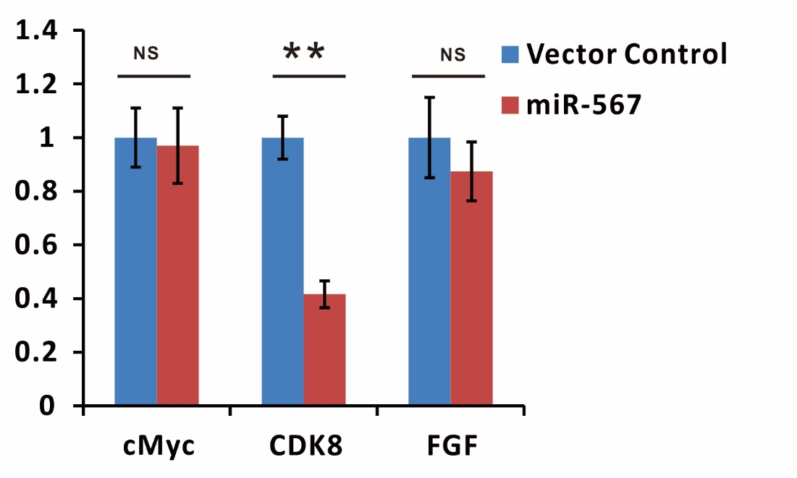
Supplement Table.1 The Oligo sequences used in the study.
Oligonucletide_Name | sequence in 5'-3'
pSEB-LncRNA HOXA-AS2 Fwd | aagaagcttgaaaaggaaacgccaagacatagaaaac
pSEB-LncRNA HOXA-AS2 Rvs | gaagaattctggacctcacaagattatttaattcttaagatg
LncRNA HOXA-AS2-Mut1 Fwd | ttgacaagagttcagctcaagttgaGTGtacatacacacactctcacacacaaattatg
LncRNA HOXA-AS2-Mut1 Rvs | cataatttgtgtgtgagagtgtgtgtatgtaCACtcaacttgagctgaactcttgtcaa
LncRNA HOXA-AS2-Mut2 Fwd | ttgacaagagttcagctcaagttgaacaGTGatacacacactctcacacacaaattatg
LncRNA HOXA-AS2-Mut2 Rvs | cataatttgtgtgtgagagtgtgtgtatCACtgttcaacttgagctgaactcttgtcaa
pSEB-si-ctrl-1 Fwd | gatcaAAAAAGCAAAGACGCAATAATACATTTTTt
pSEB-si-ctrl-1 Rvs | cgtaAAAAATGTATTATTGCGTCTTTGCTTTTTt
pSEB-si-ctrl-2 Fwd | aattaAAAAAGCACAAAGAACGACTATAATTTTTt
pSEB-si-ctrl-2 Rvs | agctaAAAAATTATAGTCGTTCTTTGTGCTTTTTt
pSEB-si-ctrl-3 Fwd | cgcgaAAAAAGAAACACGATTAACAGACATTTTTt
pSEB-si-ctrl-3 Rvs | tcgaaAAAAATGTCTGTTAATCGTGTTTCTTTTTt
pSEB-si-LncRNA HOXA-AS2-1 Fwd | gatcaAAAAAtggagaagttctgcgctccTTTTTt
pSEB-si-LncRNA HOXA-AS2-1 Rvs | cgtaAAAAAggagcgcagaacttctccaTTTTTt
pSEB-si-LncRNA HOXA-AS2-2 Fwd | gatcaAAAAAggaaccgtggagggccaacTTTTTt
pSEB-si-LncRNA HOXA-AS2-2 Rvs | cgtaAAAAAgttggccctccacggttccTTTTTt
pSEB-si-LncRNA HOXA-AS2-3 Fwd | gatcaAAAAAgacaacagtatctctgtaaTTTTTTt
pSEB-si-LncRNA HOXA-AS2-3 Rvs | cgtaAAAAAAttacagagatactgttgtcTTTTTt
hsa-mir-567 RT | GTCGTATCCAGTGCAGGGTCCGAGGTATTCGCACTGGATACGACGTTCTG
LncRNA HOXA-AS2 qPCR Fwd | attgtctccaactccaggcg
LncRNA HOXA-AS2 qPCR Rvs | ctcccactcccagaaagctg
CDK8 qPCR Fwd | ttccaatccacatgctgcct
CDK8 qPCR Rvs | cgatgcagctcagtaccgat
hsa-mir-567 qPCR Fwd | AGCCTAGTATGTTCTTCCAGG
hsa-mir-567 qPCR Rvs | GTGCAGGGTCCGAGGTCCGAG

