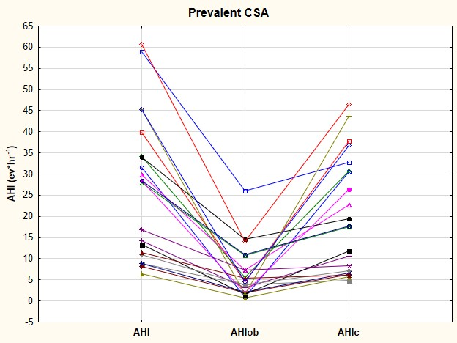
Figure E1

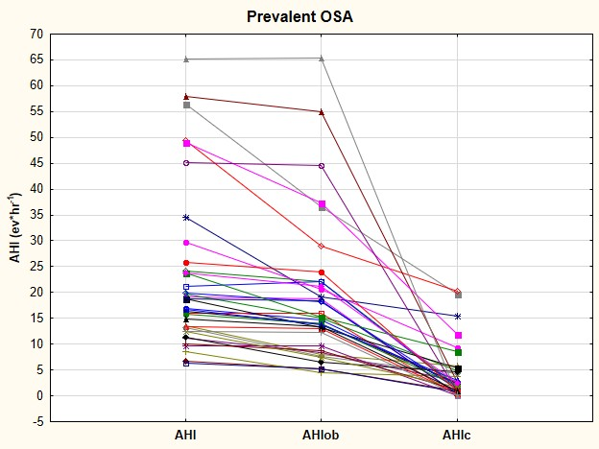
Figure E2

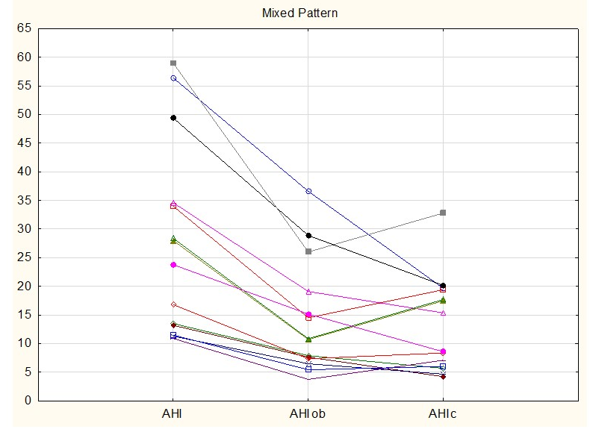
Figure E3

. Legend
Figure E1: Distribution of individual total, obstructive and central AHI in patients with a predominant OSA according to a 50% threshold
Figure E2: Distribution of individual total, obstructive and central AHI in patients with a predominant CSA according to a 50% threshold
Figure E3: Distribution of individual total, obstructive and central AHI in patients with a Mixed Pattern according to a 70% threshold

Table E1
 | No-SDB  (n=10) | dOSA  (n=36) | dCSA  (n=21) | Total  (n=67) | p
AGE (yrs) | 56.9±7.9 | 62.9±9 | 59.1± 10.7 | 60.8±9.6 | n.s.
BMI (Kg/m²) | 22.6±3.1 | 27.8±4.3 | 27.3±3.5 | 26.8±4.2 | 0.001
ESS | 7.6±5.6 | 9.2±6.2 | 8.3±5 | 8.7±5.7 | n.s.
AHI | 4±0.9 | 23±15.5 | 26.8±16.6 | 21.4±16.3 | <0.0001
AHIo | 2.6±1.2 | 18.8±13.7 | 6.3±6.1 | 12.8±13 | 0.019
AHIc | 1.45±1.1 | 4±5.2 | 20.5±13.7 | 8.7±11.6 | <0.0001
Note: Data are presented as mean ± SD unless otherwise indicated. Abbreviations: BMI body mass index. ESS Epworth sleepiness score. AHI apnoea and hypopnea index. AHIo obstructive AHI. AHIc central AHI.No-SDB No sleep disorder breathing. dOSA dominant obstructive sleep apnoea pattern. dCSA dominant central sleep apnoea pattern. MP mixed pattern.

