Supplementary Table 1. Patient Flow (Private Third-Party Payer)
Year | 2020 | 2021 | 2022 | 2023
Total population | 1,000,000 | 1,000,000 | 1,000,000 | 1,000,000
Adult population | 777,482 | 777,482 | 777,482 | 777,482
Multiple Myeloma incidence | 0.006% | 0.006% | 0.006% | 0.006%
Previously treated patients (mixed) | 100.0% | 100.0% | 100.0% | 100.0%
Proportion in treatment line (any previously treated) | 100.0% | 100.0% | 100.0% | 100.0%
Proportion of patients treated | 100.0% | 100.0% | 100.0% | 100.0%
Incident patients treated | 49 | 48 | 48 | 47

Supplementary Table 2. Patient Flow (Data from Kaiser Family Foundation. Medicare beneficiaries as a Percent of Total Population. Available from: https://www.kff.org/medicare/state-indicator/medicare-beneficiaries-as-of-total-pop/?currentTimeframe=0&sortModel=%7B%22colId%22:%22Location%22,%22sort%22:%22asc%22%7D)²⁵
Year | 2020 | 2021 | 2022 | 2023
Total population | 59,499,015 | 59,917,843 | 60,339,620 | 60,764,366
Adult population | 59,499,015 | 59,917,843 | 60,339,620 | 60,764,366
Multiple Myeloma incidence | 0.038% | 0.039% | 0.039% | 0.039%
Previously treated patients (mixed) | 100.0% | 100.0% | 100.0% | 100.0%
Proportion in treatment line (any previously treated) | 100.0% | 100.0% | 100.0% | 100.0%
Proportion of patients treated | 100.0% | 100.0% | 100.0% | 100.0%
Incident patients treated | 22,892 | 23,069 | 23,246 | 23,425

Supplementary Table 3. Adjusted Adverse Event Prevalence per Month (%)
Treatment-Emergent Adverse Events |  | XVd¹¹ |  | DPd³² | DRd³³ | EPd³⁴ | KRd³⁵ | IRd³⁶ | Vd¹¹ | Rd³³ | DAR²⁹ | DRVd³⁰ | Pd³¹
Anaemia |  |  | 1.0 | 1.1 | 0.7 | 1.0 | 0.8 | 0.6 | 0.6 | 0.9 | 0.0 | 0.4 | 2.8
Asthenia |  |  | 0.5 | 0.0 | 0.1 | 0.2 | 0.1 | 0.0 | 0.3 | 0.1 | 0.0 | 0.0 | 0.2
Back pain |  |  | 0.0 | 0.3 | 0.1 | 0.0 | 0.0 | 0.0 | 0.0 | 0.1 | 0.2 | 0.0 | 0.1
Bronchitis |  |  | 0.0 | 0.0 | 0.1 | 0.2 | 0.0 | 0.0 | 0.0 | 0.1 | 0.0 | 0.0 | 0.1
Cataract |  |  | 0.5 | 0.0 | 0.0 | 0.0 | 0.1 | 0.0 | 0.1 | 0.0 | 0.0 | 0.0 | 0.0
Constipation |  |  | 0.0 | 0.0 | 0.0 | 0.2 | 0.0 | 0.0 | 0.0 | 0.0 | 0.0 | 0.1 | 0.0
Cough |  |  | 0.0 | 0.0 | 0.0 | 0.0 | 0.0 | 0.0 | 0.0 | 0.0 | 0.0 | 0.0 | 0.0
Decreased appetite |  |  | 0.0 | 0.0 | 0.0 | 0.0 | 0.0 | 0.0 | 0.0 | 0.0 | 0.1 | 0.0 | 0.0
Diarrhoea |  |  | 0.4 | 0.0 | 0.3 | 0.0 | 0.2 | 0.1 | 0.0 | 0.1 | 0.1 | 0.3 | 0.1
Dizziness |  |  | 0.0 | 0.0 | 0.0 | 0.0 | 0.0 | 0.0 | 0.0 | 0.0 | 0.0 | 0.0 | 0.0
Dyspnoea |  |  | 0.0 | 0.3 | 0.2 | 0.3 | 0.1 | 0.0 | 0.0 | 0.0 | 0.1 | 0.0 | 0.1
Fatigue |  |  | 0.8 | 0.2 | 0.3 | 0.0 | 0.3 | 0.1 | 0.1 | 0.1 | 0.2 | 0.2 | 0.0
Hyperglycemia |  |  | 0.0 | 0.3 | 0.0 | 0.8 | 0.2 | 0.0 | 0.0 | 0.0 | 0.0 | 0.0 | 0.0
Hypokalemia |  |  | 0.0 | 0.3 | 0.0 | 0.0 | 0.4 | 0.4 | 0.0 | 0.0 | 0.0 | 0.0 | 0.0
Hypophosphataemia |  |  | 0.3 | 0.2 | 0.0 | 0.0 | 0.3 | 0.0 | 0.1 | 0.0 | 0.0 | 0.0 | 0.0
Infections and infestations |  |  | 0.0 | 2.2 | 0.0 | 0.0 | 0.0 | 0.0 | 0.0 | 0.0 | 0.0 | 0.0 | 0.0
Insomnia |  |  | 0.0 | 0.3 | 0.1 | 0.2 | 0.1 | 0.0 | 0.0 | 0.1 | 0.0 | 0.1 | 0.0
Nasopharyngitis |  |  | 0.0 | 0.0 | 0.0 | 0.0 | 0.0 | 0.0 | 0.0 | 0.0 | 0.0 | 0.0 | 0.0
Nausea |  |  | 0.5 | 0.0 | 0.1 | 0.0 | 0.0 | 0.0 | 0.0 | 0.0 | 0.0 | 0.0 | 0.0
Neutropenia |  |  | 0.5 | 5.5 | 3.0 | 1.4 | 1.5 | 1.4 | 0.2 | 2.0 | 0.0 | 1.8 | 9.9
Oedema peripheral |  |  | 0.0 | 0.0 | 0.0 | 0.0 | 0.0 | 0.0 | 0.0 | 0.1 | 0.0 | 0.1 | 0.0
Peripheral neuropathy |  |  | 0.3 | 0.0 | 0.0 | 0.0 | 0.0 | 0.0 | 0.5 | 0.0 | 0.0 | 0.3 | 0.0
Pneumonia |  |  | 0.9 | 0.8 | 0.5 | 0.5 | 0.5 | 1.1 | 0.7 | 0.4 | 0.7 | 0.0 | 1.4
Pyrexia |  |  | 0.0 | 0.0 | 0.1 | 0.0 | 0.0 | 0.0 | 0.0 | 0.1 | 0.1 | 0.1 | 0.0
Thrombocytopenia |  |  | 2.9 | 0.8 | 0.6 | 0.8 | 0.7 | 1.4 | 1.1 | 0.7 | 0.0 | 0.8 | 2.4
Upper respiratory tract infection |  |  | 0.0 | 0.0 | 0.1 | 0.0 | 0.0 | 0.3 | 0.0 | 0.1 | 0.1 | 0.0 | 0.1
Vomiting |  |  | 0.0 | 0.0 | 0.0 | 0.0 | 0.0 | 0.0 | 0.0 | 0.1 | 0.0 | 0.0 | 0.0
Weight decreased |  |  | 0.0 | 0.0 | 0.0 | 0.0 | 0.0 | 0.0 | 0.0 | 0.0 | 0.0 | 0.0 | 0.0
XVd = selinexor + bortezomib + dexamethasone; DPd = daratumumab + pomalidomide + dexamethasone; DRd = lenalidomide + dexamethasone; EPd = elotuzumab + pomalidomide + dexamethasone; KRd = carfilzomib + lenalidomide + dexamethasone; IRd = Ixazomib, lenalidomide, and dexamethasone; Vd = bortezomib + dexamethasone; Rd = lenalidomide + dexamethasone; DAR = daratumumab; DRVd = daratumumab + lenalidomide + bortezomib + dexamethasone; Pd = pomalidomide + dexamethasone

Supplementary Table 4. Final Adverse Event Costs per Month (Millions, USD)
Treatment-Emergent Adverse Events |  | XVd¹¹ | DPd³² | DRd³³ | EPd³⁴ | KRd³⁵ | IRd³⁶ | Vd¹¹ | Rd³³ | DAR²⁹ | DRVd³⁰ | Pd³¹
Anaemia |  | 15.60 | 17.82 | 10.39 | 15.94 | 12.28 | 10.13 | 9.70 | 14.75 | 0.00 | 5.96 | 43.55
Asthenia |  | 8.66 | 0.00 | 2.48 | 2.86 | 2.28 | 0.00 | 4.52 | 1.99 | 0.00 | 0.00 | 4.11
Back pain |  | 0.00 | 5.03 | 1.33 | 0.00 | 0.00 | 0.00 | 0.00 | 1.11 | 3.38 | 0.72 | 1.83
Bronchitis |  | 0.00 | 0.00 | 1.19 | 2.29 | 0.00 | 0.00 | 0.00 | 1.40 | 0.00 | 0.00 | 0.82
Cataract |  | 8.20 | 0.00 | 0.00 | 0.00 | 1.44 | 0.00 | 1.32 | 0.00 | 0.00 | 0.00 | 0.00
Constipation |  | 0.00 | 0.00 | 0.57 | 2.23 | 0.00 | 0.00 | 0.00 | 0.38 | 0.00 | 1.26 | 0.00
Cough |  | 0.00 | 0.00 | 0.20 | 0.00 | 0.00 | 0.00 | 0.00 | 0.00 | 0.00 | 0.00 | 0.00
Decreased appetite |  | 0.00 | 0.00 | 0.00 | 0.00 | 0.00 | 0.00 | 0.00 | 0.00 | 1.56 | 0.00 | 0.00
Diarrhoea |  | 5.57 | 0.00 | 4.38 | 0.00 | 2.55 | 1.33 | 0.43 | 1.95 | 1.62 | 4.29 | 0.88
Dizziness |  | 0.00 | 0.00 | 0.00 | 0.00 | 0.00 | 0.00 | 0.00 | 0.00 | 0.00 | 0.00 | 0.00
Dyspnoea |  | 0.00 | 3.66 | 2.35 | 4.53 | 1.79 | 0.00 | 0.00 | 0.39 | 1.47 | 0.00 | 1.61
Fatigue |  | 11.54 | 2.96 | 3.62 | 0.00 | 4.52 | 1.23 | 0.79 | 2.00 | 3.01 | 3.28 | 0.00
Hyperglycemia |  | 0.00 | 3.18 | 0.00 | 10.08 | 2.01 | 0.00 | 0.00 | 0.00 | 0.00 | 0.00 | 0.00
Hypokalemia |  | 0.00 | 3.87 | 0.00 | 0.00 | 6.47 | 5.25 | 0.00 | 0.00 | 0.00 | 0.00 | 0.00
Hypophosphataemia |  | 6.26 | 4.35 | 0.00 | 0.00 | 5.84 | 0.00 | 1.74 | 0.00 | 0.00 | 0.00 | 0.00
Infections and infestations |  | 0.00 | 27.51 | 0.00 | 0.00 | 0.00 | 0.00 | 0.00 | 0.00 | 0.00 | 0.00 | 0.00
Insomnia |  | 0.00 | 3.92 | 0.69 | 2.00 | 0.90 | 0.00 | 0.00 | 0.69 | 0.00 | 1.13 | 0.00
Nasopharyngitis |  | 0.00 | 0.00 | 0.00 | 0.00 | 0.00 | 0.00 | 0.00 | 0.00 | 0.00 | 0.00 | 0.00
Nausea |  | 6.99 | 0.00 | 1.06 | 0.00 | 0.00 | 0.00 | 0.00 | 0.43 | 0.00 | 0.70 | 0.00
Neutropenia |  | 13.17 | 138.77 | 75.51 | 34.54 | 37.25 | 34.69 | 4.99 | 49.62 | 0.00 | 43.84 | 247.26
Oedema peripheral |  | 0.00 | 0.00 | 0.35 | 0.00 | 0.00 | 0.00 | 0.00 | 0.70 | 0.00 | 1.14 | 0.00
Peripheral neuropathy |  | 4.97 | 0.00 | 0.00 | 0.00 | 0.00 | 0.00 | 9.59 | 0.00 | 0.00 | 6.03 | 0.00
Pneumonia |  | 15.40 | 14.94 | 9.02 | 8.92 | 9.44 | 18.95 | 12.79 | 6.30 | 11.78 | 0.00 | 24.55
Pyrexia |  | 0.00 | 0.00 | 0.88 | 0.00 | 0.00 | 0.00 | 0.00 | 0.63 | 0.95 | 0.82 | 0.00
Thrombocytopenia |  | 69.66 | 18.82 | 14.17 | 20.48 | 18.01 | 33.73 | 26.04 | 16.26 | 0.00 | 19.34 | 58.24
Upper respiratory tract infection |  | 0.00 | 0.00 | 0.70 | 0.00 | 0.00 | 3.34 | 0.00 | 0.71 | 1.34 | 0.57 | 0.73
Vomiting |  | 0.00 | 0.00 | 0.59 | 0.00 | 0.00 | 0.00 | 0.00 | 0.80 | 0.00 | 0.00 | 0.00
Weight decreased |  | 0.00 | 0.00 | 0.00 | 0.00 | 0.00 | 0.00 | 0.00 | 0.00 | 0.00 | 0.00 | 0.00
Total |  | 166.00 | 244.83 | 129.48 | 103.87 | 104.79 | 108.65 | 71.90 | 100.10 | 25.11 | 89.10 | 383.57
XVd = selinexor + bortezomib + dexamethasone; DPd = daratumumab + pomalidomide + dexamethasone; DRd = daratumumab + lenalidomide + dexamethasone; EPd = elotuzumab + pomalidomide + dexamethasone; KRd = carfilzomib + lenalidomide + dexamethasone; IRd = ixazomib, lenalidomide, and dexamethasone; Vd = bortezomib + dexamethasone; Rd = lenalidomide + dexamethasone; DAR = daratumumab; DRVd = daratumumab + lenalidomide + bortezomib + dexamethasone; Pd = pomalidomide + dexamethasone
Supplementary Table 5. Estimation of Cost per Treatment Emergent Adverse Event of Grade 3 or Higher
 |  | Inpatient costs
Treatment-Emergent Adverse Events | Average Cost of Adverse Events | Unit Cost - Inpatient (inflation adjusted) | Unit Cost - Inpatient ($)
Anaemia | 1,567 | 32,146.20 | 30,262.40
Asthenia | 1,754 | 36,119.60 | 34,002.95
Back pain | 1,575 | 32,327.32 | 30,432.90
Bronchitis | 1,407 | 28,764.72 | 27,079.07
Cataract | 1,558 | 31,970.70 | 30,097.18
Constipation | 1,366 | 27,892.31 | 26,257.78
Cough | 1,457 | 29,813.66 | 28,066.54
Decreased appetite | 1,460 | 29,888.51 | 28,137.00
Diarrhoea | 1,520 | 31,160.29 | 29,334.26
Dizziness | 1,387 | 28,328.76 | 26,668.66
Dyspnoea | 1,379 | 28,159.28 | 26,509.11
Fatigue | 1,400 | 28,622.26 | 26,944.96
Hyperglycemia | 1,199 | 24,347.31 | 22,920.53
Hypokalemia | 1,459 | 29,864.16 | 28,114.08
Hypophosphataemia | 2,061 | 42,604.69 | 40,108.00
Infections and infestations | 1,277 | 25,997.70 | 24,474.20
Insomnia | 1,227 | 24,942.13 | 23,480.49
Nasopharyngitis | 1,155 | 23,431.43 | 22,058.32
Nausea | 1,514 | 31,008.12 | 29,191.00
Neutropenia | 2,504 | 52,000.78 | 48,953.47
Oedema peripheral | 1,240 | 25,228.92 | 23,750.48
Peripheral neuropathy | 1,821 | 37,530.31 | 35,330.98
Pneumonia | 1,795 | 36,985.15 | 34,817.78
Pyrexia | 890 | 17,797.53 | 16,754.57
Thrombocytopenia | 2,434 | 50,529.25 | 47,568.17
Upper respiratory tract infection | 1,251 | 25,457.94 | 23,966.07
Vomiting | 1,415 | 28,938.93 | 26,700.16
Weight decreased | 1,536 | 31,486.58 | 29,641.43
Note: It was assumed that 4.72% and 95.28% of all adverse events occurred in an inpatient- and outpatient- setting, respectively. Outpatient costs i.e. the cost of physician visits were assumed to be $52.33 for all adverse events. In BOSTON, 4.7% (114 out of 2,302) of treatment-emergent adverse events experienced in were severe (BOSTON patient-level data. Physician visit cost source: CPT Unit cost - 99213 - Office or other outpatient visit for the evaluation and management of an established patient.

Supplementary Figure 1. Absolute Budget Impact, (Millions, USD)
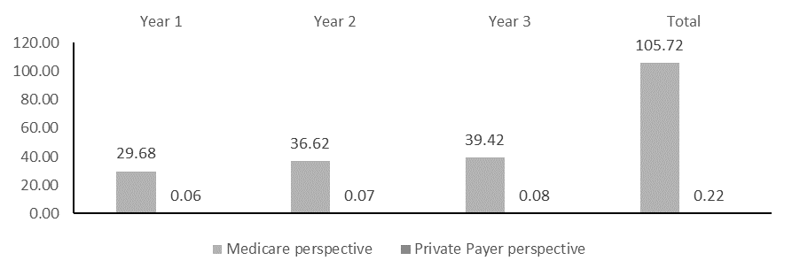

Supplementary Figure 2. Relative Budget Impact, (%)
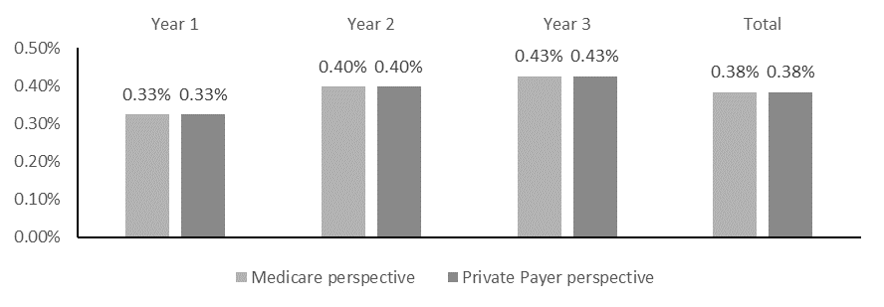

Supplementary Figure 3. Tornado Diagram - Absolute Budget Impact (Millions, USD)
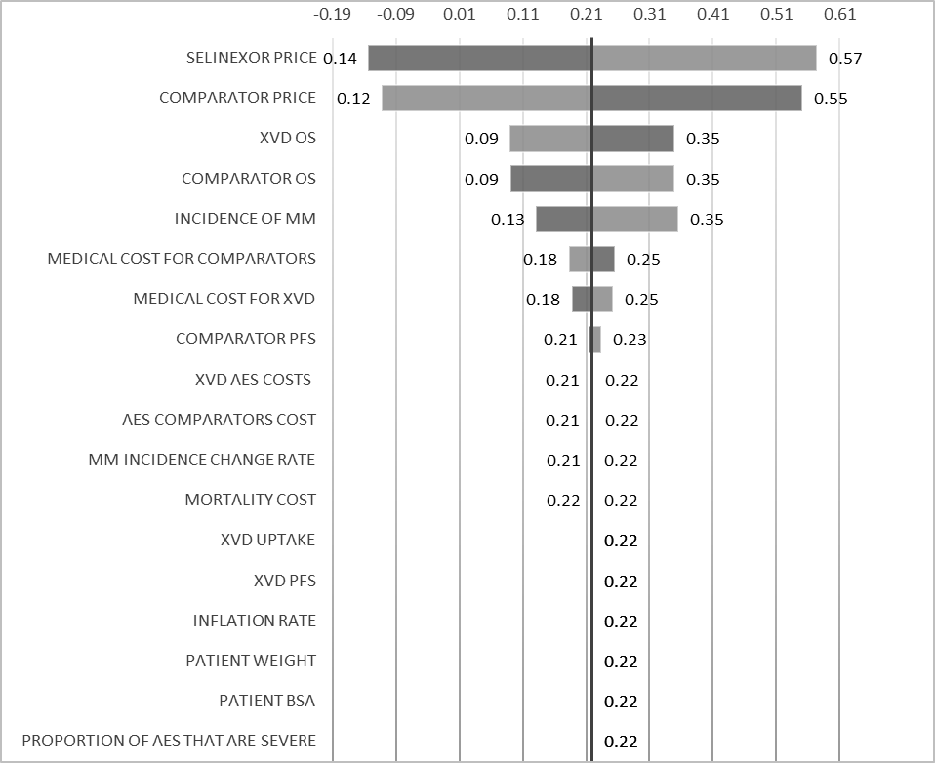
AEs=adverse events; BSA=body surface area; MM=multiple myeloma; OS=overall survival; PFS=progression-free survival; XVd=selinexor-bortezomib-dexamethasone

Supplementary Table 6. One-way sensitivity analysis results for a private payer Absolute Budget Impact (Millions, USD)
 | Lower bound | Base case | Upper bound | Difference
Selinexor price | -0.14 | 0.22 | 0.57 | 0.71
Comparator price | 0.55 | 0.22 | -0.12 | 0.66
XVd Overall survival | 0.35 | 0.22 | 0.09 | 0.26
Comparator OS | 0.09 | 0.22 | 0.35 | 0.26
Incidence of MM | 0.13 | 0.22 | 0.35 | 0.22
Medical cost for Comparators | 0.25 | 0.22 | 0.18 | 0.07
Medical cost for XVd | 0.18 | 0.22 | 0.25 | 0.06
Comparator progression free survival | 0.21 | 0.22 | 0.23 | 0.02
XVd AEs costs | 0.21 | 0.22 | 0.22 | 0.00
AEs comparators cost | 0.22 | 0.22 | 0.21 | 0.00
MM incidence change rate | 0.22 | 0.22 | 0.21 | 0.00
Mortality cost | 0.22 | 0.22 | 0.22 | 0.00
XVd uptake | 0.22 | 0.22 | 0.22 | 0.00
XVd progression free survival | 0.22 | 0.22 | 0.22 | 0.00
Inflation rate | 0.22 | 0.22 | 0.22 | 0.00
Patient weight | 0.22 | 0.22 | 0.22 | 0.00
Patient body surface area | 0.22 | 0.22 | 0.22 | 0.00
Proportion of AEs that are severe | 0.22 | 0.22 | 0.22 | 0.00
USD = US dollars; XVd = selinexor + bortezomib + dexamethasone; OS = overall survival; MM = multiple myeloma; AE = adverse events

