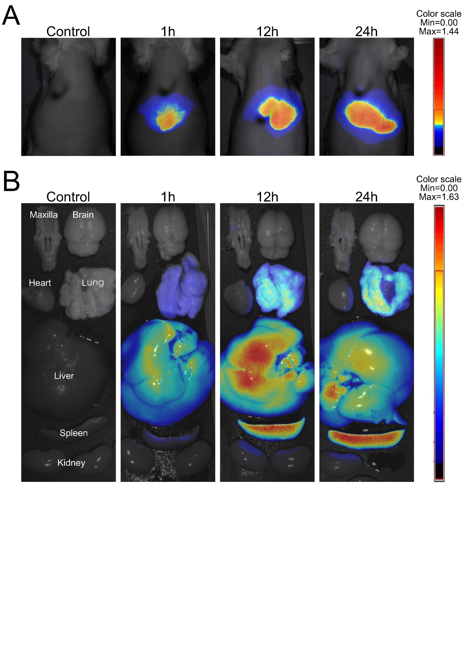Supplementary Figure S1. Biodistribution of DiR-labeled sEV-AT. (A) Non-invasive live animal imaging in rats after intravenous injection of DiR-labeled sEV-AT. (B) Ex vivo images of major organs from rats after intravenous injection of DiR-labeled sEV-AT.
Abbreviations: sEV-AT, small extracellular vesicles derived from adipose tissue.

