Supplementary materials
Stage | Review |  |  |  |  | Referral
Task No. | 10 | 11 | 12 | 13 | 14 | 15
Task name | Read the letter | Walk | Answer questions  for review | Offered the PR class | Request information about PR | Read the letter
Vision | 12 | 12 | 0 | 0 | > | 0
Hearing | 0 | 4 | 8 | 8 | 8 | 0
Concentration | 4 | 4 | 8 | 8 | 8 | 4
Memory | 12 | 8 | 12 | 12 | 0 | 12
Literacy | 12 | 4 | 0 | 0 | > | 12
Speech Comp. | 0 | 0 | 8 | 8 | 8 | 0
Speaking | 0 | 0 | 12 | 12 | 12 | 0
Strength | 0 | 0 | 0 | 0 | 0 | 0
Dexterity | 0 | 0 | 0 | 0 | 0 | 0
Forward/Up | 0 | 0 | 0 | 0 | 0 | 0
Down | 0 | 0 | 0 | 0 | 0 | 0
Strength | 1 | 0 | 0 | 0 | 0 | 1
Dexterity | 8 | 0 | 0 | 0 | 0 | 8
Forward/Up | 4 | 0 | 0 | 0 | 0 | 4
Down | 0 | 0 | 0 | 0 | 0 | 0
Walking | 0 | 4 | 0 | 0 | 0 | 0
Stairs | 0 | 0 | 0 | 0 | 0 | 0
Standing | 0 | 0 | 0 | 0 | 0 | 0
Table S1 Demand on every task of PR service based on Mrs Smith’s scenario
Stage | Diagnosis
Task No. | 1 | 2 | 3 | 4 | 5 | 6 | 7 | 8 | 9
Task name | Walk | Describe symptoms | Wait 20 mins | Go to the nurse's office | Describe symptoms | Read letter | Open the package (inhalers) | Read the instructions  (inhalers) | Use the inhalers
Vision | 12 | 0 | 0 | 10 | 0 | > | 10 | > | 10
Hearing | 4 | 8 | 4 | 0 | 8 | 0 | 0 | 0 | 0
Concentration | 4 | 4 | 4 | 4 | 4 | 0 | 4 | 8 | 8
Memory | 8 | 8 | 4 | 0 | 8 | 0 | 0 | 12 | 12
Literacy | 4 | 0 | 0 | 4 | 0 | > | 4 | 8 | 0
Speech Comp. | 0 | 8 | 4 | 0 | 8 | 0 | 0 | 0 | 0
Speaking | 0 | 12 | 4 | 0 | 12 | 0 | 0 | 0 | 0
Strength | 0 | 0 | 0 | 0 | 0 | 0 | 0 | 0 | 3
Dexterity | 0 | 0 | 0 | 0 | 0 | 0 | 0 | 0 | 4
Forward/Up | 0 | 0 | 0 | 0 | 0 | 0 | 0 | 0 | 6
Down | 0 | 0 | 0 | 0 | 0 | 0 | 0 | 0 | 0
Strength | 0 | 0 | 0 | 0 | 0 | 1 | 1 | 1 | 0
Dexterity | 0 | 0 | 0 | 0 | 0 | 8 | 8 | 8 | 0
Forward/Up | 0 | 0 | 0 | 0 | 0 | 4 | 4 | 4 | 0
Down | 0 | 0 | 0 | 0 | 0 | 0 | 0 | 0 | 0
Walking | 4 | 0 | 0 | 2 | 0 | 0 | 0 | 0 | 0
Stairs | 0 | 0 | 0 | 0 | 0 | 0 | 0 | 0 | 0
Standing | 0 | 0 | 0 | 0 | 0 | 0 | 0 | 0 | 0

Table S1 Demand on every task of PR service based on Mrs Smith’s scenario (continued)
Stage | Assessment
Task No. | 16 | 17 | 18 | 19 | 20 | 21 | 22 | 23 | 24 | 25
Task name | Ask her husband to help drive | Read the instructions for travel in referral letter | Walk and stop to rest after every 50m of walking  (in total 300m distance) | Provide invitation and medication to be checked | Fill in question-aires | Walking test | Obtain more info about PR | Request to tailor the class schedule | Obtain the tailored class schedule | Agree and wait to attend
Vision | 0 | > | 12 | 0 | 12 | 10 | 0 | 0 | 0 | 0
Hearing | 8 | 0 | 0 | 8 | 0 | 8 | 8 | 8 | 8 | 0
Concentration | 4 | 8 | 4 | 8 | 10 | 12 | 8 | 8 | 4 | 0
Memory | 0 | 0 | 0 | 12 | 12 | 0 | 0 | 0 | 12 | >
Literacy | 0 | 8 | 4 | 0 | 8 | 0 | 0 | 0 | 0 | 0
Speech Comp. | 8 | 0 | 0 | 8 | 8 | 8 | 8 | 8 | 8 | 0
Speaking | 8 | 0 | 0 | 12 | 8 | 8 | 8 | 8 | 0 | 0
Strength | 0 | 0 | 0 | 2 | 2 | 0 | 0 | 0 | 0 | 0
Dexterity | 0 | 6 | 0 | 0 | 0 | 0 | 0 | 0 | 0 | 0
Forward/Up | 0 | 4 | 0 | 4 | 4 | 0 | 0 | 0 | 0 | 0
Down | 0 | 0 | 0 | 0 | 0 | 0 | 0 | 0 | 0 | 0
Strength | 0 | 0 | 0 | 0 | 0 | 0 | 0 | 0 | 0 | 0
Dexterity | 0 | 0 | 0 | 0 | 0 | 0 | 0 | 0 | 0 | 0
Forward/Up | 0 | 0 | 0 | 0 | 0 | 0 | 0 | 0 | 0 | 0
Down | 0 | 0 | 0 | 0 | 0 | 0 | 0 | 0 | 0 | 0
Walking | 0 | 0 | 10 | 0 | 0 | 0 | 0 | 0 | 0 | 0
Stairs | 0 | 0 | 0 | 0 | 0 | 0 | 0 | 0 | 0 | 0
Standing | 0 | 0 | 0 | 0 | 0 | 0 | 0 | 0 | 0 | 0
Stage | PR |  |  |  |  | Overall  demand
Task No. | 26 | 27 | 28 | 29 | 30 | Overall  demand
Task name | Drive to the same place of assessment | Walk and stop 4-5 times to rest  (in total 300m) | Find out about the transport service | Request transport service | Decide to quit | Overall  demand
Vision | 12 | 12 | 8 | 0 | 12 | >
Hearing | 8 | 0 | 0 | 8 | 8 | 8
Concentration | 12 | 4 | 4 | 4 | 12 | 12
Memory | 12 | 0 | 4 | 12 | 12 | >
Literacy | 4 | 4 | 0 | 0 | 4 | >
Speech Comp. | 0 | 0 | 0 | 8 | 0 | 8
Speaking | 0 | 0 | 0 | 8 | 0 | 12
Strength | 8 | 0 | 0 | 0 | 8 | 8
Dexterity | 4 | 0 | 0 | 0 | 4 | 6
Forward/Up | 6 | 0 | 0 | 0 | 6 | 6
Down | 0 | 0 | 0 | 0 | 0 | 0
Strength | 8 | 0 | 0 | 0 | 8 | 8
Dexterity | 4 | 0 | 0 | 0 | 4 | 8
Forward/Up | 6 | 0 | 0 | 0 | 6 | 6
Down | 0 | 0 | 0 | 0 | 0 | 0
Walking | 0 | 10 | 0 | 0 | 10 | 10
Stairs | 0 | 0 | 0 | 0 | 0 | 0
Standing | 0 | 0 | 0 | 0 | 0 | 0

Figure S1: The pre-defined (demand measure) scales
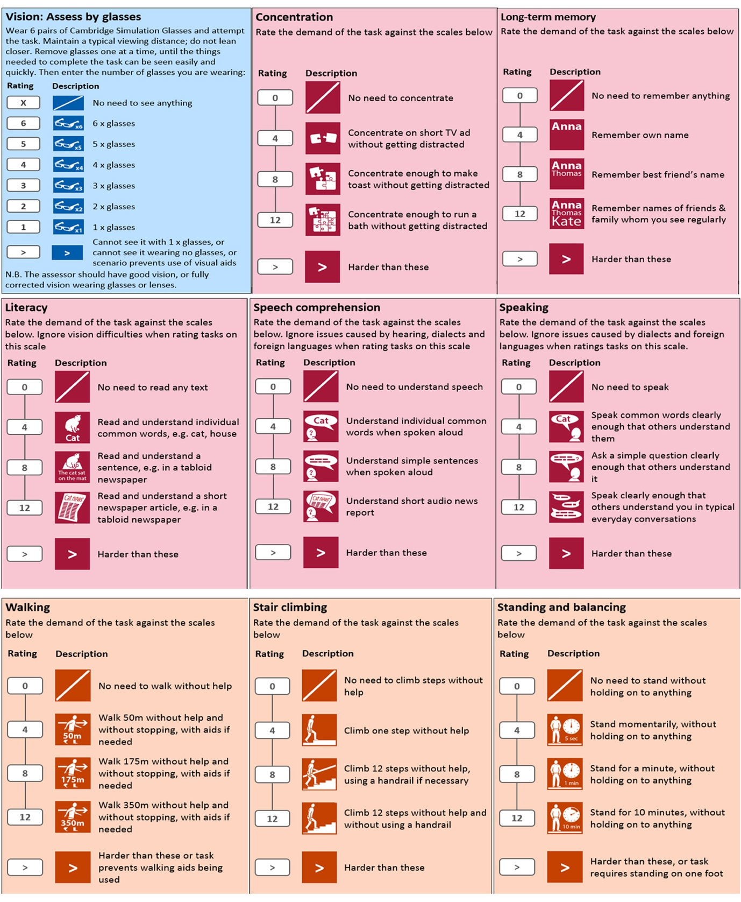

Figure S1: The pre-defined (demand measure) scales (continued)
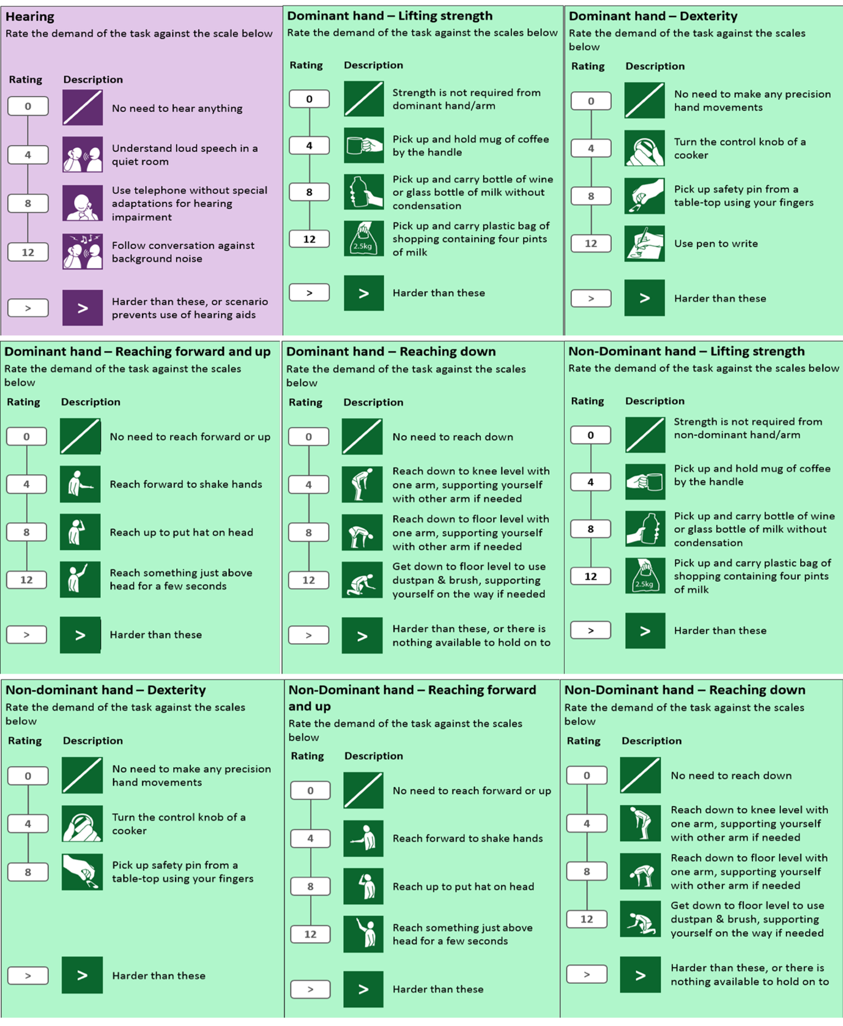

Figure S2: Your COPD Care Reminder final version
