Supplementary materials

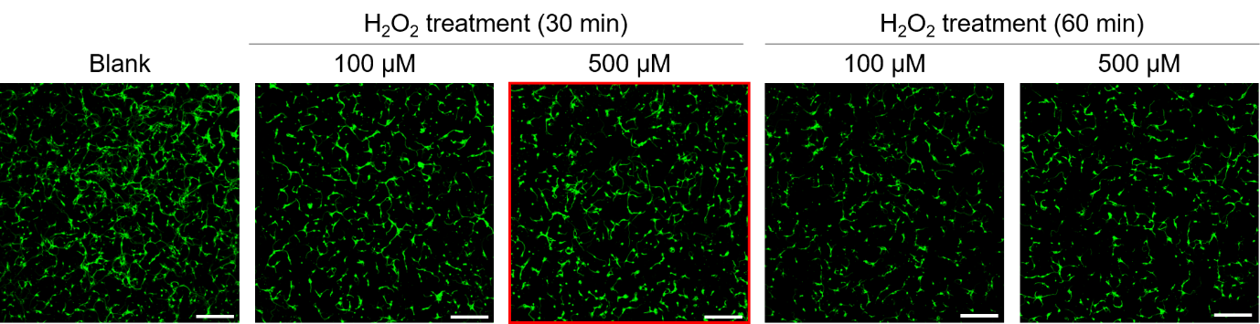

Supplementary Figure 1: Immunocytochemical analysis of cortical neuron to assess the H₂O₂ optimal concentration and incubation period. Representative immunocytochemical images showing Tuj1 (green) in cortical neurons treated with 100 or 500 μM H₂O₂ for 30 min or 1 h. White scale bar = 200 µm.
Supplementary Figure 2: Assessment of the formation the NLRP3-ASC complex by double staining with NLRP3 (red) and ASC (green). Representative immunocytochemical images showing NLRP3 and ASC staining in cortical neurons treated with 10, 25, and 50 µg/mL of LLT with H₂O₂ exposure. White scale bar = 50 µm, yellow scale bar = 5 µm.

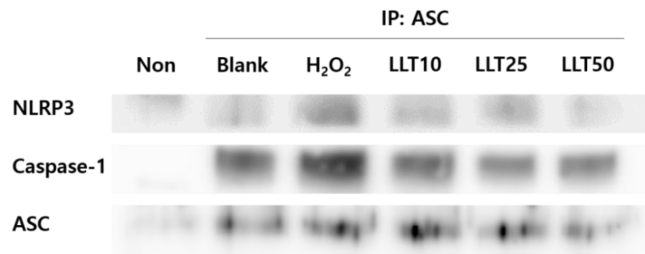
Supplementary Figure 3: Immunoprecipitation (IP) assay to determine the NLRP3 (135 kDa) and Caspase-1 (pro-forms, 48 kDa) interaction with ASC (22 kDa) in cell lysate from cortical neurons. Non-antibody group was used as a loading control.

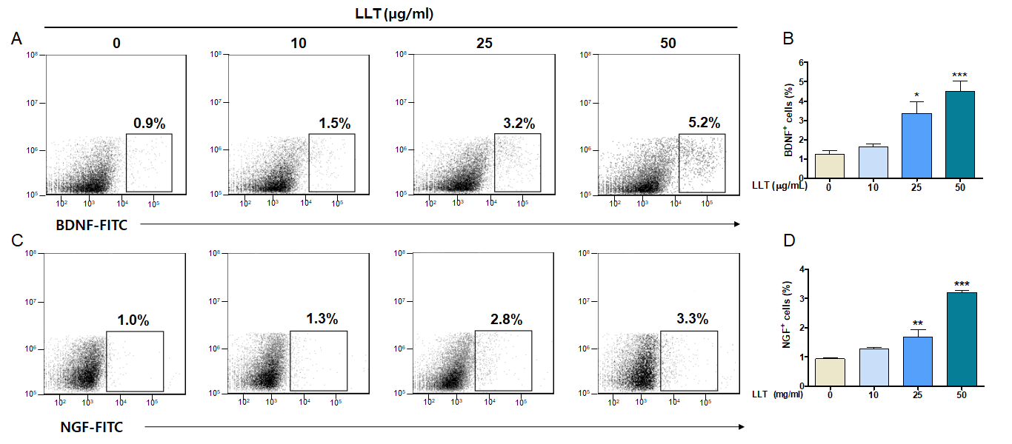
Supplementary Figure 4: BDNF and NGF Flow cytometry analysis of cortical neuron treated with 10, 25 and 50 µg/ml of LLT without H₂O₂ exposure. a) Representative dot plots graphs showing BDNF expression. b) Quantification of BDNF-positive cells at the single cell level. c) Representative dot plots graphs showing NGF expression. d) Quantification of NGF-positive cells at the single cell level. Data represent mean ± SEM of six independent experiments. Statistically significant differences compared with blank group by one-way ANOVA with Tukey’s post-hoc test. (*p < 0.05; **p < 0.01; ***p < 0.001).
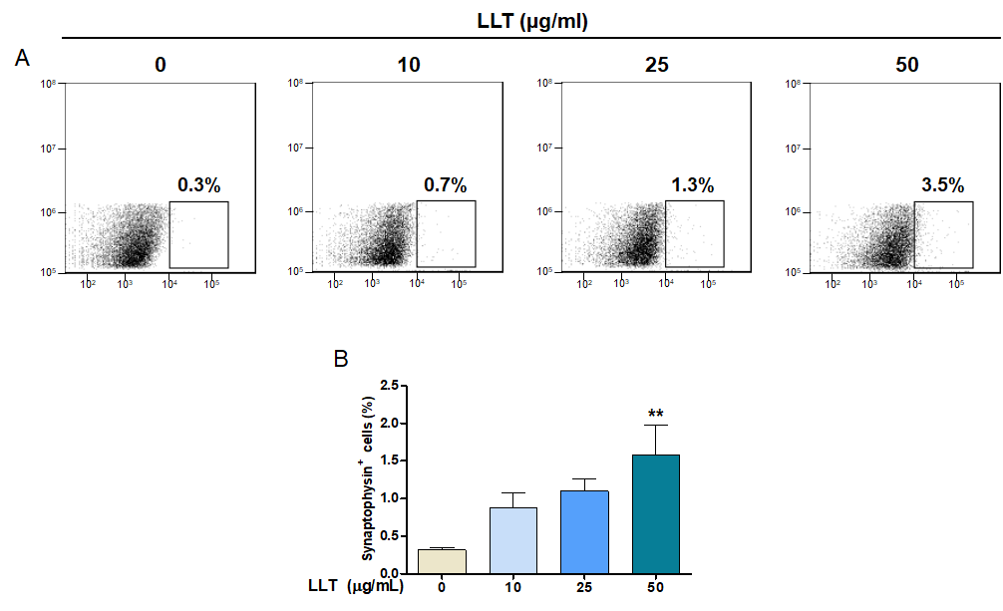
Supplementary Figure 5: Synaptophysin Flow cytometry analysis of cortical neuron treated with 10, 25 and 50 µg/ml of LLT without H₂O₂ exposure. a) Representative dot plots graphs showing Synaptophysin expression. b) Quantification of Synaptophysin-positive cells at the single cell level. Data represent mean ± SEM of six independent experiments. Statistically significant differences compared with blank group by one-way ANOVA with Tukey’s post-hoc test. (*p < 0.05; **p < 0.01; ***p < 0.001).

