Table S1. Information for candidate bioactive components of HLJDD.
Herb | Number | Molecule Name | MW | OB (%) | DL | Molecules structure
CR/ PCC | MOL001454 | berberine | 336.39 | 36.86 | 0.78 | 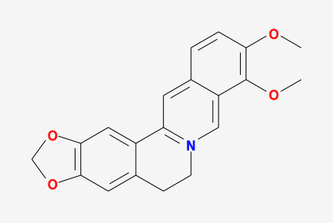
CR/ PCC | MOL013352 | Obacunone | 454.56 | 43.29 | 0.77 | 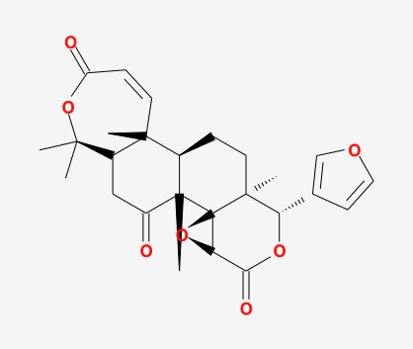
CR/ PCC | MOL002894 | berberrubine | 322.36 | 35.74 | 0.73 | 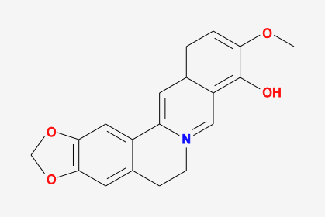
CR/ SR | MOL002897 | epiberberine | 336.39 | 43.09 | 0.78 | 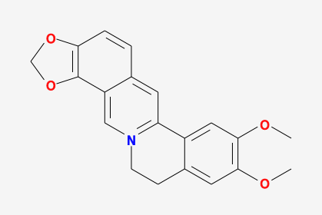
CR | MOL002903 | (R)-Canadine | 339.42 | 55.37 | 0.77 | 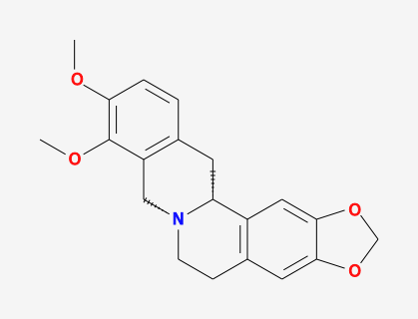
CR | MOL002904 | Berlambine | 351.38 | 36.68 | 0.82 | 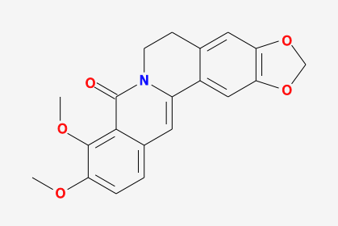
CR | MOL002907 | Corchoroside A_qt | 404.55 | 104.95 | 0.78 | 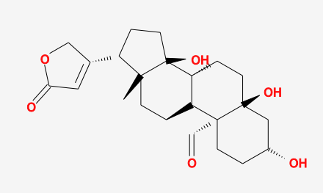
CR/ PCC | MOL000622 | Magnograndiolide | 266.37 | 63.71 | 0.19 | 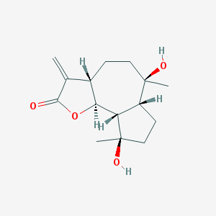
CR/ PCC | MOL000762 | Palmidin A | 510.52 | 35.36 | 0.65 | 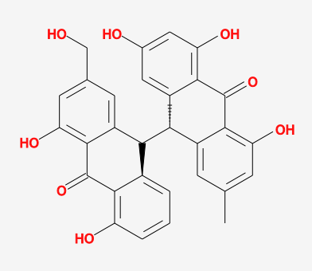
CR/ PCC | MOL000785 | palmatine | 352.44 | 64.6 | 0.65 | 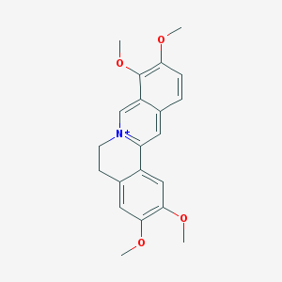
CR/ PCC | MOL000098 | quercetin | 302.25 | 46.43 | 0.28 | 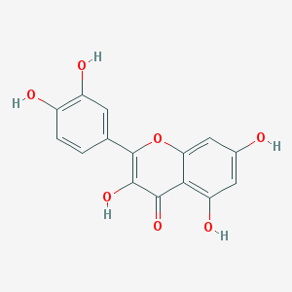
CR/ PCC/ SR | MOL001458 | coptisine | 320.34 | 30.67 | 0.86 | 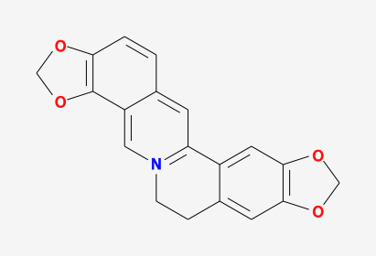
CR/ PCC | MOL002668 | Worenine | 334.37 | 45.83 | 0.87 | 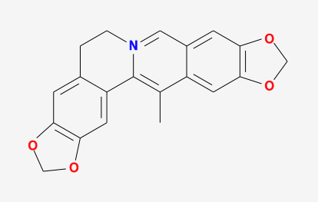
CR | MOL008647 | Moupinamide | 313.38 | 86.71 | 0.26 | 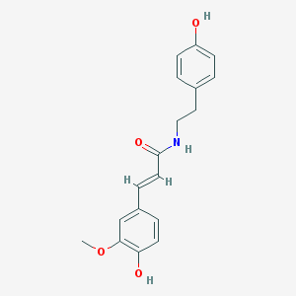
SR | MOL001689 | acacetin | 284.28 | 34.97 | 0.24 | 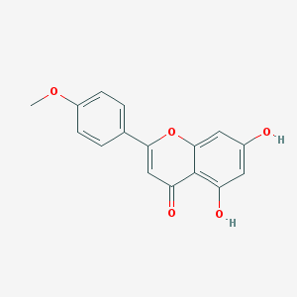
SR | MOL000173 | wogonin | 284.28 | 30.68 | 0.23 | 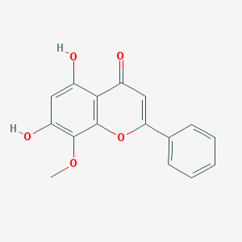
SR | MOL000228 | (2R)-7-hydroxy-5-methoxy-2-phenylchroman-4-one | 270.3 | 55.23 | 0.2 | 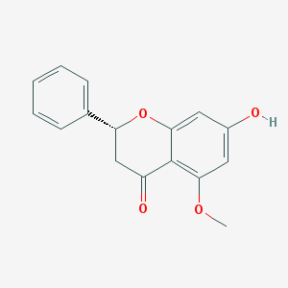
SR | MOL002714 | baicalein | 270.25 | 33.52 | 0.21 | 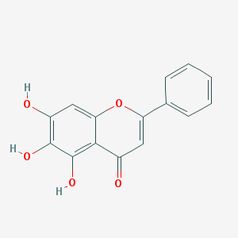
SR | MOL002908 | 5,8,2'-Trihydroxy-7-methoxyflavone | 300.28 | 37.01 | 0.27 | 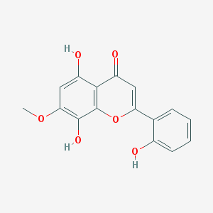
SR | MOL002909 | 5,7,2,5-tetrahydroxy-8,6-dimethoxyflavone | 376.34 | 33.82 | 0.45 | 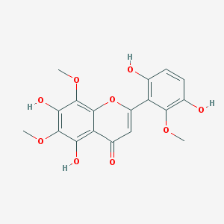
SR | MOL002910 | Carthamidin | 288.27 | 41.15 | 0.24 | 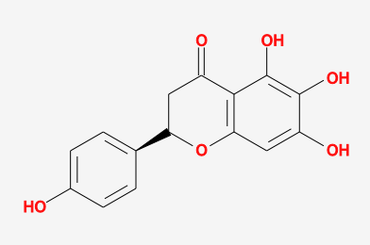
SR | MOL002911 | 2,6,2',4'-tetrahydroxy-6'-methoxychaleone | 302.3 | 69.04 | 0.22 | 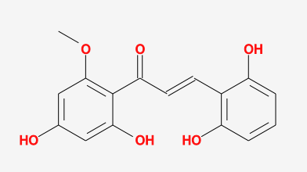
SR | MOL002913 | Dihydrobaicalin_qt | 272.27 | 40.04 | 0.21 | 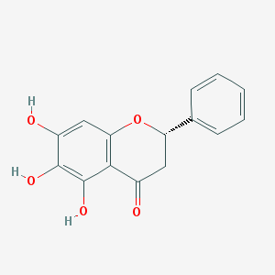
SR | MOL002914 | Eriodyctiol (flavanone) | 288.27 | 41.35 | 0.24 | 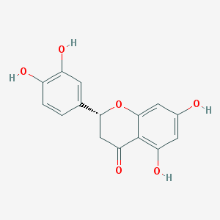
SR | MOL002915 | Salvigenin | 328.34 | 49.07 | 0.33 | 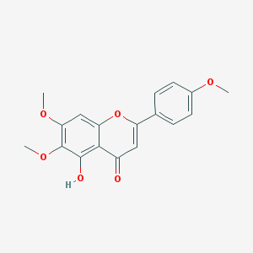
SR | MOL002917 | 5,2',6'-Trihydroxy-7,8-dimethoxyflavone | 330.31 | 45.05 | 0.33 | 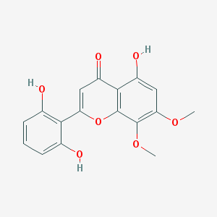
SR | MOL002925 | 5,7,2',6'-Tetrahydroxyflavone | 286.25 | 37.01 | 0.24 | 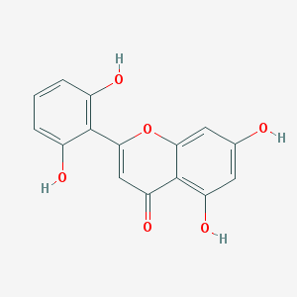
SR | MOL002926 | dihydrooroxylin A | 286.3 | 38.72 | 0.23 | 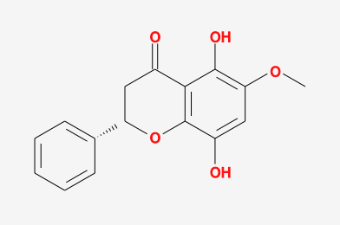
SR | MOL002927 | Skullcapflavone II | 374.37 | 69.51 | 0.44 | 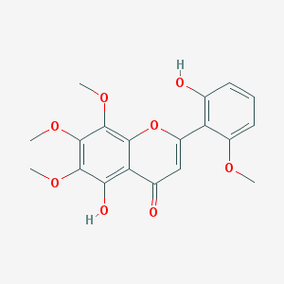
SR | MOL002928 | oroxylin a | 284.28 | 41.37 | 0.23 | 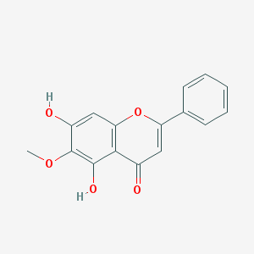
SR | MOL002932 | Panicolin | 314.31 | 76.26 | 0.29 | 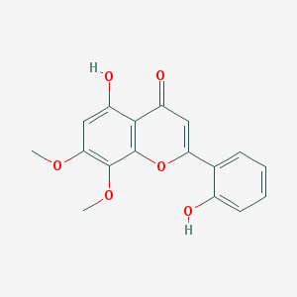
SR | MOL002933 | 5,7,4'-Trihydroxy-8-methoxyflavone | 300.28 | 36.56 | 0.27 | 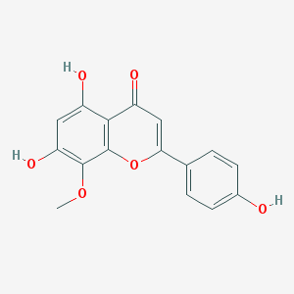
SR | MOL002934 | NEOBAICALEIN | 374.37 | 104.34 | 0.44 | 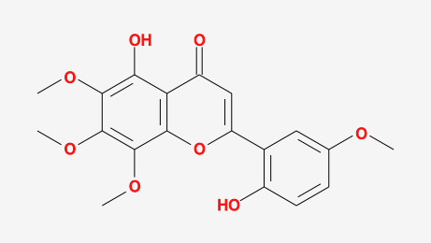
SR | MOL002937 | DIHYDROOROXYLIN | 286.3 | 66.06 | 0.23 | 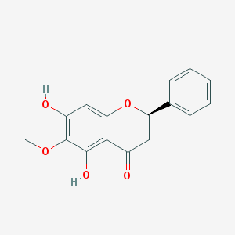
SR | MOL000358 | beta-sitosterol | 414.79 | 36.91 | 0.75 | 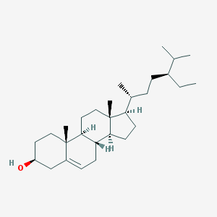
SR | MOL000359 | sitosterol | 414.79 | 36.91 | 0.75 | 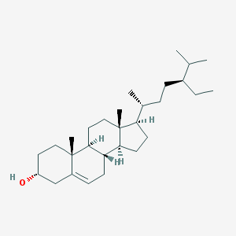
SR | MOL000525 | Norwogonin | 270.25 | 39.4 | 0.21 | 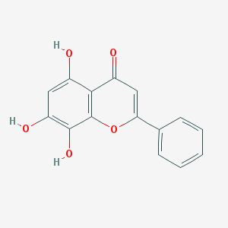
SR | MOL000552 | 5,2'-Dihydroxy-6,7,8-trimethoxyflavone | 344.34 | 31.71 | 0.35 | 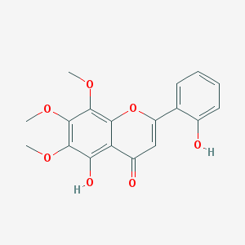
SR | MOL000073 | ent-Epicatechin | 290.29 | 48.96 | 0.24 | 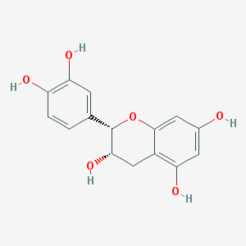
SR | MOL000449 | Stigmasterol | 412.77 | 43.83 | 0.76 | 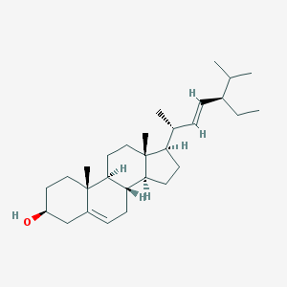
SR | MOL001490 | bis[(2S)-2-ethylhexyl] benzene-1,2-dicarboxylate | 390.62 | 43.59 | 0.35 | 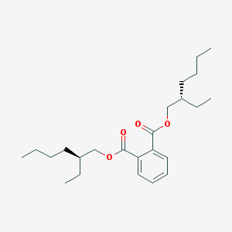
SR | MOL001506 | Supraene | 410.8 | 33.55 | 0.42 | 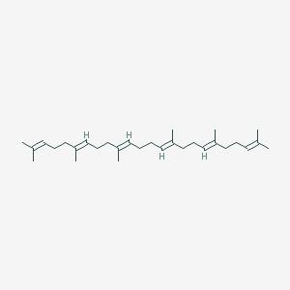
SR | MOL002879 | Diop | 390.62 | 43.59 | 0.39 | 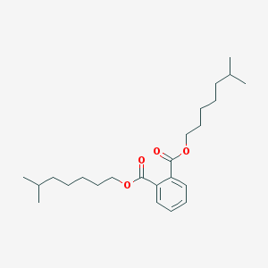
SR | MOL008206 | Moslosooflavone | 298.31 | 44.09 | 0.25 | 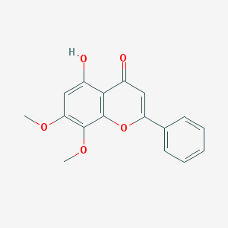
SR | MOL010415 | 11,13-Eicosadienoic acid, methyl ester | 322.59 | 39.28 | 0.23 | 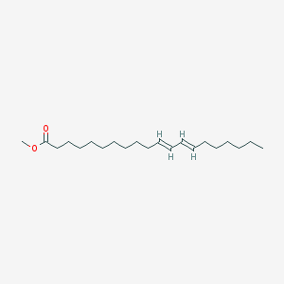
SR | MOL012245 | 5,7,4'-trihydroxy-6-methoxyflavanone | 302.3 | 36.63 | 0.27 | 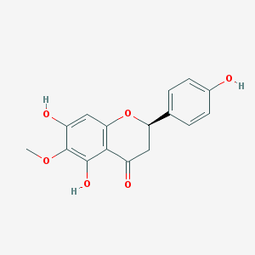
SR | MOL012246 | 5,7,4'-trihydroxy-8-methoxyflavanone | 302.3 | 74.24 | 0.26 | 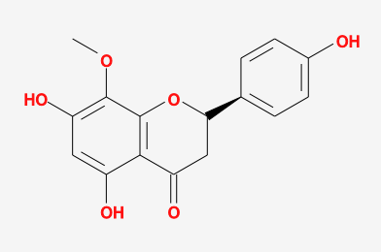
SR | MOL012266 | rivularin | 344.34 | 37.94 | 0.37 | 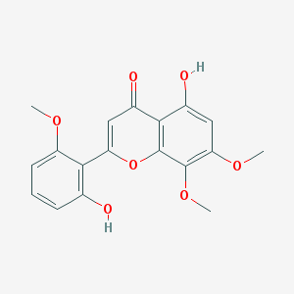
PCC | MOL000787 | Fumarine | 353.4 | 59.26 | 0.83 | 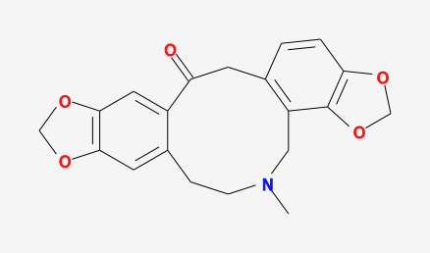
PCC | MOL000790 | Isocorypalmine | 341.44 | 35.77 | 0.59 | 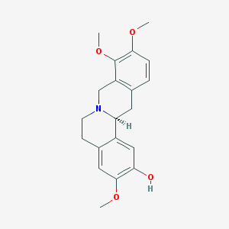
PCC | MOL001131 | phellamurin_qt | 356.4 | 56.6 | 0.39 | 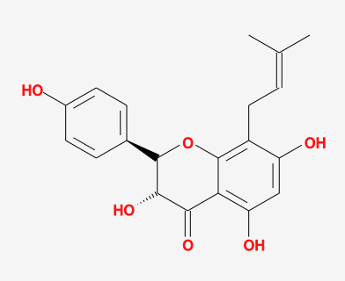
PCC | MOL001455 | (S)-Canadine | 339.42 | 53.83 | 0.77 | 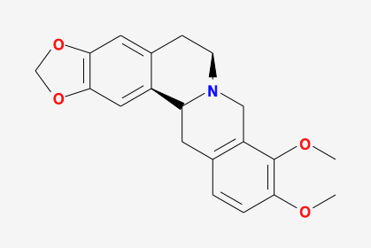
PCC | MOL002636 | Kihadalactone A | 512.7 | 34.21 | 0.82 | 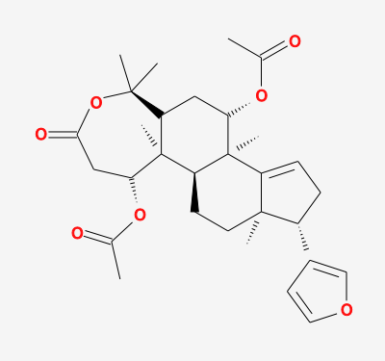
PCC | MOL002641 | Phellavin_qt | 374.42 | 35.86 | 0.44 | 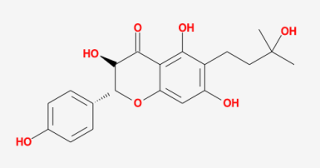
PCC | MOL002643 | delta 7-stigmastenol | 414.79 | 37.42 | 0.75 | 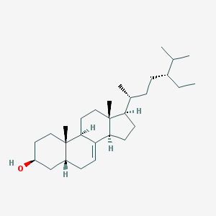
PCC | MOL002644 | Phellopterin | 300.33 | 40.19 | 0.28 | 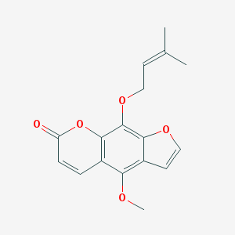
PCC | MOL002651 | Dehydrotanshinone II A | 292.35 | 43.76 | 0.4 | 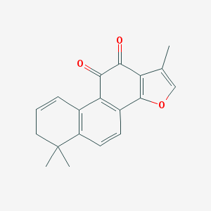
PCC | MOL002652 | delta7-Dehydrosophoramine | 242.35 | 54.45 | 0.25 | 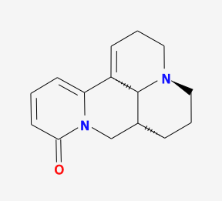
PCC | MOL002656 | dihydroniloticin | 458.8 | 36.43 | 0.81 | 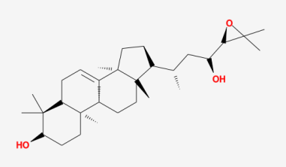
PCC | MOL002659 | kihadanin A | 486.56 | 31.6 | 0.7 | 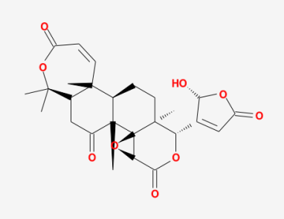
PCC | MOL002660 | niloticin | 456.78 | 41.41 | 0.82 | 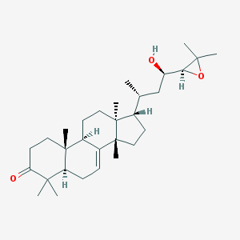
PCC | MOL002662 | rutaecarpine | 287.34 | 40.3 | 0.6 | 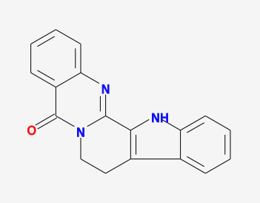
PCC | MOL002663 | Skimmianin | 259.28 | 40.14 | 0.2 | 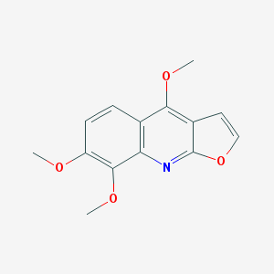
PCC | MOL002666 | Chelerythrine | 332.37 | 34.18 | 0.78 | 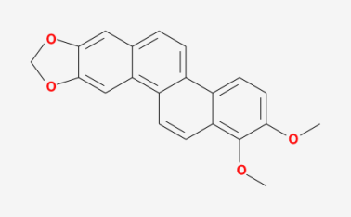
PCC | MOL002670 | Cavidine | 353.45 | 35.64 | 0.81 | 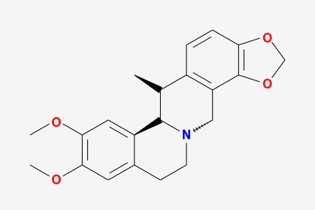
PCC | MOL002671 | Candletoxin A | 608.79 | 31.81 | 0.69 | 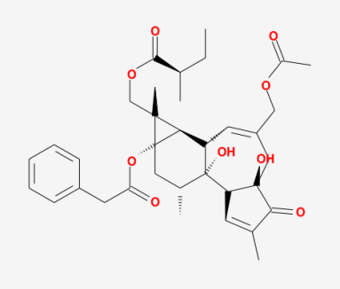
PCC | MOL002672 | Hericenone H | 580.88 | 39 | 0.63 | 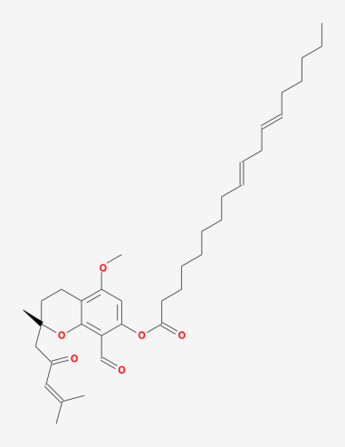
PCC | MOL002673 | Hispidone | 472.78 | 36.18 | 0.83 | 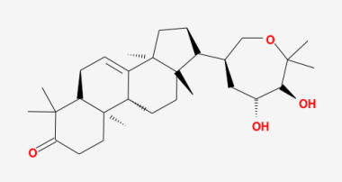
PCC | MOL005438 | campesterol | 400.76 | 37.58 | 0.71 | 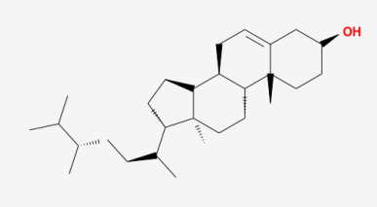
PCC | MOL006392 | dihydroniloticin | 458.8 | 36.43 | 0.82 | 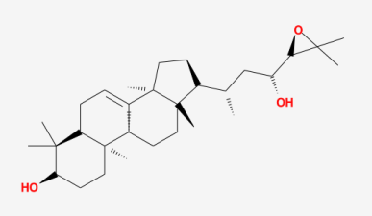
PCC | MOL006401 | melianone | 470.76 | 40.53 | 0.78 | 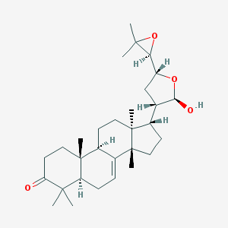
PCC | MOL006413 | phellochin | 488.83 | 35.41 | 0.82 | 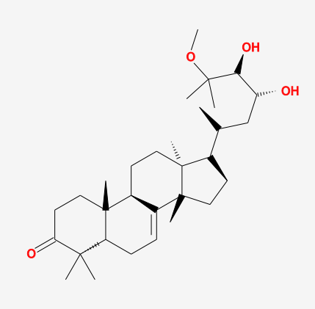
PCC | MOL006422 | thalifendine | 322.36 | 44.41 | 0.73
GF | MOL001406 | crocetin | 328.44 | 35.3 | 0.26 | 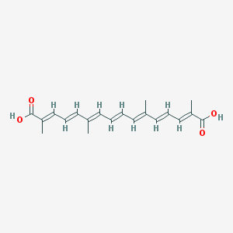
GF | MOL001663 | (4aS,6aR,6aS,6bR,8aR,10R,12aR,14bS)-10-hydroxy-2,2,6a,6b,9,9,12a-heptamethyl-1,3,4,5,6,6a,7,8,8a,10,11,12,13,14b-tetradecahydropicene-4a-carboxylic acid | 456.78 | 32.03 | 0.76 | 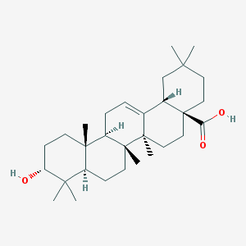
GF | MOL001941 | Ammidin | 270.3 | 34.55 | 0.22 | 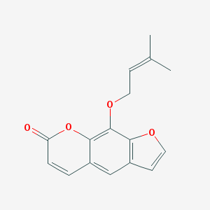
GF | MOL000422 | kaempferol | 286.25 | 41.88 | 0.24 | 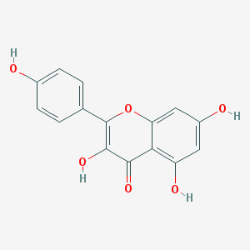
GF | MOL001942 | isoimperatorin | 270.3 | 45.46 | 0.23 | 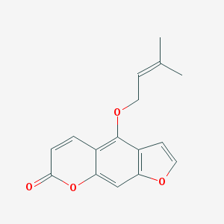
GF | MOL002883 | Ethyl oleate (NF) | 310.58 | 32.4 | 0.19 | 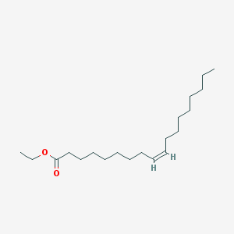
GF | MOL003095 | 5-hydroxy-7-methoxy-2-(3,4,5-trimethoxyphenyl)chromone | 358.37 | 51.96 | 0.41 | 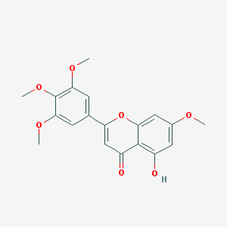
GF | MOL007245 | 3-Methylkempferol | 300.28 | 60.16 | 0.26 | 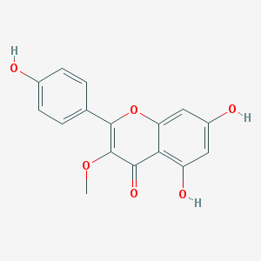
GF | MOL009038 | GBGB | 550.57 | 45.58 | 0.83 | 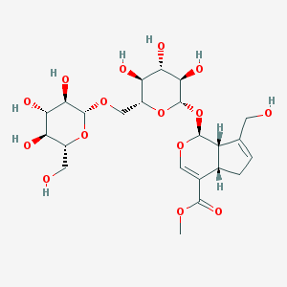
CR: Coptidis Rhizoma; SR: Scutellariae Radix; PCC: Phellodendri Chinensis Cortex; GF: Gardeniae Fructus.

Table S2. Protein targets of HLJDD.
Target | Common name | Uniprot ID
Myeloperoxidase | MPO | P05164
Phosphoinositide-3-Kinase Regulatory Subunit 1 | PIK3R1 | P27986
Adenosine A2a receptor | ADORA2A | P29274
Death Associated Protein Kinase 1 | DAPK1 | P53355
SRC Proto-Oncogene, Non-Receptor Tyrosine Kinase | SRC | P12931
Protein Tyrosine Kinase 2 | PTK2 | Q05397
Matrix metalloproteinase 13 | MMP13 | P45452
Matrix metalloproteinase 3 | MMP3 | P08254
Carbonic anhydrase III | CA3 | P07451
Arachidonate 15-lipoxygenase | ALOX15 | P16050
Multidrug resistance-associated protein 1 | ABCC1 | P33527
Matrix metalloproteinase 9 | MMP9 | P14780
Phosphatidylinositol-4,5-Bisphosphate 3-Kinase Catalytic Subunit Gamma | PIK3CG | P48736
Matrix metalloproteinase 2 | MMP2 | P08253
Protein kinase N1 | PKN1 | Q16512
Casein Kinase 2 Alpha 1 | CSNK2A1 | P68400
Arachidonate 12-lipoxygenase | ALOX12 | P18054
Hepatocyte growth factor receptor | MET | P08581
CaM kinase II beta | CAMK2B | Q13554
Anaplastic Lymphoma Receptor Tyrosine Kinase | ALK | Q9UM73
AKT Serine/Threonine Kinase 1 | AKT1 | P31749
Cytochrome P450 1B1 | CYP1B1 | Q16678
Tyrosine-protein kinase receptor UFO | AXL | P30530
ATP-binding cassette sub-family G member 2 | ABCG2 | Q9UNQ0
Apurinic/Apyrimidinic Endodeoxyribonuclease 1 | APEX1 | P27695
Aldo-keto reductase family 1 member C4 | AKR1C4 | P17516
Aldo-Keto Reductase Family 1 Member A1 | AKR1A1 | P14550
Cyclin-dependent kinase 6 | CDK6 | Q00534
Cyclin-dependent kinase 2 | CDK2 | P24941
Arginase-1 | ARG1 | P05089
Tyrosinase | TYR | P14679
Aryl hydrocarbon receptor | AHR | P35869
Beta-galactoside alpha-2,6-sialyltransferase 1 | ST6GAL1 | P15907
Solute carrier family 22 member 12 | SLC22A12 | Q96S37
Poly [ADP-ribose] polymerase-1 | PARP1 | P09874
Transthyretin | TTR | P02766
Matrix metalloproteinase 12 | MMP12 | P39900
CD38 Molecule | CD38 | P28907
Aldo-keto reductase family 1 member B10 | AKR1B10 | O60218
Matrix metalloproteinase 1 | MMP1 | P03956
Monoamine oxidase B | MAOB | P27338
C-C chemokine receptor type 2 | CCR2 | P41597
Forkhead box protein O1 | FOXO1 | Q12778
Calpain 1 | CAPN1 | P07384
Rat anti-rabbit macrophage antibody 11 | RAM11 | A5HC69
Cytochrome P450 2C9 | CYP2C9 | P11712
Cytochrome P450 3A4 | CYP3A4 | P08684
Dihydrofolate reductase | DHFR | P00374
Melanocortin receptor 4 | MC4R | P32245
5-lipoxygenase activating protein | ALOX5AP | P20292
Phosphodiesterase 4B | PDE4B | Q07343
Intercellular cell adhesion molecule-1 | ICAM1 | P05362
Acyl coenzyme A:cholesterol acyltransferase 1 | SOAT1 | P35610
Nuclear factor erythroid 2-related factor 2 | NFE2L2 | Q16236
Janus Kinase 1 | JAK1 | P23458
Fms Related Receptor Tyrosine Kinase 4 | FLT4 | P35916
Epoxide hydratase 2 | EPHX2 | P34913
LYN Proto-Oncogene, Src Family Tyrosine Kinase | LYN | P07948
Complement factor D | CFD | P00746
Colony Stimulating Factor 1 Receptor | CSF1R | P07333
Interleukin-1 receptor-associated kinase 4 | IRAK4 | Q9NWZ3
P2X purinoceptor 7 | P2RX7 | Q99572
Platelet endothelial cell adhesion molecule-1 | CD31 | P16284
Isocitrate Dehydrogenase (NADP(+)) 1 | IDH1 | O75874
Voltage-gated L-type calcium channel alpha-1C subunit | CACNA1C | Q13936
Tyrosine-protein kinase TIE-2 | TEK | Q02763
Histone deacetylase 3 | HDAC3 | O15379
Histone deacetylase 6 | HDAC6 | Q9UBN7
Histone deacetylase 2 | HDAC2 | Q92769
Histone deacetylase 5 | HDAC5 | Q9UQL6
Heat Shock Protein 90 Alpha Family Class B Member 1 | HSP90AB1 | P08238
Butyrylcholinesterase | BCHE | P06276
Adrenergic receptor alpha-2 | ADRA2C | P18825
Alpha-2b adrenergic receptor | ADRA2B | P18089
Muscarinic acetylcholine receptor M1 | CHRM1 | P11229
Cytochrome P450 2D6 | CYP2D6 | P10635
Histone deacetylase 7 | HDAC7 | Q8WUI4
Histone deacetylase 4 | HDAC4 | P56524
Histone deacetylase 9 | HDAC9 | Q9UKV0
5-Hydroxytryptamine Receptor 3A | HTR3A | P46098
Glucagon-like peptide 1 receptor | GLP1R | P43220
Cell division control protein 42 homolog | CDC42 | P60953
Peptidyl-prolyl cis-trans isomerase NIMA-interacting 1 | PIN1 | Q13526
Lysine-specific demethylase 4C | KDM4C | Q9H3R0
Muscarinic acetylcholine receptor M3 | CHRM3 | P20309
Galectin-3 | LGALS3 | P17931
Galectin-9 | LGALS9 | O00182
Thymidylate synthase | TYMS | P04818
Urotensin II receptor | UTS2R | Q9UKP6
Heat Shock Protein 90 Alpha Family Class A Member 1 | HSP90AA1 | P07900
Epoxide hydrolase 1 | EPHX1 | P07099
Solute Carrier Family 1 Member 1 | SLC1A1 | P43005
Protein Tyrosine Kinase 2 Beta | PTK2B | Q14289
Neuropeptide Y receptor Y5 | NPY5 | Q15761
Sphingosine-1-Phosphate Receptor 2 | S1PR2 | O95136
Lysophosphatidic Acid Receptor 2 | LPAR2 | P13569
Sphingosine-1-Phosphate Receptor 3 | S1PR3 | Q99500
Sphingosine-1-Phosphate Receptor 1 | S1PR1 | P21453
Platelet Derived Growth Factor Receptor Alpha | PDGFRA | P11309
Isoprenylcysteine Carboxyl Methyltransferase | ICMT | O60725
Monoglyceride Lipase | MGLL | Q99685
5-Hydroxytryptamine Receptor 2B | HTR2B | P22303
Glycogen Phosphorylase L | PYGL | P30518
Polo Like Kinase 1 | PLK1 | P06213
NIMA related kinase 2 | NEK2 | P51955
NIMA related kinase 6 | NEK6 | Q15746
Carbonic Anhydrase 5A | CA5A | P35218
NUAK Family Kinase 1 | NUAK1 | P43405
Hydroxysteroid 17-Beta Dehydrogenase 1 | HSD17B1 | P14061
Adenosine A3 Receptor | ADORA3 | P0DMS8
Protein Tyrosine Phosphatase Receptor Type S | PTPRS | Q13332
Methylpurine-DNA Glycosylase | MPG | P53350
Tankyrase | TNKS | O95271
Dynamin 1 | DNM1 | Q05193
Dopamine Receptor D3 | DRD3 | P35462
Quinoid Dihydropteridine Reductase | QDPR | P09417
N-Ribosyldihydronicotinamide:Quinone Reductase 2 | NQO2 | P25024
cell division cycle 25B | CDC25B | P30305
The melanocortin 1 receptor | MC1R | P56817
Acetyl-CoA Carboxylase Beta | ACACB | O00763
Glutamate Ionotropic Receptor AMPA Type Subunit 1 | GRIA1 | O60285
Dopamine Receptor D5 | DRD5 | P42330
Dopamine Receptor D1 | DRD1 | P21728
Pim-2 proto-oncogene, serine/threonine kinase | PIM2 | Q9UNQ1
Gamma-Aminobutyric Acid Type A Receptor Subunit Alpha5 | GABRA5 | P11511
Bombesin Receptor Subtype 3 | BRS3 | P32247
SUZ12 Polycomb Repressive Complex 2 Subunit | SUZ12 | Q15022
RB binding protein 4 | RBBP4 | P43166
Bromodomain Containing 3 | BRD3 | Q15059
poly (A) binding protein cytoplasmic 1 | PABPC1 | P11940
Cell Division Cycle 25C | CDC25C | O43570
Eukaryotic Translation Initiation Factor 4H | EIF4H | P22748
Phospholipase A2 Group IVB | PLA2G4B | Q9H2K2
Cholinergic Receptor Muscarinic 5 | CHRM5 | P03372
Glucagon Receptor | GCGR | Q92731
Sigma Non-Opioid Intracellular Receptor 1 | SIGMAR1 | Q99720
Recombinant Human SUMO E1 | SAE1 | Q9UBE0
Histone deacetylase 8 | HDAC8 | Q9BY41
Cholinergic receptor nicotinic alpha 4 subunit | CHRNA4 | P10721
Sodium Voltage-Gated Channel Alpha Subunit 9 | SCN9A | P15121
Lysine Demethylase 4A | KDM4A | Q15078
Cholinergic Receptor Muscarinic 4 | CHRM4 | P21397
Cholinergic receptor nicotinic alpha 5 subunit | CHRNA5 | P30532
Solute Carrier Family 18 Member A2 | SLC18A2 | Q09540
Solute Carrier Family 18 Member A3 | SLC18A3 | Q16572
MAPK Interacting Serine/Threonine Kinase 2 | MKNK2 | P49841
Protein tyrosine kinase 6 | PTK6 | Q13882
Histone deacetylase 10 | HDAC10 | Q969S8
Tubulin Beta 1 Class VI | TUBB1 | Q9H47B

