ORIGINAL RESEARCH Stepankova et al

The anti-proliferative activity of coordination compound-based ZnO nanoparticles as a promising agent against triple negative breast cancer cells
Hana Stepankova^{1,2}
Marcin Swiatkowski³
Rafal Kruszynski³
Pavel Svec¹
Hana Michalkova¹
Vendula Smolikova^{1,2}
Andrea Ridoskova^{1,4}
Zbynek Splichal^{1,2}
Petr Michalek^{1,2}
Lukas Richtera^{1,2}
Pavel Kopel⁵
Vojtech Adam^{1,2}
Zbynek Heger^{1,2}
Simona Rex^{1,2}

¹ Department of Chemistry and Biochemistry, Mendel University in Brno, Brno, Czechia; ² Central European Institute of Technology, Brno University of Technology, Brno, Czechia; ³ Institute of General and Ecological Chemistry, Lodz University of Technology, Lodz, Poland; ⁴ Central European Institute of Technology, Mendel University in Brno, Brno, Czechia; ⁵Department of Inorganic Chemistry, Faculty of Science, Palacky University, Olomouc, Czechia
Correspondence: Simona Rex
Department of Chemistry and Biochemistry, Mendel University in Brno, Zemedelska 1665/1, CZ-613 00 Brno, Czechia
Tel +420-5-4513-3350
Fax +425-5-4521-2044
Email simona.rex@mendelu.cz

S1. SUPPLEMENTARY EXPERIMENTAL SECTION
S1.1. Synthesis (experimental details)
Samples of zinc carbonate (0.10 mol, 12.54 g each) were suspended in solutions of carboxylic acids (formic, acetic, propionic, butyric, isobutyric and valeric; 0.15 mol of acid in 150 cm³ of water, c = 1.0 mol·dm⁻³). Such reaction mixtures were heated under reflux at 100°C for 3 h. An unreacted excess of zinc carbonate was filtered off. The concentrations of zinc carboxylates in the final solutions were determined via EDTA titration of zinc cations (at pH = 10, in presence of eriochrome black T as an analytical indicator) [1]. The solution containing 0.050 mol of respective zinc carboxylate was mixed with solution containing 0.025 mol of HMTA (3.50 g in 20 cm³ of water). The mixtures were stirred on magnetic stirrer for about 30 minutes and left to crystallize at room temperature. Yields (in relation to: zinc carboxylate / HMTA): compound 1 [Zn(H₂O)₆](HCOO)·2(HMTA)·4H₂O - 24% / 96%; compound 2 [Zn(CH₃COO)₂(HMTA)(H₂O)] – 47% / 94%; compound 3 [Zn₃(OH)(C₂H₅COO)₅(HMTA)]_{n} – 93% / 62%; compound 5 [Zn₂(i-C₃H₇COO)₄(HMTA)₂] – 43% / 86%.
S1.2. Notes on crystal structure refinement
Four propionate anions of compound 3 show symptoms of disorder, exhibiting in prolation or oblation of anisotropic displacement ellipsoids. In one case (anion containing C38 atom), the two domains of disordered anion can be distinguished. The methyl group of the anion is placed in two positions of crystal net with 0.6:0.4 participation of domains. The distinguishable even slightly different location of other three anions is not observed. The measured electron density and difference Fourier syntheses electron density was analysed to establish the reason of the prolation and oblation effects. In these three cases, the electron density shows smooth change (without any well distinguishable maximum) within the displacement ellipsoids. This proves that the disorder is dynamic in character in this case. The diffusion of the electron density in the respective amount of space causes that the disorder cannot be refined (and modelled) in a form of split densities of separated atoms. Consequently, the introduction of respective disorder models (containing two or more domains) into refinement of compound 3 leads to worsening of refinement parameters. Beside that these two-domain disorder refinements (after fulfilling stability criteria) contain the atoms with distinctly larger prolation effects or even displacement ellipsoids collapsed out of metric space (anti-matter diffraction effect), which is chemically and physically impossible (Supplementary Figure S9). The maxima on the difference Fourier syntheses observed directly outside the anisotropic displacement ellipsoids (as well as minima observed inside the anisotropic displacement ellipsoids) originate from the non-ellipsoidal distribution of the electron density. It must be outlined that some displacement ellipsoids are prolate or oblate spheroids, but they cover the major part of electron density, the linkage between the atoms, as well as placement of the atoms cannot be different, and the quality of the refinement fulfils the requirements of the unambiguous refinement. The disorder of anions is caused by the “loose” crystal packing, i.e. there are small voids around the anion (if the anion is considered as composed from balls with radii equal to van der Waals radii of respective atoms) which allows both small differences of placement of anions in the crystal net (the general position is the same but the atoms positions may differ in small fractions of Å) and diffusion of the electron density into the voids.

S1.3. References
1. Welcher FJ: The Analytical Uses of Ethylenediamine Tetraacetic Acid. Van Nostrand; 1965.

S2. SUPPLEMENTARY TABLES AND FIGURES
Table S1. Products of reactions between zinc carboxylates and HMTA (C₆H₁₂N₄).
carboxylate | zinc carboxylate : HMTA reaction stoichiometry
carboxylate | 2:1 [this work] | 1:1 [1] | 1:2 [1]
formate | [Zn(H₂O)₆](HCOO)₂·2(C₆H₁₂N₄)·4H₂O (1)  + Zn(HCOO)₂ | [Zn(H₂O)₆](HCOO)₂·2(C₆H₁₂N₄)·4H₂O (1)  + Zn(HCOO)₂ | [Zn(H₂O)₆](HCOO)₂·2(C₆H₁₂N₄)·4H₂O (1)
acetate | [Zn(CH₃COO)₂(C₆H₁₂N₄)(H₂O)] (2)  + Zn(CH₃COO)₂ | [Zn(CH₃COO)₂(C₆H₁₂N₄)(H₂O)] (2) | [Zn(CH₃COO)₂(C₆H₁₂N₄)(H₂O)] (2)  + C₆H₁₂N₄
propionate | [Zn₃(C₂H₅COO)₅(OH)(C₆H₁₂N₄)]_{n} (3)  + C₆H₁₂N₄ | [Zn₂(C₂H₅COO)₄(C₆H₁₂N₄)(H₂O)]_{n} (3A)  + C₆H₁₂N₄ | [Zn₂(C₂H₅COO)₄(C₆H₁₂N₄)(H₂O)]_{n} (3A)  + C₆H₁₂N₄
butyrate | Zn(n-C₃H₇COO)₂  + C₆H₁₂N₄ | [Zn₂(n-C₃H₇COO)₄(C₆H₁₂N₄)(H₂O)]_{n} (4A)  + C₆H₁₂N₄ | [Zn₂(n-C₃H₇COO)₄(C₆H₁₂N₄)(H₂O)]_{n} (4A)  + C₆H₁₂N₄
isobutyrate | [Zn₂(i-C₃H₇COO)₄(C₆H₁₂N₄)₂] (5)  + Zn(i-C₃H₇COO)₂ | [Zn(i-C₃H₇COO)₂(C₆H₁₂N₄)]_{n}·n(H₂O) (5A) | [Zn(i-C₃H₇COO)₂(C₆H₁₂N₄)]_{n}·n(H₂O) (5A)  + C₆H₁₂N₄

Table S2. Crystal data and structure refinement details for the compounds 3 and 5.
Compound | 3 | 5
Empirical formula | C₄₂H₇₆N₈O₂₂Zn₆ | C₂₈H₅₂N₈O₈Zn₂
Formula weight | 1437.32 | 759.51
Crystal system | Monoclinic | Monoclinic
Space group | P2₁/c | C2/m
Temperature (K) | 100.0(1) | 100.0(1)
Wavelength (Å) | 1.54184 λ(CuKα) | 1.54184 λ(CuKα)
Unit cell dimensions
a (Å) | 18.5529(1) | 16.9795(1)
b (Å) | 17.9917(1) | 12.1911(1)
c (Å) | 18.2481(1) | 8.3399(1)
α (°) | 90.00 | 90.00
β (°) | 113.817(1) | 100.404(1)
γ (°) | 90.00 | 90.00
Volume (Å³) | 5572.45(7) | 1697.97(3)
Z, Calculated density (Mg/m³) | 4, 1.713 | 2, 1.486
Absorption coefficient (mm⁻¹) | 3.563 | 2.230
F(000) | 2960 | 800
Crystal size (mm) | 0.211 x 0.155 × 0.085 | 0.465 x 0.106 × 0.049
θ Range for data collection (°) | 3.580 to 78.952 | 4.490 to 78.958
Index ranges | −22 ≤ h ≤ 23  −22 ≤ k ≤ 20  −23 ≤ l ≤ 21 | −21 ≤ h ≤ 20  −15 ≤ k ≤ 14  −10 ≤ l ≤ 10
Reflections collected / unique | 91677 / 11602 | 14214 / 1824
R_{int} | 0.0306 | 0.0223
Completeness to θ = 67° (%) | 100.0 | 100.0
Min. and max. transmission | 0.664 and 1.000 | 0.485 and 1.000
Data / restraints / parameters | 11602 / 0 / 723 | 1824 / 0 / 114
Goodness-of-fit on F² | 1.029 | 1.085
Final R indices [I>2σ(I)] | R1 = 0.0337,  wR2 = 0.0867 | R1 = 0.0220,  wR2 = 0.0567
R indices (all data) | R1 = 0.0355,  wR2 = 0.0867 | R1 = 0.0224,  wR2 = 0.0570
Largest diff. peak and hole (e·Å⁻³) | 2.356 and −0.931 | 0.324 and −0.338

Table S3. Selected structural data of the compounds 3 and 5.
i—j | d_{ij} (Å) | ν_{ij} (v.u.) | i—j—k | α_{ijk} (°)
compound 3
Zn1—O1 | 2.0193(17) | 0.416 | O1—Zn1—O3 | 117.60(8)
Zn1—O3 | 1.9574(18) | 0.492 | O1—Zn1—O5 | 123.18(8)
Zn1—O5 | 1.9943(17) | 0.445 | O1—Zn1—O11 | 89.61(7)
Zn1—O11 | 2.0578(16) | 0.375 | O1—Zn1— N6^{i} | 80.08(7)
Zn1—N6^{i} | 2.2931(19) | 0.236 | O3—Zn1—O5 | 117.19(8)
 | ∑ν_{ij} | 1.965 | O3—Zn1—O11 | 102.14(7)
 |  |  | O3—Zn1—N6^{i} | 87.95(7)
 |  |  | O5—Zn1—O11 | 92.83(7)
 |  |  | O5—Zn1—N6^{i} | 87.98(7)
 |  |  | O11 —Zn1—N6^{i} | 168.13(7)
Zn2—O2 | 2.0228(17) | 0.412 | O2—Zn2—O7 | 126.34(7)
Zn2—O7 | 2.0022(17) | 0.436 | O2—Zn2—O9 | 114.39(8)
Zn2—O9 | 1.9644(18) | 0.482 | O2—Zn2—O11 | 90.42(7)
Zn2—O11 | 2.0565(16) | 0.377 | O2—Zn2—N3^{ii} | 79.96(7)
Zn2—N3^{ii} | 2.2718(18) | 0.250 | O7—Zn2—O9 | 117.23(8)
 | ∑ν_{ij} | 1.957 | O7—Zn2—O11 | 90.22(7)
 |  |  | O7—Zn2—N3^{ii} | 86.68(7)
 |  |  | O9—Zn2—O11 | 104.59(7)
 |  |  | O9 —Zn2—N3^{ii} | 89.55(7)
 |  |  | O11—Zn2—N3^{ii} | 165.33(7)
Zn3—O4 | 2.1103(18) | 0.325 | O4—Zn3—O6 | 90.64(8)
Zn3—O6 | 2.1210(17) | 0.316 | O4—Zn3—O8 | 177.25(9)
Zn3—O8 | 2.1215(18) | 0.316 | O4—Zn3—O10 | 84.33(9)
Zn3—O10 | 2.0806(19) | 0.353 | O4—Zn3—O11 | 94.90(7)
Zn3—O11 | 2.0632(16) | 0.369 | O4—Zn3—N1 | 92.94(7)
Zn3—N1 | 2.2026(18) | 0.302 | O6—Zn3—O8 | 92.08(8)
 | ∑ν_{ij} | 1.981 | O6—Zn3—O10 | 174.49(8)
 |  |  | O6—Zn3—O11 | 86.32(7)
 |  |  | O6—Zn3—N1 | 87.52(7)
 |  |  | O8—Zn3—O10 | 92.95(9)
 |  |  | O8—Zn3—O11 | 85.65(7)
 |  |  | O8—Zn3—N1 | 86.80(7)
 |  |  | O10—Zn3—O11 | 96.33(7)
 |  |  | O10—Zn3—N1 | 90.48(7)
 |  |  | O11—Zn3—N1 | 170.07(7)
Zn4—O12 | 2.0225(18) | 0.413 | O12—Zn4—O14 | 130.08(9)
Zn4—O14 | 2.0050(18) | 0.433 | O12—Zn4—O16 | 110.75(8)
Zn4—O16 | 1.956(2) | 0.494 | O12—Zn4—O22 | 89.42(7)
Zn4—O22 | 2.0476(16) | 0.386 | O12—Zn4—N2 | 80.05(7)
Zn4—N2 | 2.2710(19) | 0.250 | O14—Zn4—O16 | 117.40(9)
 | ∑ν_{ij} | 1.976 | O14—Zn4—O22 | 93.35(7)
 |  |  | O14—Zn4—N2 | 84.28(7)
 |  |  | O16—Zn4—O22 | 101.41(7)
 |  |  | O16—Zn4—N2 | 93.85(7)
 |  |  | O22—Zn4—N2 | 163.80(7)
Zn5—O13 | 2.0199(18) | 0.415 | O13—Zn5—O18 | 114.30(8)
Zn5—O18 | 1.9796(18) | 0.464 | O13—Zn5—O20 | 124.82(8)
Zn5—O20 | 2.0072(17) | 0.430 | O13—Zn5—O22 | 92.77(7)
Zn5—O22 | 2.0405(16) | 0.393 | O13—Zn5—N7^{iii} | 82.33(7)
Zn5—N7^{iii} | 2.2711(18) | 0.250 | O18—Zn5—O20 | 118.38(7)
 | ∑ν_{ij} | 1.952 | O18—Zn5—O22 | 102.11(7)
 |  |  | O18—Zn5—N7^{iii} | 88.42(7)
 |  |  | O20—Zn5—O22 | 91.46(7)
 |  |  | O20 —Zn5—N7^{iii} | 83.80(7)
 |  |  | O22 —Zn5—N7^{iii} | 169.47(7)
Zn6—O15 | 2.0924(17) | 0.342 | O15—Zn6—O17 | 94.82(8)
Zn6—O17 | 2.1254(18) | 0.312 | O15—Zn6—O19 | 175.23(7)
Zn6—O19 | 2.1039(17) | 0.331 | O15—Zn6—O21 | 91.57(7)
Zn6—O21 | 2.1429(17) | 0.298 | O15—Zn6—O22 | 87.38(7)
Zn6—O22 | 2.0600(16) | 0.373 | O15—Zn6—N5 | 89.51(7)
Zn6—N5 | 2.1958(19) | 0.307 | O17—Zn6—O19 | 87.28(8)
 | ∑ν_{ij} | 1.963 | O17—Zn6—O21 | 172.86(7)
 |  |  | O17—Zn6—O22 | 91.31(7)
 |  |  | O17—Zn6—N5 | 90.25(7)
 |  |  | O19—Zn6—O21 | 86.59(7)
 |  |  | O19—Zn6—O22 | 96.89(7)
 |  |  | O19—Zn6—N5 | 86.17(7)
 |  |  | O21—Zn6—O22 | 85.81(6)
 |  |  | O21—Zn6—N5 | 92.98(7)
 |  |  | O22—Zn6—N5 | 176.63(7)
compound 5
Zn1—N1 | 2.0589(15) | 0.444 | N1—Zn1—O1 | 103.76(4)
Zn1—O1 | 2.0247(10) | 0.410 | N1—Zn1—O1^{iv} | 103.76(4)
Zn1—O1^{iv} | 2.0247(10) | 0.410 | N1—Zn1—O2^{v} | 95.62(4)
Zn1—O2^{v} | 2.0583(10) | 0.375 | N1—Zn1—O2^{vi} | 95.62(4)
Zn1—O2^{vi} | 2.0583(10) | 0.375 | O1—Zn1—O1^{iv} | 90.12(7)
 | ∑ν_{ij} | 2.014 | O1—Zn1—O2^{v} | 85.81(5)
 |  |  | O1—Zn1—O2^{vi} | 160.61(4)
 |  |  | O1^{iv}—Zn1—O2^{v} | 160.61(4)
 |  |  | O1^{iv}—Zn1—O2^{vi} | 85.81(5)
 |  |  | O2^{v}—Zn1—O2^{vi} | 91.77(7)
Symmetry transformations used to generate equivalent atoms: (i) x+1, y, z; (ii) x, -y+1.5, -z-0.5; (iii) x, -y+1.5, -z+0.5; (iv) x, -y+1, z; (v) -x+1, y, -z; (vi) -x+1, -y+1, -z.

Table S4. Hydrogen bonds in the studied compounds [Å, °].
D—H···A | d(D—H) | d(H···A) | d(D···A) | <(DHA)
compound 3
C1—H1A···O12 | 0.99 | 2.40 | 2.986(3) | 117.4
C2—H2A···O2^{i} | 0.99 | 2.34 | 2.939(3) | 118.1
C3—H3A···O8 | 0.99 | 2.50 | 3.076(3) | 116.7
C3—H3B···O6 | 0.99 | 2.38 | 3.006(3) | 120.2
C4—H4A···O7^{i} | 0.99 | 2.60 | 3.134(3) | 113.6
C4—H4B···O14 | 0.99 | 2.49 | 3.057(3) | 115.9
C5—H5B···O12 | 0.99 | 2.39 | 2.980(3) | 117.3
C6—H6A···O2^{i} | 0.99 | 2.45 | 3.025(3) | 116.3
C6—H6B···O9^{i} | 0.99 | 2.60 | 3.148(3) | 114.8
C7—H7B···O1^{ii} | 0.99 | 2.32 | 2.935(3) | 119.5
C8—H8B···O13^{i} | 0.99 | 2.40 | 3.023(3) | 120.1
C9—H9A···O17 | 0.99 | 2.50 | 3.070(3) | 116.1
C9—H9B···O19 | 0.99 | 2.43 | 3.033(3) | 118.9
C10—H10B···O20^{i} | 0.99 | 2.63 | 3.159(3) | 113.6
C11—H11A···O1^{ii} | 0.99 | 2.43 | 3.021(3) | 117.5
C11—H11B···O3^{ii} | 0.99 | 2.61 | 3.145(3) | 114.1
C12—H12A···O20^{i} | 0.99 | 2.62 | 3.152(3) | 113.7
C12—H12B···O13^{i} | 0.99 | 2.36 | 2.988(3) | 120.6
compound 5
C1—H1A···O2^{iii} | 0.99 | 2.53 | 3.1202(19) | 117.7
C6—H6···N3^{iv} | 1.00 | 2.70 | 3.5793(17) | 147.1
Symmetry transformations used to generate equivalent atoms: (i) x, -y+1.5, z+0.5; (ii) x-1, y, z; (iii) -x+1, y, -z; (iv) -x+1, -y+1, -z+1.

Figure S1. The IR spectra of compounds 3 and 5.

Table S5. Vibrational frequencies (cm⁻¹) and their assignments for the compounds 3 and 5.
3 | zinc propionate | HMTA | assignment | 5 | zinc isobutyrate | HMTA | assignment
3447 br |  |  | ν OH
2979 m | 2973 m |  | ν_{as} CH₃ | 2955 m | 2969 s |  | ν_{as} CH₃
2941 m | 2935 m |  | ν_{s} CH₃ | 2928 m | 2931 m |  | ν_{s} CH₃
2878 w | 2879 w | 2872 m | ν_{s} CH₂ | 2878 w | 2871 m | 2872 m | ν C_{α}H, ν_{s} CH₂
1608 s | 1540 s |  | ν_{as} COO | 1616 s |  |  | ν_{as} COO
1463 s | 1470 m | 1456 s | σ CH₂ | 1462 s | 1475 s | 1456 s | δ_{as} CH₃, σ CH₂
1429 s | 1407 m |  | ν_{s} COO | 1419 s | 1423 s |  | ν_{s} COO
1401 w | 1374 m |  | δ_{s} CH₃ | 1375 m | 1377 m | 1370 s | δ_{s} CH₃, ω CH₂
1375 w |  | 1370 s | ω CH₂ | 1361 m | 1359 m |  | δ_{s} CH₃
1318 m | 1315 m |  | ω CH₂ | 1330 w | 1311 s |  | δ C_{α}H
1307 m |  |  | ω CH₂ | 1298 m | 1290 w |  | δ C_{α}H
1292 m |  |  | ω CH₂ | 1250 s |  |  | ρ CH₂
1275 m |  |  | ρ CH₂ | 1228 s |  | 1240 s | ρ CH₂
1253 s |  |  | ρ CH₂ | 1169 w | 1170 m |  | ρ_{as} CH₃
1234 s |  | 1240 s | ρ CH₂ | 1130 w |  |  | ρ_{as} CH₃
1224 m |  |  | ρ CH₂ | 1097 m | 1098 s |  | ρ_{s} CH₃
1079 m | 1082 s |  | ρ-α CH₃, ν CC | 1059 s |  |  | ρ_{s} CH₃
1064 m |  |  | ρ-α CH₃, ν CC | 1023 s |  | 1007 s | ν CN
1055 m |  |  | ρ-α CH₃, ν CC | 997 s |  |  | ν CN
1027 s |  | 1007 s | ν CN | 925 w | 926 m |  | ρ_{s} CH₃
993 s |  |  | ν CN | 915 m |  |  | ρ_{s} CH₃
924 m |  |  | ν CC | 840 w | 843 m |  | σ COO, ν_{s} (C_{β})₂C_{α}C
901 m | 908 s |  | ν CC | 828 m |  |  | σ COO, ν_{s} (C_{β})₂C_{α}C
881 w |  |  | ν CC | 822 m |  |  | σ COO, ν_{s} (C_{β})₂C_{α}C
842 m |  |  | ρ CH₂, ρ-γ CH₃,  ν CN | 805 w |  | 812 s | ν CN
826 w |  |  | ρ CH₂, ρ-γ CH₃, ν CN | 787 s | 766 m |  | ω COO
811 m | 812 s | 812 s | ρ CH₂, ρ-γ CH₃, ν CN | 760 m |  |  | ω COO
793 m |  |  | ρ CH₂, ρ-γ CH₃, ν CN | 715 s |  |  | ω COO
784 m |  |  | ρ CH₂, ρ-γ CH₃, ν CN | 663 s | 667 m | 672 s | σ COO, δ NCN
720 m | 707 s |  | σ COO | 614 w | 646 m |  | σ COO
681 m |  |  | δ NCN | 525 w | 549 m |  | δ C_{α}C
672 m |  | 672 s | δ NCN | 503 w |  | 512 s | ω NCN
659 m |  |  | δ NCN
522 w |  |  | ω NCN
507 w |  |  | ω NCN
498 w |  |  | ω NCN
Vibrations symbols: w – weak, m – medium, s – strong, br – broadened, ν – stretching, δ – bending, σ – scissoring, ρ – rocking, τ – twisting, ω – wagging, α – in plane, γ – out of plane, as – asymmetric, s – symmetric.

Figure S2. The plot of thermogravimetric data for compounds 3 and 5.

Fig S3. Hydrodynamic diameter stability for nanoparticles incubated for up to 72 h in Ringer‘s solution at 37 °C.

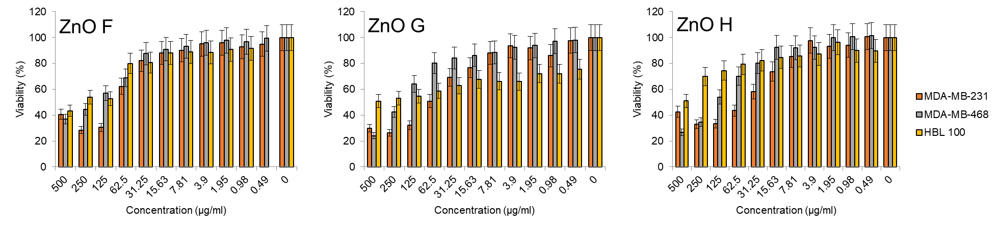
Fig. S4. Viability of MDA-MB-231, MDA-MB-468 and HBL-100 cells treated with various concentrations of ZnO F-H.

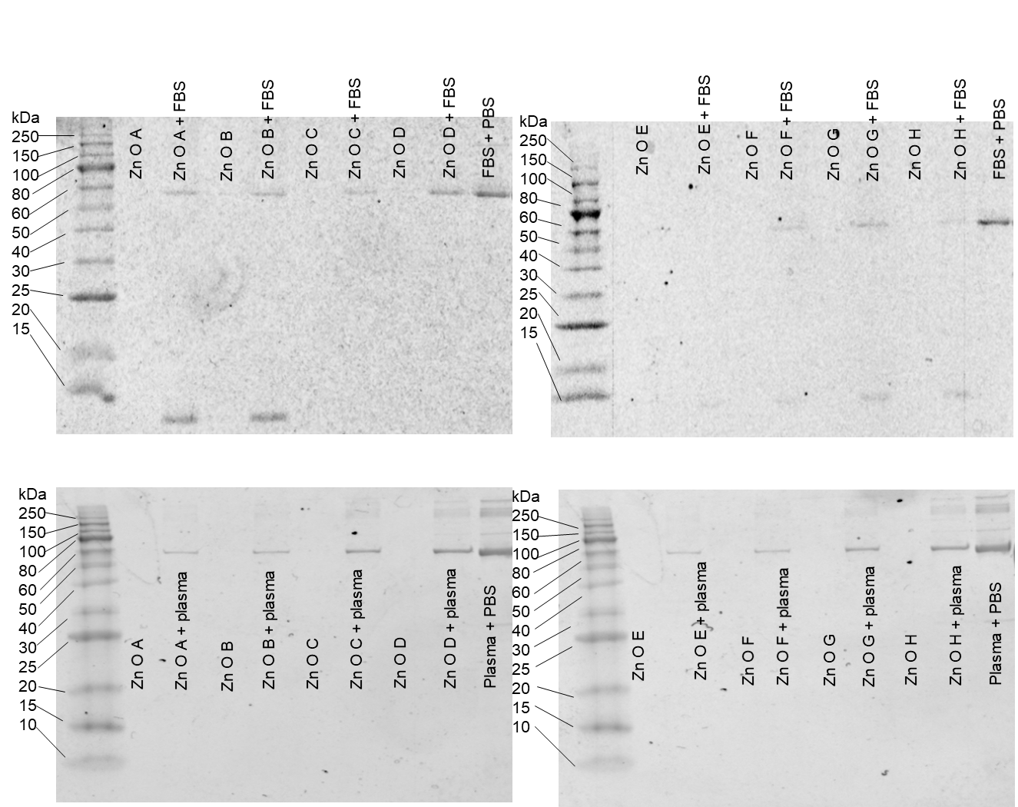
Fig S5. Biological identity of ZnO NPs in fetal bovine serum (top) and human plasma (bottom).

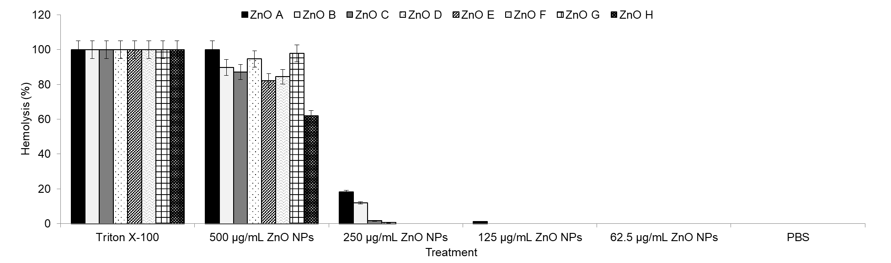
Fig S6. Hemolysis of RBCs caused by varied concentrations of ZnO NPs.

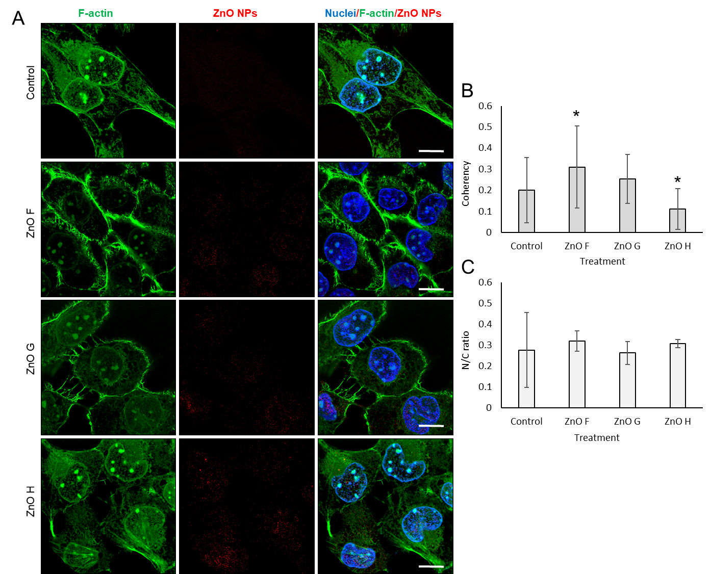
Fig S7. (A) Representative confocal micrographs of HBL-100 cells exposed to ZnO NPs for 24 h, fixed and visualised for F-actin stained with phalloidin and reflectance of ZnO NPs. Scale bar, 10 µm. (B) The coherency of F-actin filaments. * shows significantly (p<0.05) altered coherency compared to the untreated cells. (C) The N/C ratio of cells.
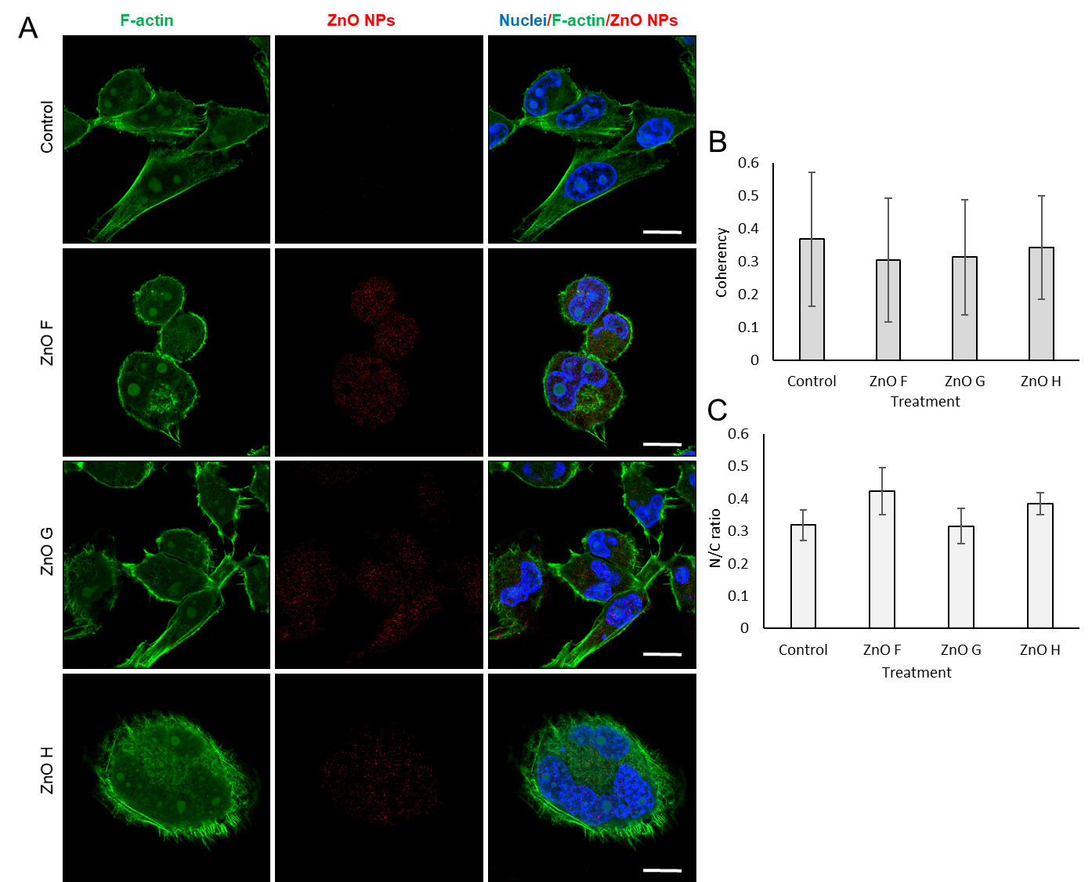
Fig S8. (A) Representative confocal micrographs of MDA-MB-231 cells exposed to ZnO NPs for 24 h, fixed and visualised for F-actin stained with phalloidin and reflectance of ZnO NPs. Scale bar, 10 µm. (B) The coherency of F-actin filaments. (C) The N/C ratio of cells.

Fig S9. The examples of refinement of aliphatic chain of propionic anions as non-disordered (a, c, e) and disordered over two positions (b, d, f).

