Supplementary Figure 1 Subgroup analysis of OS
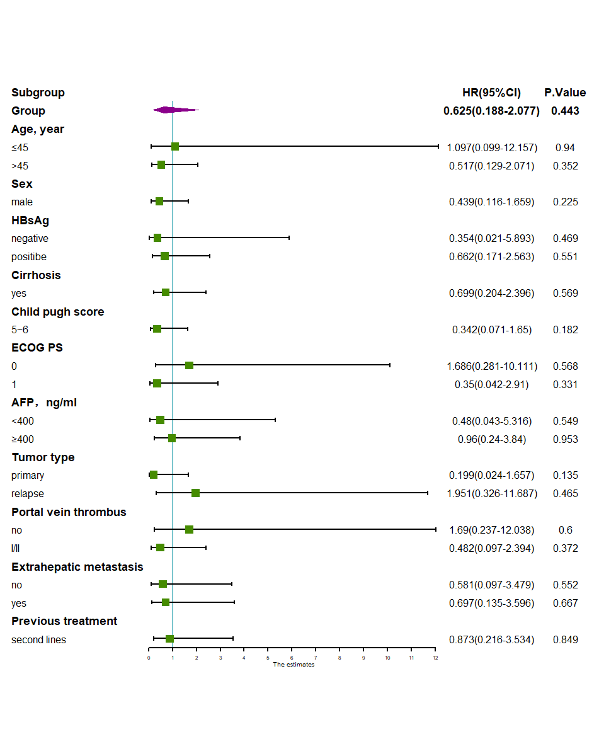

Supplementary Figure 2 Subgroup analysis of PFS
