Supporting Information

Nucleolin-targeting AS1411 aptamer-modified micelle for the co-delivery of doxorubicin and miR-519c to improve the therapeutic efficacy in hepatocellular carcinoma treatment

Xiao Liang,# Yudi Wang,# Hui Shi, Mengmeng Dong, Haobo Han*, Quanshun Li*

Key Laboratory for Molecular Enzymology and Engineering of Ministry of Education, School of Life Sciences, Jilin University, Changchun 130012, China

*Corresponding authors.
Tel. and Fax: +86-431-85155200.
E-mail: quanshun@jlu.edu.cn (Q. Li); hanhaobo@jlu.edu.cn (H. Han).
#These authors contributed equally to the work.

1. Determination of nucleolin expression in different cells
The cells were seeded in 6-well plates at a density of 2.5×10⁵ cells/well and incubated at 37 °C overnight. Afterwards, the medium was removed, and the cells were fixed in 4% paraformaldehyde for 20 min. Then, the fixed cells were treated with 0.2% Triton X-100 in PBS for 5 min, blocked with 10% goat serum for 1 h, and incubated with Alexa Fluor® 488-labeled nucleolin antibody at 4 °C overnight. After washing with PBS, the cells were stained with DAPI solution and observed on LSM 710 confocal laser scanning microscope (Carl Zeiss Microscopy LLC, Jena, Germany).

2. Determination of intracellular doxorubicin concentration
The HepG2 cells were seeded in 6-well plates at a density of 3.0×10⁵ cells/well and cultured overnight. The cells were treated with different micelles containing 0.6 μM DOX for 4, 12, 24 and 48 h, respectively. Afterward, the cells were harvested, lysed with methanol and subjected to the sonication at 80 W for 5 min. The lysates were centrifuged at 15,000 rpm for 15 min to obtain the supernatants for further LC-MS/MS analysis to determine the intracellular doxorubicin concentration. The quantitative measurement was performed using a Shimadzu LC-20 HPLC system coupled with an AB SCIEX API 4000 mass spectrometer (Applied Biosystems Sciex, Ontario, Canada) in the positive ion mode.

3. Live/Dead cell staining assay
The HepG2 cells were seeded in 6-well plates at a density of 2.5×10⁵ cells/well containing 2 mL of 10% FBS-harboring DMEM and incubated at 37 ºC overnight. The cells were then treated with different micelles containing 0.6 μM DOX for 72 h. After washing with Dulbecco's phosphate-buffered saline (DPBS) twice, the cells were stained with live/dead assay reagents in the detection kit for 30 min in the dark. Finally, the stained cells were washed with 1 mL DPBS twice and observed on an Olympus IX71 fluorescence microscopy (Tokyo, Japan).

4. Caspase activities assay
The HepG2 cells were seeded in 6-well plates and incubated with different micelles containing 0.6 μM DOX for 48 h as described above. The analysis of caspase-3, -8 and -9 activities was conducted according to the corresponding assay kits. Briefly, 2.0×10⁴ cells after the micelles’ treatment were suspended in lysis buffer and incubated with the corresponding substrates at room temperature for 1.5 h. The activities of caspase-3, -8, and -9 were detected through the luminescence intensity of each sample using a Synergy HTX Multi-mode microplate reader (BioTek, Auckland, New Zealand).

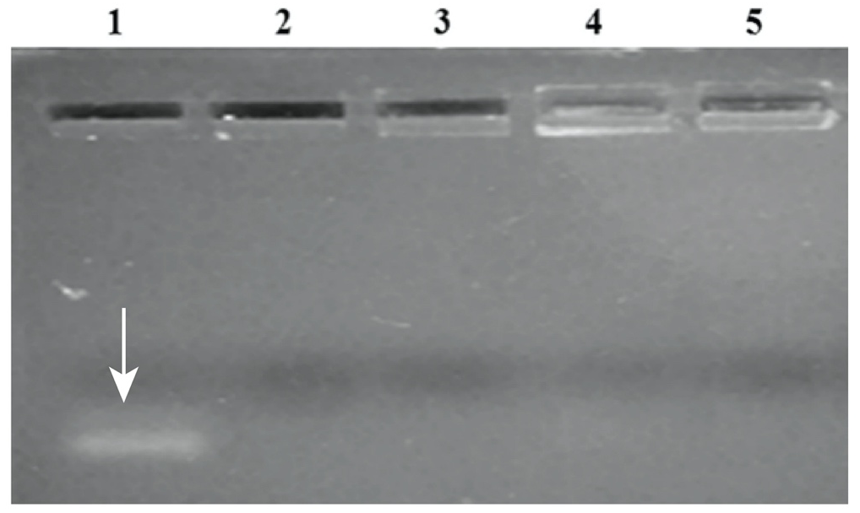
Figure S1. Agarose gel electrophoresis to confirm the conjugation of AS1411 aptamer on micelles. Lane 1: free aptamer, lane 2: M micelles, lane 3: MAS micelles, lane 4: MDP micelles, and lane 5: MDPAS micelles.

Figure S2. TEM images of M, MDP and MDPAS micelles.

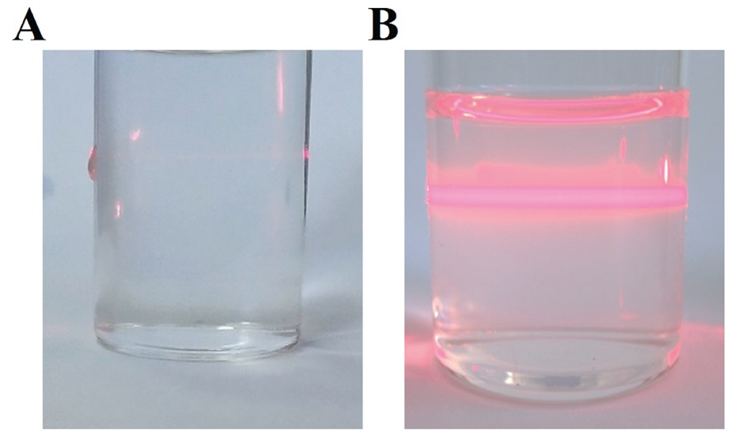
Figure S3. The Tyndall effect of PBS (A) and MDPAS micelles (B) stored at 4 °C for 60 days.

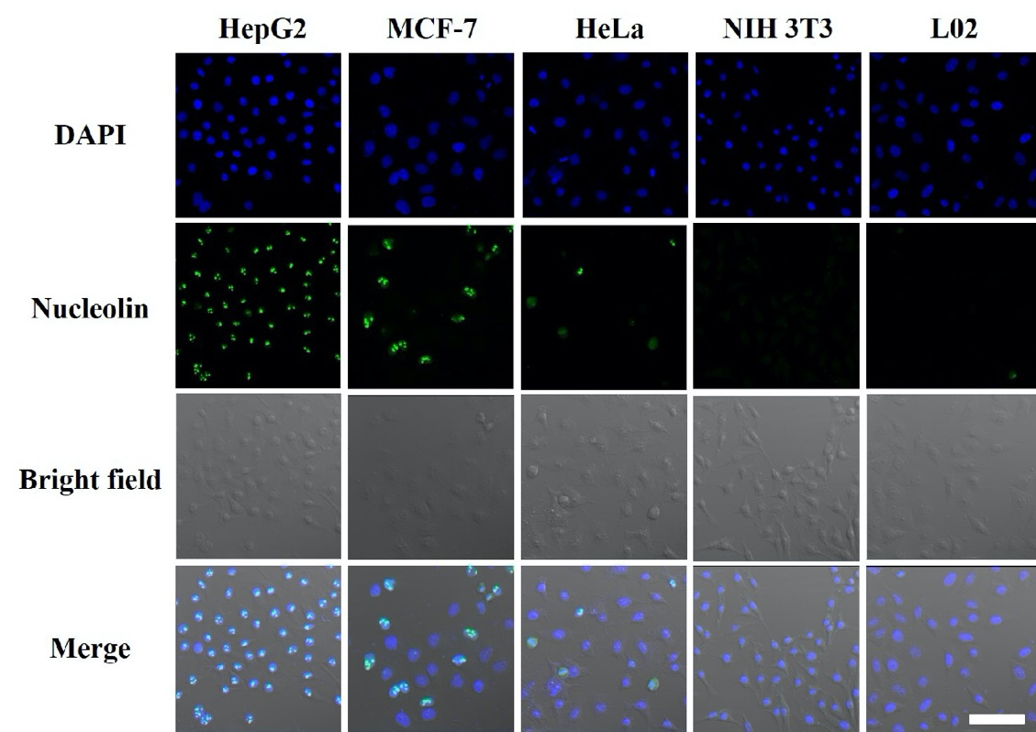
Figure S4. The CLSM images for analyzing the expression level of nucleolin on the membrane of different cells. Blue (DAPI, nucleus) and green (Alexa Fluor® 488, nucleolin). Scale bar: 100 μm.

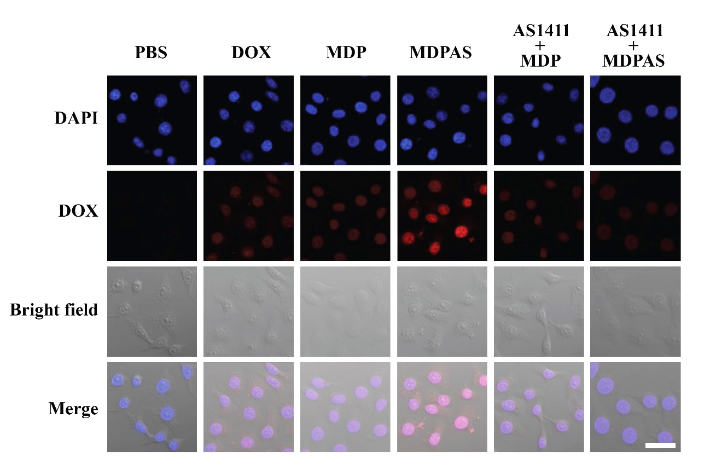
Figure S5. The CLSM images of cellular internalization in HepG2 cells after the treatment with different formulations. Blue (DAPI, nucleus) and red (DOX). Scale bar: 50 μm.

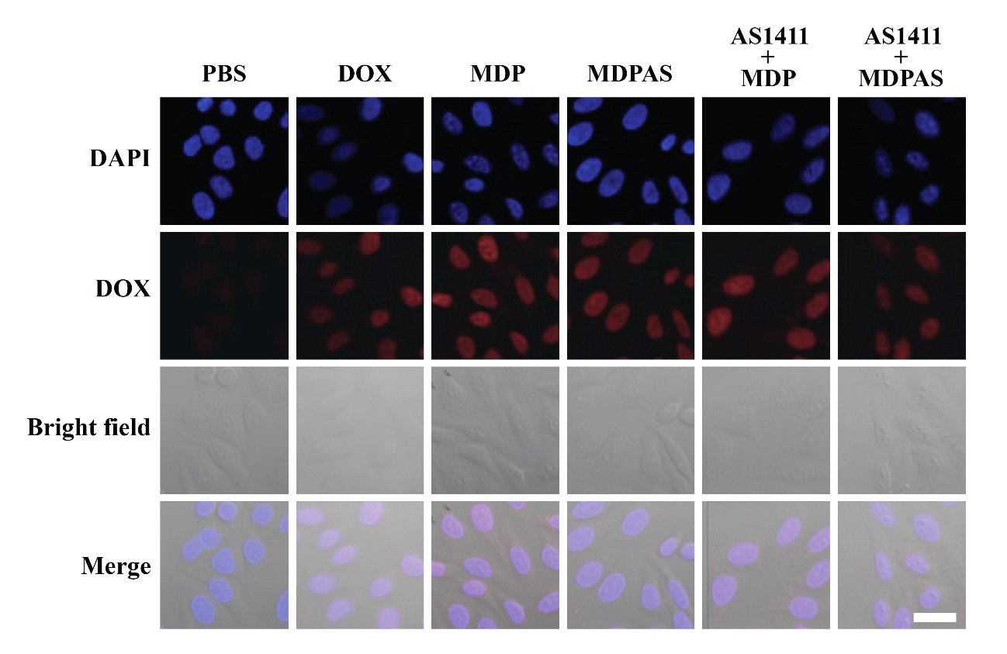
Figure S6. The CLSM images of cellular internalization in L02 cells after the treatment with different formulations. Blue (DAPI, nucleus) and red (DOX). Scale bar: 50 μm.

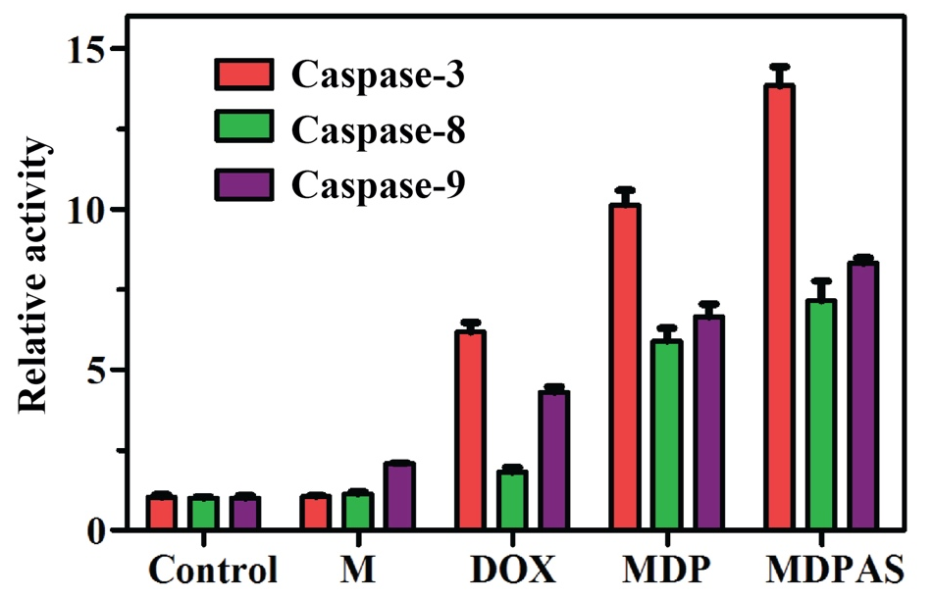
Figure S7. The relative activity of caspase-3, -8 and -9 in HepG2 cells after the treatment with different micelles.

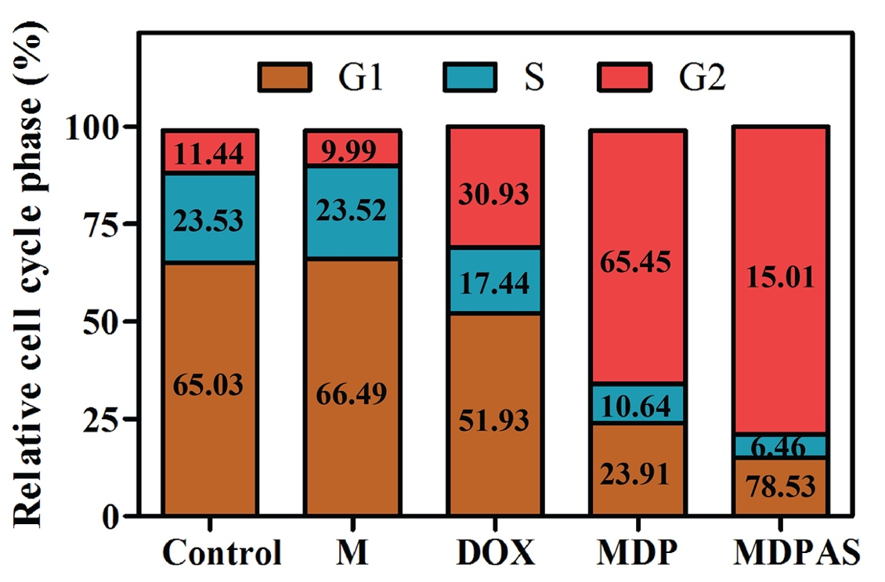
Figure S8. Quantification of cell cycle phase in HepG2 cells after the treatment with different formulations.

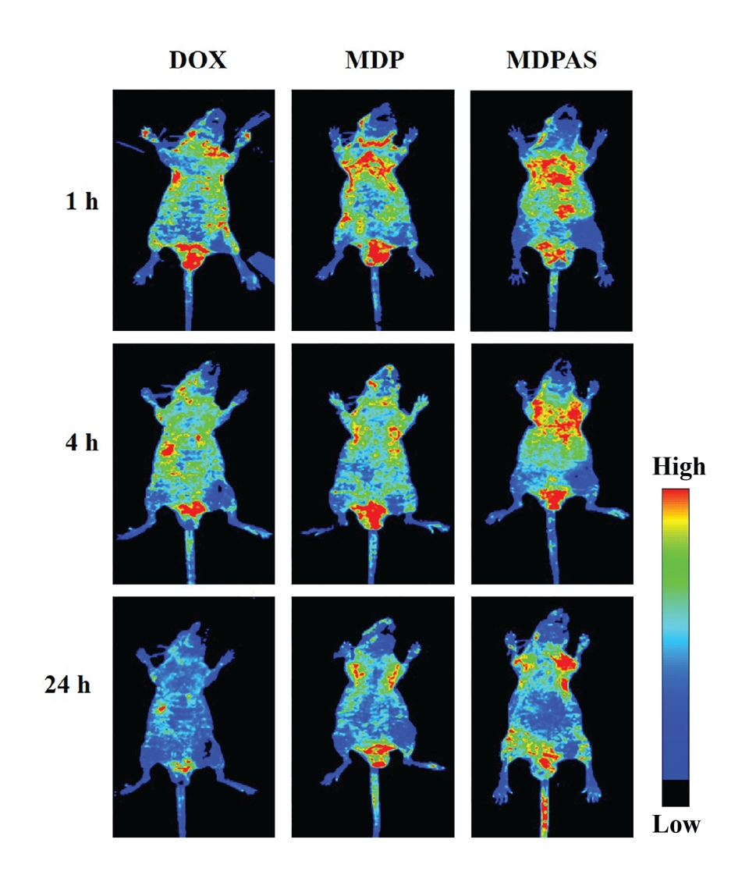
Figure S9. In vivo biodistribution of micelles in HepG2 cells-bearing mice after 1, 4 and 24 h post-injection (n=3 per group).

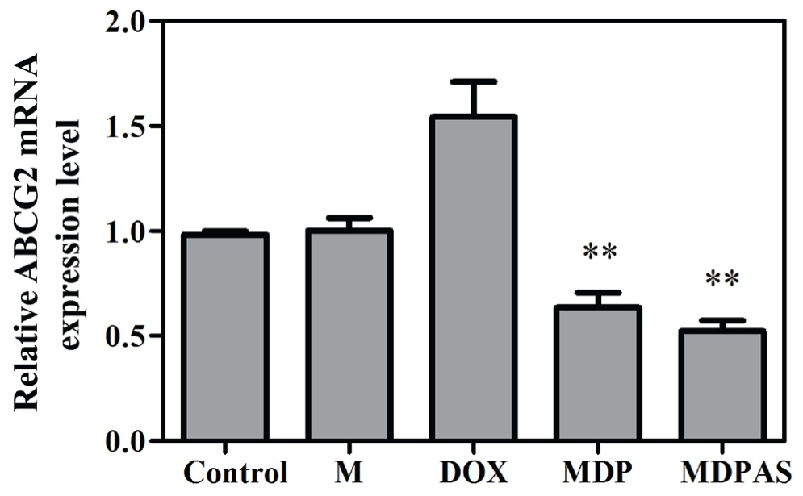
Figure S10. The relative expression level of ABCG2 in tumor tissues of HepG2 -xenografted mice received different formulations using qPCR technique (**p < 0.01, vs. control group).

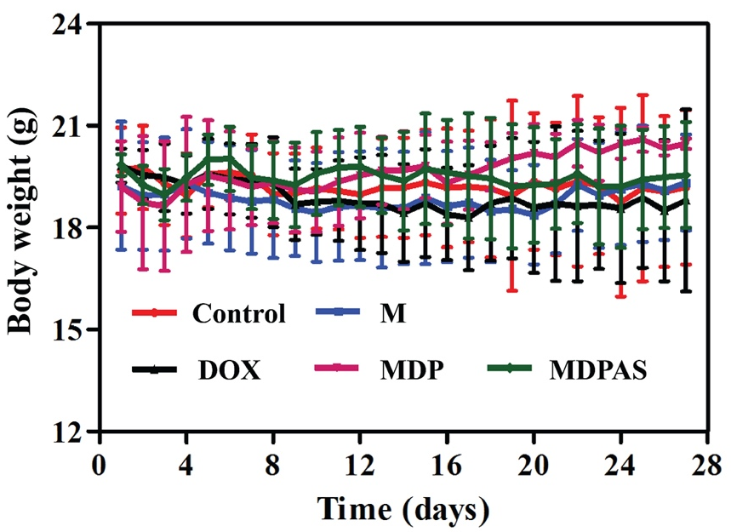
Figure S11. The body weight change of HepG2 tumor-bearing mice treated with different formulations.

Table S1. The drug loading efficiency (DL) and encapsulation efficiency (EE) of DOX and miR-519c plasmid in MDPAS micelles.
 | DOX | miR-519c plasmid
Drug loading efficiency (DL) | 4.76% | 0.68%
Encapsulation efficiency (EE) | 51.93% | 86.53%

