Supplementary materials

Extracellular vesicles from Akkermansia muciniphila elicit antitumor immunity against prostate cancer via modulation of CD8⁺ T cells and macrophages
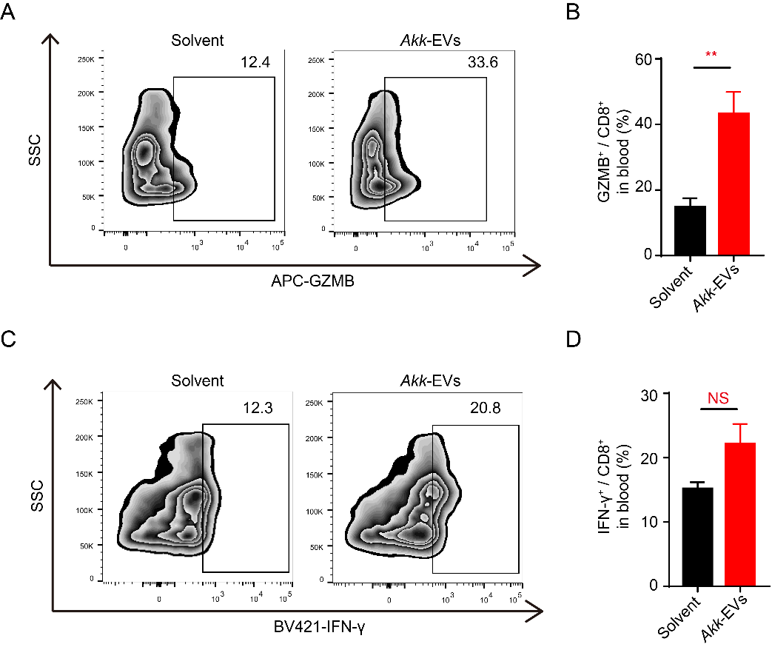
Figure S1 Akk-EVs showed a similar elevated proportion of GZMB⁺ and IFN-γ⁺ lymphocytes in peripheral blood. Flow cytometry analysis of the amount of GZMB and IFN-γ of CD8⁺ T cells in the peripheral blood from solvent- or Akk-EVs-treated mice. Representative plots (A and C) and quantitative analysis (B and D) were shown. Data are shown as mean ± SEM. ** P < 0.01. NS, not significant.

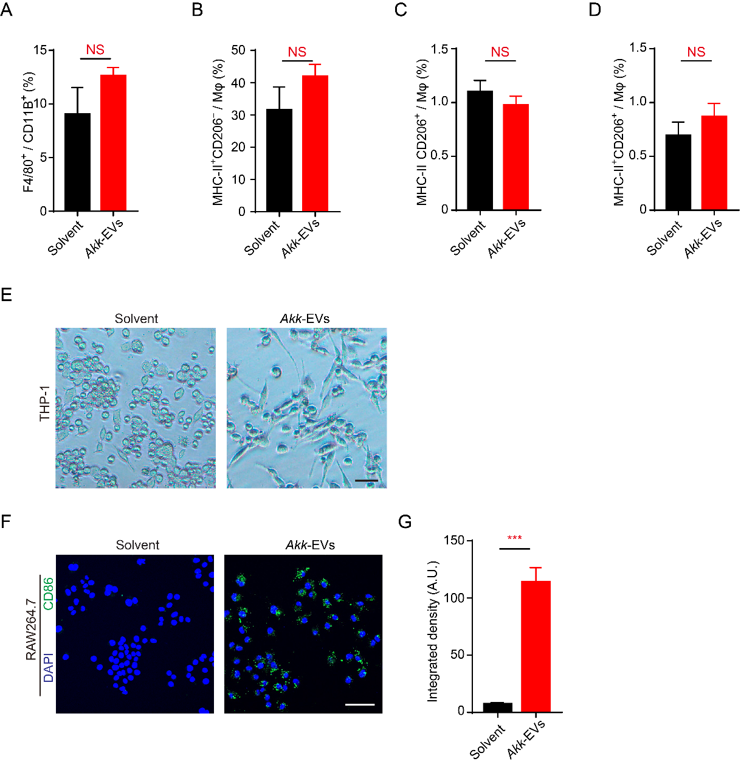
Figure S2 Effects of Akk-EVs on macrophages in vivo and in vitro. (A-D) Quantitative analysis of macrophages and its subpopulation of peripheral blood from solvent- or Akk-EVs- treated mice detected by flow cytometry. n = 5 per group. (E) Representative images of the morphology of PMA-differentiated THP-1 macrophages after different treatments (solvent or Akk-EVs). Scale bar: 20 μm. (F and G) Representative images (F) and quantification (G) of CD86 immunofluorescence staining in RAW264.7 cells treated with solvent or Akk-EVs after 48h. Scale bar: 50 μm. Data are shown as mean ± SEM. *** P < 0.001. NS, not significant.

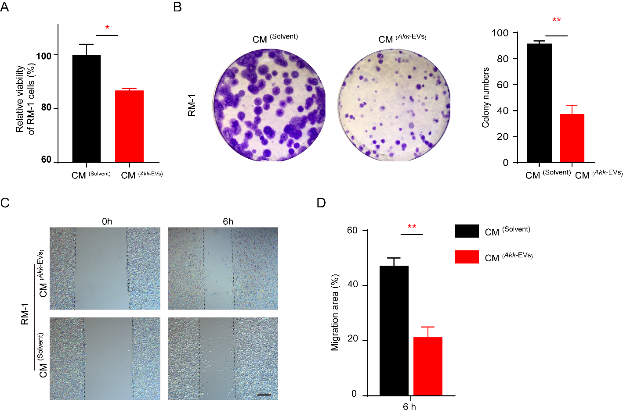
Figure S3 Effects of Akk-EVs-treated RAW264.7 cells on the proliferation and invasion of RM-1 cells. (A) CCK-8 analysis of the viability of mouse PCa cell line RM-1 receiving different CM treatments for 24 h. n = 4 per group. (B) Representative images and quantitative analysis of the crystal violet-stained colonies formed by RM-1 cells of different groups for 14 days. n = 3 per group. (C and D) Representative images (C) and quantification of the migration rates (D) of scratch wound healing assay in RM-1 cells after different CM treatments at indicated time point. Scale bar: 200 μm. n = 4 per group. Data are shown as mean ± SEM. *P < 0.05, **P < 0.01.

