Supplementary Material

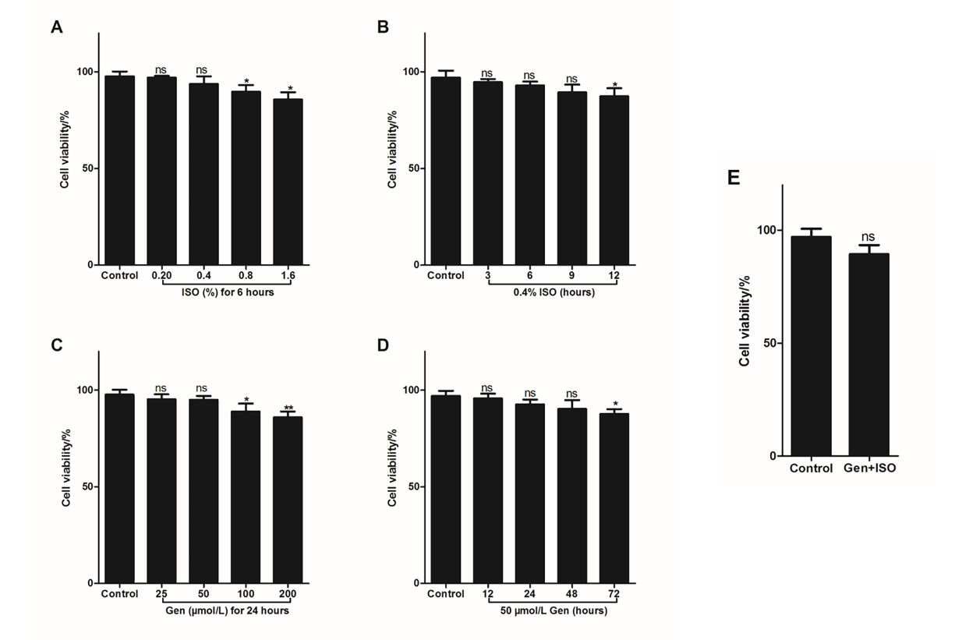
Figure S1 Screening of working concentration/time of BV2 cells by genistein and isoflurane. BV2 cells was stimulated with different concentration of isoflurane for 6 hours (A), or 0.4% isoflurane for different times (B), or different concentration of genistein for 24 hours (C), or 50 μmol/L genistein for 24 hours (D); Or BV2 cells was firstly stimulated with or without 50 μmol/L genistein for 24 hours and then stimulated with 0.4% isoflurane for 6 hours. At last, cell viability of BV2 cells was analyzed by CCK8 kit. Data was expressed as (mean ± SD), and P value was calculated by One-way ANOVA. ns was P>0.05, * was P<0.05 and ** was P<0.01 vs control group.

