Online Supplementary Materials:
Figure S1. Changes of mRNA expression of IL-25, IL-17RB, and antiviral host factors after RSV infection at different time-points, as indicated by a heatmap using RT-qPCR. Red color indicates up-regulation, while blue color indicates down-regulation. p < 0.05 is considered statistically significant.

Figure S2. Inhibition of viral replication titers by different concentrations of IFN-α. Titration of IFN-α concentrations to determine working drug dose to be used in the main experiments. The y-axis depicts the fold changes in viral titers. p < 0.05 is considered statistically significant.

Figure S3. Cell viability assay of hNECs with IFN-α treatment. Viability of IFN-α treated hNECs decreased, but showed no significant differences compared with infected hNECs, which indicated no additional toxicity than that caused by influenza infection.

Figure S4. Co-localization of IL-25 and viral-nucleoprotein in nasal epithelial cells. Representative IF images of influenza-infected hNECs are shown at 1000× magnification. Green – influenza virus nucleoprotein (NP); red – IL-25; blue – DAPI.

Figure S5. Proposed model of IL-25 induction during active respiratory virus infection in airway epithelial cells and its amelioration by IFN-α treatment. Left: Upon viral infection, epithelial cells express IL-25 which may lead to type 2 inflammation via downstream immune cells. Right: Pretreatment using antivirals such as IFN-α results in efficient inhibition of active influenza virus replication. The reduction in virus replication in turn reduces virus-mediated production of IL-25, which can potentially reduce type 2 inflammation.

Table S1. Sequences of primers used for RT-qPCR analysis
Table S2. Demographics of subjects
Table S3. Information on donors of human nasal epithelial cells used in this study
Figure S1
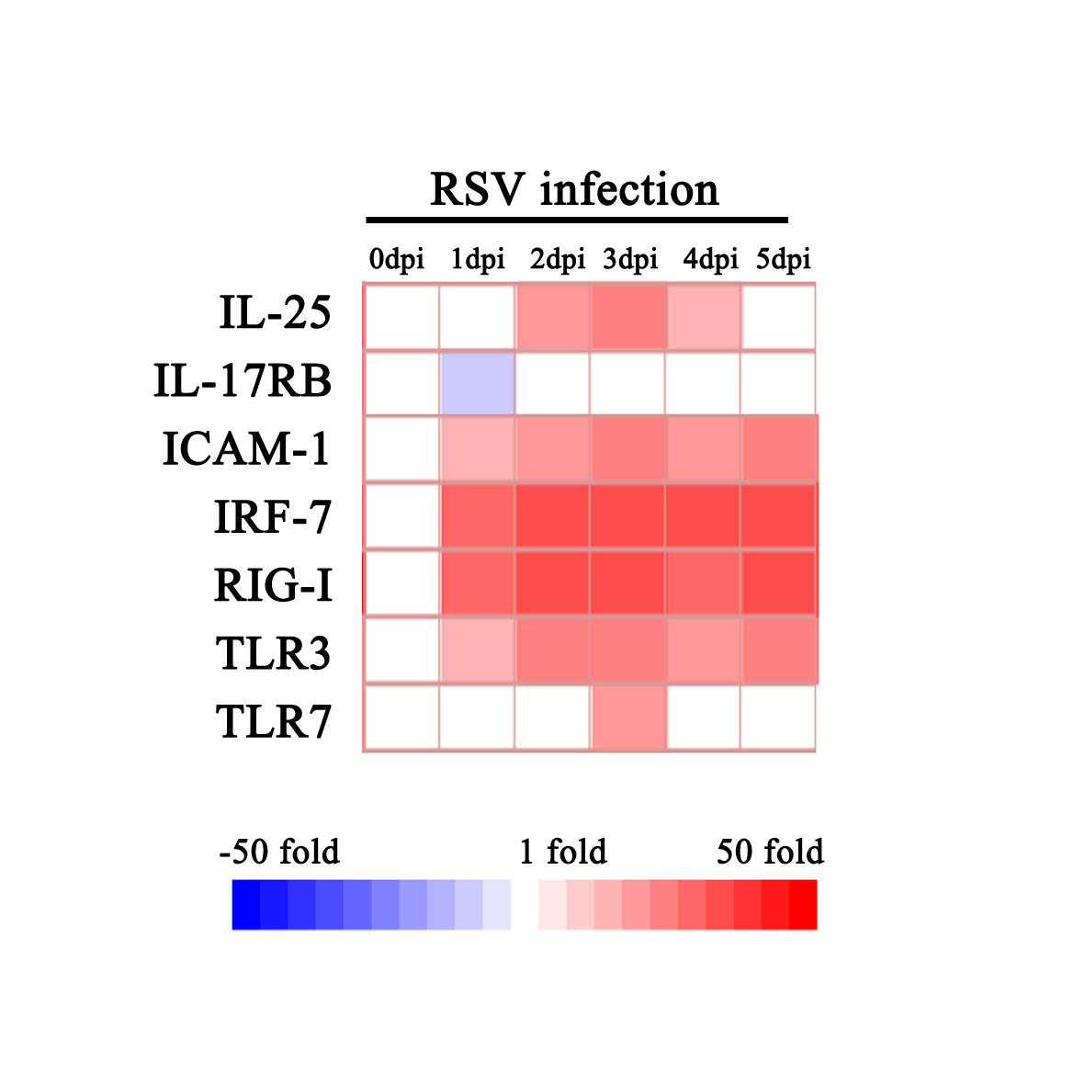
Figure S2
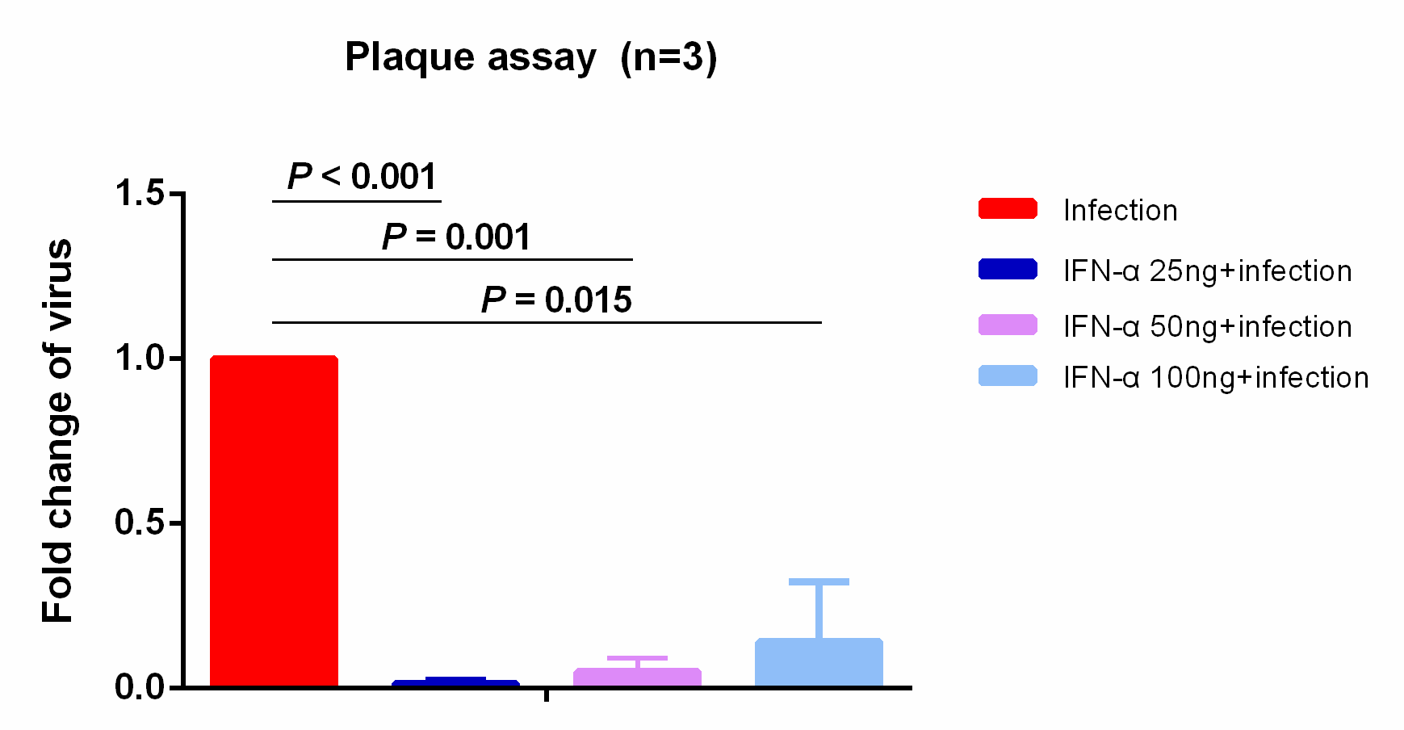

Figure S3

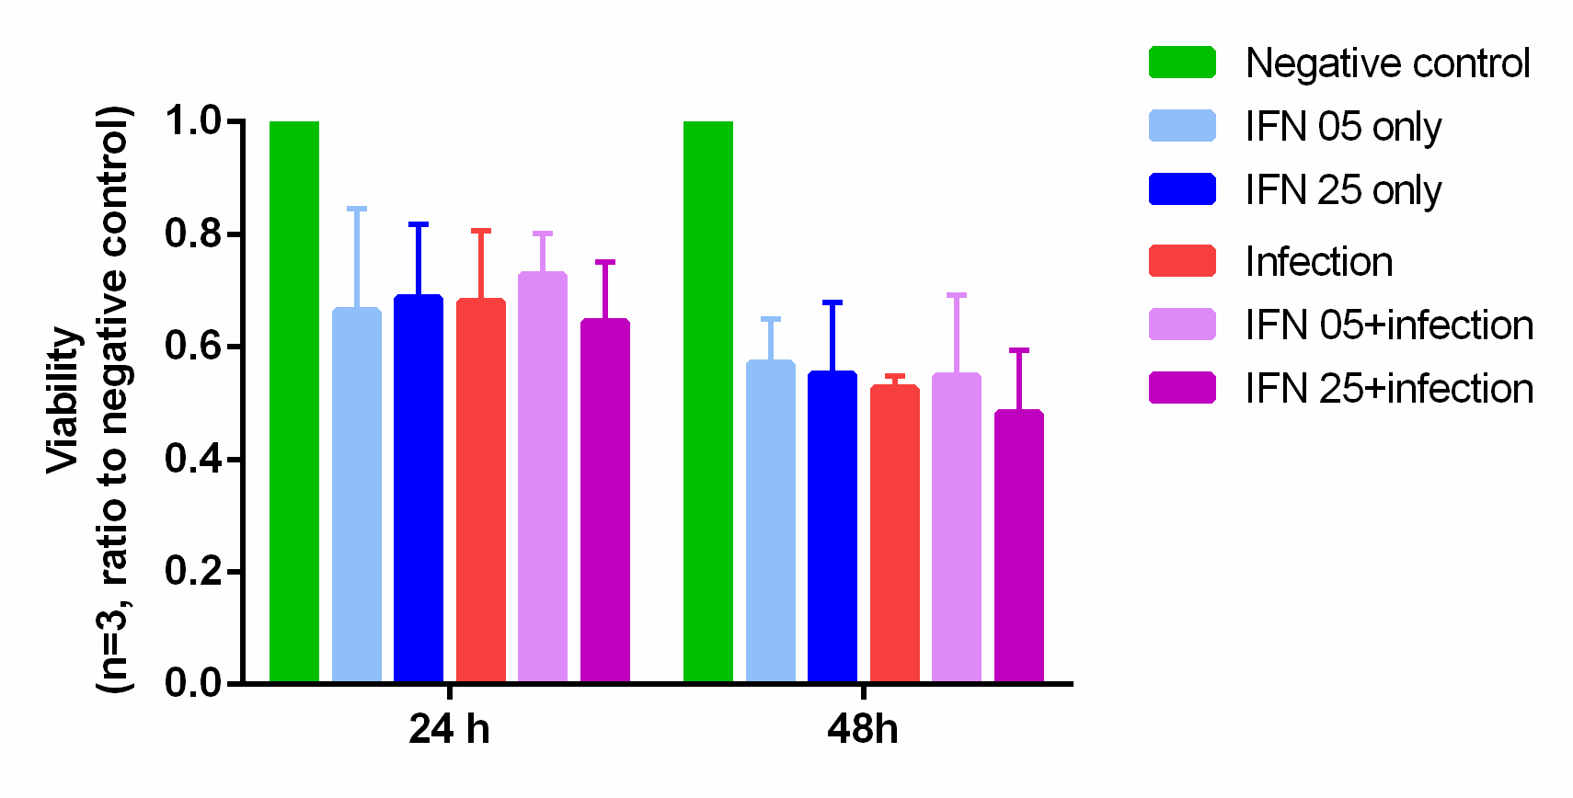

Figure S4

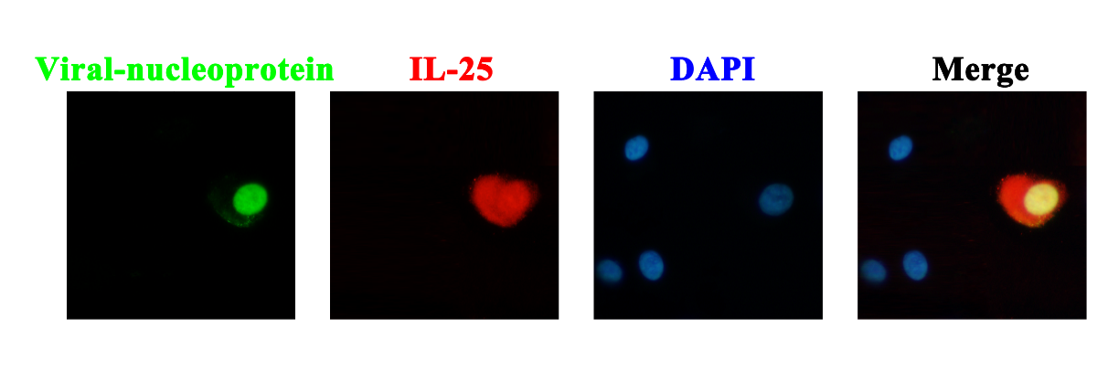

Figure S5
Table S1. Sequences of primers used for RT-qPCR analysis
Target gene |  | Forward |  | Reverse
 | IL-25 | CCAGGTGGTTGCATTCTTGG |  | TGGCTGTAGGTGTGGGTTCC
 | IL-17RB | GGCTTCCTATCCCACCAATT |  | AGGCTGTTTGTAGGCTGCA
 | IL-4 | GCAGTT CTACAGCCACCATG |  | ATGATCGTCTTTAGCCTTTCC
 | IL-5 | ATCTTTCAGGGAATAGGCACAC |  | CCGTCTTTCTTCTCCACACTTT
 | IL-13 | AGCATGGTATGGAGCATCAA |  | CAGCATCCTCTGGGTCTTCT
 | IFN-γ | TTTTGAAGAATTGGAAAGAGGA |  | CACTTGGATGAGTTCATGTATTG
 | IL-17A | TCAACGCTGATGGGAACG |  | TCTTGCTGGATGGGGACA
 | ICAM1 | ACCATCTACAGCTTTCCG |  | TCACACTTCACTGTCACC
 | IRF7 | TCTTCTTCCAAGAGCTGG |  | CTATCCAGGGAAGACACAC
 | RIG-I | GGTATAGAGTTACAGGCATTTC |  | TTGTTTACTAGTGTTGTGGC
 | TLR3 | AGATTCAAGGTACATCATGC |  | CAATTTATGACGAAAGGCAC
 | TLR7 | AGATATAGGATCACTCCATGC |  | CTTCCAAAATGGAATGTAGAGG
 | β-actin | GTCACCAACTGGGACGACA |  | CACAGCCTGGATAGCAACG
 | PGK1 | CTCAACAACATGGAGATTGG |  | CTTTGGACATTAGGTCTTTGAC
ICAM1, intercellular adhesion molecule 1; IFN-γ, interferon-gamma; IL, interleukin; IRF7, interferon regulatory factor 7; PGK1, phosphoglycerate kinase 1; RIG-I, retinoic acid-inducible gene I; TLR, toll-like receptor

Table S2. Demographics of subjects
 | Control Subjects | Patients with CRSsNP | Patients with CRSwNP
No. | 15 | 25 | 60
Tissue sampled | UP | UP | NP
Age (years), mean (SD) | 34·1 (11·20) | 35·2 (9·51) | 36·4 (9·44)
Atopy, no. (%) | 3 (20·0) | 4 (16·0) | 13 (21·67)
Asthma, no. (%) | 0 | 0 | 0
Aspirin sensitivity, no. | 0 | 0 | 0
Sex (male/female) | 10/5 | 16/9 | 43/17
NP endoscopic scores,  mean (SD) | N/A | N/A | 5·4 (1·42)
CT scores, mean (SD) | N/A | 7·28 (2·54) | 12·25 (4·98)#
Total IgE (IU/mL), mean (SD) | 11·9 (5·35) | 76·05 (33·64)* | 85·72 (47·86)*
Methodologies used
Tissue IHC | 15 | 25 | 60
Tissue mRNA | 15 | 25 | 60
Flow cytometry | 0 | 0 | 6
Luminex | 0 | 10 | 20

Definition of abbreviations: CRSsNP, chronic rhinosinusitis without nasal polyps; CRSwNP, chronic rhinosinusitis with nasal polyps; NP, nasal polyps; UP, uncinate process; N/A, not applicable. *p<0·05, compared with control subjects. #p<0·05, compared with subjects with CRSsNP.

Table S3. Information on donors of human nasal epithelial cells used in this study
Code | Age ( Y ) | Sex | Diagnosis | Sample | Smoking history | Drug treatment* | Interventions
H 01 | 22 | M | SD+AR | IT | Non-smoker | Yes | Infection with  influenza H3N2 virus (Aichi 2 strain), rhinovirus (RV16 strain), and respiratory syncytial virus (A2 strain),  and screening the concentrations and toxicity of IFN-α protein
H 02 | 39 | M | SD+AR | IT | Non-smoker | Yes
H 03 | 22 | M | SD | IT | Non-smoker | Yes
H 04 | 22 | M | SD+AR | IT | Non-smoker | Yes
H 05 | 42 | M | SD | IT | Non-smoker | No
H 06 | 61 | M | CRSwNP | NP | Non-smoker | No
H 07 | 67 | F | CRSwNP | NP | Non-smoker | Yes
H 08 | 26 | M | CRSwNP | NP | Non-smoker | Yes
H 09 | 63 | M | CRSwNP | NP | Non-smoker | Yes
H 10 | 41 | M | CRSwNP | NP | Non-smoker | Yes
H 11 | 59 | M | CRSwNP | NP | Non-smoker | No
H 12 | 29 | M | SD | IT | Non-smoker | No
H 13 | 33 | M | SD+AR | IT | Non-smoker | Yes
H 14 | 58 | M | CRSwNP | NP | Non-smoker | Yes | Pretreatment with IFN-α and infection with influenza H3N2 virus (Aichi 2 strain)
H 15 | 47 | M | CRSwNP | NP | Non-smoker | Yes
H 16 | 65 | M | CRSwNP | NP | Non-smoker | Yes
H 17 | 46 | M | CRSwNP | NP | Non-smoker | Yes

Y, years; F, female; M, male; AR, allergic rhinitis; IT, inferior turbinate; SD, septal deviation; NP, nasal polyp; CRSwNP, Chronic rhinosinusitis with nasal polyps. *Corticosteroids and/or antibiotics within 3 months before surgery.

