Figure S1: UV-Vis absorbance spectra of citrate capped silver nanoparticle samples with increasing sizes: 10 nm: AgNP-I (Left), 20 nm: AgNP-II (Middle) and 50 nm: AgNP-III (Right) over 24 hours in different pH values.
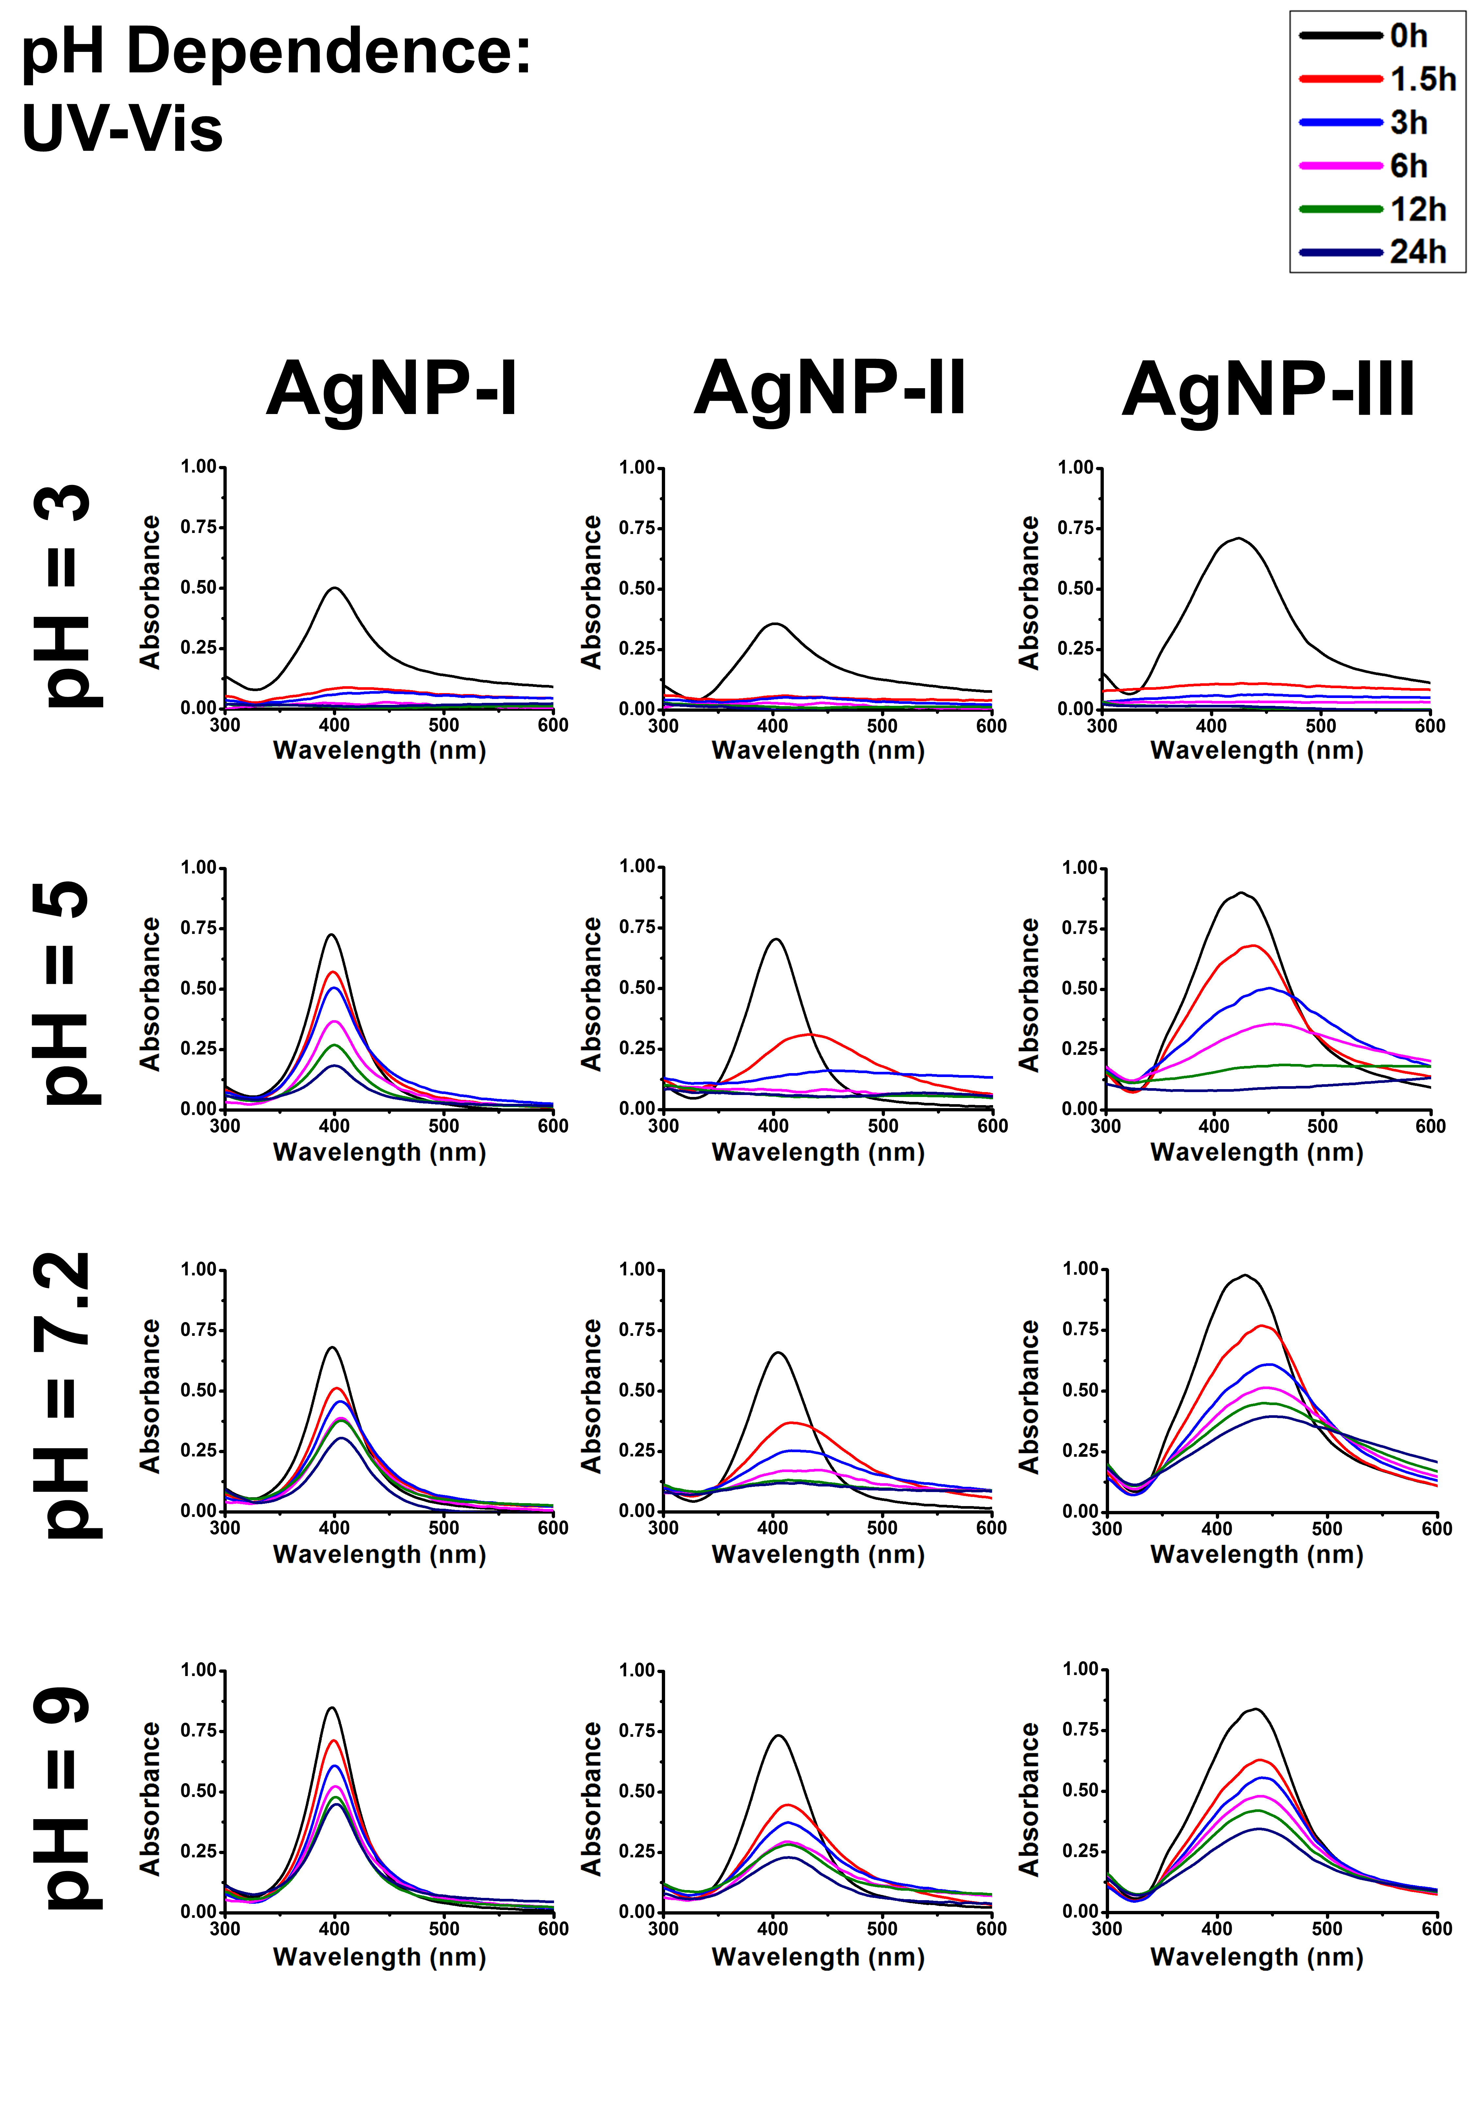
Figure S2: UV-Vis absorbance spectra of citrate capped silver nanoparticle samples with increasing sizes: 10 nm: AgNP-I (Left), 20 nm: AgNP-II (Middle) and 50 nm: AgNP-III (Right) over 24 hours in different NaCl concentrations.
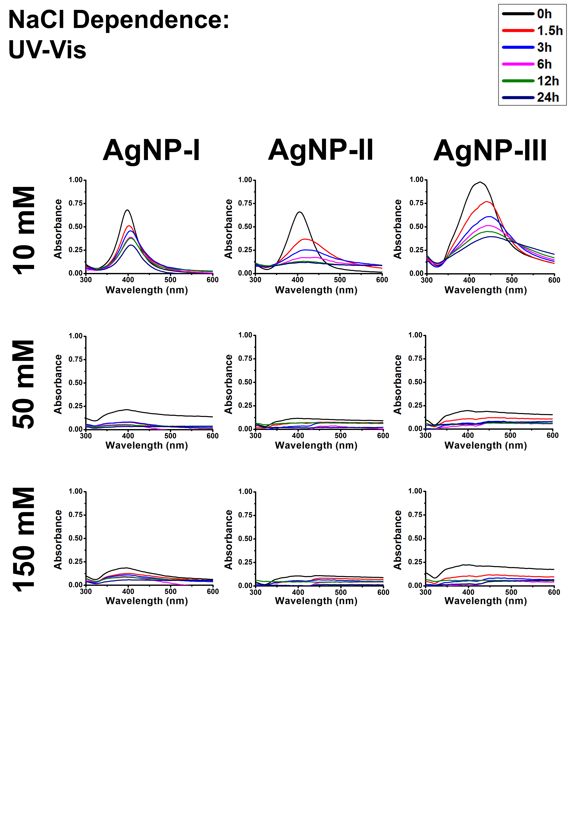

Figure S3: UV-Vis absorbance spectra of citrate capped silver nanoparticle samples with increasing sizes: 10 nm: AgNP-I (Left), 20 nm: AgNP-II (Middle) and 50 nm: AgNP-III (Right) over 24 hours in different glucose concentrations.
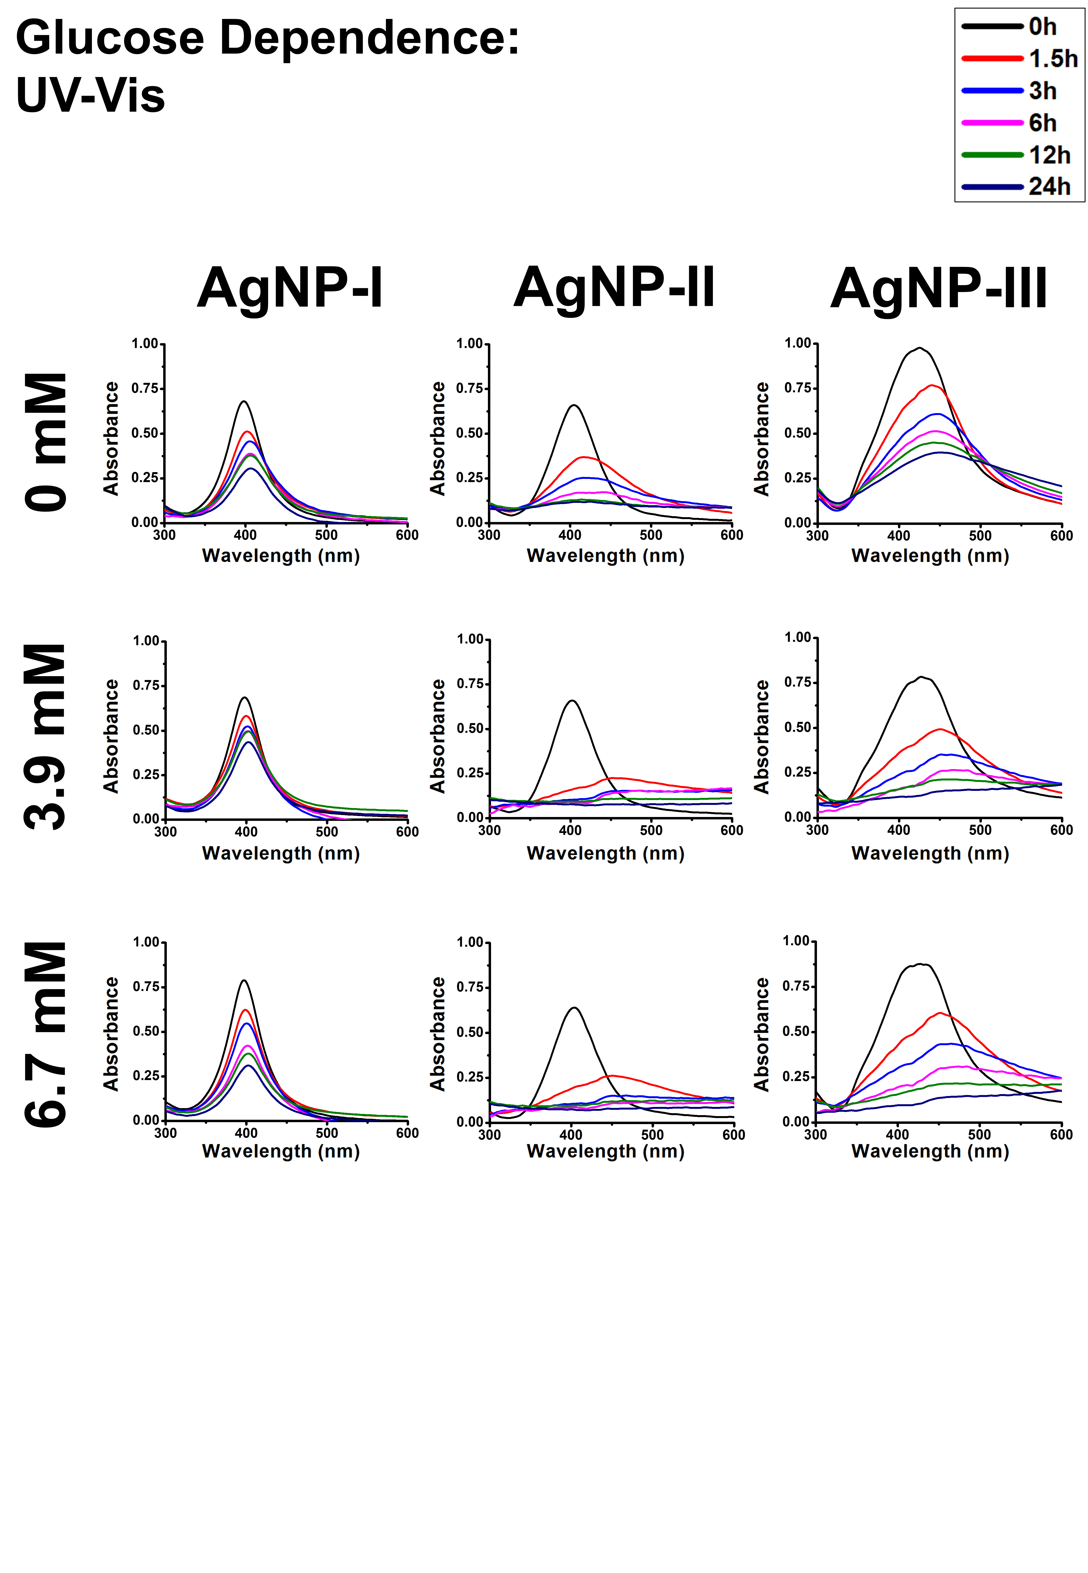

Figure S4: UV-Vis absorbance spectra of citrate capped silver nanoparticle samples with increasing sizes: 10 nm: AgNP-I (Left), 20 nm: AgNP-II (Middle) and 50 nm: AgNP-III (Right) over 24 hours in the presence of glutamine.
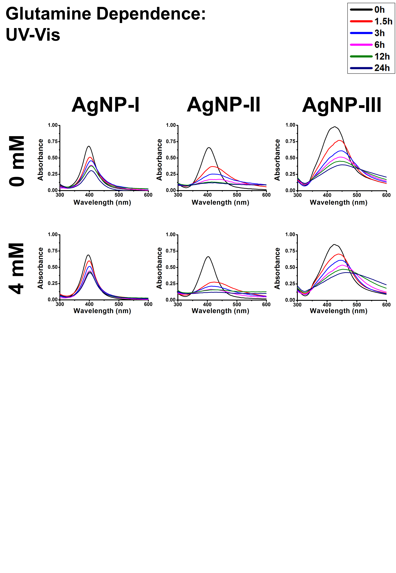

Figure S5: UV-Vis absorbance spectra of citrate capped silver nanoparticle samples with increasing sizes: 10 nm: AgNP-I (Left), 20 nm: AgNP-II (Middle) and 50 nm: AgNP-III (Right) over 24 hours in the presence of cell culture components DMEM and FBS.
